Name…………………………… …………………………….…Index No:………………...…………………
School …………………………………………………….………Candidate’s Signature ……….…..…………
Date:………………………………………
231/1
BIOLOGY
PAPER 1
(THEORY)
JULY / AUGUST 2024
TIME: 2 HOURS

NAKURU NORTH SUB -COUNTY JOINT MOCK 2024

Kenya Certificate of Secondary Education (K.C.S.E)

231/1
BIOLOGY
PAPER 1

TIME: 2 HOURS

INSTRUCTIONS TO CANDIDATES
- Write your name, Admission number and name of your school in the spaces provided above
- Sign and write the date of examination in the spaces provided.
- Answer all the questions in the spaces provided.
- This paper consists of 8printed pages.
- Candidates should check to ascertain that all pages are printed as indicated and that no questions are missing
For Examiners Use Only
Question | Maximum score | Candidate’s score
1- 29 | 80

1. (a) Differentiate between gaseous exchange and ventilation. (2 marks)
...........................................................................................................................................................................................................................................................................................................................................................................................................................................................................................................................................................................................................................................

(b) Name the respiratory sites of the following:

(i) Fish (1 mark)
......................................................................................................................................................................................................................................................................................................................

(ii) Insects (1 mark)
......................................................................................................................................................................................................................................................................................................................

2. A portion of a nucleic acid is shown below;
-S-P-S-P-S-P-S-P-S-P- S -
C C G U G C
a) Name the nucleic acid to which the portion belongs. Give a reason. (2 marks)
.................................................................................................................................................................................................................................................................................................................................................................................................................................................................................

b) Write down the sequence of bases of a complimentary strand to the one above. (1 mark)
.................................................................................................................................................................................................................................................................................................................................................................................................................................................................................
3. The diagram below illustrates a growing pollen tube

- Name the part labeled B (1mark)
…………………………………………………………………………………………………………..………………………………………………………………………………………………………..
…………………………………………………………………………………………………………
- Explain the role of parts labeled A (2marks)
…………………………………………………………………………………………………………..………………………………………………………………………………………………………..…………………………………………………………………………………………………………

4. Name two components of Mammalian blood that play a role in blood clotting. (2mks)
…………………………………………………………………………………………………………..………………………………………………………………………………………………………..…………………………………………………………………………………………………………

5. (a) Name the parts of a mammalian ear which carry out the following functions.
i) Balance and posture. (l mark)
…………………………………………………………………………………………………………………………………………………………………………………………………………

ii) Hearing. (l mark)
…………………………………………………………………………………………………………………………………………………………………………………………………………

(b) State the importance of presence of glands in auditory canal. (l mark)
…………………………………………………………………………………………………………………………………………………………………………………………………………

6. (a) State the function of co-factors in cell metabolism. (1mark)
…………………………………………………………………………………………………………………………………………………………………………………………………………

(b) Give one example of a metallic co-factor. (l mark)
……………………………………………………………………………………………………………………………………………………………………………………………………………………
- A potted plant was kept in the dark for 48 hours. Two leaves X and Y were treated as shown in the diagram below.

The experimental set-up was kept in sunlight for 6 hours after which starch test was carried out on the two leaves.

- Give a reason why potassium hydroxide pellets were put in a transparent polythene bag with leave Y (1mark)
…………………………………………………………………………………………………………..………………………………………………………………………………………………………..…………………………………………………………………………………………………………
- What were the results of the starch test on leaves X and Y? (2marks)
…………………………………………………………………………………………………………..………………………………………………………………………………………………………..…………………………………………………………………………………………………………
…………………………………………………………………………………………………………
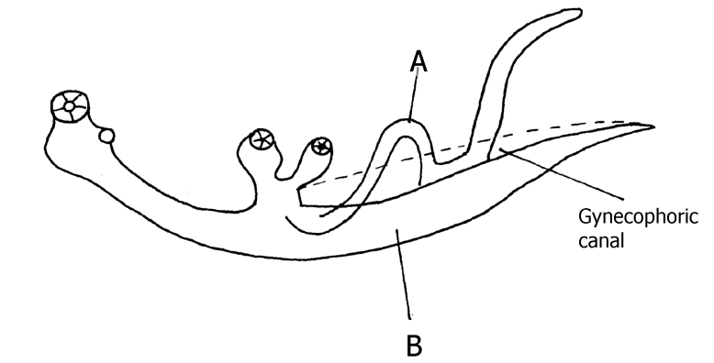
8. The diagram below shows two organisms of the same species (2marks)

- State the sex of organism A and B. (2marks)
…………………………………………………………………………………………………………..…………………………………………………………………………………………………..………………………………………………………………………………………………………
b) Name the disease caused by the above organism. (1mark)
…………………………………………………………………………………………………………..………………………………………………………………………………………………………..
9. Identify the physiological process involved in the following

a) Feeding in Venus fly trap ( insectivorous plant) (1mark)
…………………………………………………………………………………………………………..………………………………………………………………………………………………………..
b) Absorption of mineral salts by plant roots. (1mark)

…………………………………………………………………………………………………………..………………………………………………………………………………………………………..
10. a) Explain how the following parts of a mammalian reproductive system are adapted to their functions. (2 marks)
i) Testis
…………………………………………………………………………………………………………..………………………………………………………………………………………………………..…………………………………………………………………………………………………………
ii) Uterus
…………………………………………………………………………………………………………..………………………………………………………………………………………………………..…………………………………………………………………………………………………………
b) Explain why removal of the ovary after four months of pregnancy does not terminate pregnancy. (2 marks)
…………………………………………………………………………………………………………..………………………………………………………………………………………………………..…………………………………………………………………………………………………………
…………………………………………………………………………………………………………
11. State the role of the following hormones in homeostasis
i) Antidiuratic hormone (vasopressin) (1 mark)
…………………………………………………………………………………………………………..………………………………………………………………………………………………………..
ii) Aldosterone hormone (1 mark)
…………………………………………………………………………………………………………..………………………………………………………………………………………………………..…………………………………………………………………………………………………………
12. Name parts of the brain which control
(a) Involuntary activities e.g breathing (1mark)
…………………………………………………………………………………………………………..………………………………………………………………………………………………………..
(b) Control voluntary body movement (1mark)
…………………………………………………………………………………………………………..………………………………………………………………………………………………………..
13. During a strenuous exercise, the chemical process represented by the equation below takes place in human muscles
C₆H₁₂O₆ 2CH₃CH(OH)COOH + 150KJ
(Glucose) (substance x) (energy)

(a) What is the name of this process (1mark)
…………………………………………………………………………………………………………..………………………………………………………………………………………………………..
(b) Name the substance X (1mark)
…………………………………………………………………………………………………………..………………………………………………………………………………………………………..
(c) What happens to the muscle if x accumulates to critical level (1mark)
…………………………………………………………………………………………………………..………………………………………………………………………………………………………..
14. (a) Define the term ‘parthenocarpy’. (1mark)

…………………………………………………………………………………………………………..………………………………………………………………………………………………………..…………………………………………………………………………………………………………
…………………………………………………………………………………………………………
(b) Name two plant growth hormones that promote parthenocarpy. (2marks)

…………………………………………………………………………………………………………..………………………………………………………………………………………………………..…………………………………………………………………………………………………………

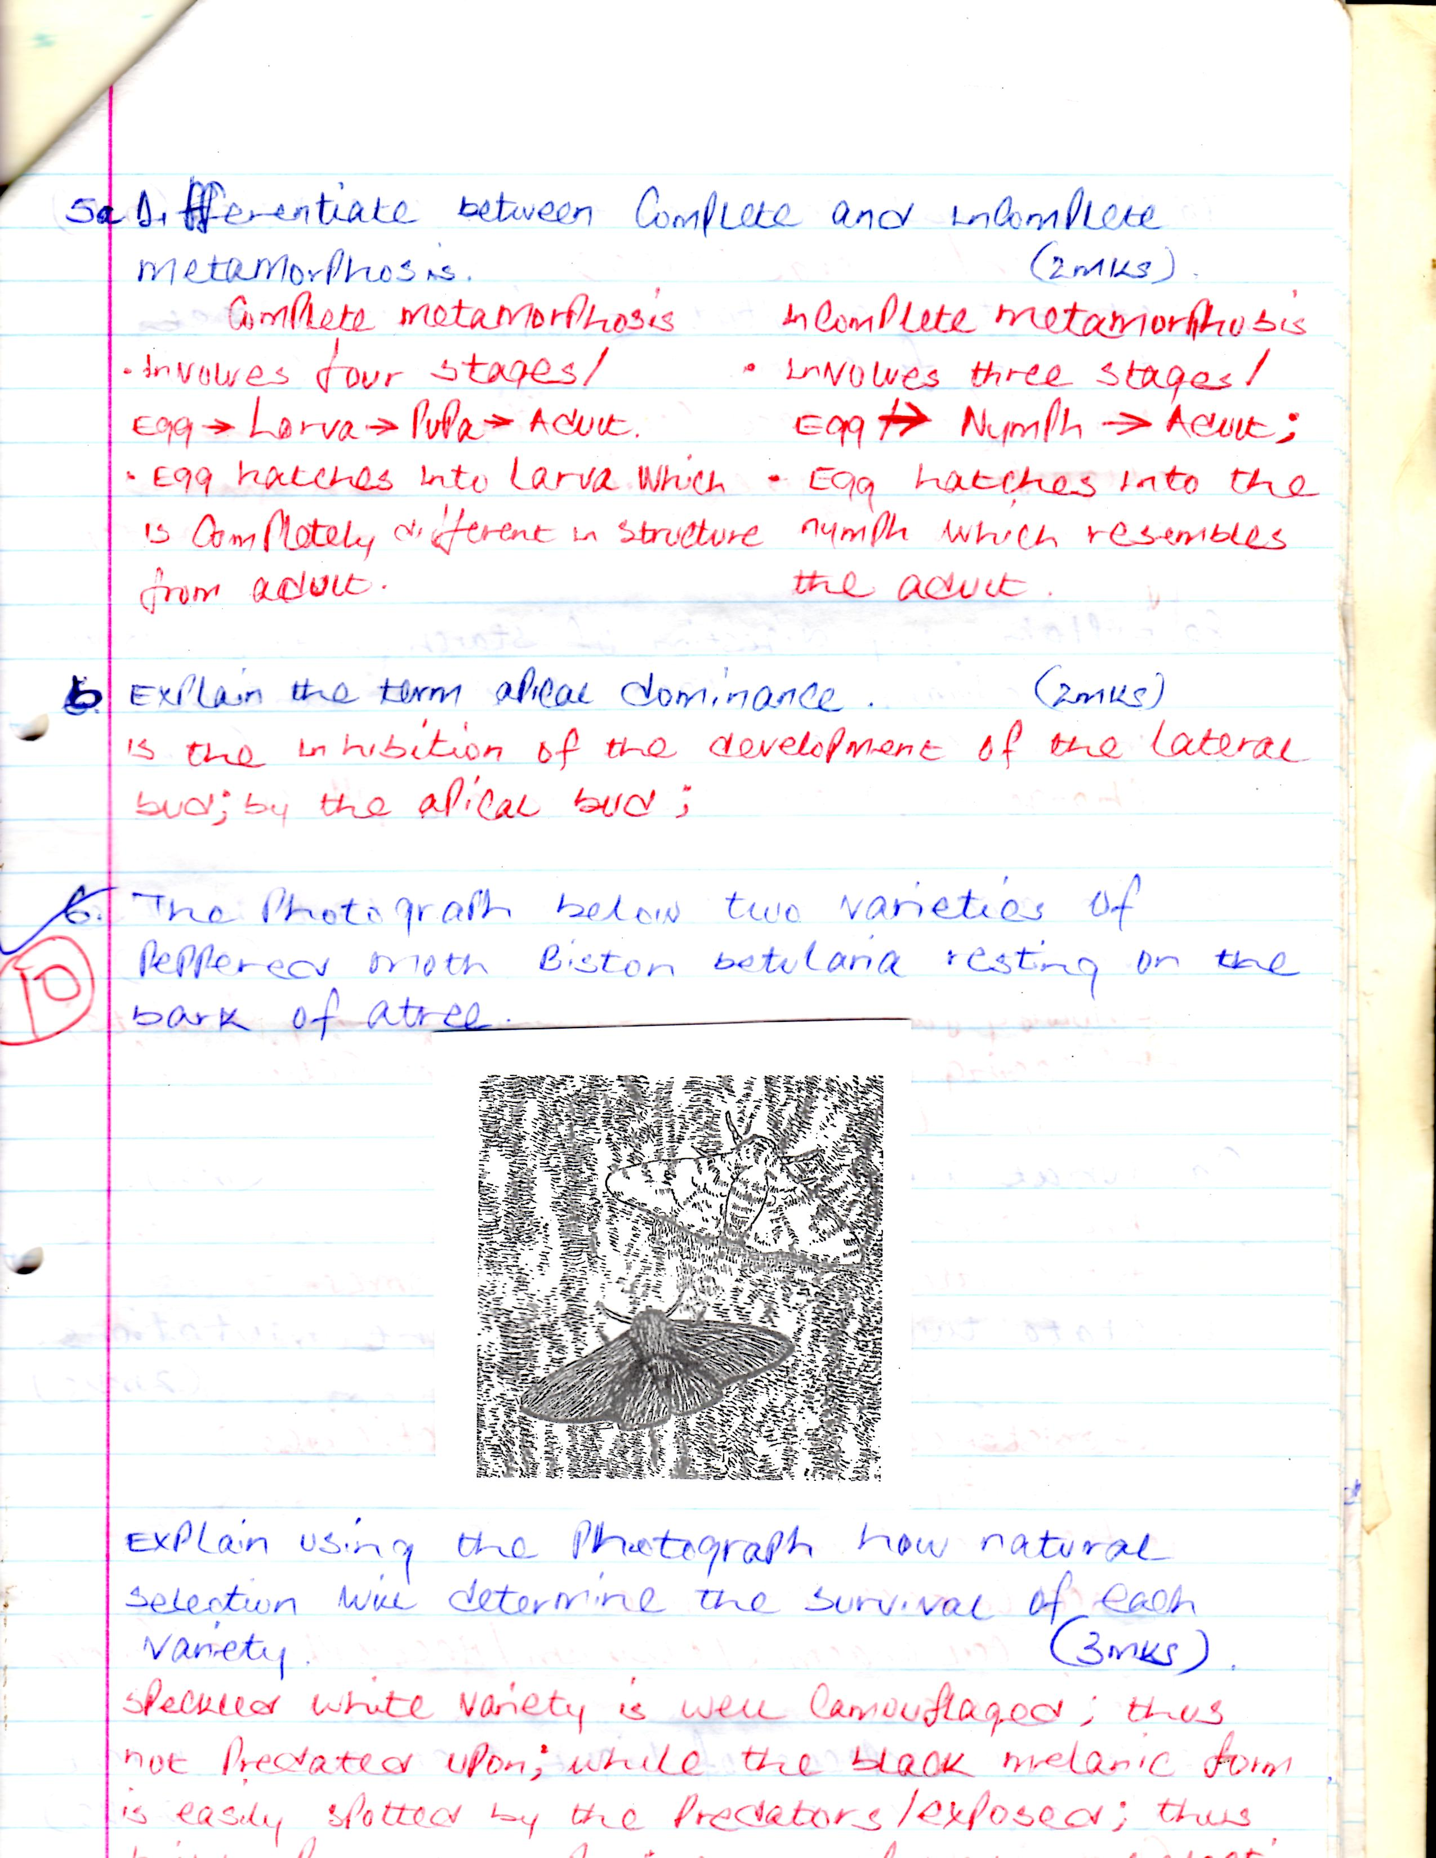
15. The photograph below are two varieties of peppered moth biston betularia resting on the bark of a tree. (3marks)

Explain using the photograph how natural selection will determine the survival of each variety. (3marks)
…………………………………………………………………………………………………………..………………………………………………………………………………………………………..…………………………………………………………………………………………………………
…………………………………………………………………………………………………………
16. State the importance of the following features of mammalian lungs.
- Spongy and elastic (1 mark)

…………………………………………………………………………………………………………..………………………………………………………………………………………………………..
- Pleural fluid (1 mark)

…………………………………………………………………………………………………………..………………………………………………………………………………………………………..
- Identify the use of the following apparatus (3marks)
- Bait trap
..…………………………………………………………………………………………………………..……………………………………………………………………………………………............................................................................................................................................................…
- Specimen bottle
……………………………………………………………………………………………………..……………………………………………………………………………………………………..……………………………………………………………………………………………………

- Pitfall trap
………………………………………………………………………………………….………….……..………………………………………………………………………………………………………..……………………………………………………………………………………………

18. State two feature common in mammals and bird (2 marks)
…………………………………………………………………………………………………………..………………………………………………………………………………………………………..…………………………………………………………………………………………………………

19. The lungs and ileum are adapted for absorption. State three features they have in common which facilitate absorption. (3marks)
…………………………………………………………………………………………………………..………………………………………………………………………………………………………..……………………………………………………………………………………………………………………………………………………………………………………………………………………..………………………………………………………………………………………………………..…………………………………………………………………………………………………………

20. (a) Why is blood group AB described as universal recipient? (2mks)
…………………………………………………………………………………………………………..………………………………………………………………………………………………………..…………………………………………………………………………………………………………

(b) Suggest why blood does not clot in blood vessels of a healthy person. (l mark)
…………………………………………………………………………………………………………..………………………………………………………………………………………………………..…………………………………………………………………………………………………………
21. (a) State why the placenta is considered as an endocrine gland. (l mark)
…………………………………………………………………………………………………………..………………………………………………………………………………………………………..…………………………………………………………………………………………………………

(b) Describe how the embryo in human is protected during pregnancy. (2marks)
…………………………………………………………………………………………………………..………………………………………………………………………………………………………..…………………………………………………………………………………………………………

22. State three effects of dumping untreated sewage into a river. (3marks)
…………………………………………………………………………………………………………..………………………………………………………………………………………………………..……………………………………………………………………………………………………………………………………………………………………………………………………………………..………………………………………………………………………………………………………..

23. (a) State three functions of Obturator Foramen in the pelvic girdle in a mammal. (3marks)
..………………………………………………………………………………..……………………………………………..…………………………………………………………..……………………………………………………………………………..…………………………..………………………………………………………………………………………………………..................……..………

(b) What is a

(i) Tendon? (1mark)
..........…………………..………………………………………………………………………………….......................................................................................................................................................................................................................................................................................……………………….
(ii) Ligament? (1 mark)
...…………………………………….....………………………………………………………………………………..........................................................................................................................................................................................................................................................................................………..
24. (a) Name the plant excretory product which is used for:
(i). Treatment of malaria. (l mark)
…………………………………………………………………………………………………………..………………………………………………………………………………………………………..
(ii). As a beverage. (l mark)
…………………………………………………………………………………………………………..………………………………………………………………………………………………………..
(b) Explain why lactic acid is not considered as an excretory product though it’s toxic to tissues.
(l mark)
…………………………………………………………………………………………………………..………………………………………………………………………………………………………..…………………………………………………………………………………………………………
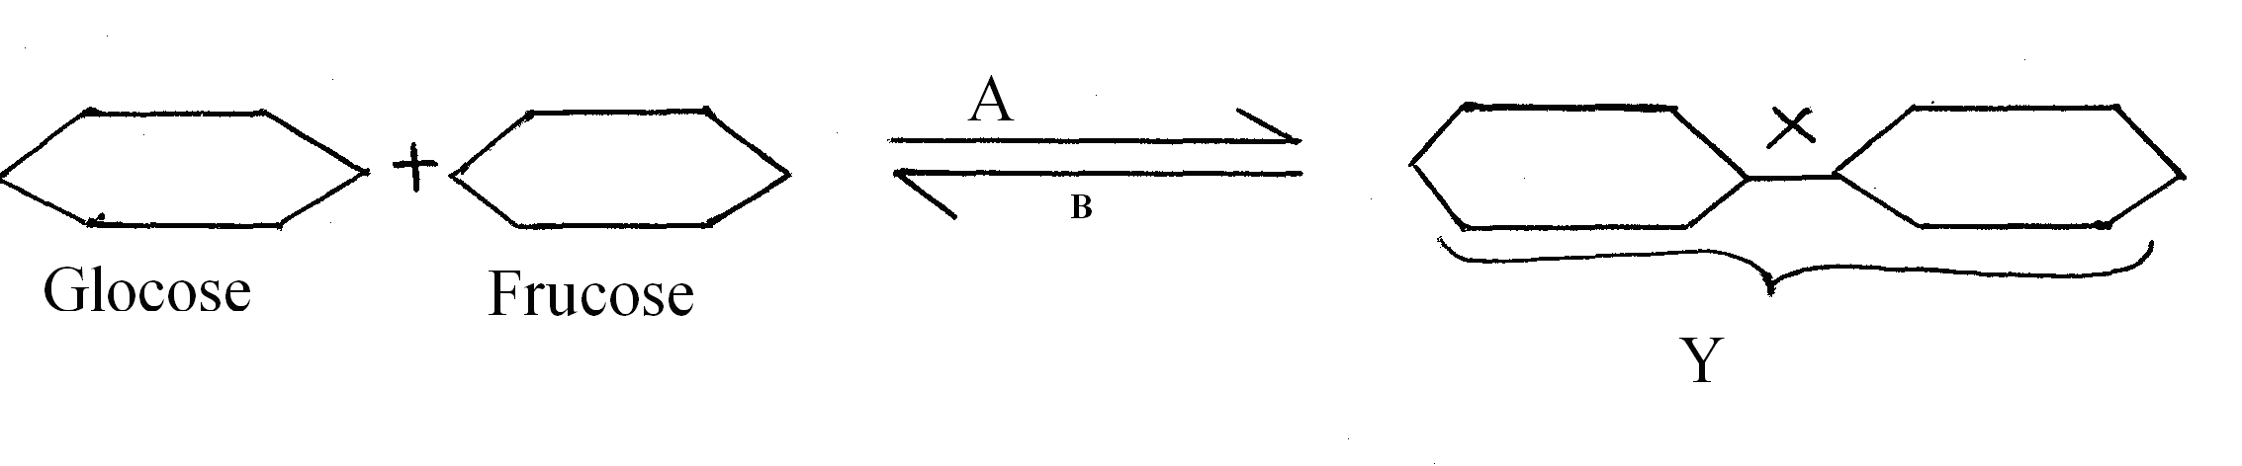
25. Study the reaction below and answer the questions that follow.

i) State the biological process that takes place represented by A (1mark)
…………………………………………………………………………………………………………..………………………………………………………………………………………………………..
ii) What Biological process is represented by B (1mark)
…………………………………………………………………………………………………………..………………………………………………………………………………………………………..
iii) State the product Y (1mark)
…………………………………………………………………………………………………………..………………………………………………………………………………………………………..
iv) State the bond represented by X (1mark)
…………………………………………………………………………………………………………..………………………………………………………………………………………………………..
26. Give three components of a simple reflex arc. (3 marks)
…………………………………………………………………………………………………………..………………………………………………………………………………………………………..…………………………………………………………………………………………………………

