

**MARANDA HIGH SCHOOL**

***Kenya Certificate Of Secondary Education***

**THE 2024 MOCK EXAMINATION**

**231/1 BIOLOGY PAPER 1**

**June, 2024 TIME: 2 Hrs**

**Name**: …………………………………….…….……Admission No: ……………

**231/1- BIOLOGY**

Thursday, 6th June, 2024

Afternoon

2.00-4.30pm

**Stream**: ……………………….. **Signature**: ……….........

**Instructions**

1. *Write your* ***name****,* ***admission number, date, stream and signature*** *in the spaces provided above.*
2. *All answers must be written in the spaces provided in the booklet.*
3. ***This paper consists of 12 printed pages with 32 questions. Candidates should check the question paper to ascertain that all the pages are printed as indicated and that no questions are missing***
4. *Candidate should answer the questions in* ***English***

**­­­­­­­­­­­­­­­­­­­­­­­­­­­­­­­______________________________________________________­**

**FOR EXAMINERS’USE ONLY**

|  |  |  |
| --- | --- | --- |
| **QUESTION** | **MAXIMUM SCORE** | **CANDIDATE’S SCORE** |
| **1-32** | **80** |  |

1. **(a)** Other than having many features in common, state another characteristic of species.

(1 mark)

**………………………………………………………………………………………………**

**(b)** State **two** characteristics of Kingdom Monera that are not found in other Kingdoms.

(2 marks)

**………………………………………………………………………………………………………………………………………………………………………………………………**

1. **(a)** Name the cell organelle found in abundance in white blood cells. (1 mark)

**………………………………………………………………………………………………**

**(b)** Give a reason for your answer in (a) above. (1 mark)

**………………………………………………………………………………………………**

1. A tall, light skinned lady with pimples on her face has long hair and limbs.

**(a)** List **two** characteristics which the lady has that are due to inheritance (2 marks)

**………………………………………………………………………………………………………………………………………………………………………………………………**

**(b)** Explain why most recessive genes expressed phenotypically are found in male offspring in humans. (2 marks)

**………………………………………………………………………………………………………………………………………………………………………………………………………………………………………………………………………………………………**

1. How is the sebaceous gland in the human skin adapted to its function? (2 marks)

**…..………………………………………………………………………………………………**

1. An experiment was set up as shown in the diagram below.

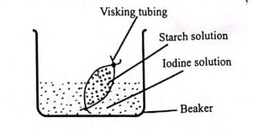

**(a)** At the end of the experiment it was observed that the starch turned Blue-black while the colour of iodine solution in the beaker did not change. Account for this observation.

(3 marks)

**………………………………………………………………………………………………………………………………………………………………………………………………………………………………………………………………………………………………**

1. **(a)** Name the cartilage found between the bones of vertebral column. (1 mark)

**……………………………………………………………………………………………**

**(b)** State the function of the cartilage named in **(a)** above. (1 mark)

**………………………………………………………………………………………………**

1. Explain why low blood sugar level is harmful to the health of a human being. (2 marks)

**………………………………………………………………………………………………………………………………………………………………………………………………………………………………………………………………………………………………………..**

1. **(a).** Give reasons for the following:
2. The head of the fish is inflexible. (1 mark)

**………………………………………………………………………………………………**

**ii.** Scales overlap facing backwards. (1 mark)

**……………………………………………………………………………………………..**

**(b)** Name the type of fins that prevent pitching in a tilapia fish. (1 mark)

**………………………………………………………………………………………………..**

1. The illustration below shows a summary of the main phases of the human menstrual cycle.

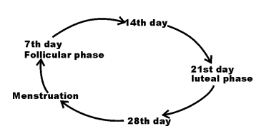

**(a)** Name the process that takes place around the 14th day. (1 mark)

**………………………………………………………………………………………………**

**(b)** Name **two** hormones produced at the follicular phase. (2 marks)

**………………………………………………………………………………………………………………………………………………………………………………………………(c)** Under which **two** conditions would the cycle be interrupted? (2 marks)

**………………………………………………………………………………………………………………………………………………………………………………………………**

1. Distinguish between dioecism and monoecism conditions in flowering plants. (2 marks)

**………………………………………………………………………………………………………………………………………………………………………………………………………………………………………………………………………………………………………..**

1. **(a)** What is the end product of respiration in animals that is not found in plants when there is insufficient oxygen supply? (1 mark)

**…………….……………………………………………………………………………………**

**(b)** What is glycolysis? (1 mark)

**…..………………………………………………………………………………………………**

1. **(a).** Name the opening to the chamber of the heart of an insect. (1 mark)

**…………………………………………………………………………………………………..**

**(b).** Explain how the structure named in **12 (a).** above adapted to its function. (2 marks)

**…………………………………………………………………………………………………**

**…………………………………………………………………………………………………**

1. Name **two** nutrients that are absorbed without being digested by enzymes the alimentary canals of humans. (2 marks)

**……………………………………………………………………………………………………………………………………………………………………………………………………**

1. Other than transport, state **two** functions of blood plasma. (2 marks)

**……………………………………………………………………………………………………………………………………………………………………………………………………..**

1. If anti **B** serum was added into two blood samples, agglutination occurred. Name **two** possible blood groups of the samples. (2 marks) **……………………………………………………………………………………………………………………………………………………………………………………………………**
2. State the function of the following parts of the ear.

**(a).** Oval window. (1 mark)

**…………………………………………….………………………………………………**

**(b)**. Semi-circular canals. (1 mark)

**………………………………………………………………………………………………**

1. The diagram below is a transverse section of a plant organ.

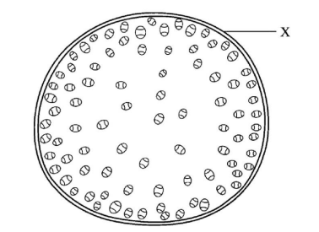

**(a)** Name the plant organ from which the section was obtained. (1 mark)

**………………………………………………………………………………………………**

**(b)** Name the class to which the organism from which section was obtained belongs.

(1 mark)

**………………………………………………………………………………………………**

**(c)** Give a reason for your answer in **(b)** above. (1 mark)

**………………………………………………………………………………………………**

1. Give **two** roles of ethene hormone in plants. (2 marks)

**…………………………………………………………………………………………………………………………………………………………………………………………………...**

1. Explain how convergent evolution occurs. (3 marks)

**……………………………………………………………………………………………………………………………………………………………………………………………………………………………………………………………………………………………………….**

1. The diagram below illustrates a growing pollen tube.

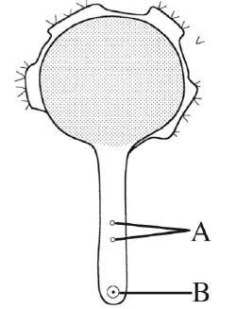

**(a)** Name the part labeled **B.** (1 mark)

**………………………………………………………………………………………………**

**(b)** Explain the role of the part labeled **A**. (2 marks)

**…………...………………………………………………………………………………….**

**…..…………………………………………………………………………………………..**

1. **(a)** Give a reason why the image is **not** formed when light is focused on the blind spot.

(1 mark)

**………………………………………………………………………………………………**

**(b)** When reading a book, the letters looked directly are clear and sharp whereas the surrounding letters are blurred. Explain. (2 marks)

**………………………………………………………………………………………………………………………………………………………………………………………………………………**

1. Distinguish between Parthenogenesis and Parthenocarpy. (2 mark)

**……………………………………………………………………………………………………………………………………………………………………………………………………..**

1. The diagram below shows a bean seedling pinned in a horizontal position inside a klinostat.

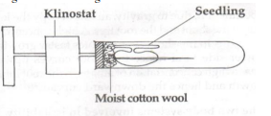

**(a)** State the role of a klinostat in tropism. (1 mark)

**…………………………………………………………………………………………..**

**(b)** What observation would be made if the klinostat was rotating. (1 mark)

**…………………………………………………………………………………………..**

1. Name **two** glands that secrete hormones that control metamorphosis in insects. (2 marks)

**……………………………………………………………………………………………………………………………………………………………………………………………………..**

1. Distinguish between mutualism and commensalism. (1 mark)

**……………………………………………………………………………………………………………………………………………………………………………………………………..**

1. Explain why flying birds and insects excrete their wastes in form of uric acid. (2 marks)

**…………………………………………………………………………………………………..…………………………………………………………………………………………………..**

1. The table below shows the concentration in parts per million of sodium and iodide ions in sea water and cell sap of a plant.

|  |  |  |
| --- | --- | --- |
|  | Sodium ions | Iodide ions |
| Sea water | 200 | 22 |
| Cell sap | 35 | 487 |

**(a)** Which **one** of the twoions intake will be affected if the plant was sprayed by cyanide.

(1 marks)

**………………………………………………………………………………………………**

**(b)** Explain your answer in (a) above. (2 marks)

**………………………………………………………………………………………………………………………………………………………………………………………………………………………………………………………………………………………………**

1. **(a)** 100 white and 100 black mice were released in an area inhabited by jackals. After six weeks, it was established that 80 black and 23 white mice had remained. Account for the above observation. (3 marks)

**………………………………………………………………………………………………………………………………………………………………………………………………………………………………………………………………………………………………………..**

**(b)** Name the evolution theory that supports this observation. (1 mark)

**………………………………………………………………………………………………………**

1. In an experiment, the stem of a plant was cut above the soil surface and a thin, transparent tube inserted immediately as shown below.

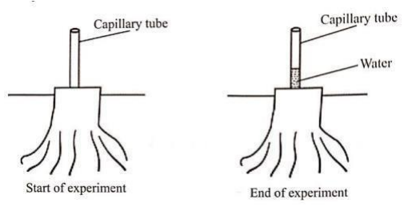

**(a)** Account for the observation made at the end of the experiment. (2 marks) **…………………………………………………………………………………………………...…………………………………………………………………………………………………...........(b)** Give one adaptation of phloem to its function. (1 mark) **……………………………………………………………………………………………………………………………………………………………………………………………………………....**

1. A student inserted a nail into the stem of a plant a 1 metre above the soil. 2 years late he noticed the plant had grown taller yet the nail was still 1 metre above the soil surface in the stem. Account for the observation. (2 marks)

**……………………………………………………………………………………………………………………………………………………………………………………………………..**

1. A locust moults 5 times before reaching adult size. Draw a graph of growth curve expected if the length of the locust is plotted against time. (2 marks)

**32.** The equation below represents a certain physiological process. Study it and answer the questions below.

C18H36O2 + 26O2 18CO2 + 18H2O + ATP

**(a)** Calculate the respiratory quotient of the substrate. (2 marks)

**………………………………………………………………………………………………………………………………………………………………………………………………………………………………………………………………………………………………………………………**

**THIS IS THE LAST PRINTED PAGE**