**NAME…………………………………………….........… .........CLASS……………………….**

**ADM NO…………………… INDEX NO………………………..... DATE: …………………**

**231/1**

**BIOLOGY**

**PAPER 1**

**THEORY**

**JUNE 2024**

**TIME: 2 HOURS MARKING SCHEME**

**KASSU JET EXAMINATIONS**

***Kenya Certificate of Secondary education***

**BIOLOGY PAPER I**

**JUNE 2024**

**2 HOURS**

**Instructions**

* Write your name, class and admission number in the space provided above.
* Write the date of the examination in the space provided above.
* Answer all the questions in the spaces provided.

**For Examiner’s use only**

|  |  |  |
| --- | --- | --- |
| **QUESTION** | **MAXIMUM SCORE** | **CANDIDATE’S SCORE** |
| **1 – 32** | **80** |  |

*This paper consists of 10 printed pages.*

*Candidates should check the question paper to ascertain that all the pages are printed as indicated and no questions are missing.*

1. (i) Some herbaceous stems have very little strengthening tissue yet still remain upright.

Explain. (2 marks)

***They have Parenchyma cells / tissues which absorbs water and become turgid***

(ii) Name the strengthening material in sclerenchyma (1 mark)

***Lignin***

1. State the functions of the following structures of the human brain. (3 marks)

Cerebrum. ***Controls senses such as hearing and taste; integrating of sensory impulse human individualistic vision intelligence memory.***

Cerebellum. ***Co-ordinate body movement/ maintain balance and posture / dextenty in the movement***

Medulla oblongata;  ***Controls breathing / vomiting / swallowing involuntary movement / salivation / body temperature / sleep and wakefulness / feeding and drinking***

**3.** The diagram shows a simple reflex arc.

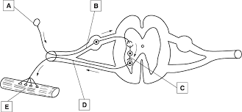

Explain how an impulse is transmitted across the gap between neurons C and D (3 marks)

***When an impulse reaches the synaptic knob[ of the sensory neurone] , it causes the synaptic knob to discharge the neurotransmitter into the synaptic cleft;***

***The neurotransmitter diffuses across the cleft and binds to the specific receptors on the postsynaptic membrane;***

1. (a) Based on the structure available on this diagram classify this type of stem. (1 mark)

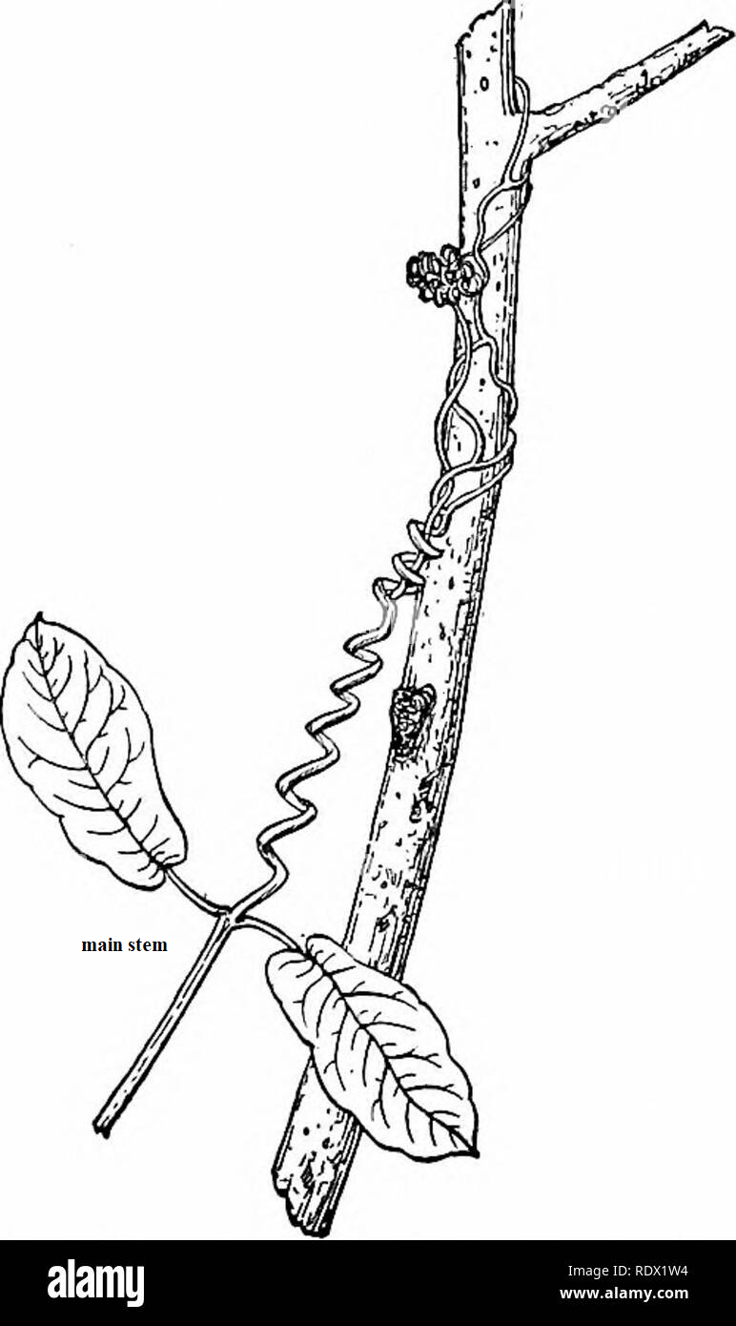

**Herbaceous stem**

(b) How is the other type of stem different from this one? (1 mark)

***They have support tissues whose cells have stiff, thickened or lignified walls;***

1. State the importance of tactic response among some memebrs of kingdom Protoctista.

(1 mark)

***Move towards favorable environment;***

1. State two differences between tropisms and taxes. (2 marks)

|  |  |  |
| --- | --- | --- |
|  | **Tropism** | **Taxes** |
| (i) | **Growth responses and are therefore more permanent;** | **Locomotory response therefore temporary** |
| (ii) | **Responses are slow;** | **Responses are fast** |
| (iii) | **Tropisms are brought about by growth hormones;** | **Taxes are not influenced by growth hormones** |

1. Explain continental drift as an evident of evolution. (2 marks)

***Current continents existed as one large land mass; the present continent drifted leading to isolation of organisms; organisms in each continent evolved along different lines, hence emergence of new species***

1. Why are some bacteria able to resist the effect of antibiotics? (2 marks)

***They have a gene for resistance which is acquired through mutation; When bacteria are exposed to antibiotics for some time, they become used or adapted to living in presence of the drug The gene is passed to the offspring therefore establishing a population of drug resistant;***

1. The diagram below illustrates the arrangement of bones and muscles in the human arm.

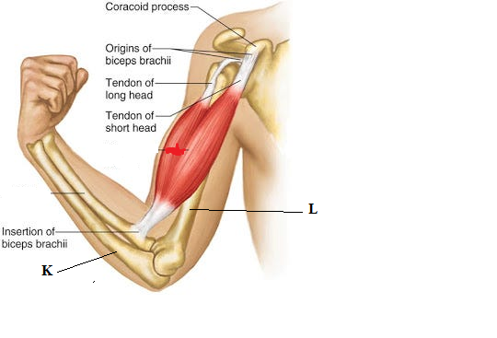

(i) Name the bone labelled K (1 mk)

*K –* ***ulna;***

(ii) Explain how the upward movement of the lower arms is brought about by the bones and muscles shown in the diagram above. (2 mks)

***The biceps muscles contract while triceps relaxes; this causes the lower part of the arm to move upwards;***

1. Jerry’s blood crystallizes at low oxygen concentration. He is married to Janice whose blood does not crystalize in low oxygen concentration. Work out the probability of the couple producing children with the same fate as their father Jerry. (4 marks)

Parental genotype: dd x DD;

Gamates 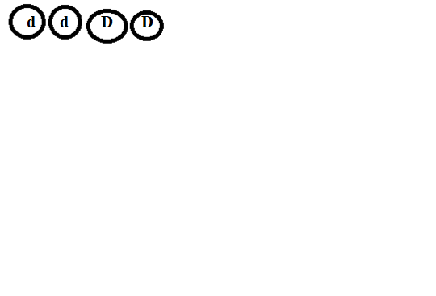 ;

|  |  |  |
| --- | --- | --- |
| GAMATES | D | D |
| d | ***Dd*** | ***Dd*** |
| d | ***Dd*** | ***Dd*** |

Probability 0%;

1. State the causative agents for the following diseases
2. Syphilis ***Treponema pallidium*** (1mark)
3. Trichomoniasis ***Trichomonas vaginalis*** (1mark)
4. What do you understand by the term ecological niche? (1mark)

***The position that an organism occupies in a habitat including its physical space and role***

1. The diagram below shows the feeding relationship between rabbits and wolves in a given habitat over a period of 25 years. Study it and answer the questions that follow

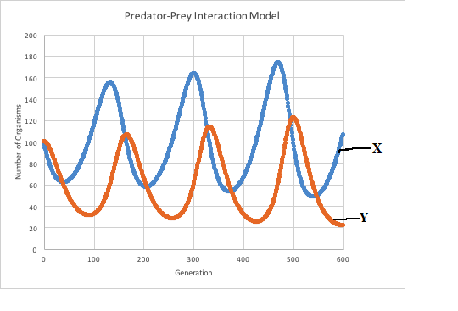

1. Name the type of feeding relationship. (1mark)

***Predation***

1. Which organism in the relationship above is represented by the curve labeled X and Y (2 marks)

X ***rabbits***

Y ***wolves***

1. The diagram below represents a human reproductive organ.

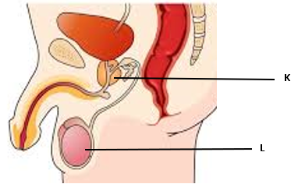

(i) State **two** adaptations of the structure labelled L to its functions. (2 marks)

***Seminiferous tubules are long and highly coiled tubes; provides a large surface area for sperm production;***

***Giant sertoli cells; which nourishes the sperms;***

***Interstitial cells secrete male hormones /androgens;***

(ii) Explain the role of the role of the gland labelled K (1mark)

***Secretes an alkaline fluid that neutralizes vaginal fluids;activates the sperms;.***

1. The diagram below shows different developmental stages of a given organism.

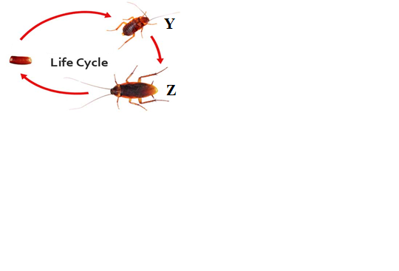

(a) Identify the stages represented by letter Y and Z (2 marks)

Y **nymph**

Z **Adult**

(b) Identify the hormones which play a role in the above process and state where they are produced (2 marks)

|  |  |
| --- | --- |
| **Hormone** | **Site of production** |
| ***Ecdysone*** | ***Prothoracic gland*** |
| ***Juvenile*** | ***Corpora allata*** |

15. State the mode of asexual reproduction in yeast (1 mark)

***Budding***

16. Name **two** substances that leave the foetal blood through the placenta into maternal blood stream. (2 marks)

***Carbon (IV) oxide***

***Nitrogenous waste***

17. Besides venation, State **two o**ther external characteristics of leaves that can be used to classify plants. (2 marks)

***Phyllotaxy;leaf apex;leaf type;leaf margin;leaf shape***

18. The graph below shows the concentration antibodies produced during a primary infection and secondary infection against time. Study the graph and answer the question below.

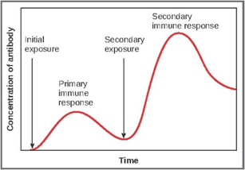

(a) Name the type of immunity illustrated by the graph (1 mark)

**Naturally acquired active immunity**

(b) In a blood test a few drops of anti-B serum were added to two samples of blood separately. No agglutination occurred in either of them. What were the blood groups of the two samples (2 marks)

**B**

**AB**

19. (a) State two ways in which opening of the stomata is important to plants (2 marks)

**Transpiration**

**Gaseous exchange**

(b) Explain how accumulation of carbon (IV) oxide in a leaf affects the stomata (3 marks)

**Accumulation of carbon (iv) oxide in the leaf lowers the pH of the cell sap of the guard cell; this activates enzymes that catalyze the conversion if starch to glucose. Making the cell sap of the guard cell hypertonic to cell sap of the adjacent epidermal cells; guard cells absorb water become turgid leading to opening of the stomata.**

20. Explain each of the following observations:

(a) The stump of a severed tree trunk may exude copious quantities of fluids after cutting

(1 mark)

**Root pressure**

(b) Leaf fall reduces the rate of transpiration (1 mark)

**Reduces the total surface area expected for water loss**

(c) The xylem tissue is made up of dead tissue (1 mark)

***To prevent utilization of the substances they transport***

21. (a) During the process of respiration, the breakdown of glucose occurs in phases.

Explain why these phases are necessary?

(2 marks)

**- *High amounts of energy produced would burn the cells***

***- Some of the intermediate products a given step serves as raw materials for other reactions***

(b) Explain why the rate of production of lactic acid increases during exercise

(2 marks)

***Demand for oxygen is higher than the supply: cell start respiring anaerobically to produce energy***

22. Explain why body temperature regulation is more difficult in a hot humid conditions

(2 marks)

***High temperature leads to increased sweating: high humidity slows down evaporation leaving accumulation of sweat on skin;***

23. Suggest **two** ways in which plants compensate for lack of complex excretory organs

(2 marks)

***They manufacture their own food hence less water***

***Most of their wastes are less toxic***

24. State **two** factors that would lead to a decrease in the rate of photosynthesis. (2 marks)

***- Very low temperature***

***- Low concentration of Carbon(IV) oxide***

***- Low light intensity***

1. Knowledge and skills acquired in the course of studying biology are very important. Justify the above statement. (2 marks)

***Study of biology enables understanding of the developmental stages in the human body, solving environmental like drought, global warming and enhanced international cooperation in areas of medical research.***

1. The ileum is highly coiled in mammals, State **two** biological significance of this feature?

(2 marks)

***Slow down the rate of movement of food thus allow more time for absorption and digestion to take place***

1. Caecum is part of the digestive system of some herbivores. What is its role in digestion?

(1 mark)

***Contain anaerobic bacteria which secrete enzyme /cellulose that digest cellulose;***

1. The diagram below is that of a certain plant tissue.

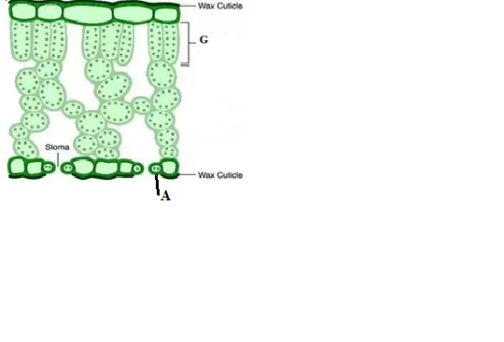

1. Name the structures labeled G. (1 mark)

***Palisade mesophyll***

1. State **two** adaptations of the specialized cell labeled A to its functions? (2 marks)

***Chloroplasts present to synthesize glucose raising osmotic pressure of guard cells; uneven thickness of the wall; allow opening of stoma***

1. A student was viewing a slide prepared of an epidermal cell under medium power objective lens. The specimen appeared blurred. Which part of the microscope would the student adjust to obtain a clearer view? (1mark)

***Fine adjustment knob; mirror; diaphragm***

1. (i) Define active transport. (1 mark)

***Movement of molecules or ions against a concentration gradient across a living cell membrane with the utilization of energy;***

(ii) Why are the following factors important in the process of active transport in cells?

1. Oxygen (1 mark)

***Oxidizes glucose to generate energy used in active transport;***

1. Optimum temperature (1 mark)

***Activates respiratory enzymes increasing rates of oxidation of glucose hence high rate of active transport;***

1. (i) Suggest a likely habitat of an organism with an active contractile vacuole.

(1 mark)

***Fresh water***

(ii) Give a reason for your answer above. (1 mark)

***Osmoregulation***

1. How is dark stage of photosynthesis dependent on light stage? (2 marks)

***Light stages generate hydrogen atoms and ATP; utilized in dark reaction of photosynthesis;***