**NAME……………………………..………..ADM NO……………………SIGN………………….**

**INDEX NO………………………………………..STREAM…………………….**

**231/3**

**BIOLOGY PAPER 3**

**(Theory)**

**JULY, 2024**

Time: 1 hours 45 minutes

**MOKASA II JOINT EVALUTION EXAMINATION**

*Kenya Certificate of Secondary Education*

* Write your name, Index Number in the spaces provided above.
* Write the date of examination in the space provided above.
* Answer ALL the questions in the spaces provided below each question in the question paper.

**FOR EXAMINER’S USE ONLY**

|  |  |  |
| --- | --- | --- |
| **Question** | **Maximum score** | **Candidate’s score** |
| 1 | **14** |  |
| 2 | **14** |  |
| 3 | **13** |  |
| **TOTAL** | **40** |  |

You are provided with solution X and Y, Iodine solution, Benedict’s solution, visking tubing and two pieces of thread.

(a) Using the reagents provided, carry out appropriate tests on solutions X and Y.

Ensure that droppers are not interchanged.

Iodine test (4marks)

|  |  |  |  |
| --- | --- | --- | --- |
| Solution | Procedure | Observation | Conclusion |
| Solution X |  |  |  |
| Solution Y |  |  |  |

Benedict’s test (4marks)

|  |  |  |  |
| --- | --- | --- | --- |
| Solution | Procedure | Observation | Conclusion |
| Solution X |  |  |  |
| Solution Y |  |  |  |

(b) Tie one end of the visking tubing tightly with a thread. Using a dropper, place about 3ml of solution Y in the tubing and tie the open end tightly. Rinse the visking ensuring there is no leakage and immerse it in solution X in a beaker. Leave the set up to stand for about 20 minutes.

Using the contents of the visking tubing and the beaker, carry out the appropriate tests using the reagents provided.

1. Iodine test (2mks)

|  |  |  |
| --- | --- | --- |
| Contents | Observation | Conclusion |
| Visking tubing |  |  |
| Beaker |  |  |

1. Benedict’s test (2mks)

|  |  |  |
| --- | --- | --- |
| Contents | Observation | Conclusion |
| Visking tubing |  |  |
| Beaker |  |  |

(c) Account for the observation made in (b)(ii) above in the visking tubing. (2mks)

**…………………………………………………………………………………………………………………………………………………………………………………………………………………………………………………………………………………………………………………………………………………………………………………………………………**

2.You are provided with the following materials and apparatus.

* Two prepared slides labelled E and K respectively containing a certain tissue obtained from the human body.
* Access to a light microscope with at least low and medium power objective lens.

Observe the prepared slides of a human tissue under medium power objective lens of the light microscope.

a) Identify with reasons the structures seen under the medium power objective of the light microscope. Draw and label the structures in the table below. (6marks)

|  |  |  |  |
| --- | --- | --- | --- |
|  | Identity | Reason | Diagram |
| E |  |  |  |
| K |  |  |  |

b) Calculate the magnification of the image observed in the slide labelled K under low power objective lens (2marks)

…………………………………………………………………………………………………………………………..……………………………………………………………………………………………………………………………………………………………………………..

c)Explain why the high power objective lens cannot be used with coarse adjustment knob during observation of the prepared slides above. (1mark)

……………………………………………………………………………………………………………………………………………………………………………………………………

d) State the adaptations of the human structures observed in slide E to its functions (3marks)

……………………………………………………………………………………………………………………………………………………………………………………………………………………………………………………………………………………………………………………………………………………………………………………………………………………………………………………………………………………………………………

e)(i) If a slide of a complete human tissue showing all the components is prepared, which amongst the two tissues is likely to be observed in abundance. (1mark)

…………………………………………………………………………………………………..

ii) Give reason for your answer in e(i) above (1mark)

……………………………………………………………………………………………………………………………………………………………………………………………………..

3.Below are photographs of mammalian bones **J** and **R** obtained from the same region of the body. Study them and answer the questions that follow.

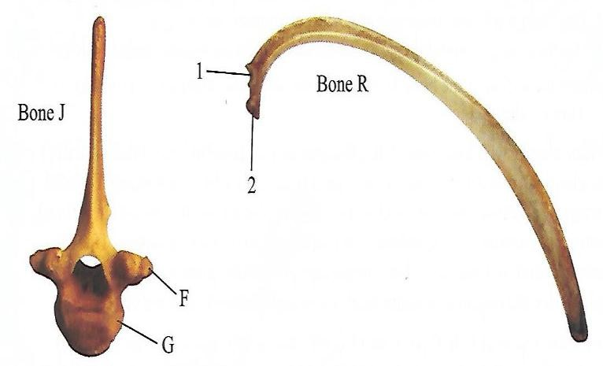

1. Giving reasons, identify bone J and R. (4mks)

|  |  |  |
| --- | --- | --- |
| Bone | Identity | Reason |
| J |  |  |
| R |  |  |

1. (i) Name the parts labeled 1,2,F and G (4mks)

1…………………………………………………………………………………………2…………………………………………………………………………………………F…………………………………………………………………………………………G………………………………………………………………………………………...

(ii)Which of the labeled part of bone J does structures 1 and 2 on bone R articulate. (2mks)

……………………………………………………………………………………………………………………………………………………………………………………..

(iii) Make a drawing to show how and bones J and R articulate (3mks)