NAME………………………………………ADM NO: …………….CLASS……………

231/3

BIOLOGY

PAPER 3

PRACTICAL

MARCH/APRIL 2024

TIME: 1 ¾ HOURS

**LANJET PRE MOCK EVALUATION EXAMINATION - 2024**

*Kenya Certificate of Secondary Education*

231/3

BIOLOGY

PAPER 3

PRACTICAL

TIME: 1 ¾ HOURS

**Instructions To Candidates**

* *Write your Name, Class and Adm No. in the spaces provided above*
* *Answer ALL the questions in the spaces provided*
* *You are required to spend the first* ***15 minutes*** *of the* ***1 3/4 hours*** *reading the whole paper carefully before commencing your work.*
* *This paper consists of* ***6***  *printed pages*
* *Candidates should answer the questions in English*

**FOR EXAMINERS USE ONLY**

**For Examiners Use Only**

|  |  |  |
| --- | --- | --- |
| **Question** | **Maximum score** | **Candidate’s score** |
| **1** | **16** |  |
| **2** | **11** |  |
| **3** | **13** |  |
| **Total Score** | **40.** |  |

1. You are provided with a suspension labelled M.

a) Using the reagents provided only, test for the food substances present in the suspension. In the table below, record the food tested, procedure, observation and conclusions. 12 marks.

|  |  |  |  |
| --- | --- | --- | --- |
| **Food TEST** | **Procedure** | **Observation** | **Conclusion** |
|  |  |  |  |
|  |  |  |  |
|  |  |  |  |

b) Name two enzymes that may be required to digest suspension M in the alimentary canal in human. (2mark)

c) State role of the following in the experiment. (2marks)

(i) Sodium hydrogen carbonate

(ii) Dilute hydrochloric acid

1. Experimental evidence shows that most mutations results to variations among organisms. The illustrations I, II, III and IV below show different possible types of chromosome mutations. Study them keenly.

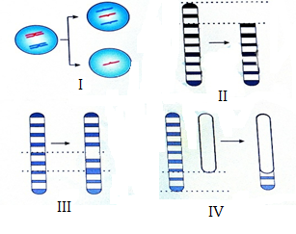

a) Identify the types of chromosome mutations illustrated. (4 marks)

Illustration Name of mutation

I

II

III

IV

b) State the effect of the mutation illustrated in III. (1 mark)

c) In most cases, the mutation in II could be lethal. Explain. (2 marks)

d) During which stage of mitosis does the mutation in I above occur? (1 mark)

e) i) Define a mutation (1 mark)

ii) Give two possible environmental mutagens. (2marks)

1. The diagrams below represent body parts of some organisms (animals). Study them and answer the question that follow

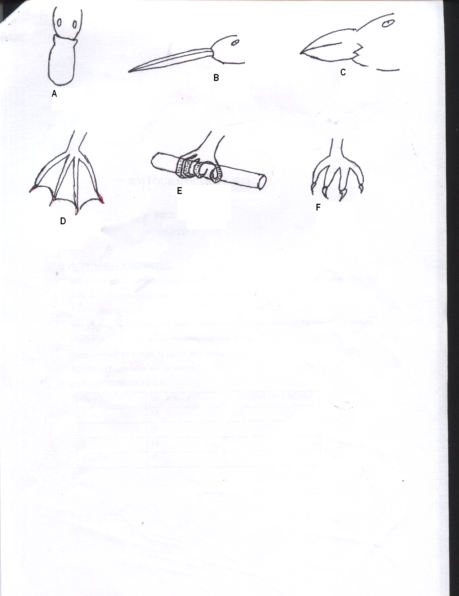

1. (i) Suggest the type of food eaten by organisms with the parts labeled A, B, C and F (4mks)

Food Reason

A

B

C

F

(ii) With reasons, suggest the likely habitat of the organism from which the parts labeled D and E were obtained (4mks)

Part Habitat Reason

D

E

1. (i) Suggest the type of evolution that is exemplified by the organisms labeled D, E and F. Give reason for your answer.

The type of evolution (2mks)

Reason

(ii) Suggest the significance of the above named type of evolution for the organism (1mk)

1. (i) Explain briefly the meaning of analogous structures (1mk)

(ii) Give one example of analogous structure (1mk)