**NAME………………...…………………………………………. INDEX NO……………………………**

**CANDIDATE’S SIGNATURE………………….…………DATE…………………………………….**

**443/1**

**AGRICULTURE PAPER 1**

**THEORY**

**MOKASA II 2024**

**TIME: 2 HOURS**

**MOKASA II**

***Kenya Certificate of Secondary Education***

**AGRICULTURE**

2 Hours

**Instructions to Candidates:**

1. Write your name and index number in the spaces provided above.
2. Sign and write the date of examination in space provided.
3. This paper consists of three sections; A, B and C.
4. Answer all the questions in section A and B.
5. Answer any two questions in section C.
6. All answers should be written in spaces provided in question paper.

**FOR EXAMINER’S USE ONLY**

|  |  |  |  |
| --- | --- | --- | --- |
| **SECTION** | **Question** | **Maximum score** | **Candidates score** |
| **A** | **1 - 21** | **30** |  |
| **B** | **22 - 25** | **20** |  |
| **C** |  | **20** |  |
|  | **20** |  |
| **Total Score** | **90** | |  |

**SECTION A (30MKS)**

***Answer all the questions in this section in the spaces provided.***

1. Distinguish between organic farming and mixed farming. 2mks

………………………………………………………………………………………………………………………………………………………………………………………………………………………………………………………………………………………………………………………………………………………………………………………………………………………………………………………………

1. State **two** benefits of levelling during land preparation. 1mk

………………………………………………………………………………………………………………………………………………………………………………………………………………………………

1. State **three** places to avoid during soil sampling. 11/2mks

………………………………………………………………………………………..…..………………………………………………………………………………………..……..…………………………………………………………………………………………………………………………………………………

1. State **four** parameters used in measuring the national economic development. 2mks

………………………………………………………………………………………………………………………………………………………………………………………………………………………………………………………………………………………………………………………………………………………………………………………………………………………………………………………………

1. Give **four** advantages of leasehold land tenure system. 2mks

………………………………………………………………………………………………………………………………………………………………………………………………………………………………………………………………………………………………………………………………………………………………………………………………………………………………………………………………

1. Give **two** reasons why burning should be discouraged as a method of land clearing. 1mk

………………………………………………………………………………………………………………………………………………………………………………………………………………………………

1. State **three** agents of soil erosion. 11/2mks

………………………………………………………………………………………………………………………………………………………………………………………………………………………………………………………………………………………………………………………………………………

1. List **two** disadvantages of using plastic pipes in the farm. 1mk

………………………………………………………………………………………………………………………………………………………………………………………………………………………………

1. Define the law of diminishing return. 1mk

………………………………………………………………………………………………………………………………………………………………………………………………………………………………

1. State **three** factors that dictates the method to adopt in weed control. 11/2mks

………………………………………………………………………………………………………………………………………………………………………………………….…………………………………...…………………………………………………………………………………………………………….

1. State **two** disadvantages of mulching in crop production. 1mk

………………………………………………………………………………………………………………………………………………………………………………………………………………………………………………………………………………………………………………………………………………

1. Give **two** types of diseases that affect onions. 1mk

………………………………………………………………………………………………………………………………………………………………………………………………………………………………

1. Give **three** ways in which pastures are classified. 11/2mks

…………………………………………………………………………………………………………………………………………………………………....……………………………………………………………………………………………………...………………………………………………………………….

1. Mention **three** factors that influence crop rotation. 11/2mks

………………………………………………………………………………………………………………………………………………………………………………………………………………………………………………………………………………………………………………………………………………

1. Outline the relationship between scarcity and choice as used in agricultural 1mk

………………………………………………………………………………………………………………………………………………………………………………………………………………………………………………………………………………………………………………………………………………

1. State **two** functions of light in crop production. 1mk

………………………………………………………………………………………………………………………………………………………………………………………………………………………………

1. State **four** factors influencing soil formation. 2mks

………………………………………………………………………………………………………………………………………………………………………………………………………………………………………………………………………………………………………………………………………………………………………………………………………………………………………………………………

1. Give **four** advantages of using banking services. 2mks

………………………………………………………………………………………………………………………………………………………………………………………………………………………………………………………………………………………………………………………………………………………………………………………………………………………………………………………………

1. State **three** advantages of biological pest control. 11/2mks

………………………………………………………………………………………………………………………………………………………………………………………………………………………………………………………………………………………………………………………………………………

1. Give **two** characteristics of plants used as green manure. 1mk

………………………………………………………………………………………………………………………………………………………………………………………………………………………………

1. List **four** information contained in a receipt. 2mks

………………………………………………………………………………………………………………………………………………………………………………………………………………………………………………………………………………………………………………………………………………………………………………………………………………………………………………………………

**SECTION B (20MKS)**

***Answer all questions in this section in the spaces provided.***

1. The following table gives the monthly demand and supply schedule of potatoes in all secondary schools in Kenya. Use it to answer the questions that follow.

**Price per Kg Demand in Kgs Supply in Kgs**

10 23 59

9 30 57

8 36 54

7 41 50

6 45 45

5 48 39

4 50 32

3 51 25

(a) Draw the graph of demand and supply against price 2mks

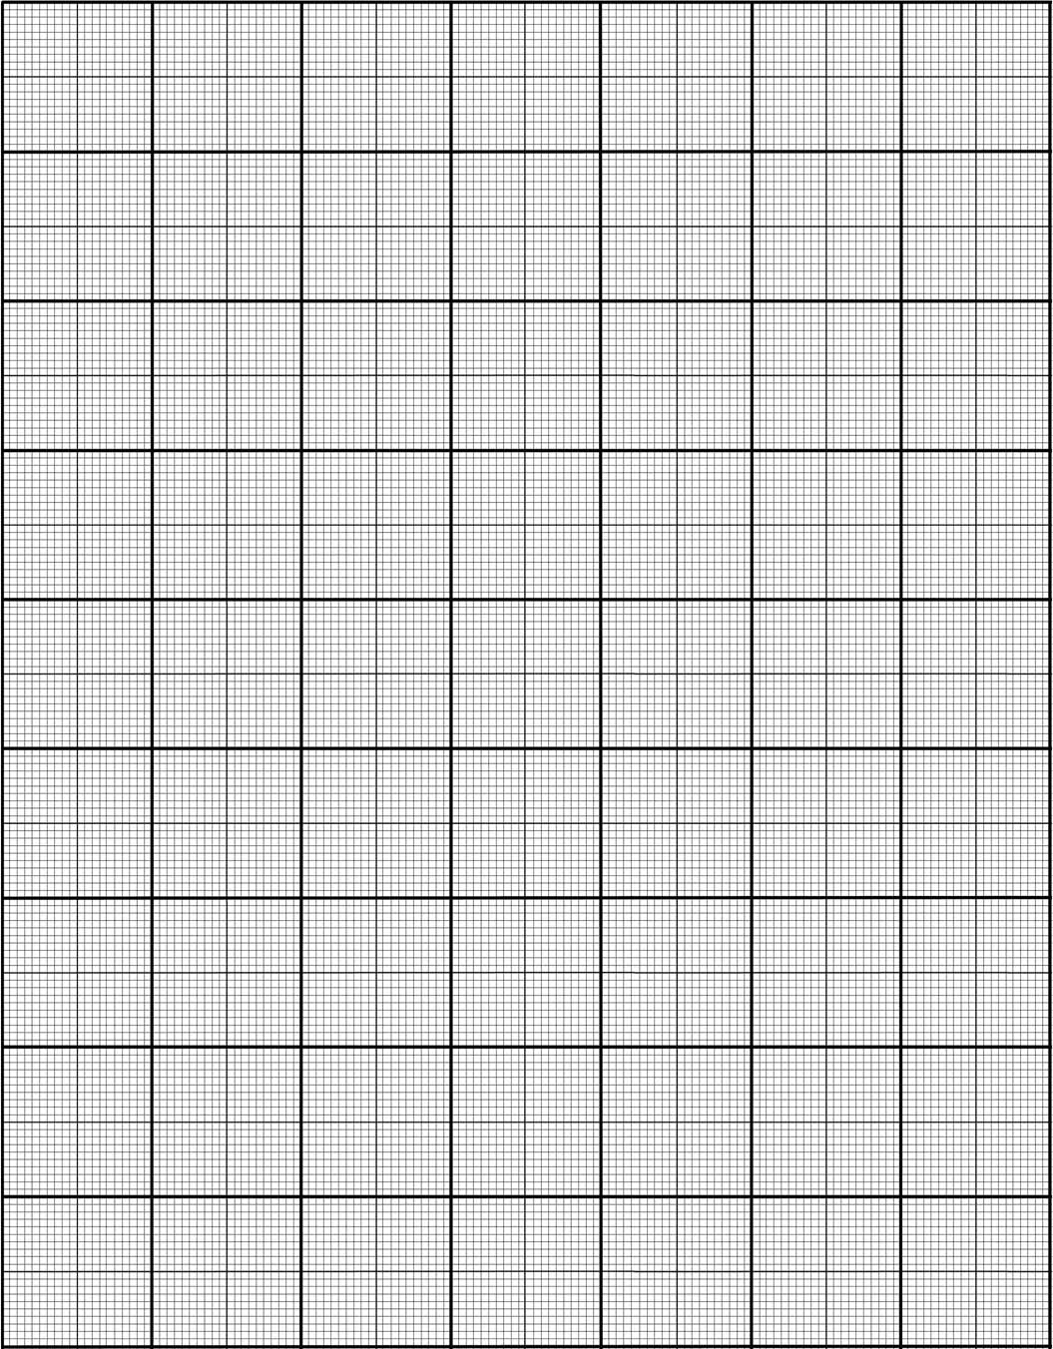

(b) What is the equilibrium price? ½mk

………………………………………………………………………………………………………………………

(c) State the effects of a government imposing a maximum price of:

(i) Kshs. 5 per kg 1mk

………………………………………………………………………………………………………………………………………………………………….…………………………………………………………..

(ii) Kshs. 7 per kg 1mk

………………………………………………………………………………………………………………………………………………………………………………………………………………………………

(d) State one factor that influences price of a good or service. ½mk

………………………………………………………………………………………………………………………

1. The diagram below illustrates crop diseases, study the diagrams carefully and answer the questions that follow.

E:\scans\201906210336.tif

1. Identify the crop disease illustrate in the diagrams.

P…………………………………………………………………………………………………… 1mk

Q…………………………………………………………………………………………………… 1mk

1. Give the causative agent for each of the diseases illustrated above.

P…………………………………………………………………………………………………… 1mk

Q…………………………………………………………………………………………………... 1mk

1. State one cultural method used in the control of disease illustrated by Q. 1mk

……………………………………………………………………………………………………………..

1. Below is an illustration of an activity carried out in agroforestry.

E:\scans\201906210346.tif

1. Identify the activity being carried out in the above diagram. 1mk

………………………………………………………………………………………………………………

1. State two reasons for carrying out the activity identified above. 2mks

………………………………………………………………………………………………………………………………………………………………………………………………………………………………

1. Name two types of tree nurseries 2mks

………………………………………………………………………………………………………………………………………………………………………………………………………………………………

1. The diagrams below illustrate field management practices. Study them carefully and answer the questions that follow.

E:\scans\201906210356.tif

1. Identify the field practices.

M…………………………………………………………………………………………………… 1mk

N……………………………………………………………………………………………………. 1mk

1. Name a crop that can be managed using management (M) above. 1mk

………………………………………………………………………………………………………………

1. Give one reason for carrying out each of the management practices above. 2mks

M……………………………………………………………………………………………………………

N……………………………………………………………………………………………………………

**Section C(40mks)**

***Answer only two questions from this section in the spaces provided after question 28***

1. a) Explain five government policies that influence Agriculture in Kenya 5mks

b) Outline five importance of budding and grafting in orange production 5mks

c) State and explain five factors that influence mass wasting 10mks

1. i) Explain four precautions considered when harvesting pyrethrum 4mks

ii) Outline four factors that determine the quality of hay 4mks

iii) State and explain six methods of fertilizer application in crop production 12mks

1. a) Outline eight principles of a co-operative 8mks

b) Describe the procedure of transplanting a tree seedling 6mks

c) Give six importance of drainage as a method of land reclamation 6mks

…………………………………………………………………………………………………………………………………………………………………………………………………………………………………………………………………………………………………………………………………………………………………………………………………………………………………………………………………………………………………………………………………………………………………………………………………………………………………………………………………………………………………………………………………………………………………………………………………………………………………………………………………………………………………………………………………………………………………………………………………………….…………………………………………………………………………………………………………………………………………………………………………………………………………………………………………………………………………………………………………………………………………………………………………………………………………………………………………………………………………………………………………………………………………………………………………………………………………………………………………………………………………………………………………………………………………………………………………………………………………………………………………………………………………….…………………………………………………………………………………………………………………………………………………………………………………………………………………………………………………………………………………………………………………………………………………………………………………………………………………………………………………………………………………………………………………………………………………………………………………………………………………………………………………………………………………………………………………………………………………………………………………………………………………………………………………………………………………….…………………………………………………………………………………………………………………………………………………………………………………………………………………………………………………………………………………………………………………………………………………………………………………………………………………………………………………………………………………………………………………………………………………………………………………………………………………………………………………………………………………………………………………………………………………………………………………………………………………………………………………………………………………….…………………………………………………………………………………………………………………………………………………………………………………………………………………………………………………………………………………………………………………………………………………………………………………………………………………………………………………………………………………………………………………………………………………………………………………………………………………………………………………………………………………………………………………………………………………………………………………………………………………………………………………………………………………….…………………………………………………………………………………………………………………………………………………………………………………………………………………………………………………………………………………………………………………………………………………………………………………………………………………………………………………………………………………………………………………………………………………………………………………………………………………………………………………………………………………………………………………………………………………………………………………………………………………………………………………………………………………………………………………………………………………………………………………………………………………………………………………………………………………………………………………………………………………………………………………………………………………………………………………………………………………………………………………………………………………………………………………………………………………………………………………………………………………………………………………………………………………………………………………………………………………………………………………………………………………………………………………………………………………………………………………………………….…………………………………………………………………………………………………………………………………………………………………………………………………………………………………………………………………………………………………………………………………………………………………………………………………………………………………………………………………………………………………………………………………………………………………………………………………………………………………………………………………………………………………………………………………………………………………………………………………………………………………………………………………………………….…………………………………………………………………………………………………………………………………………………………………………………………………………………………………………………………………………………………………………………………………………………………………………………………………………………………………………………………………………………………………………………………………………………………………………………………………………………………………………………………………………………………………………………………………………………………………………………………………………………………………………………………………………………….…………………………………………………………………………………………………………………………………………………………………………………………………………………………………………………………………………………………………………………………………………………………………………………………………………………………………………………………………………………………………………………………………………………………………………………………………………………………………………………………………………………………………………………………………………………………………………………………………………………………………………………………………………………….…………………………………………………………………………………………………………………………………………………………………………………………………………………………………………………………………………………………………………………………………………………………………………………………………………………………………………………………………………………………………………………………………………………………………………………………………………………………………………………………………………………………………………………………………………………………………………………………………………………………………………………………………………………….…………………………………………………………………………………………………………………………………………………………………………………………………………………………………………………………………………………………………………………………………………………………………………………………………………………………………………………………………………………………………………………………………………………………………………………………………………………………………………………………………………………………………………………………………………………………………………………………………………………………………………………………………………………………………………………………………………………………………………………………………………………………………………………………………………………………………………………………………………………………………………………………………………………………………………………………………………………………………………………………………………………………………………………………………………………………………………………………………………………………………………………………………………………………………………………………………………………………………………………………………………………………………………………………………………………………………………………………………….…………………………………………………………………………………………………………………………………………………………………………………………………………………………………………………………………………………………………………………………………………………………………………………………………………………………………………………………………………………………………………………………………………………………………………………………………………………………………………………………………………………………………………………………………………………………………………………………………………………………………………………………………………………….…………………………………………………………………………………………………………………………………………………………………………………………………………………………………………………………………………………………………………………………………………………………………………………………………………………………………………………………………………………………………………………………………………………………………………………………………………………………………………………………………………………………………………………………………………………………………………………………………………………………………………………………………………………….…………………………………………………………………………………………………………………………………………………………………………………………………………………………………………………………………………………………………………………………………………………………………………………………………………………………………………………………………………………………………………………………………………………………………………………………………………………………………………………………………………………………………………………………………………………………………………………………………………………………………………………………………………………….…………………………………………………………………………………………………………………………………………………………………………………………………………………………………………………………………………………………………………………………………………………………………………………………………………………………………………………………………………………………………………………………………………………………………………………………………………………………………………………………………………………………………………………………………………………………………………………………………………………………………………………………………………………….…………………………………………………………………………………………………………………………………………………………………………………………………………………………………………………………………………………………………………………………………………………………………………………………………………………………………………………………………………………………………………………………………………………………………………………………………………………………………………………………………………………………………………………………………………………………………………………………………………………………………………………………………………………………………………………………………………………………………………………………………………………………………………………………………………………………………………………………………………………………………………………………………………………………………………………………………………………………………………………………………………………………………………………………………………………………………………………………………………………………………………………………………………………………………………………………………………………………………………………………………………………………………………………………………………………………………………………………………….…………………………………………………………………………………………………………………………………………………………………………………………………………………………………………………………………………………………………………………………………………………………………………………………………………………………………………………………………………………………………………………………………………………………………………………………………………………………………………………………………………………………………………………………………………………………………………………………………………………………………………………………………………………….…………………………………………………………………………………………………………………………………………………………………………………………………………………………………………………………………………………………………………………………………………………………………………………………………………………………………………………………………………………………………………………………………………………………………………………………………………………………………………………………………………………………………………………………………………………………………………………………………………………………………………………………………………………….…………………………………………………………………………………………………………………………………………………………………………………………………………………………………………………………………………………………………………………………………………………………………………………………………………………………………………………………………………………………………………………………………………………………………………………………………………………………………………………………………………………………………………………………………………………………………………………………………………………………………………………………………………………….…………………………………………………………………………………………………………………………………………………………………………………………………………………………………………………………………………………………………………………………………………………………………………………………………………………………………………………………………………………………………………………………………………………………………………………………………………………………………………………………………………………………………………………………………………………………………………………………………………………………………………………………………………………….………………………………………………………………………………………………………………………………………………………………………………………………………………………………………………………………………………………………………………………………………………………………………………………………………………………………………………………………………………………………………………………………………………………………………………………………………………………………………………………………………………………………………………………………………………………………………………………………