**Name: ……………………………………………... Index no ……..…......................................**

**School: …………………………………………….. Candidate’s sign …………………….......**

**Class………………………………………….…..… Adm No…………………...……………...**

**AGRICULTURE 443/2**

**JUNE 2024**

**TIME: 2 HOURS**

**FORM FOUR KASSU JET MOCK 2024**

***Kenya Certificate of Secondary Education (K.C.S.E.)***

**Agriculture**

**Paper 2**

**INSTRUCTIONS TO CANDIDATES:**

* *Write your name and index number in the spaces provided above.*
* *Sign and write the date of examination in the spaces provided above.*
* *This paper consists of three sections A, B and C.*
* *Answer* ***all*** *the questions in section A and B.*
* *Answer any* ***two*** *questions in section C.*
* *All answers should be written in the spaces provided.*
* *This paper consists of 12 printed pages.*
* *Candidates should check the question paper to ascertain that all the pages are printed as indicated and that no questions are missing.*
* *Candidates should answer all the questions in English.*

***For Examiner’s Use Only:***

|  |  |  |  |
| --- | --- | --- | --- |
| **SECTION** | **QUESTIONS** | **MAXIMUM SCORE** | **CANDIDATES SCORE** |
| A | 1-19 | 30 |  |
| B | 20-23 | 20 |  |
| C |  | 20 |  |
|  | 20 |  |
|  | **TOTAL SCORE** | **90** |  |

**SECTION A (30 MARKS)**

1. Give the appropriate term used to refer to each of the following.
2. Young one of a rabbit. $(\frac{1}{2}mk)$

………………………………………………………………………………………………

1. Mature female cattle. $(\frac{1}{2}mk)$

………………………………………………………………………………………………

1. State **three** factors that determine the effectiveness of an acaricide. $(1\frac{1}{2}mk)$

………………………………………………………………………………………………..…………………………………………………………………………………………………..…………………………………………………………………………………………………..……………………………………………………………………………………………………..

1. Outline **four** factors considered when formulating a livestock ration. (2mks)

…………………………………………………………………………………………………………………………………………………………………………………………………………………………………………………………………………………………………………………………………………………………………………………………………………

1. List **three** methods used in selection of breeding stock in livestock production. $(1\frac{1}{2}mk)$

……………………………………………………………………………………………………………………………………………………………………………………………………………………………………………………………………………………………………… …………………………………………………………………………………………………

1. State how each of the following practices help to control livestock diseases.
2. Quarantine $(\frac{1}{2}mk)$

………………………………………………………………………………………………………………………………………………………………………………………………

1. Prophylactic measures. $(\frac{1}{2}mk)$

………………………………………………………………………………………………………………………………………………………………………………………………

1. State **four** reasons for seasoning timber. (2mks)

…………………………………………………………………………………………………………………………………………………………………………………………………………………………………………………………………………………………………………………………………………………………………………………………………………

1. Give **two** processes carried out by a combine harvester when harvesting wheat. (1mk)

……………………………………………………………………………………………………………………………………………………………………………………………………

1. State **two** functions of lubrication system in a tractor. (1mk)

………………………………………………………………………………………………………………………………………………………………………………………………………………………………………………………………………………………………………

1. State **four** factors that stimulate milk let-down in a lactating cow. (2mks)

…………………………………………………………………………………………………………………………………………………………………………………………………………………………………………………………………………………………………………………………………………………………………………………………………………

1. Give **two** reasons for using litter in a poultry house. (1mk)

………………………………………………………………………………………………………………………………………………………………………………………………………………………………………………………………………………………………………

1. Give **four** conditions that reduce the quality of eggs for hatching. (2mks)

…………………………………………………………………………………………………………………………………………………………………………………………………………………………………………………………………………………………………………………………………………………………………………………………………………

1. State **four** ways of restraining cattle during routine management. (2mks)

…………………………………………………………………………………………………………………………………………………………………………………………………………………………………………………………………………………………………………………………………………………………………………………………………………

1. Give the use of each of the following workshop tools.
2. Cold chisel. $(\frac{1}{2}mk)$

………………………………………………………………………………………………………………………………………………………………………………………………

1. Rip saw. $(\frac{1}{2}mk)$

………………………………………………………………………………………………………………………………………………………………………………………………

1. Give **four** reasons why colostrum is important in calf feeding. (2mks)

………………………………………………………………………………………………..…………………………………………………………………………………………………..…………………………………………………………………………………………………..…………………………………………………………………………………………………............................................................................................................................................................

1. State **four** harmful effects of lice in pigs. (2mks)

………………………………………………………………………………………………..…………………………………………………………………………………………………..…………………………………………………………………………………………………..…………………………………………………………………………………………………............................................................................................................................................................

1. Give **four** reasons for swarming of bees. (2mks)

………………………………………………………………………………………………..…………………………………………………………………………………………………..…………………………………………………………………………………………………..…………………………………………………………………………………………………..……………………………………………………………………………………………………..

1. State **four** factors that lead to an increase in the respiratory rate of livestock. (2mks)

…………………………………………………………………………………………………………………………………………………………………………………………………………………………………………………………………………………………………………………………………………………………………………………………………………

1. Outline **four** signs of heat in rabbits. (2mks)

…………………………………………………………………………………………………………………………………………………………………………………………………………………………………………………………………………………………………………………………………………………………………………………………………………

1. Name **two** nutritional diseases in cattle. (1mk)

……………………………………………………………………………………………………………………………………………………………………………………………………

**SECTION B (20 MARKS)**

1. The photograph below represents an external parasite of livestock. Study it carefully and answer the questions that follow.

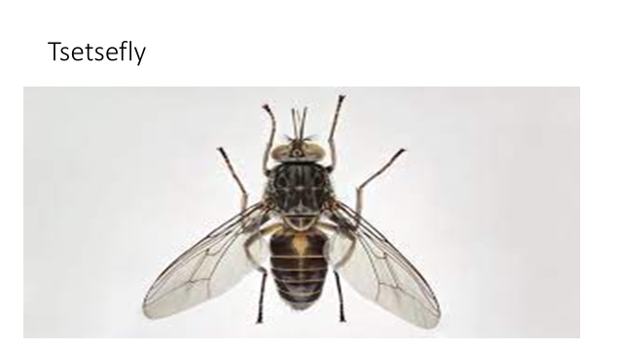

1. Identify the parasite. (1mk)

………………………………………………………………………………………………

1. What is the economic importance of the parasite to a livestock farmer? (1mk)

………………………………………………………………………………………………………………………………………………………………………………………………

1. State **three** non-chemical methods of controlling the above parasite. (3mks)

………………………………………………………………………………………………………………………………………………………………………………………………………………………………………………………………………………………………………………………………………………………………………………………………

1. The illustration below shows two different livestock families. Use it to answer the questions that follow.

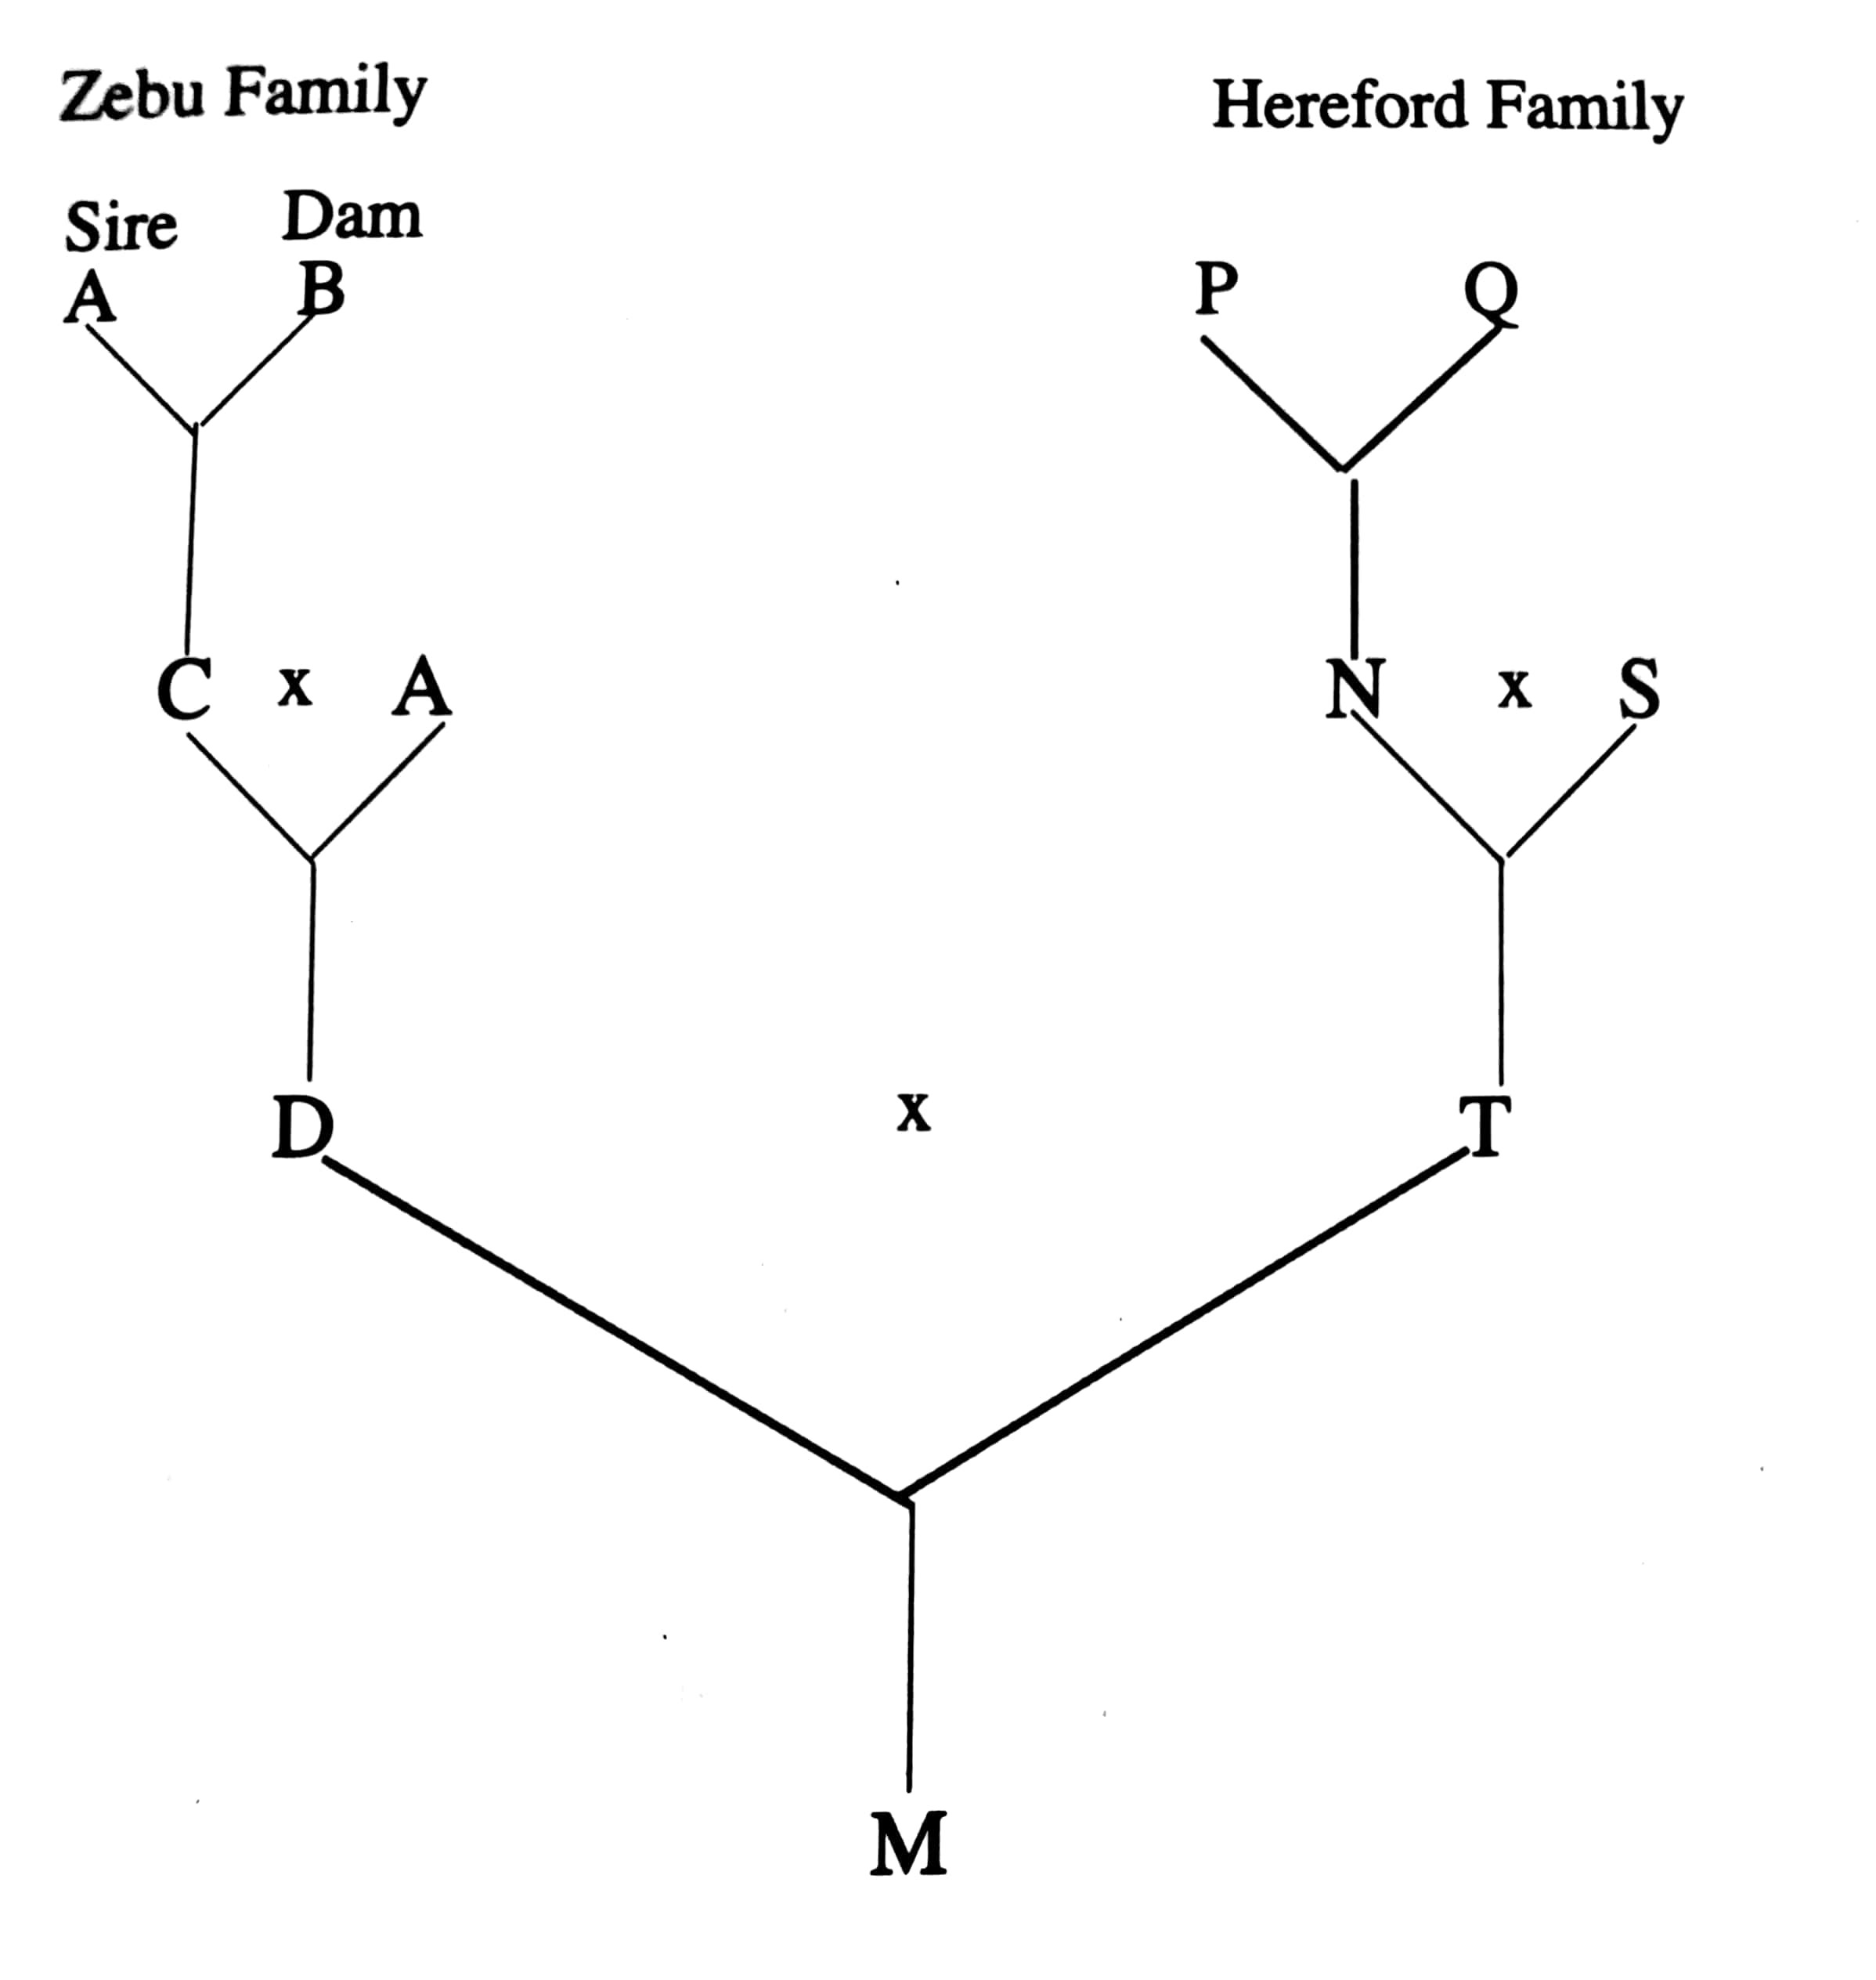

1. Identify the breeding system between
2. C and A (1mk)

………………………………………………………………………………………

1. D and T (1mk)

………………………………………………………………………………………

1. State **two** advantages of the breeding system identified in a) ii) above (2mks)

………………………………………………………………………………………………………………………………………………………………………………………………………………………………………………………………………………………………

1. What name is given to offspring M. (1mk)

………………………………………………………………………………………………

1. Below is a diagram of sheep. Study it carefully and answer the questions that follow.

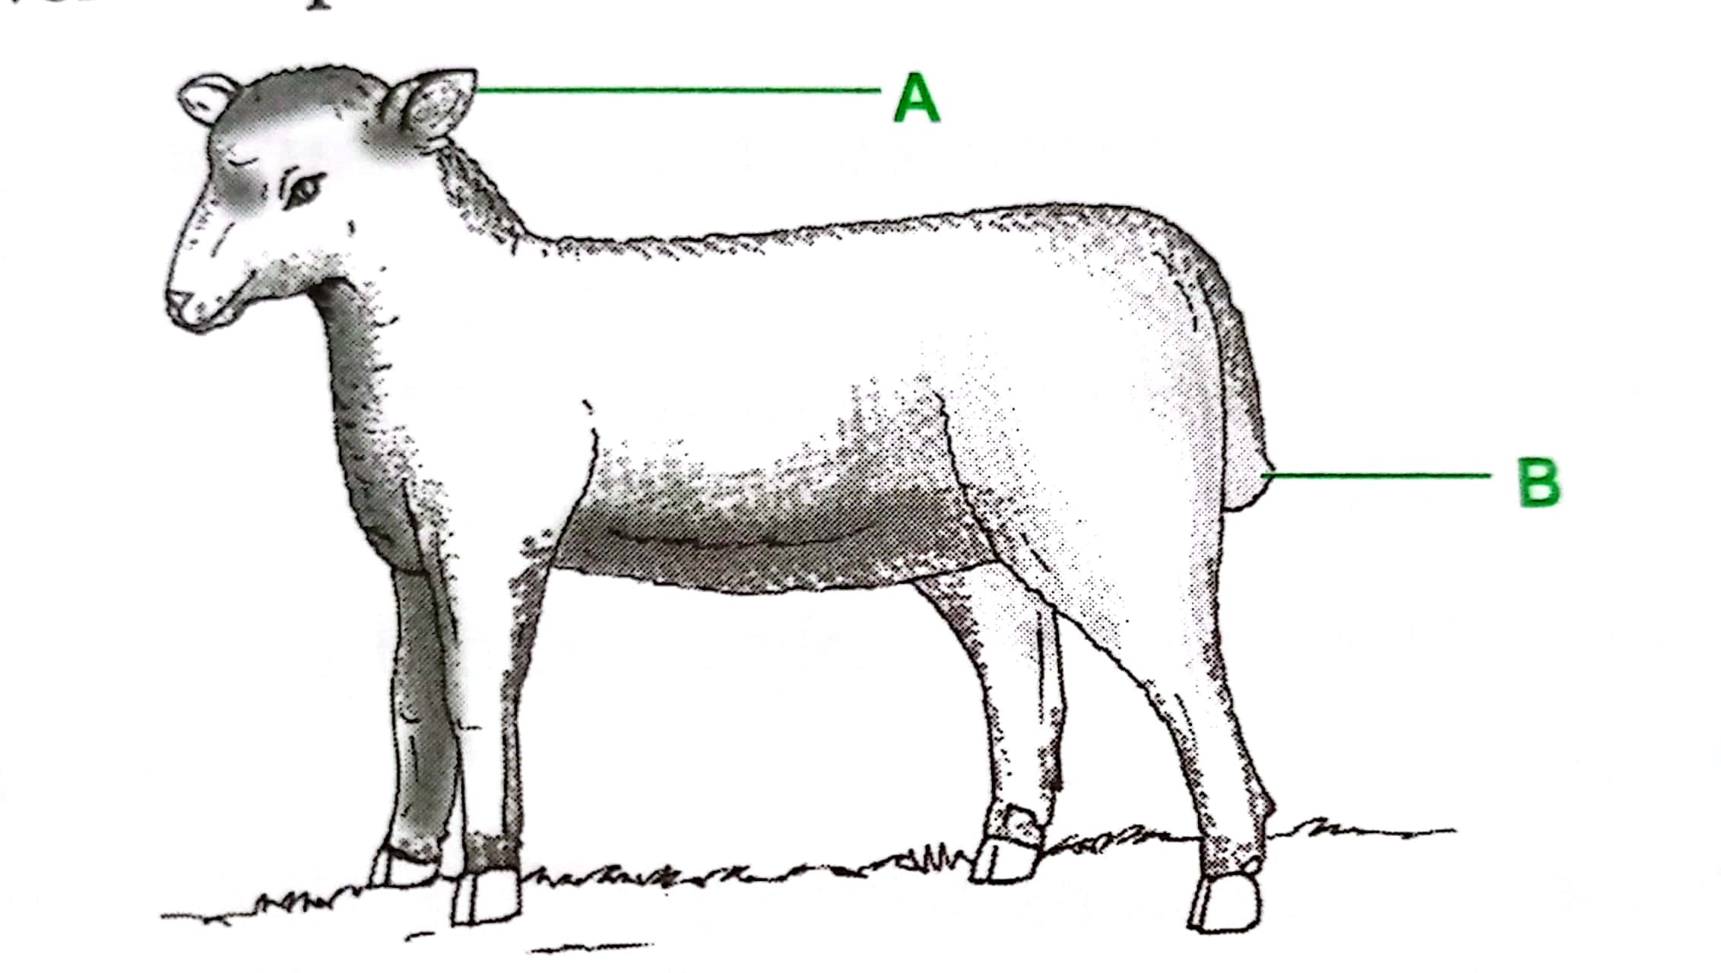

1. Name the management practice carried out in the part labelled B if the sheep is an ewe.

(1mk)

………………………………………………………………………………………………

1. Name one tool in each case that can be used to carry out operations on the parts labelled A and B. (2mks)

A……………………………………………………………………………………………

B………………………………………………………………………………………….....

1. What is raddling as used in the management of sheep. (1mk)

……………………………………………………………………………………………………………………………………………………………………………………………………………………………………………………………………………………………....

1. The following illustration show the behavior of chicks at different temperatures in a brooder

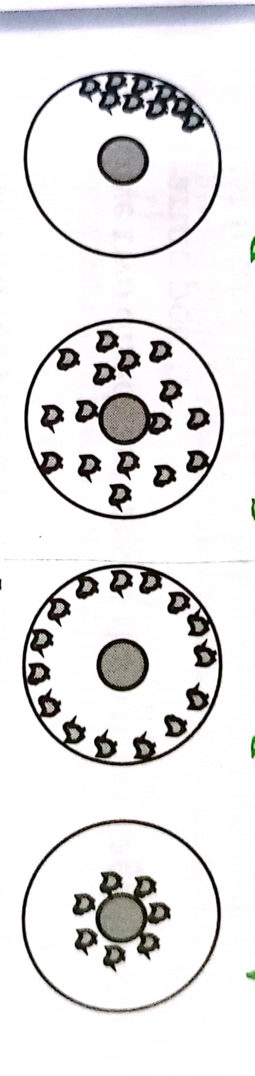 

C D E

1. Explain the temperature conditions in each of the four diagrams C, D, E (3mks)

C…………………………………………………………………………………………….

D……………………………………………………………………………………………

E……………………………………………………………………………………………

1. Draw a diagram to show the behavior of the chicks if the temperature in the brooder is the right one. (1mk)
2. Explain why the brooder guard is rounded. (1mk)

………………………………………………………………………………………………………………………………………………………………………………………………

**SECTION C (40 MARKS)**

1. a) Discuss foot and mouth disease under the following sub headings:
2. Causal organism (1mk)
3. Livestock species attacked (2mks)
4. Symptoms of attack. (4mks)
5. Control measures. (3mks)

b) Explain **five** factors that affect digestibility of food in livestock. (5mks)

c) State **five** advantages of a four stroke cycle engine. (5mks)

1. a) Explain the procedure of establishing a fish pond. (5mks)

b) Outline **five** differences between exotic cattle breeds and indigenous cattle breeds. (5mks)

c) State the features of an ideal calf pen. (5mks)

d) Outline **five** symptoms of round worm infestation in cattle. (5mks)

1. a) Describe the preparation and management of a brooder before and after the arrival of day old chicks. (5mks)

b) Describe the uses of various equipment that are used in honey harvesting. (5mks)

c) Give **five** advantages of farm mechanization. (5mks)

d) Outline **five** factors considered when selecting construction materials. (5mks)

………………………………………………………………………………………………..…………………………………………………………………………………………………..…………………………………………………………………………………………………..…………………………………………………………………………………………………..…………………………………………………………………………………………………..…………………………………………………………………………………………………..…………………………………………………………………………………………………..…………………………………………………………………………………………………..…………………………………………………………………………………………………..…………………………………………………………………………………………………..…………………………………………………………………………………………………..…………………………………………………………………………………………………..…………………………………………………………………………………………………..…………………………………………………………………………………………………..…………………………………………………………………………………………………..…………………………………………………………………………………………………..…………………………………………………………………………………………………..…………………………………………………………………………………………………..…………………………………………………………………………………………………..…………………………………………………………………………………………………..………………………………………………………………………………………………………………………………………………………………

………………………………………………………………………………………………..…………………………………………………………………………………………………..…………………………………………………………………………………………………..…………………………………………………………………………………………………..…………………………………………………………………………………………………..…………………………………………………………………………………………………..…………………………………………………………………………………………………..…………………………………………………………………………………………………..…………………………………………………………………………………………………..…………………………………………………………………………………………………..…………………………………………………………………………………………………..…………………………………………………………………………………………………..…………………………………………………………………………………………………..…………………………………………………………………………………………………..…………………………………………………………………………………………………..…………………………………………………………………………………………………..…………………………………………………………………………………………………..…………………………………………………………………………………………………..…………………………………………………………………………………………………..…………………………………………………………………………………………………..………………………………………………………

………………………………………………………………………………………………..…………………………………………………………………………………………………..…………………………………………………………………………………………………..…………………………………………………………………………………………………..…………………………………………………………………………………………………..…………………………………………………………………………………………………..…………………………………………………………………………………………………..…………………………………………………………………………………………………..…………………………………………………………………………………………………..…………………………………………………………………………………………………..…………………………………………………………………………………………………..…………………………………………………………………………………………………..…………………………………………………………………………………………………..…………………………………………………………………………………………………..…………………………………………………………………………………………………..…………………………………………………………………………………………………..…………………………………………………………………………………………………..…………………………………………………………………………………………………..…………………………………………………………………………………………………..…………………………………………………………………………………………………..………………………………………………………..

………………………………………………………………………………………………..…………………………………………………………………………………………………..…………………………………………………………………………………………………..…………………………………………………………………………………………………..…………………………………………………………………………………………………..…………………………………………………………………………………………………..…………………………………………………………………………………………………..…………………………………………………………………………………………………..…………………………………………………………………………………………………..…………………………………………………………………………………………………..…………………………………………………………………………………………………..…………………………………………………………………………………………………..…………………………………………………………………………………………………..…………………………………………………………………………………………………..…………………………………………………………………………………………………..…………………………………………………………………………………………………..…………………………………………………………………………………………………..…………………………………………………………………………………………………..…………………………………………………………………………………………………..…………………………………………………………………………………………………..………………………………………………………

………………………………………………………………………………………………..…………………………………………………………………………………………………..…………………………………………………………………………………………………..…………………………………………………………………………………………………..…………………………………………………………………………………………………..…………………………………………………………………………………………………..…………………………………………………………………………………………………..…………………………………………………………………………………………………..………………………………………………………………………………………………..…………………………………………………………………………………………………..…………………………………………………………………………………………………..…………………………………………………………………………………………………..…………………………………………………………………………………………………..…………………………………………………………………………………………………..…………………………………………………………………………………………………..…………………………………………………………………………………………………..…………………………………………………………………………………………………..…………………………………………………………………………………………………..…………………………………………………………………………………………………..…………………………………………………………………………………………………..…………………………………………………………

………………………………………………………………………………………………..……………………………………………………………………………………………………………………………………………………………………………………………………………………

………………………………………………………………………………………………..…..………………………………………………………………………………………………..……..……………………………………………………………………………………………..………..…………………………………………………………………………………………..…………..………………………………………………………………………………………..……………..……………………………………………………………………………………..………………..…………………………………………………………………………………..…………………..………………………………………………………………………………..……………………..……………………………………………………………………………..………………………..…………………………………………………………………………..…………………………..………………………………………………………………………..……………………………..……………………………………………………………………..………………………………..…………………………………………………………………..…………………………………..………………………………………………………………..……………………………………..……………………………………………………………..…………………………………………………………………………………………………………………………………………………………………………………………………………………………………………………………………………………………………………………………………………………………………………………………………………………………………………………………………………