**NAME: ………………………………………….. INDEX NO: …………………………………………….**

**CANDIDATES SIGNATURE: ………………………… DATE: …………………………………………..**

**NAKURU NORTH SUB -COUNTY JOINT MOCK 2024**

***Kenya Certificate of Secondary Education***

**443/2**

**AGRICULTURE**

**PAPER 2**

**JULY/AUGUST 2024**

**TIME: 2 ½ HOURS**

**INSTRUCTIONS TO CANDIDATES**

**(a) Write your name and Index Number in the spaces provided above.**

**(b) Sign and write the date of the examinations in the spaces provided above.**

**(c) This paper has three sections: A, B, and C. Answer all questions in section A and B**

**and any two questions in section.**

**(d) Write your answers in the spaces provided on the question paper.**

**FOR EXAMINER’S USE ONLY**

|  |  |  |  |
| --- | --- | --- | --- |
| **SECTION** | **QUESTIONS** | **MAXIMUM**  **SCORE** | **CANDIDATES SCORE** |
| **A** | **1 – 16** | **30** |  |
| **B** | **17 – 20** | **20** |  |
| **C** | **21 - 23** | **40** |  |
| **TOTAL SCORE** |  | **90** |  |

***This paper consists of 7 printed pages. Candidates should check the question paper to ascertain that all pages are printed as indicated and that no pages are missing.***

**SECTION A: (30 MARKS)**

**Answer all questions in this section in the spaces provided.**

1. State four external predisposing factors of livestock diseases. (2 mks)

……………………………………………………………………………………………………

……………………………………………………………………………………………………

……………………………………………………………………………………………………

……………………………………………………………………………………………………

2. List three importance of flushing in sheep management. (1 ½ mks)

……………………………………………………………………………………………………

……………………………………………………………………………………………………

……………………………………………………………………………………………………

3. Give three reasons why honey harvesting is discouraged at night. (1 ½ mks)

……………………………………………………………………………………………………

……………………………………………………………………………………………………

……………………………………………………………………………………………………

4. State two distinguishing external characteristics of California white rabbit. (2 mks)

……………………………………………………………………………………………………

……………………………………………………………………………………………………

5. Name two maintenance practices of an ox-cart. (1 mk)

……………………………………………………………………………………………………

……………………………………………………………………………………………………

6. Name three types of calf pens that can be constructed on a farm. (1 ½ mks)

……………………………………………………………………………………………………

……………………………………………………………………………………………………

……………………………………………………………………………………………………

7. Name the set of tools used for the following farm operations.

(a) Controlling bloat. (1 mk)

……………………………………………………………………………………………………

(b) Restraining an animal during an agricultural show exhibition. (1 mk)

……………………………………………………………………………………………………

8. Give three control measures of fleas in a flock of layers. (1 ½ mks)

……………………………………………………………………………………………………

……………………………………………………………………………………………………

……………………………………………………………………………………………………

9. Give four reasons for raddling in sheep management. (2 mks)

……………………………………………………………………………………………………

……………………………………………………………………………………………………

……………………………………………………………………………………………………

……………………………………………………………………………………………………

10. State four roles played by the engine oil in a tractor. (2 mks)

……………………………………………………………………………………………………

……………………………………………………………………………………………………

……………………………………………………………………………………………………

……………………………………………………………………………………………………

11. List four components of power transmission system in a tractor. (2 mks)

……………………………………………………………………………………………………

……………………………………………………………………………………………………

……………………………………………………………………………………………………

……………………………………………………………………………………………………

12. Identify the following breeds of livestock:

(i) A pig with dished face, erect ears and white colour (1k mk)

………………………………………………………………………………………………..

(ii) A beef breed of cattle which is cream in colour and the male weighs upto 1200kg

………………………………………………………………………………………………..

(iii) A breed of goat usually with long hair (1 mk)

………………………………………………………………………………………………..

(iv) A wool sheep with long curly wool usually covers its face (1 mk)

………………………………………………………………………………………………..

13. State four reasons for handling livestock in the farm. (2 mks)

……………………………………………………………………………………………………

……………………………………………………………………………………………………

……………………………………………………………………………………………………

……………………………………………………………………………………………………

14. Give two notifiable diseases in cattle. (1 mk)

……………………………………………………………………………………………………

……………………………………………………………………………………………………

15. Name five milking materials and equipments required during milking of a cow. (2 ½ mks)

……………………………………………………………………………………………………

……………………………………………………………………………………………………

……………………………………………………………………………………………………

……………………………………………………………………………………………………

……………………………………………………………………………………………………

16. State three disadvantages of natural methods of calf rearing. (1 ½ mks)

……………………………………………………………………………………………………

……………………………………………………………………………………………………

……………………………………………………………………………………………………

**SECTION B: (20 MARKS)**

**Answer all the questions in this section in the spaces provided.**

17. Below is a diagram showing a cross-section of a chicken brooder. Use it to answer the questions

that follow.

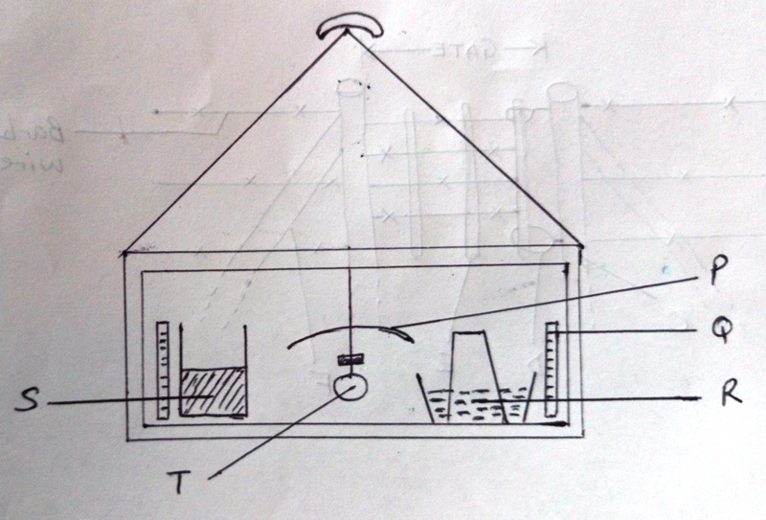

(a) Identify the parts labeled P,Q,R,S and T. (2 ½ mks)

P ……………………………………

Q …………………………………..

R…………………………………..

S…………………………………..

T…………………………………..

(b) What is the purpose of the part labeled Q? (1 mk)

……………………………………………………………………………………………………

(c) State two ways by which temperature in the brooder may be raised. (2 mks)

……………………………………………………………………………………………………

……………………………………………………………………………………………………

(d) Name any material that would be suitable for use as litter in the brooder. (½ mks)

……………………………………………………………………………………………………

18. The diagram below represents parts of a water harvesting structure. Study it carefully and answer

the questions that follow.

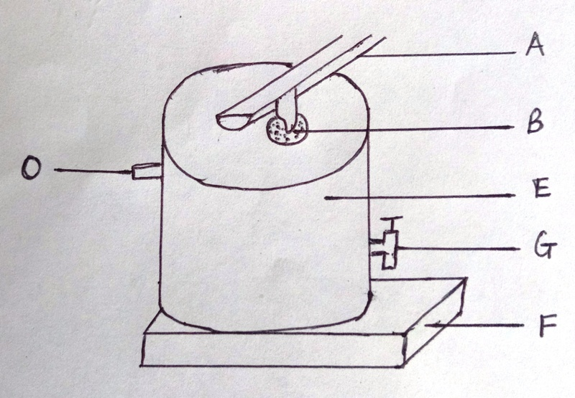

(a) Name the parts labeled A and O on the diagram. (2 mks)

A ………………………………..

O ………………………………..

(b) Identify the method of water harvesting illustrated. (1 mk)

……………………………………………………………………………………………………

(c) State the use of the part labeled B. (1 mk)

……………………………………………………………………………………………………

(d) State two maintenance practices needed for part labeled E. (2 mks)

……………………………………………………………………………………………………

……………………………………………………………………………………………………

19. The diagram below shows a livestock parasite. Study it and answer the questions that follow.

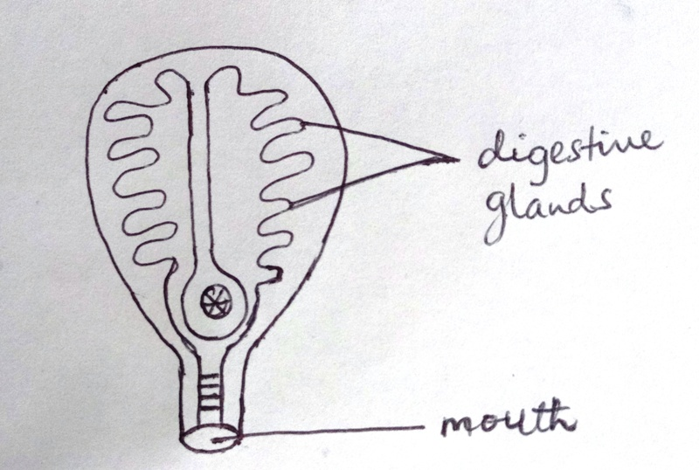

(a) Name the parasite. (1 mk)

……………………………………………………………………………………………………

(b) Name the final host of the parasite and the part of the body of the host where it is found.

(2 mks)

……………………………………………………………………………………………………

(c) State the intermediate host of the parasite. (1 mk)

……………………………………………………………………………………………………

20. The diagram below shows a type of a farm gate. Study the diagram and answer the questions that

follow.

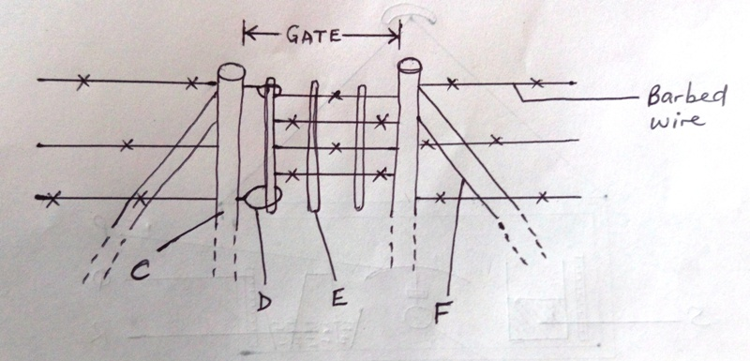

(a) Identify the type of gate shown. (1 mk)

……………………………………………………………………………………………………

(b) Name the parts labeled C, D and E. (3 mks)

C …………………………….

D ……………………………

E …………………………….

(c) State one function of the part labeled F. (1 mk)

……………………………………………………………………………………………………

**SECTION C: (40 MARKS)**

**Answer any two questions from this section on the answer sheets provided.**

21. (a) Outline the procedure of training a calf for bucket feeding. (5 mks)

(b) Highlight the advantages of artificial incubation. (5 mks)

(c) Explain various practices used to prevent livestock diseases. (10 mks)

22. (a) Explain the various uses of livestock in the farm. (10 mks)

(b) Identify and explain the various conditions that pre-dispose livestock to diseases in the farm.

(10 mks)

23. (a) Explain the limitations of tractor power in the farm. (6 mks)

(b) Explain the operational differences between a disc plough and a mouldboard plough.

(8 mks)

(c) Discuss the advantages of four stroke engines on the farm. (6 mks)

………………………………………………………………………………………………………………………………………………………………………………………………………………………………………………………………………………………………………………………………………………………………………………………………………………………………………………………………………………………………………………………………………………………………………………………………………………………………………………………………………………………………………………………………………………………………………………………………………………………………………………………………………………………………………….………………………………………………………………………………………………………………………………………………………………………………………………………………………………………………………………………………………………………………………………………………………………………………………………………………………………………………………………………………………………………………………………………………………………………………………………………………………………………………………………………………………………………………………………………………………………………………………………………………………………………………………………………………………………………….………………………………………………………………………………………………………………………………………………………………………………………………………………………………………………………………………………………………………………………………………………………………………………………………………………………………………………………………………………………………………………………………………………………………………………………………………………………………………………………………………………………………………………………………………………………………………………………………………………………………………………………………………………………………………….………………………………………………………………………………………………………………………………………………………………………………………………………………………………………………………………………………………………………………………………………………………………………………………………………………………………………………………………………………………………………………………………………………………………………………………………………………………………………………………………………………………………………………………………………………………………………………………………………………………………………………………………………………………………………….………………………………………………………………………………………………………………………………………………………………………………………………………………………………………………………………………………………………………………………………………………………………………………………………………………………………………………………………………………………………………………………………………………………………………………………………………………………………………………………………………………………………………………………………………………………………………………………………………………………………………………………………………………………………………….……………………………………………………………………………………………………………………………………………………………………………………………………………………………………………………………………………………………………………………………………………………………………………………………………………………………………………………………………………………………………………………………………………………………………………………………………………………………………………………………………………………………………………………………………………………………………………………………

………………………………………………………………………………………………………………………………………………………………………………………………………………………………………………………………………………………………………………………………………………………………………………………………………………………………………………………………………………………………………………………………………………………………………………………………………………………………………………………………………………………………………………………………………………………………………………………………………………………………………………………………………………………………………….……………………………………………………………………………………………………………………………………………………………………………………………………………………………………………………………………………………………………………………………………………………………………………………………………………………………………………………………………………………………………………………………………………………………………………………………………………………………………………………………………………………………………………………………………………………………………………………………

………………………………………………………………………………………………………………………………………………………………………………………………………………………….…………………………………………………………………………………………………………………………………………………………………………………………………………………………

………………………………………………………………………………………………………………………………………………………………………………………………………………………….