

**MARANDA HIGH SCHOOL**

***Kenya Certificate Of Secondary Education***

**THE 2024 MOCK EXAMINATION**

**443/2 AGRICULTURE PAPER 2**

**June, 2024 TIME: 2 Hrs**

**Name**: …………………………………….……… **Admission No**: ……………

**CODE - SUBJECT**

Wednesday, 12th June, 2024

Afternoon

2:00pm-4:00pm

**Stream**: ………………….. **Signature**: ……….........

**INSTRUCTIONS TO CANDIDATES**

1. *Write your* ***name****,* ***admission number, date, stream and signature*** *in the spaces provided above.*
2. *Answer* ***all*** *the questions in section A and B.*
3. *Answer any* ***two*** *questions in section C. Indicate on the grid the question number done.*
4. *All answers must be written in the spaces provided in the booklet.*
5. ***This paper consists of 14 printed pages with 21 questions. Candidates should check the question paper to ascertain that all the pages are printed as indicated and that no questions are missing***
6. *Candidate should answer the questions in* ***English***

**FOR EXAMINER’S USE ONLY**

|  |  |  |  |
| --- | --- | --- | --- |
| **SECTIONS** | **QUESTIONS** | **MAXIMUM SCORE** | **CANDIDATES SCORE** |
| **A** | **1-14** | **30** |  |
| **B** | **15-18** | **20** |  |
| **C** |  | **20** |  |
|  | **20** |  |
| **TOTAL SCORE** | | **90** |  |

**SECTION A (30 marks)**

**Answer ALL questions from this section**.

1. Name the **two** products obtained from dual purpose sheep. (1 mark)

______________________________________________________________________________________________________________________________________________________________________________________________________________________________

1. Give **two** practices that should be done to a newly born calf with difficult breathing. (1 mark)

____________________________________________________________________________________________________________________________________________________

1. (a) What is meant by the term two host tick? (1 mark)

__________________________________________________________________________

(b) Give **two** examples of two host ticks in cattle. (1 mark)

____________________________________________________________________________________________________________________________________________________

1. State **four** disadvantages of using plunge dips in tick control.

(2 marks)

________________________________________________________________________________________________________________________________________________________________________________________________________________________________________________________________________________________________________

1. (a) State the functions of the following farm tools and equipment:

(i) Pipe cutter; (½ mark)

__________________________________________________________________________

(ii) Wire strainer. (½ mark)

__________________________________________________________________________

(b) Name **four** tools that can be used to assemble a jembe. (2 marks)

__________________________________________________________________________ __________________________________________________________________________ __________________________________________________________________________ __________________________________________________________________________

(c) Name the complementary tool for each of the tools named below:

(i) Trochar: (½ mark)

__________________________________________________________________________

(ii) Hand drill. (½ mark)

__________________________________________________________________________

1. Name **two** livestock diseases controlled through embryo transplant. (1 mark)

____________________________________________________________________________________________________________________________________________________

1. State **three** factors that limit external parasite control in Kenya. (1½ marks)

______________________________________________________________________________________________________________________________________________________________________________________________________________________________

1. State **four** characteristics of the Duroc Jersey pig. (2 marks)

________________________________________________________________________________________________________________________________________________________________________________________________________________________________________________________________________________________________________

1. Name **four** categories of poultry feeds according to the stages of growth of birds. (2 marks)

________________________________________________________________________________________________________________________________________________________________________________________________________________________________________________________________________________________________________

1. State **four** ways in which a vaccine can be administered to livestock. (2 marks)

__________________________________________________________________________ __________________________________________________________________________ __________________________________________________________________________ __________________________________________________________________________

1. (a) Name **three** protozoan diseases of cattle. (1½ marks)

__________________________________________________________________________ __________________________________________________________________________ __________________________________________________________________________

(b) State **four** symptoms of rinderpest in cattle. (2 marks)

________________________________________________________________________________________________________________________________________________________________________________________________________________________________________________________________________________________________________

1. State **four** maintenance practices carried out on a spray race. (2 marks)

________________________________________________________________________________________________________________________________________________________________________________________________________________________________________________________________________________________________________

1. (a) Give **four** reasons for proper feeding in livestock rearing. (2 marks)

________________________________________________________________________________________________________________________________________________________________________________________________________________________________________________________________________________________________________

(b) State **four** good hygiene practices in livestock feeding. (2 marks)

________________________________________________________________________________________________________________________________________________________________________________________________________________________________________________________________________________________________________

1. State **four** reasons why kids should be weighed immediately after birth. (2 marks)

________________________________________________________________________________________________________________________________________________________________________________________________________________________________________________________________________________________________________

**SECTION B *(20 marks)***

***Answer all the questions in this section in the spaces provided***

1. The picture below shows a poultry farm structure.

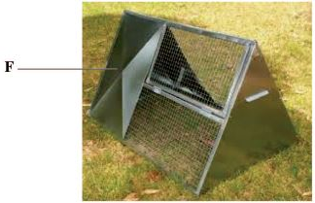

(a) Identify the farm structure. (1 mark)

__________________________________________________________________________

(b) Apart from metal, name **two** materials that can be used for the part labeled F. (2 marks)

__________________________________________________________________________

__________________________________________________________________________

(c) State **three** disadvantages of using the farm structure illustrated above in poultry rearing. (3 marks)

__________________________________________________________________________ __________________________________________________________________________ __________________________________________________________________________

1. The picture below illustrates a livestock organ infested by a parasite labelled **E.**

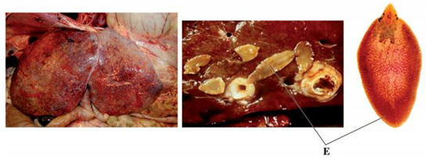

(a) Name the disease the livestock is suffering from. (1 mark)

__________________________________________________________________________

(b) Identify the parasite labeled **E.**   (1 mark)

__________________________________________________________________________

(c) State **two** control measures for the parasite. (2 marks)

__________________________________________________________________________ __________________________________________________________________________

(d) State **two** signs of infestation shown in the picture above. (2 marks)

__________________________________________________________________________ __________________________________________________________________________

1. The pictures below illustrate two rabbit breeds.

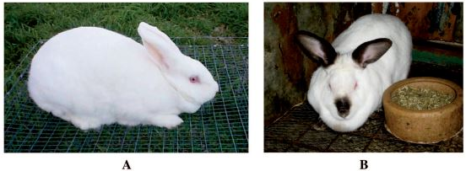

(a) Name the rabbit breeds shown above.

**A**  (1 mark)

__________________________________________________________________________

**B** (1 mark)

__________________________________________________________________________

(b) Name the major feeding practice missing from the photograph labeled B. (1 mark)

__________________________________________________________________________

(c) Give **one** advantage of housing the rabbits on the ﬂoor illustrated above. (1 mark)

__________________________________________________________________________

1. The following is an illustration of a chick suffering from malnutrition.

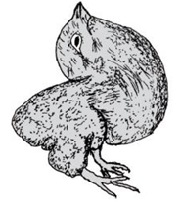

(a) Identify the mineral deﬁciency shown by the chick. (1 mark)

__________________________________________________________________________

(b) Apart from the symptom illustrated above, give **three** other symptoms of mineral deﬁciency in poultry. (3 marks)

__________________________________________________________________________ __________________________________________________________________________ __________________________________________________________________________

**SECTION C (40 marks)**

***Answer any two questions from this section in the spaces provided after question 21.***

1. (a) Describe **ten** factors considered when selecting a breeding stock.(10 marks)

(b) Describe the causes of low egg production in layers. (10 marks)

1. (a) Describe how the late weaning programme is conducted in a dairy calf. (12 marks)

(b) Describe how a newly constructed pond is prepared and stocked with ﬁngerlings. (8 marks)

1. (a) (i) Describe short-term tractor servicing. (10 marks)

(ii) Explain the maintenance practices that should be carried out on an ox-cart. (5 marks)

(b) State **ﬁve** indicators that can be observed on a goat to conﬁrm sickness. (5 marks)

________________________________________________________________________________________________________________________________________________________________________________________________________________________________________________________________________________________________________________________________________________________________________________________________________________________________________________________________________________________________________________________________________________________________________________________________________________________________________________________________________________________________________________________________________________________________________________________________________________________________________________________________________________________________________________________________________________________________________________________________________________________________________________________________________________________________________________________________________________________________________________________________________________________________

__________________________________________________________________________________________________________________________________________________________________________________________________________________________________________________________________________________________________________________________________________________________________________________

__________________________________________________________________________________________________________________________________________________________________________________________________________________________________________________________________________________________________________________________________________________________________________________

____________________________________________________________________________________________________________________________________________________

__________________________________________________________________________________________________________________________________________________________________________________________________________________________________________________________________________________________________________________________________________________________________________________

____________________________________________________________________________________________________________________________________________________

__________________________________________________________________________________________________________________________________________________________________________________________________________________________________________________________________________________________________________________________________________________________________________________

________________________________________________________________________________________________________________________________________________________________________________________________________________________________________________________________________________________________________________________________________________________________________________________________________________________________________________________________________________________________________________________________________________________________________________________________________________________________________________________________________________________________________________________________________________________________________________________________________________________________________________________________________________________________________________________________________________________________________________________________________________________________________________________________________________________________________________________________________________________________________________________________________________________________

____________________________________________________________________________________________________________________________________________________

__________________________________________________________________________________________________________________________________________________________________________________________________________________________________________________________________________________________________________________________________________________________________________________

______________________________________________________________________________________________________________________________________________________________________________________________________________________________________________________________________________________________________________________________________________________________________________________________________________________________________________________________________________________________________________________________________________________________________________________________________________________________________________________________________________________________________________________________________________________________________________________________________________________________________________

__________________________________________________________________________________________________________________________________________________________________________________________________________________________________________________________________________________________________________________________________________________________________________________

____________________________________________________________________________________________________________________________________________________

__________________________________________________________________________________________________________________________________________________________________________________________________________________________________________________________________________________________________________________________________________________________________________________

____________________________________________________________________________________________________________________________________________________

____________________________________________________________________________________________________________________________________________________________________________________________________________________________________________________________________________________________________________________________________________________________________________________________________________________________________________________________________________________________________________________________________________________________________________________________________________________________________________________________________________________________________________________________________________________________________________________________________________________________________________________________________________________________________________________________________________________________________________________________________________________________________________________________________________

__________________________________________________________________________________________________________________________________________________________________________________________________________________________________________________________________________________________________________________________________________________________________________________

____________________________________________________________________________________________________________________________________________________

__________________________________________________________________________________________________________________________________________________________________________________________________________________________________________________________________________________________________________________________________________________________________________________

____________________________________________________________________________________________________________________________________________________

______________________________________________________________________________________________________________________________________________________________________________________________________________________________________________________________________________________________________________________________________________________________________________________________________________________________________________________________________________________________________________________________________________________________________________________________________________________________________________________________________________________________________________________________________________________________________________________________________________________________________________

__________________________________________________________________________________________________________________________________________________________________________________________________________________________________________________________________________________________________________________________________________________________________________________

____________________________________________________________________________________________________________________________________________________

______________________________________________________________________________________________________________________________________________________________________________________________________________________________