**FORM FOUR KASSU JET MOCK 2024**

***Kenya Certificate of Secondary Education (K.C.S.E.)***

**Agriculture**

**Paper 2**

**Marking scheme**

**SECTION A (30 MARKS)**

1. Give the appropriate term used to refer to each of the following.
2. Young one of a rabbit. $(\frac{1}{2}mk)$

*-Kindling.*

1. Mature female cattle. $(\frac{1}{2}mk)$

*Cow.*

1. State **three** factors that determine the effectiveness of an acaricide. $(1\frac{1}{2}mk)$

*-Active ingredients of the acaricide/ ability to kill ticks.*

*-Persistence of acaricide/stability of the acaricide/ability to remain effective after fouling with hair, mud, dung and dirt.*

*-Concentration of the acaricide in the mixture.*

*-Weather condition during application.*

*-Thoroughness/skill of application.*

1. Outline **four** factors considered when formulating a livestock ration. (2mks)

*-Nutrient requirements of the animal.*

*-Age of the animal.*

*-Type of animal whether ruminant or non-ruminant.*

*-Availability of feedstuff.*

*-Cost of the feedstuff.*

1. List **three** methods used in selection of breeding stock in livestock production. $(1\frac{1}{2}mk)$

*-Mass selection*

*-Progeny testing*

*-Contemporary comparison*

1. State how each of the following practices help to control livestock diseases.
2. Quarantine $(\frac{1}{2}mk)$

*-By restricting animal movements and their products from and into the affected areas and in the event of an outbreak of a notifiable disease thus preventing the spread of the disease.*

1. Prophylactic measures. $(\frac{1}{2}mk)$

*-By preventing the occurrence of the disease using preventive measures.*

1. State **four** reasons for seasoning timber. (2mks)

*-To prevent warping.*

*-To prevent fungal infestation/rotting.*

*-To resist weather conditions.*

*-To resist insect damage.*

1. Give **two** processes carried out by a combine harvester when harvesting wheat. (1mk)

*-Threshing of the grains.*

*-Cleaning of the grains.*

1. State **two** functions of lubrication system in a tractor. (1mk)

*-It helps to increase the efficiency of the machine and reduces the rate of wear and tear of moving parts.*

*-It reduces the heat created by the rubbing surfaces and act as a seal between them.*

*-Acts as a cleaning agent as it washes off all dust, dirt, soot and metal chippings from the oil paths to the sump.*

*-Oiling prevents rusting of stationary machines.*

1. State **four** factors that stimulate milk let-down in a lactating cow. (2mks)

*-Washing the udder with warm water.*

*-Allowing the calf to suckle for a while.*

*-Feeding the cow during milking.*

*-Regular milking time.*

*-Sound associated with milking.*

*-Massaging the udder when washing it.*

*-Presence of milkman/milking parlour.*

1. Give **two** reasons for using litter in a poultry house. (1mk)

*-Helps to keep the poultry house warm.*

*-Helps to keep the poultry house dry by absorbing moisture from bird droppings.*

1. Give **four** conditions that reduce the quality of eggs for hatching. (2mks)

*-Small size*

*-Candling qualities (Double yolk, hard shell, blood spots)*

*-Not fertilized.*

*-Cracked shell*

*-Dirty eggs*

*-Age more than 10 days old.*

*-Rough shell*

1. State **four** ways of restraining cattle during routine management. (2mks)

*-Use of a crush.*

*-Use of a head yoke.*

*-Use of ropes /halters/casting*

*-Use of lead stick and bull ring.*

*-Use of holding/isolation pen/yard.*

1. Give the use of each of the following workshop tools.
2. Cold chisel. $(\frac{1}{2}mk)$

*-Cutting thick sheets of metal.*

1. Rip saw. $(\frac{1}{2}mk)$

*-Used for cutting wood along the grains.*

1. Give **four** reasons why colostrum is important in calf feeding. (2mks)

*-Its highly digestible*

*-It’s highly nutritious and contains vitamins for growth and disease resistance.*

*-Has antibodies that enable the calf to resist early disease infection*

*-Its good in cleaning the bowels of the calf (has a laxative effect)*

*-It is highly palatable.*

1. State **four** harmful effects of lice in pigs. (2mks)

*-Causes irritation to the skin.*

*-Heavy infestation will cause loss of health in animals.*

*-Poor feeding and emaciation.*

*-Loss of production.*

*-Restlessness and anaemia conditions.*

1. Give **four** reasons for swarming of bees. (2mks)

*-Shortage of food and water*

*-Outbreak of diseases and parasites*

*-Damage of brood and combs.*

*-Lack of adequate ventilation*

*-Dampness and bad smell*

*-Sick or infertile queen.*

*-Overcrowding*

1. State **four** factors that lead to an increase in the respiratory rate of livestock. (2mks)

*-Large body size*

*-High amount of exercise done*

*-High degree of excitement.*

*-High environmental temperature.*

1. Outline **four** signs of heat in rabbits. (2mks)

*-Restlessness*

*-Frequent urination*

*-Swollen vulva.*

*-The doe throws itself on its sides*

*-She rubs herself against the wall or any other solid object.*

*-The doe tries to contact other rabbits in the next hutch by peeping through the cage walls.*

1. Name **two** nutritional diseases in cattle. (1mk)

*-Scours.*

*-Milk fever.*

**SECTION B (20 MARKS)**

1. The photograph below represents an external parasite of livestock. Study it carefully and answer the questions that follow.

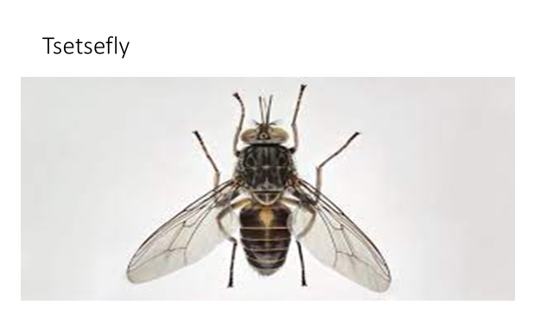

1. Identify the parasite. (1mk)

*-Tsetsefly (Glossina spp)*

1. What is the economic importance of the parasite to a livestock farmer? (1mk)

*-Transmits trypanosomiasis/nagana/ sleeping sickness.*

1. State **three** non-chemical methods of controlling the above parasite. (3mks)

*-Bush clearing to destroy breeding places of flies.*

*-Sterilizing of the male tsetse flies by use of chemicals eg radio isotopes.*

*-Creating buffer zones near game reserves thereby preventing the transmission of infection from wild animals to livestock.*

*-Trapping of the flies*

1. The illustration below shows two different livestock families. Use it to answer the questions that follow.

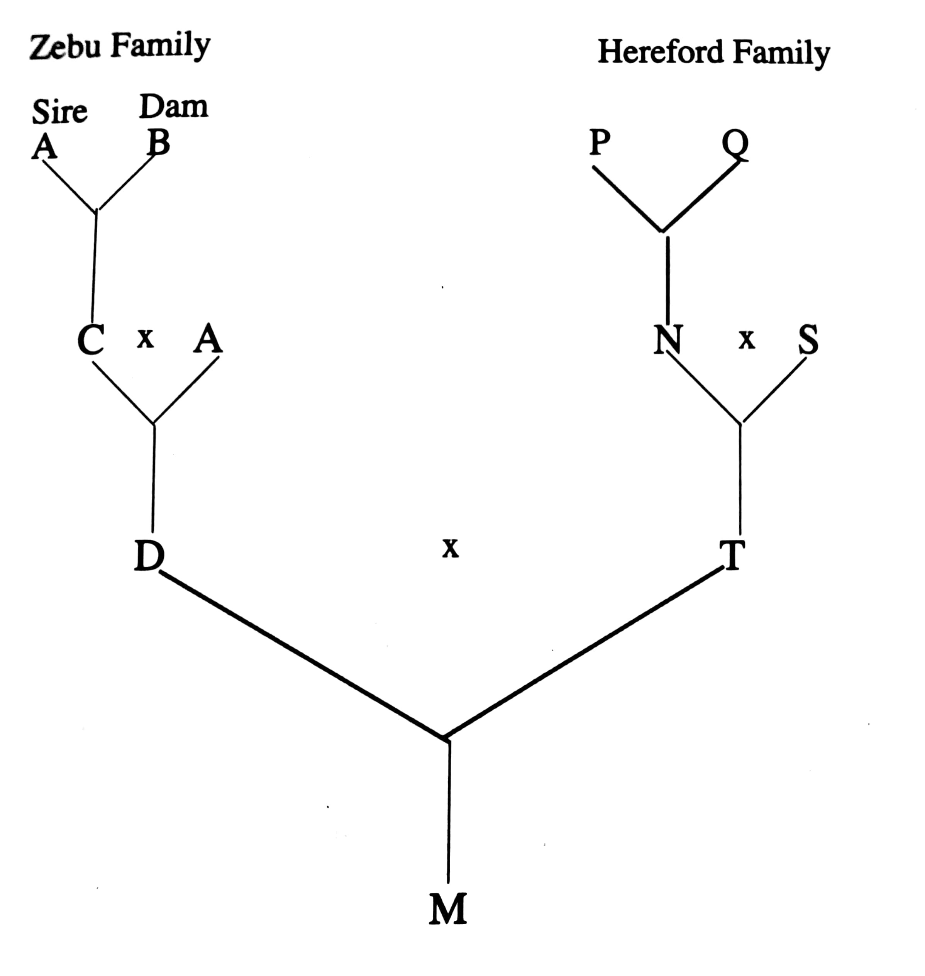

1. Identify the breeding system between
2. C and A (1mk)

*-Close breeding/parent sib mating.*

1. D and T (1mk)

*-Cross breeding.*

1. State **two** advantages of the breeding system identified in a) ii) above (2mks)

*-Heterosis (hybrid vigour) can be exploited. Hybrids perform better than the original breeds.*

*-It helps to establish grade animals.*

*-It can be used to change the breed ie from one breed to another.*

*-It is a much quicker method of producing the required animal.*

1. What name is given to offspring M. (1mk)

*-Hybrid.*

1. Below is a diagram of sheep. Study it carefully and answer the questions that follow.

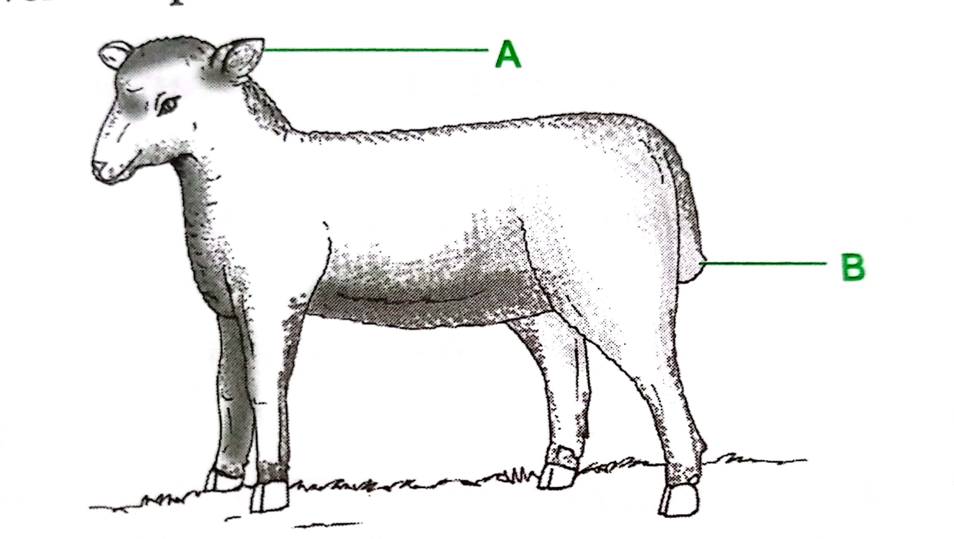

1. Name the management practice carried out in the part labelled B if the sheep is an ewe.

(1mk)

-Docking

1. Name one tool in each case that can be used to carry out operations on the parts labelled A and B. (2mks)
2. *Ear notcher*
3. *Elastrator and rubber ring, Burdizzo and sharp knife, Hot iron.*
4. What is raddling as used in the management of sheep. (1mk)

*This is the practice of fitting the rams with breeding chutes or ram harness on the briskets which are painted in different colours during breeding. Alternatively, the rams can be painted with different colours on the underside.*

1. The following illustration show the behavior of chicks at different temperatures in a brooder

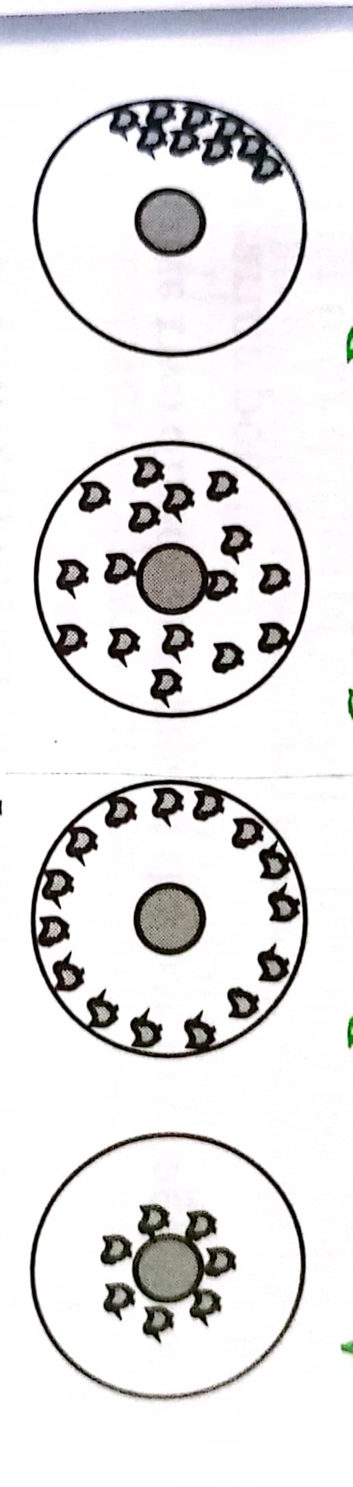

C D E

1. Explain the temperature conditions in each of the four diagrams C, D, E (3mks)

*C-There is draught from the side directly opposite where the chicks have crowded.*

*D-It is very cold in the brooder. The chicks crowd around the heat source to get warmed.*

*E-There is too much heat in the brooder causing the chicks to move far away from the heat source.*

1. Draw a diagram to show the behavior of the chicks if the temperature in the brooder is the right one. (1mk)



1. Explain why the brooder guard is rounded. (1mk)

*-It helps to avoid overcrowding at one point which may lead to suffocation.*

**SECTION C (40 MARKS)**

1. a) Discuss foot and mouth disease under the following sub headings:
2. Causal organism (1mk)

- *Virus/ Enterovirus picorna*

1. Livestock species attacked (2mks)

*-Cattle, sheep, goats and pigs.*

1. Symptoms of attack. (4mks)

*-Drooling of saliva.*

*-Vesicles in the mouth, muzzle, feet, teats, udder and the rumen.*

*-Smacking of lips*

*-Kicking of the feet*

*-Lameness*

*-Abortion may occur.*

1. Control measures. (3mks)

*-Vaccination.*

*-Quarantine*

*-Mass slaughter.*

b) Explain **five** factors that affect digestibility of food in livestock. (5mks)

*-Chemical composition of the feed eg % of lignin or cellulose will influence digestibility.*

*-The form in which the food is offered to the animal eg crushed maize is more digestible than whole grain.*

*-The species of the animal eg the digestibility of grass is higher in sheep than in pigs.*

*-The ratio of energy to protein will affect digestibility. The higher the ratio the lower the digestibility.*

*-The quantity of feed already present in the digestive system of an animal.*

c) State **five** advantages of a four stroke cycle engine. (5mks)

*-Produce high power and can do heavy farm work.*

*-They have an efficient fuel and oil utilization.*

*-They perform a wide range of farm operations.*

*-The engine is efficiently cooled with water thus allowing the production of large engine sizes.*

*-Exhaust gases are effectively expelled from the cylinders*

1. a) Explain the procedure of establishing a fish pond. (5mks)

*-Site selection*

*-Site marking eg inlet and outlet*

*-Clearing the land ie removing all the vegetation.*

*-Digging the pond-Soil is dug out upper side 0.5m deep and the lower side 1.5m deep.*

*-Constructing the dyke-This is the wall that is constructed all round the pond.*

*-Constructing the inlet, outlet and spillway.*

1. Outline **five** differences between exotic cattle breeds and indigenous cattle breeds. (5mks)

|  |  |
| --- | --- |
| ***Exotic cattle breeds*** | ***Indigenous cattle breeds*** |
|  |  |
| *They have no humps.* | *They have humps* |
| *They have low tolerance to high temperatures. Are popular in cool climates of the Kenyan highlands.* | *They are fairly tolerant to high temperatures due to the presence of dewlap and thick hides.* |
| *They are highly susceptible to tropical diseases.* | *They have high tolerance to tropical diseases eg trypanosomiasis.* |
| *They have fast growth rates leading to early maturity.* | *They have a slow growth rate leading to late maturity* |
| *They are good producers of both meat and milk.* | *They have low production of both meat and milk due to inheritance of poor characteristics.* |
| *They cannot walk for long distances.* | *They can walk for long distances in search of food and water.* |
| *They have short calving intervals of one calf per year if well managed.* | *They have long calving intervals of more than 1 year.* |

c) State the features of an ideal calf pen. (5mks)

*-****Should have concrete floors****-This makes cleaning easy*

*-****Should have adequate space-*** *for feeding, exercise and watering equipment.*

*-****Single housing****-The housing should allow only one calf per pen so as to prevent calves from licking each other which results in hair balls in the stomach and also controls the spread of worms and skin infection.*

*-****Proper lighting****-Allows enough light into the pen for synthesis of vitamin D.*

*-****Proper drainage****- Facilitates free flow of urine and water. Poor drainage causes dampness which pre-disposes the calf to infections.*

*-****Draught free****-The windward side should be completely solid to prevent cold winds which pre-dispose the calf to infections eg pneumonia.*

*-****Leak proof roof****-Wetness encourages disease infections eg pneumonia and scours.*

*-****Proper ventilation****-Allows free air circulation.*

d) Outline **five** symptoms of round worm infestation in cattle. (5mks)

*-Anorexia under heavy infestation*

*-Stiff dry coat or staring coat.*

*-Dehydration and a pale mucosa*

*-Eggs and adults are seen in feaces*

*-General emaciation*

*-The animal may have diarrhoea*

*-Anaemic condition where infestation is heavy.*

*-Pot bellies especially in young animals*

1. a) Describe the preparation and management of a brooder before and after the arrival of day old chicks. (5mks)

*-The brooder should be ready 2-3days before chicks arrive.*

*-All equipment’s should be functioning.*

*-The brooder house and the brooder equipment should be thoroughly cleaned and disinfected.*

*-On arrival the chicks are fed on chick mash (20-22%DCP and vitamin A and D) for eight weeks.*

*-Provide plenty of water and check on the chicks regularly for the first two weeks.*

*-Chicks should be vaccinated at:*

* *2 weeks against gumboro.*
* *3-4 weeks against Newcastle.*
* *7 weeks against fowl typhoid.*
* *Coccidiosis is controlled by giving coccidiostats through water and feed.*

*-Provide roosts at 6weeks for chicks to perch on.*

*-Introduce growers mash in the 7th week which should be $\frac{1}{4}$ mixed with $\frac{3}{4}$ ration of chick mash.*

*-Remove chicks at 8weeks from the brooder and take them to the main poultry house.*

*-In the 9th week chicks are feed on grower’s mash only.*

b) Describe the uses of various equipment that are used in honey harvesting. (5mks)

*-Protective gear eg overall, veil, gum boots, hand gloves protects the person harvesting from bee stings.*

*-Smoker-Used to introduce smoke into the bee hive.*

*-Hive tool- Used for cutting honey combs during harvesting. It is also used to separate the top bars.*

*-Honey container with a light cover used for placing honey after harvesting.*

*-Bee brush used for brushing off bees from the honey comb.*

c) Give **five** advantages of farm mechanization. (5mks)

*-Makes farm operations faster.*

*-Makes work easier and enjoyable/ reduce drudgery*

*-Improves efficiency as more work can be done within a short period of time.*

*-High quality job is done than human labour.*

*-It economizes on the use of labour.*

*-It increases production by benefiting from economies of large scale.*

*-Tends to encourage farmers to consolidate their land.*

*-Pest and disease outbreak can be controlled relatively in a shorter time.*

d) Outline **five** factors considered when selecting construction materials. (5mks)

*-Availability of the materials*

*-Cost of the materials.*

*-Suitability of the materials*

*-Suitability of each type of material to the prevailing weather conditions.*

*-Durability of the materials.*

*-Strength of the materials*

*-Workability of the materials*