**Name: ………………………………………..…..Index No: ……………..…..class: …………**

**443/2**

**AGRICULTURE**

**PAPER 2**

**MOKASA II EXAMINATION – 2024**

**2 HOURS**

**K.C.S.E EXAMINATION**

**MOKASA II EXAMINATION – 2024**

**AGRICULTURE**

**PAPER 2**

**2 HOURS**

**Instructions to candidates**

1. Write your **name** and **index number** in the spaces provided above.
2. This paper consists of **three** sections: **A, B** and **C**
3. Answer **all** questions in sections **A** and **B** and any other question from section **C.**
4. **Do Not** plug any pages from the question paper.
5. Candidates should check the question paper to ascertain that all the pages are printed as indicated and that no questions are printed as indicated and that no questions are missing. Number of printed pages are ***10***

**FOR EXAMINER`S USE ONLY**

|  |  |  |  |  |
| --- | --- | --- | --- | --- |
| **SECTION** | **QUESTIONS** | **MAXIMUM SCORE** | | **CANDIDATE SCORE** |
| **A** | 1. **17** | **30** | |  |
| **B** | **18 – 21** | **20** | |  |
| **C** | **22 – 23** | **40** | |  |
| **TOTAL** | | **90** |  |

**SECTION A (30MARKS)**

***Answer all questions in the spaces provided***

1. Name **two** species of camels. (1mk)

………………………………………………………………………………………………………

………………………………………………………………………………………………………

1. State **four** general uses of solar energy. (2mks)

………………………………………………………………………………………………………

………………………………………………………………………………………………………

………………………………………………………………………………………………………

………………………………………………………………………………………………………

1. Name **four** tick borne diseases. (2mks)

………………………………………………………………………………………………………

………………………………………………………………………………………………………

………………………………………………………………………………………………………

………………………………………………………………………………………………………

1. What is the use of a **strip cup**? (1/2mk)

………………………………………………………………………………………………………

………………………………………………………………………………………………………

1. Give **three** ways used to improve production in indigenous cattle. (11/2mk)

………………………………………………………………………………………………………

………………………………………………………………………………………………………

………………………………………………………………………………………………………

1. Name a breed of sheep with a lambing percentage of above 125% and whose fleece is inferior due to black fibers. (1/2mk)

………………………………………………………………………………………………………

………………………………………………………………………………………………………

1. State **four** ways of controlling tsetse flies. (2mks)

………………………………………………………………………………………………………

………………………………………………………………………………………………………

………………………………………………………………………………………………………

………………………………………………………………………………………………………

1. State **four** factors that are considered when formulating a livestock ration. (2mks)

………………………………………………………………………………………………………

………………………………………………………………………………………………………

………………………………………………………………………………………………………

1. Differentiate between **mothering ability** and **prolificacy** in livestock breeding. (2mks)

………………………………………………………………………………………………………

………………………………………………………………………………………………………

………………………………………………………………………………………………………

1. State **two** reasons why it is necessary to place sugar syrup close to a beehive. (1mk)

………………………………………………………………………………………………………

………………………………………………………………………………………………………

1. Give **four** advantages of embryo transplant. (2mks)

………………………………………………………………………………………………………

………………………………………………………………………………………………………

………………………………………………………………………………………………………

………………………………………………………………………………………………………

1. Give the appropriate term that refers to each of the following.
2. Young one of a rabbit. (1/2mk)

………………………………………………………………………………………………………

1. Mature male goat (1/2mk)

………………………………………………………………………………………………………

1. A young female (1/2mk)

………………………………………………………………………………………………………

1. (a) Give **two** advantages of concrete blocks over timber as building materials. (1mk)

………………………………………………………………………………………………………

………………………………………………………………………………………………………

(b) State **three** disadvantages of using steel in construction of farm buildings. (11/2mk)

………………………………………………………………………………………………………

………………………………………………………………………………………………………

………………………………………………………………………………………………………

1. State **four** causes of egg eating in a flock of layers. (2mks)

………………………………………………………………………………………………………

………………………………………………………………………………………………………

………………………………………………………………………………………………………

………………………………………………………………………………………………………

1. State **four** disadvantages of fold system in poultry rearing. (2mks)

………………………………………………………………………………………………………

………………………………………………………………………………………………………

………………………………………………………………………………………………………

………………………………………………………………………………………………………

1. (a) Name **three** ways of caponization in poultry. (11/2mk)

………………………………………………………………………………………………………

………………………………………………………………………………………………………

………………………………………………………………………………………………………

(b) Give **four** characteristics of a good vaccine. (2mks)

………………………………………………………………………………………………………

………………………………………………………………………………………………………

………………………………………………………………………………………………………

………………………………………………………………………………………………………

1. State **four** reasons for carrying out egg curdling. (2mks)

………………………………………………………………………………………………………

………………………………………………………………………………………………………

………………………………………………………………………………………………………

………………………………………………………………………………………………………

**SECTION B (20 MARKS)**

***Answer all questions in this section in the spaces provided.***

1. Diagrams F and G illustrates chicks suffering from some essential feed nutrients. Study the diagrams and answer the questions that follow.

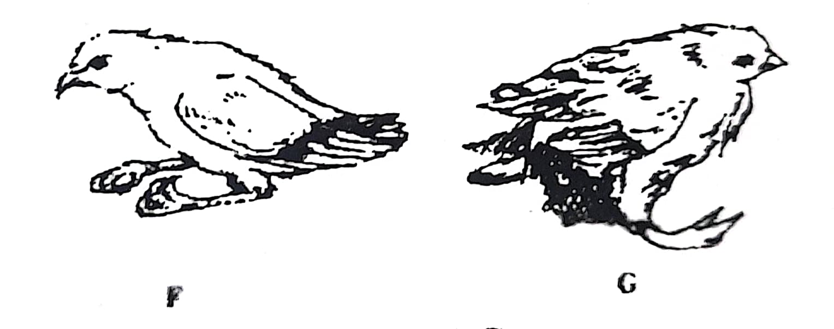

1. Name the deficient nutrient in F and G. (2mks)

**F**………………………………………………………………………………………………………………………………..**G**…………………………………………………………………………………………………………………………………

1. Outline **one** method in each case used to control the condition in F and G. (2mks)

**F**

………………………………………………………………………………………………………………………………

**G**

........................................................................................................................................

1. Below is an illustration of an internal parasite in livestock.

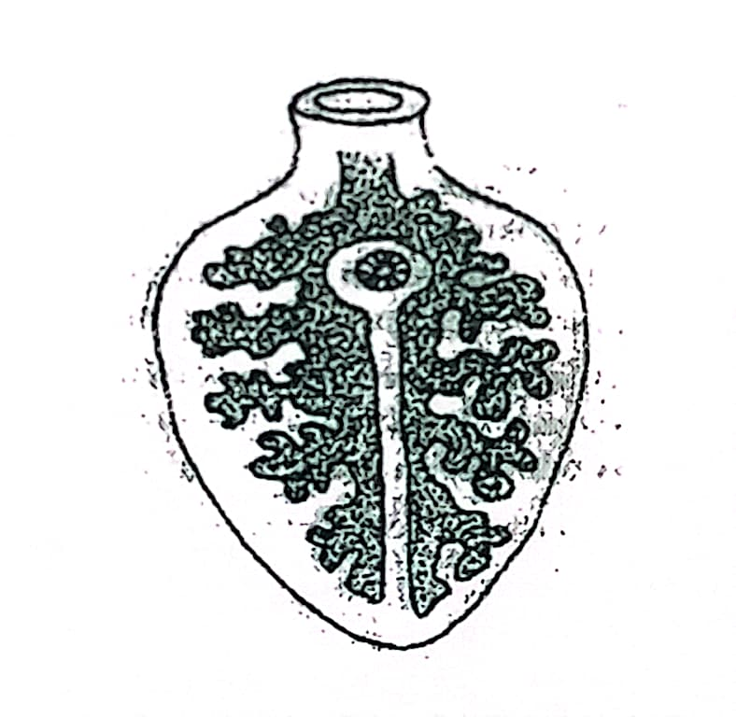

1. Identify the parasite. (1mk)

…………………………………………………………………………………………………………………………………

1. Name **one** final host for the parasite. (1mk)

…………………………………………………………………………………………………………………………………..

1. Name the intermediate host for the parasite. (1mk)

…………………………………………………………………………………………………………………………………

1. State **two** control measures of the parasite. (2mks)

……………………………………………………………………………………………………………………………………………………………………………………………………………………………………………………………………

1. The diagram below shows a cross section of a cows’ udder.

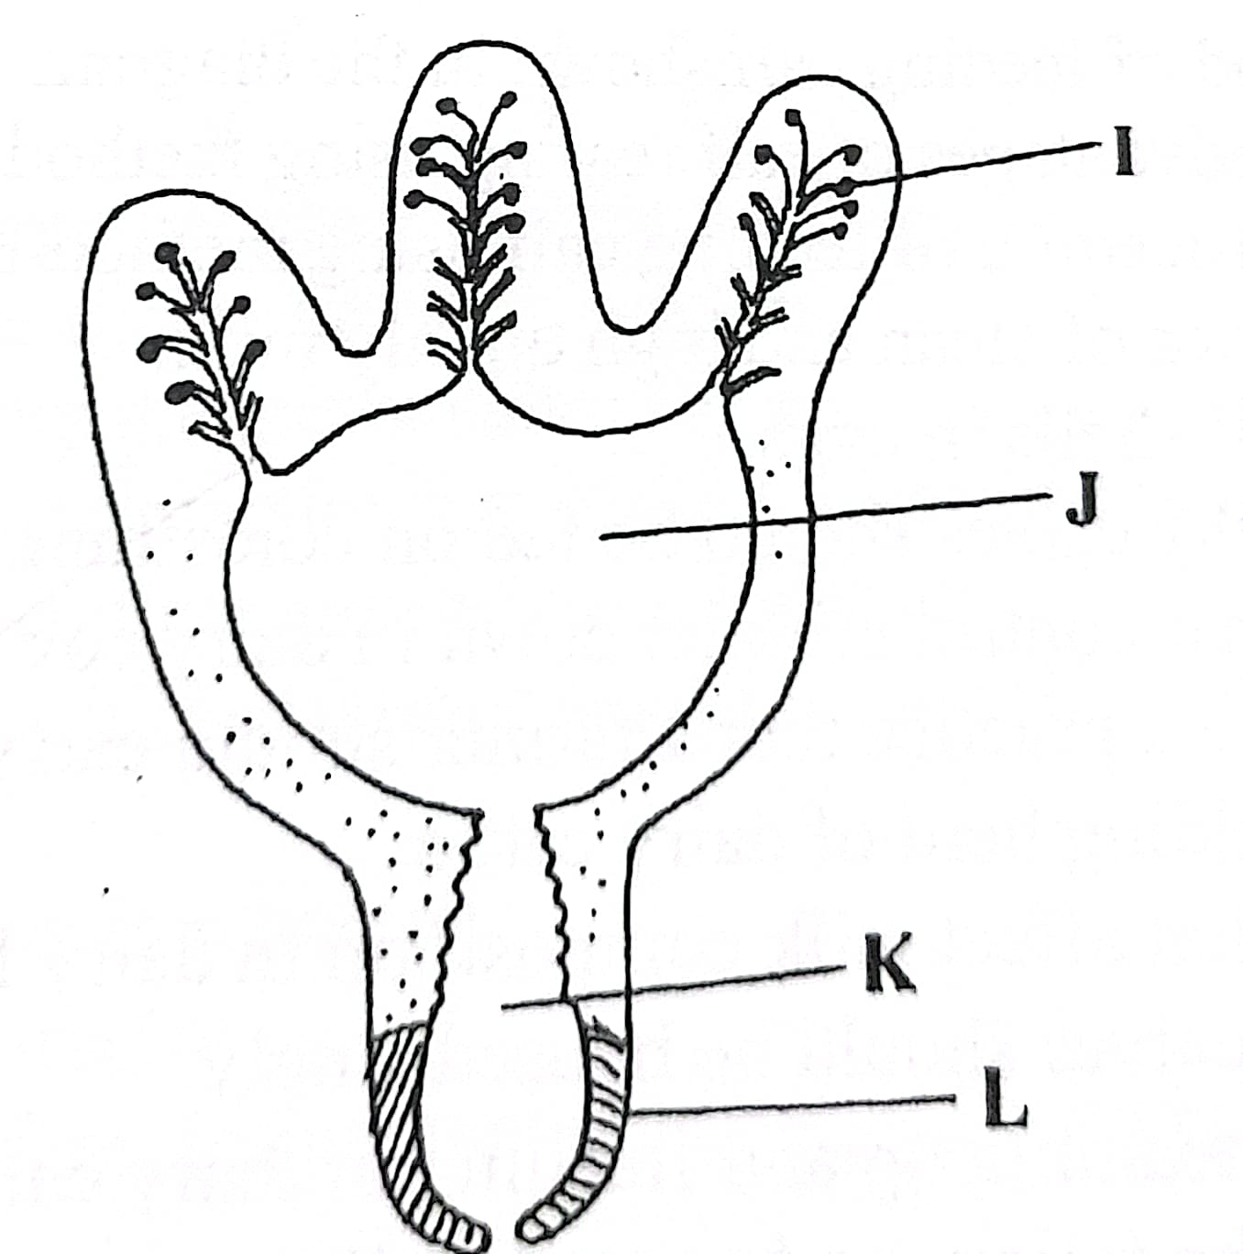

1. Label the parts **I, J, K** and **L**. (2mks)

**I**…………………………………………………………………………………………………………………………………

**J**…………………………………………………………………………………………………………………………………

**K**…………………………………………………………………………………………………………………………………

**L**…………………………………………………………………………………………………………………………………

1. What is milk letdown. (1mk)

……………………………………………………………………………………………………………………………………………………………………………………………………………………………………………………………………..…………………………………………………………………………………………………………………………………..

1. Name two hormones responsible for milk letdown. (2mks)

………………………………………………………………………………………………………………………………..……………………………………………………………………………………………………………………………………..

1. Below is a diagram of a farm equipment. 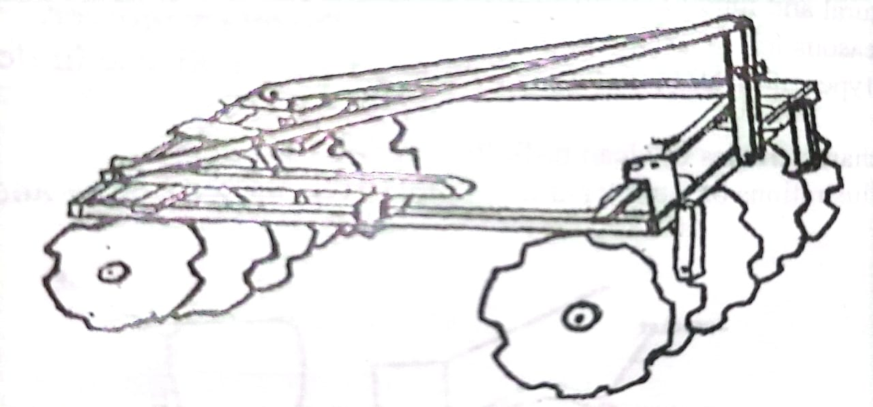
2. Identify the equipment. (1mk)

……………………………………………………………………………………………………………………………........

1. State **one** function of the toothed notches. (1mk)

…………………………………………………………………………………………………………………………………..

1. State **one** way of increasing the depth of penetration of the equipment. (1mk)

…………………………………………………………………………………………………………………………………..

1. State **Three** maintenance practices carried out on the equipment shown above.

(2mks)

………………………………………………………………………………………………………………………………..……………………………………………………………………………………………………………………………………..

………………………………………………………………………………………………………………………………..……………………………………………………………………………………………………………………………………..

**SECTION C (40 MARKS)**

***Answer any two questions from this section in the spaces provided.***

1. (a) Describe milk fever diseases under the following sub headings
2. Animal affected (1mk)

………………………………………………………………………………………………………

1. Causes of the diseases (1mk)

………………………………………………………………………………………………………

1. Symptoms of the diseases (5mks)

………………………………………………………………………………………………………

………………………………………………………………………………………………………

………………………………………………………………………………………………………

………………………………………………………………………………………………………

………………………………………………………………………………………………………

………………………………………………………………………………………………………

1. Control and treatment (3mks)

………………………………………………………………………………………………………

………………………………………………………………………………………………………

………………………………………………………………………………………………………

………………………………………………………………………………………………………

(b) Outline **five** features of an ideal calf pen. (5mks)

………………………………………………………………………………………………………

………………………………………………………………………………………………………

………………………………………………………………………………………………………

………………………………………………………………………………………………………

………………………………………………………………………………………………………

(c) State **five** care and maintenance practices of a tractor battery. (5mks)

………………………………………………………………………………………………………

………………………………………………………………………………………………………

………………………………………………………………………………………………………

………………………………………………………………………………………………………

………………………………………………………………………………………………………

1. (a) State and explain **five** preservative measures of livestock diseases. (10mks)

………………………………………………………………………………………………………

………………………………………………………………………………………………………

………………………………………………………………………………………………………

………………………………………………………………………………………………………

………………………………………………………………………………………………………

………………………………………………………………………………………………………

………………………………………………………………………………………………………

………………………………………………………………………………………………………

………………………………………………………………………………………………………

………………………………………………………………………………………………………

………………………………………………………………………………………………………

(b) Outline **six** factors considered when choosing poultry system. (6mks)

………………………………………………………………………………………………………

………………………………………………………………………………………………………

………………………………………………………………………………………………………

………………………………………………………………………………………………………

………………………………………………………………………………………………………

………………………………………………………………………………………………………

………………………………………………………………………………………………………

………………………………………………………………………………………………………

(c) Name **four** parts of a piggery (pigsty) unit and give the function of each part. (4mks)

………………………………………………………………………………………………………

………………………………………………………………………………………………………

………………………………………………………………………………………………………

………………………………………………………………………………………………………

1. (a) Describe the procedure of training a calf to take milk from a bucket. (5mks)

………………………………………………………………………………………………………

………………………………………………………………………………………………………

………………………………………………………………………………………………………

………………………………………………………………………………………………………

………………………………………………………………………………………………………

………………………………………………………………………………………………………

(b) State **eight** advantages of battery cage system. (8mks)

……………………………………………………………………………………………………

………………………………………………………………………………………………………

………………………………………………………………………………………………………

………………………………………………………………………………………………………

………………………………………………………………………………………………………

………………………………………………………………………………………………………

………………………………………………………………………………………………………

………………………………………………………………………………………………………

………………………………………………………………………………………………………

………………………………………………………………………………………………………

………………………………………………………………………………………………………

………………………………………………………………………………………………………

………………………………………………………………………………………………………

………………………………………………………………………………………………………

………………………………………………………………………………………………………

………………………………………………………………………………………………………

(c) Outline **seven** factors considered when selecting a heifer for breeding. (7mks)

…………………………………………………………………………………………………

………………………………………………………………………………………………………

………………………………………………………………………………………………………

………………………………………………………………………………………………………

………………………………………………………………………………………………………

………………………………………………………………………………………………………

………………………………………………………………………………………………………

………………………………………………………………………………………………………

………………………………………………………………………………………………………

………………………………………………………………………………………………………

………………………………………………………………………………………………………

………………………………………………………………………………………………………