**MOKASA 2 2024**

**AGRICULTURE PAPER 2(443/2) MARKING SCHEME.**

**SECTION A (30MARKS)**

***Answer all questions in the spaces provided***

1. Name **two** species of camels. (1mk)

Dromedary

Bactrian

1. State **four** general uses of solar energy. (2mks)

For drying farm produce

For heating water

For distillation of clean water

For cooking

For generating electricity

1. Name **four** tick borne diseases. (2mks)

* East coast fever
* Red water(Babesiosis)
* Anaplasmosis (Gall – sickness)
* Heart water

1. What is the use of a **strip cup**? (1/2mk)

It is used to check whether a cow has mastitis and any other abnormality in milk

1. Give **three** ways used to improve production in indigenous cattle. (11/2mk)

* Through breeding
* Proper feeding
* Proper control of parasites and diseases
* Provision of good housing

1. Name a breed of sheep with a lambing percentage of above 125% and whose fleece is inferior due to black fibers. (1/2mk)

* Hampshire Down

1. State **four** ways of controlling tsetse flies. (2mks)

* Bush clearing to destroy breeding grounds
* Spraying their breeding grounds with appropriate insecticides
* Use of fly traps with impregnated nets
* Use of sterilsing agents i.e Radio Isotopes to sterilize the males.

1. State **four** factors that are considered when formulating a livestock ration. (2mks)

* Nutrient requirement of the animal
* Age of the animal
* Type of animal whether ruminant or non – ruminant
* Availability of feedstuffs
* Cost of the foodstuffs

1. Differentiate between **mothering ability** and **prolificacy** in livestock breeding. (2mks)

Mothering ability refers to the natural instinct towards their young ones while prolificacy is the ability of an animal to give birth to many young ones. ( Mark as a whole)

1. State **two** reasons why it is necessary to place sugar syrup close to a beehive. (1mk)

* To supplement the feed during time of scarcity
* To prevent the bees from absconding
* To attract bees into a new hive
* To encourage multiplication
* To ease access to feed

1. Give **four** advantages of embryo transplant. (2mks)

* It stimulates milk production in a female that was not ready to produce milk
* A highly productive female can be spread over a large area to benefit farmers.
* It is easier to transport embryos in test – tubes than the whole animal
* Embryos can be stored for long periods awaiting availability of a recipient female.
* It is possible to implant embryo from a high quality female to less valuable female and hence improve performance of offspring.

1. Give the appropriate term that refers to each of the following.
2. Young one of a rabbit. (1/2mk)

Kindling

1. Mature male goat (1/2mk)

Buck/ Billy

1. A young female of a hen (1/2mk)

Pullet

1. (a) Give **two** advantages of concrete blocks over timber as building materials. (1mk)

* resistant to fire
* resistant to insect damage
* resistant to weather elements
* Cannot rot
* It is durable.

(b) State **three** disadvantages of using steel in construction of farm buildings. (11/2mk)

- It is expensive

- Steel is heavy hence difficult/expensive to transport

- Requires skill to install

- can be affected by weather elements or can rot.

1. State **four** causes of egg eating in a flock of layers. (2mk

* Presence of broken or soft – shelled eggs on the floor
* Too much or bright light in the nests allowing birds to see the eggs
* Idleness of birds
* Inadequate laying boxes forcing birds to lay eggs on the floor
* Insufficient supply of minerals such as calcium, making birds to look for minerals elsewhere.

1. State **four** disadvantages of fold system in poultry rearing. (2mks)

* Few birds Are kept per fold
* It is laborious in movement of folds from place to place.
* Record keeping for individual birds is difficult
* The fold is not long lasting.
* Cannot be used to raise large number of birds.
* Diseases can easily be spread amongst birds.

1. (a) Name **three** ways of caponization in poultry. (11/2mk)

* - injecting stilbestrol hormone
* -implanting pellets of female sex hormone just underneath the skin of the neck of the bird
* -through surgical method using the open method to remove testes.

(b) Give **four** characteristics of a good vaccine. (2mks)

- Immunity it produces should be as good as natural immunity

- should have long keeping life, shelf life should be long

- should be easy to administer

- should have no side effects when inoculated or vaccinated

- should be compatible with the other vaccines given to the animal

- A single dose should produce life long immunity.

1. State **four** reasons for carrying out egg candling. (2mks)

* Determine freshness of eggs
* Detect abnormalities in eggs
* Determine fertilized eggs
* To confirm chick development.

**SECTION B (20 MARKS)**

1. Diagrams F and G illustrates chicks suffering from some essential feed nutrients. Study the diagrams and answer the questions that follow.

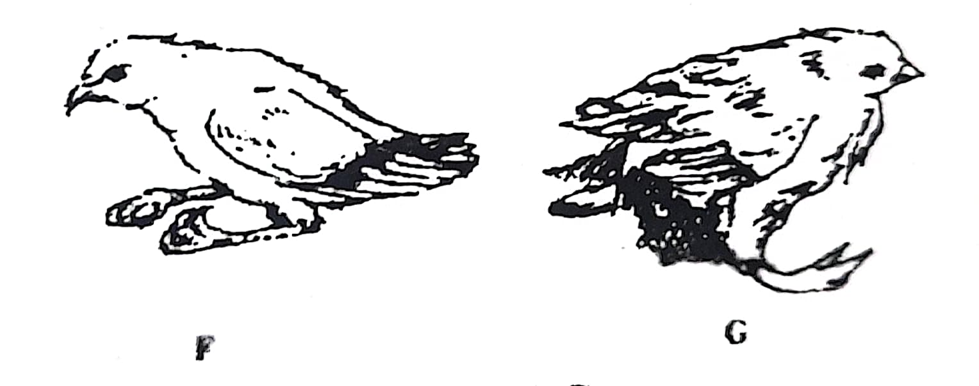

1. Name the deficient nutrient in **F** and **G**. (2mks)

***F. Vitamin B2***

***G. Vitamin D***

1. Outline one method in each case used to control the condition in **F** and **G**. (2mks)

**F.**

**- feeding the chicks with whole grains i.e legumes, maize grains e.t.c and their by-products**

-***Feed the chicks with meat meal/fish meal***

**G.**

**- *Giving bird green grass/vegetables***

***- subjecting the bird to sunlight.***

1. Below is an illustration of an internal parasite in livestock.

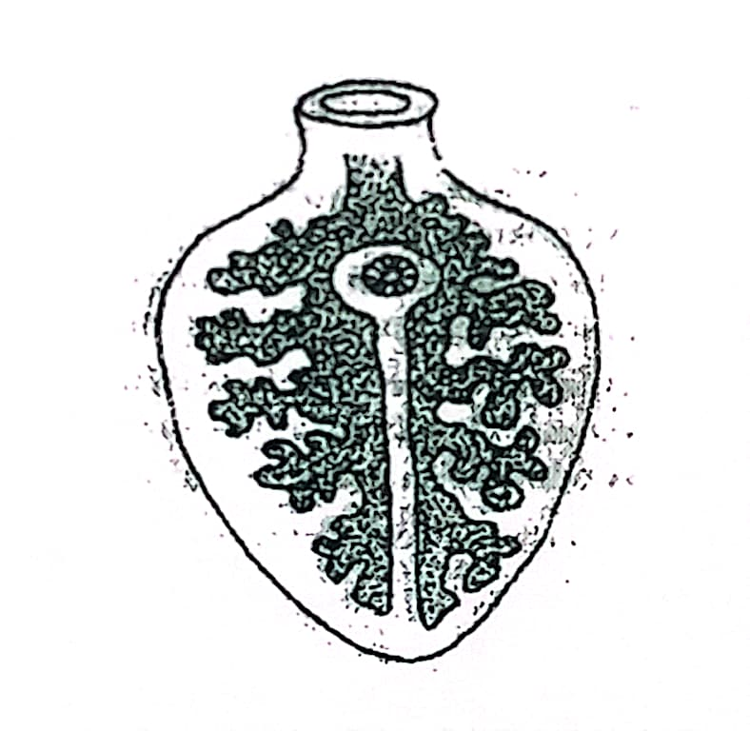

1. Identify the parasite. (1mk)

* ***Liver fluke***

1. Name **one** final host for the parasite. (1mk)

* ***Cattle, sheep and goat***

1. Name the intermediate host for the parasite. (1mk)

* ***Fresh water snail/ mud snail***

1. State ***two*** control measures of the parasite. (2mks)

* *Physically killing them*
* *Chemically by use of copper sulphate solution, sodium pentachloro-phenate, calcium cyanamide and n-tritylmarpholine which are added to stagnant water to kill the snails.*
* *Draining swampy areas or levelling any depressions that may hold water in the pastures.*
* *Burning of the infested pastures during the dry seasons*
* *Not grazing animals near marshy or waterlogged areas.*
* *Routine drenching of animals with anthelmintics such as sodium sulphate and hexachloroethane drugs/ routine deworming with appropriate antihelminthes.*

1. The diagram below shows a cross section of a cows’ udder.

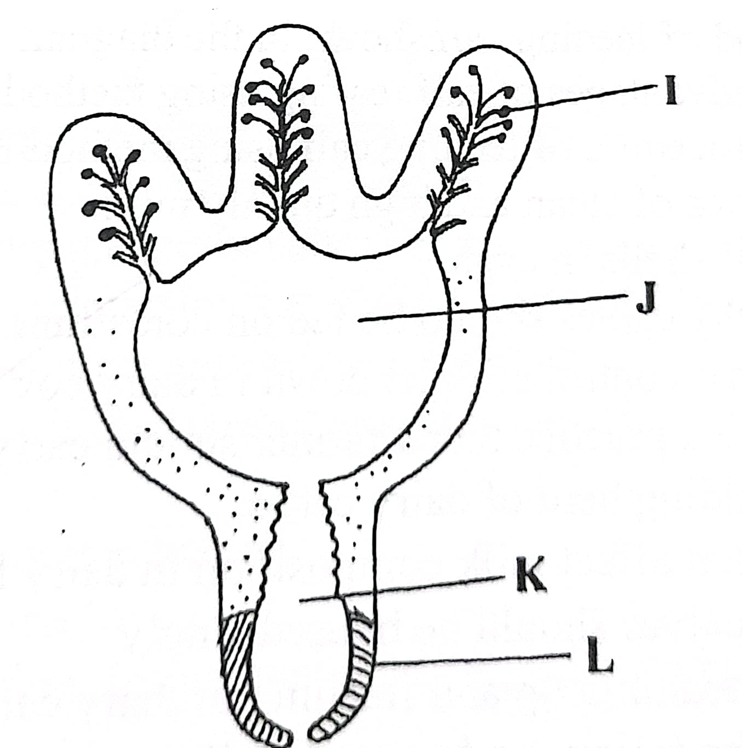

1. Label the parts I,J,K and L. (2mks)

***I.* *Alveolus***

***J. Gland cistern***

***K. Teat cistern***

***L. Teat***

1. What is milk letdown. (1mk)

* ***This is the flow of milk from the upper region of the udder to the gland and teat cistern and then out of the teat either by milking or sucking.***

1. Name two hormones responsible for milk letdown. (2mks)

* ***Oxytocin***
* ***Adrenaline***

1. Below is a diagram of a farm equipment.

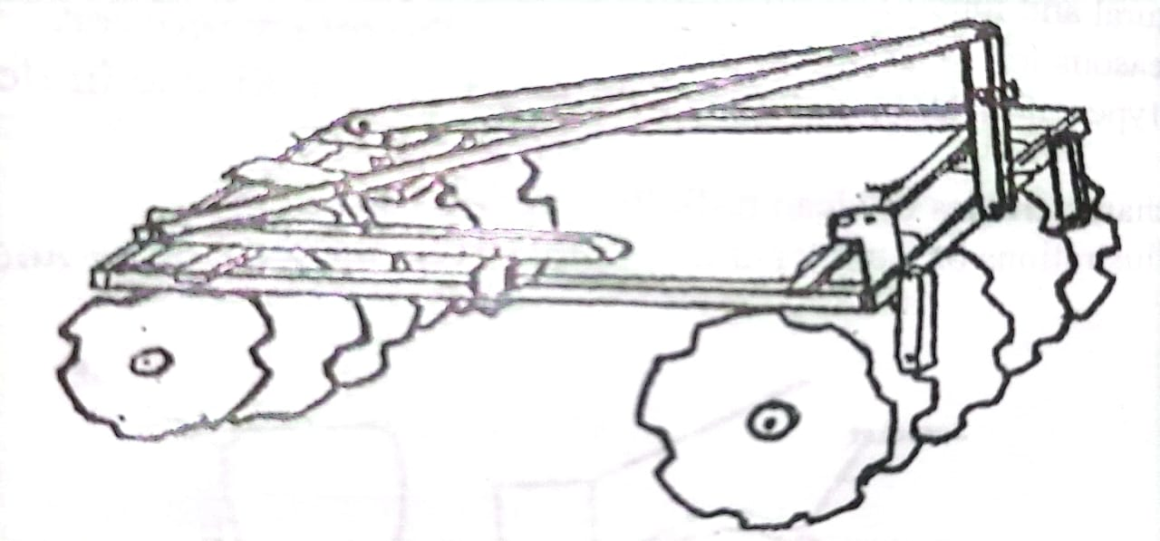

1. Identify the equipment. (1mk)

* ***Serrated disc harrow/ disc harrow***

1. State **one** function of the toothed notches. (1mk)

* ***Increase surface area for cutting***.

1. State **one** way of increasing the depth of penetration of the equipment. (2mk)

* ***Add weight on the harrow frame***
* ***Exert more hydraulic force***
* ***Sharpen the disc blades***
* ***Use fewer disc/ increase the distance between disc.***

1. State **Three** maintenance practices carried out on the equipment shown above.

(2mks)

* ***Tighten the loose bolts and nuts***
* ***Replace the worn out parts***
* ***Lubricate the moving parts***
* ***Paint/apply oil in case of long storage.***
* ***Clean after use.***

**SECTION C (40 MARKS)**

22(a) **Causes**

1. Low level of calcium in blood (1mk)
2. Animal Affected (1mk)

* High lactating cows
* Dairy goats
* Pigs

(ii) **Symptoms**

* Dullness
* Muscular twitching causing the animal to tumbles.
* Staggering as the animal moves.
* Animal falls down and becomes unconscious.
* Animal lies down on its side and whole body stiffens.
* Body function like urination, defecation and milk selection stops
* Sudden death if the animal is not treated immediately.
* Stomach content drawn into the mouth which later causes lung fever.
* Complete loss of appetite, i.e animal does not feed at all.

(iii) **Controls**

* Animal is given intraverious injection of soluble calcium salt in form of calcium lrogluconate 60gms
* Sick animal be made to rest at on its sternum( comfortable position)
* Do partial milking for the first ten days for cows with past cases.
* Provide high yielding animal with phosphorus and calcium and high dose of vitamin D and parathyroid extractions.

(b) Features of an ideal calf pen

- Cleanliness- should be easy to clean

- Dryness and warmth

- Have adequate space

- Should properly lit

- Should be well drained

- should be draught free

- Should be properly ventilated

- Should be single housing.

(1 x 5 = 5mrks)

(c ) Care and maintenance practices of a tractor battery.

* Level of electrolyte should be kept above the plate by topping with dilute distilled water
* Corroded terminals be scrapped clean and smeared with grease
* Battery should be tightly fixed in a box to avoid spillage and damage.
* Battery should be fitted correctly on the tractor
* The battery should be charged regularly and periodically.
* In case of long storage the battery contents should be emptied and battery kept upside down
* The generator fan belt should always be functional to ensure the battery is always charged.

( 1 x 5 = 5Mrks)

1. (a) **Preventive measures of livestock diseases**

* Isolation of sick animal
* Imposition of quarantine
* Use of prophylactic measures and treatment such

1. Use of prophylactic drugs, regular vaccination, control of vector and treatment of sick animals.

* Slaughtering the affected animals.
* Use of antiseptics and disinfectants.

(b) **Factors considered when choosing poultry rearing system.**

* Availability of land for rearing
* Topography of land
* Availability of labour
* Availability of appropriate equipment
* Availability of capital Security
* Availability of market
* Knowledge of the famer.

(C) **Parts of piggery and functions.**

* Feed store for storing pig feed
* Record room for keeping records
* Pig pens for keeping pigs according to ages.
* Farrowing pens for farrowing and rearing piglets
* Gilt pens – rearing young females up 12 months.
* Boar pen for housing the breeding boar
* In pig pens for pregnant pigs waiting farrowing.
* Wearier/fatteners pens – house piglets after wearing up to the age of 6 months

24(a) **Procedure of training a calf to take milk from the bucket**

* Put clean milk in a clean bucket
* Place index finger into the calf’s mouth and it starts sucking.
* Lower the finger slowly until it is submerged in milk as the calf sacks this allows the calf to drink milk.
* Slowly withdraw the finger while the calf is sucking.
* Repeat step(i) to (iv) until the calf learns how to drink milk from a bucket

(b) **Eight advantages of battery cage system.**

* Higher egg production
* Accurate egg records can be kept.
* Cannibalism and egg eating are controlled.
* Eggs are clean
* The system can easily be mechanized Birds do not contained food and water.
* Handling is easy as hens are restricted to a small place.
* Broodiness is discouraged as the birds do not reach eggs.
* Large number of birds can be kept in a small space.
* Easy to detect sick birds and isolate for treatment
* Wire floors prevent reinfection of parasitic worms and coccidian
* There is no bullying during feeding
* There is low labour requirements

(c) **Factors considered when selecting a heifer for breeding.**

* Level of performance of the parents
* Physical fitness
* Health
* Body conformation
* Temperature/ behavior
* Quality of products
* Adaptability
* Mothering ability
* Prolificacy