MANGU HIGH SCHOOL JUNE/JULY MOCK 2023
121/2
MATHS
PAPER 2

MARKING SCHEME .

1. | (x- y) ( x+y)  ( 3282 – 3272) ( 3282 + 3272)  65540 | M1  M1  A1
 |  | 3
2. | Tan x = is positive 3rd quadrant  Then sin x = ⁻3  5  Hypotense  3  h  4  h = √ 4² + 3² = √ 25 = 5  Sin x = ⁻3  5  Cos x – sin x = ⁻4 - ⁻3 = ⁻3  5 5 5  = -1  5 | B1  M1  A1 | Identification the hypotenuse  Cao  accept (-0.2)
 |  | 3
3. | 1⁶ + 6(- ½ x ) + 15(- ½ x )² + 20(- ½ x )³  = 1 – 3x + 15x² - 5 x³  4  X = -0.04  1-3 ( -0.04) + 15 (-0.04)² 5 ( -0.04) ³  4 4  = 1 + 0.12 + 0.006 + 0.0006¹⁶  = 1.12616  = 1.1262 | M1  M1  M1  A1 | For simplification  For substitution of x
 |  | 4
4. | a + ar³ = 140  2  64 + 64 r³ = 140  2  64 + 64 r³ = 280 64 r³ = 280 – 64  64 r³ = 216 r = √216  64  r = 3  2 | M1  M1  A1
 |  | 3

5. | a² = b²d²  b² –d  a²b² - a²d = b²d²  a²b² - b²d² = a²d  b²(a² - d²) = a²d  b² = a² d  a² - d²  = a² d  a² d² | M1  M1  A1 | sq on both sides  CAO
 |  | 3
6 | P = aQ + √ Q  P = 16a + 4b  ( 500 = 16a + 4b)  (800 = 25a + 5b)  2500 = 80a + 20b  3200 = 100a + 20b  -700 = -20a  35 = a  Then b = -15  Equation connecting P and Q  p = 35Q – 15 √Q | M1  M1  M1  A1 | For equation  For formation of simultaneous equations  For values of both a and b
 |  | 4
7. |  | M1  A1
 |  | 2
8 | 4.562 x 0.38 = 1.73356  ⁴ √1.73356 = 1.14745 ÷0.82  = 1.3993  = 1.4 | M1  M1  A1
 |  | 3
9. | 18 x 64 x 5  24 x 80  6 x 64  8x 16  3 days | M1  M1  A1 | For simplification
 |  | 3
10. | True value = √1 + n = 1.44 = 1.2  Approx. value  1 + n = 1 + 44 = 1.22  2 2  = 1.22 – 1.2  = 0.02  - x 100 =  1.2  = 1.67 % | M1  M1  A1
 |  | 3
11. | 3 0 a b = 3 + a b  0 4 0 c 0 4 + c  3a + 0 = 3 + a  3b + 0 = b  3a = 3 + a a = 3  2  3b + 0 = b  2b = 0  B = 0  0 + 4c = 4 + c  3c = 4  C= 4  3 | M1  M1  A1 | For matrix equation  For forming of simultaneous equation  For values of a, b and c ( correct)
12. | 2x² – 2x + x -1  ( x + 1 ( x – 1)  2x ( x – 1 ) + 1 ( x- 1)  ( x + 1 ) (n- 1 )  = ( 2x + 1)  ( x + 1 )  = 2x + 1  x + 1 | M1  M1  A1
 |  | 3
13 | - cm = 25000cm  - 1cm = 250m  - 1cm = 0.25  1cm² = 0.0625  20cm² = 20 x 0.0625  = 1.25/ cm² | M1  M1  A1
 |  | 3
14. | AB . BC = DC ⁻²  5: BC = 36  BC = 36  5  = 7.2 cm | M1  M1  A1
 |  | 3
15. | Log₁₀⁸ + Log₁₀⁷⁵⁰ - Log₁₀⁶  Log₁₀ Log₁₀ ( 8 x 750)  6  = Log₁₀¹⁰⁰⁰  = 3 | M1  M1  A1
 |  | 3
16. | P (R )= ½ x 4  12  P (R )= ½ x 3  18  = 1 + 3  - 20  = 20 + 18  120  = 38 19  - = 60 | M1  M1  M1  A1
 |  | 4

17 | Taxable income 115 x 8570 = 9855.50  100  9855.50x 12 p.a  20  5913.30  Tax  1 – 1500 150  1501 – 3000 225  3001 – 4500 375  4501 – 5913.30 494.30  1244.30 -  90.00  K £ 1154.30 pa . or  Ksh 1923.83 per month  Total Decuctions  2 x 9855.5  100  197.11 ( wcps)  +  20.00  246.00  +  Tax per month 1923.83  2386.94  Net salary  9855.50 – 2386.94  Ksh 7468.65 | M1  A1  M1  M1  M1  A1  M1  A1  M1  A1
 |  | 10
18. | i) θ ( 2πR cos θ)  360  = 60 x 2 x 22 x 6370 cos 60  360 7  = 1/3 x 22 x 910 x 0.5  = 3336 7  ii) Time ( 4 x 60) hrs  60  4 hrs.  Local time 1200 + 4  = 1600hrs  b) θ x 2πR = 800  360  = θ x 2 x πx 6370 = 800  360  - = 800 x 360  2 x π x 6370  = 7.196°  ∠ (60 – 7.196) = 52.80°  ( 52.8° N 45°E) | M1  A1  B1  M1  M1  A1  B1
19 |  | 10
 |  | 10

20. | 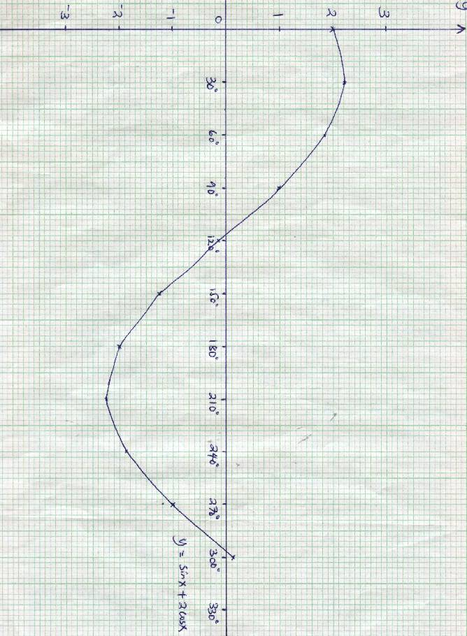  c) x = 114 ± 3° and  x = 294 ± 3°  line thro y = -1.5  d) | B2  S1  P1  C1  B2  L1  B2 | For all 6 values of y  B1 for at least 4  Appropriate scale use  plotting  curve  Points identified and stated  B1 only stated  line  Points identified and stated  B1 only stated
  X | 30 | 60 | 120 | 180 | 240 | 270
  Sin x | 0.5 | 0.87 | 0.87 | 0 | -0.87 | -1.0
  2 cos x | 1.73 | 1.0 | -1.0 | -2 | -1.0 | 0
  Y | 2.23 | 1.87 | -0.13 | -2 | -1.87 | -1.0
 |  | 10
21 | R  ²/₁₁  ⁵/₁₁ W  ⁴/₁₁ B  R  R ³/₁₁  ³/₁₂ ⁴/₁₁ W  ⁵/₁₂ w  ^{4/}₁₁ B  ⁴/₁₂ B  R  ³/₁₁  ⁵/₁₁ W  ³/₁₁ B | B2 | prob, tree

 | a) P ( RR) = ³/₁₂ x ²/₁₁  ¹/₂₂  b) P(IR) = RW or RB or WR or BR  ¹⁵/₁₃₂ + ¹²/₁₃₂ + ¹⁵/₁₃₂ + ¹²/₁₃₂  ⁹/₂₂  - p( At least white Ball ) =  P(RW) + P(WR) + P(WW) + P ( WB) + P(B)  ¹⁵/₁₃₂ + ⁹/₁₃₂ + ²⁰/₁₃₂ + ²⁰/₁₃₂ + ²⁰/₁₃₂  = ⁸⁴/₁₃₂ or ⁷/₁₁  - P(RR or WW or BB)  = ⁶/ ₁₃₂ + ²⁰/₁₃₂ + ¹²/₁₃₂  = ¹⁹_{/66} | M1  A1  M1  A1  M1  A1  M1  A1 | Or equivalent 0.04545  Or equivalent 0.4091  Or equivalent 0.6364  Or equivalent 0.2424

22 | 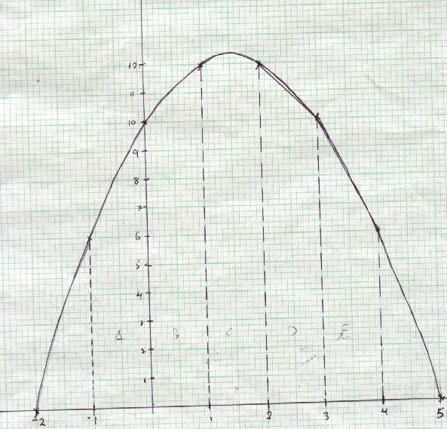  ½ ( 6 + 10 ) + ½ ( 12 + 12) + ½ ( 12 + 10 ) + ½ ( 10 + 6)  = 8 + 11 + 12 + 11 + 8 = 50cm²  u  ⁻x² + 3x + 10 = ⁻ 64 + 24 + 10 - ¹/₃ + ³/₂x –10 = 51¹/₅cm  3  = -1  = % error 51¹/₂ – 50  = 1 ½ x 100 = 2 %  51¹/₂ | B2  S1  P1  C1  M1  A1  M1  M1  M1  A1 | 8 values  B1 at least 6  Appropriate scale use  plotting  curve
  X | -2 | -1 | 0 | 1 | 2 | 3 | 4 | 5
  Y | 0 | 6 | 10 | 12 | 12 | 10 | 6 | 0
 |  | 10

23. | a) i) AC² = 8² + 6² = 100  AC = 10cm  ii) AF² = 10² + 5² = 125  AF = 11.18cm  b) Tan x = ⁵/₁₁ = 0.5  x = 26.52°  - Tan x = ⁵/₆ = 0.8333  x = 39.7° | M1  A1  M1  A1  B1  M1  A1  B1  M1  A1 | Sketch  Sketch
 |  | 10

24 | 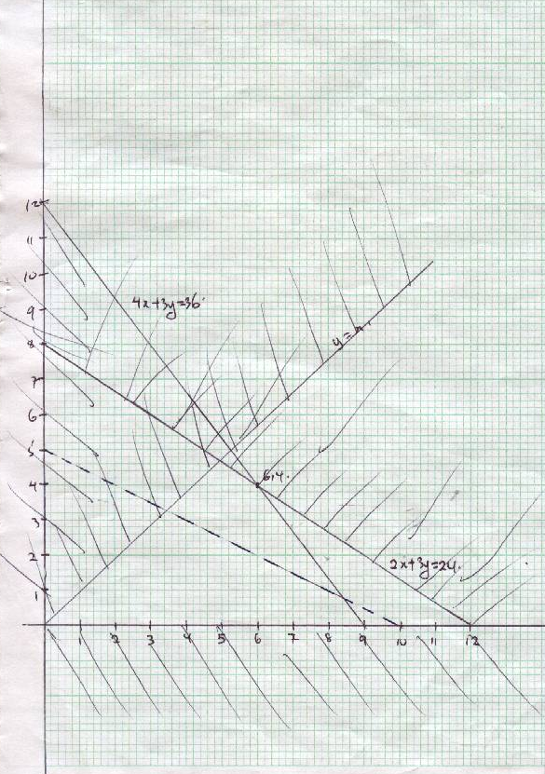 | Inequalities  x ≥O  y ≤O  4x + 3y ≤ 36  4x + 3y = 24  y = n  For shading of x ≥o and y≥ o  2x + 3y ≤ 36  y ≤ n  P profit function object we function P = 4x + 3y  Max profit at point (6,4)  P = 4(6) + 4,88)(4)  = 56  Hence he should here 6 medium of type A and 4 machine of type B | B1  B1  B1  B1  B1  shading  and line  B1  shading  and line  drawn  B1-for  shading  and line  drawn  B1  B1  B1
 |  |  | 10

