NAME……………..…………………………… ADM NO……........……. CLASS ……………….

232/2 
PHYSICS
(THEORY)
PAPER 2
JULY/AUGUST 2023
TIME: 2 HOURS

LANJET CLUSTER JOINT EVALUATION – 2023

Kenya Certificate of Secondary Education
PHYSICS
PAPER 2
(THEORY)
TIME: 2 HOURS

INSTRUCTIONS TO CANDIDATES:
(a) Write your Name and Index Number in the spaces provided above.
(b) Sign and write the date of examination in the spaces provided above.
(c) This paper consists of two Sections; A and B.
(d) Answer ALL the questions in sections A and B in the spaces provided.
(e) All workings must be clearly shown.
(f) Non-programmable silent electronic calculators and KNEC Mathematical tables may be used.
FOR EXAMINER’S USE ONLY:
Section | Question | Maximum  Score | Candidate’s  Score
A | 1 – 13 | 25
 | 14 | 10
 | 15 | 13
B | 16 | 12
 | 17 | 8
 | 18 | 12
Total Score |  | 80

SECTION A: (25 MARKS)

Answer all questions in this section in the spaces provided:

1. State two conditions under which a pinhole camera may form an image on its screen which has the same size as the object. (2mks)

____________________________________________________________________________________________________________________________________________________________________________________________________________________________________________________________________________________________________________________________________

2. The figure shows a ray of light incident along the normal. The mirror is rotated at an angle of 15º in a clockwise direction without changing the position of the incident ray,
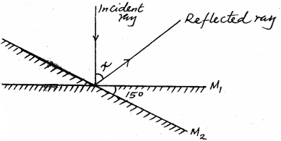

Determine the angle between the reflection ray and the incident ray. (2mks)

3. A steel is to be magnetized by electrical method as shown below. Identify the pole P and Q of the resulting magnet. (1mk)
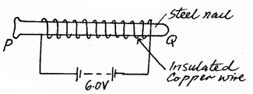

P: _________________________________________________________________________

Q: _________________________________________________________________________

4. A small chain is often seen hanging at the back of a petrol carrying lorry. State and explain its significance. (2mks)

_________________________________________________________________________________
_________________________________________________________________________________________________________________________________________________________________________________________________________________________________________________

5. The figure below shows two waveforms representing the same wave motion.
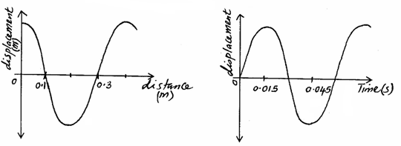

Determine the velocity of the wave. (3mks)

6. An object O is placed in front of a concave mirror and on the principal axis, as shown in the figure below. Complete the light ray diagram to locate the position of the image. (3mks)

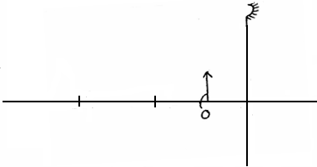
C
F

7. Arrange the following radiations in order of increasing wavelengths. (1mk)
Infrared, blue light, ultraviolet, radiowaves, χ-rays.

_________________________________________________________________________________
8. The figure below shows a block diagram of a p-n junction diode.

p

n

On the same diagram, show how a cell may be connected so that it is reverse biased. (1mk)

9. A girl standing at a distance claps her hands and hears an echo from a tall building 2 seconds later.
If the speed of sound in air is 340m/s, determine how far the building is. (3mks)

10. What do you understand by polarization as used in a simple cell? (1mk)

___________________________________________________________________________________________________________________________________________________________________________________________________________________________________________________

11. State how the defect mentioned in question 10 above is minimized in a simple cell. (1mk)

___________________________________________________________________________________________________________________________________________________________________________________________________________________________________________________

12. A current-carrying conductor AB is in a magnetic field as shown in the figure below.

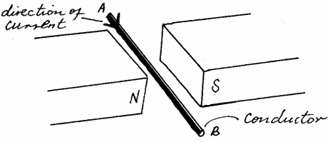

(a) Indicate the direction of force F acting on the conductor. (1mk)

(b) State two factors that determine the direction of the force F. (2mks)

___________________________________________________________________________________________________________________________________________________________________________________________________________________________________________________

13. You are given three resistors of values 5Ω, 8Ω and 12Ω. Show in a circuit diagram how you would connect them so as to give:
(a) An effective resistance of 9.8Ω. (2mks)

(b) The least effective resistance. (1mk)

SECTION B: (55 MARKS)

Answer question in this section in the spaces provided.

14. (a) Define refractive index. (1mk)

_________________________________________________________________________________________________________________________________________________________________________________________________________________________________________________

(b) The critical angle of a certain material medium is 43.2º. Determine the refractive index of the material. (2mks)

(c) (i) What do you understand by the term accommodation? (1mk)

______________________________________________________________________________________________________________________________________________________

- The diagram below shows a certain defect of vision. Name the defect. (1mk)

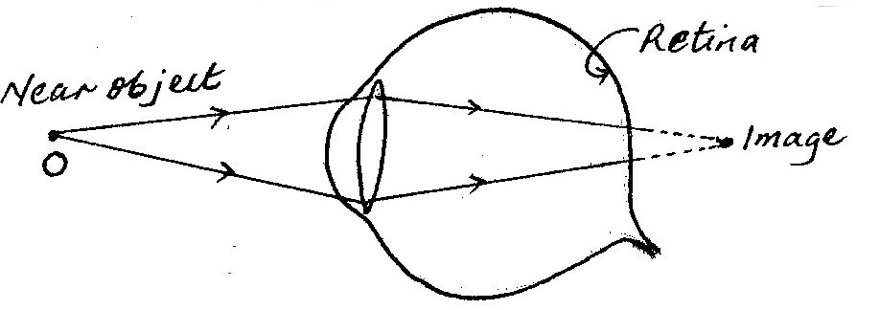

______________________________________________________________________

(iii) On the figure below show how the defect can be corrected. (2mks)
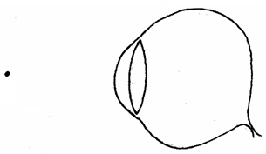

(d) An object is placed 40cm in front of a concave lens of focal length 20cm; determine the position of the image. (3mks)

15. (a) (i) State Lenz’s a law of electromagnetic induction. (1mk)

___________________________________________________________________________________________________________________________________________________________________________________________________________________________________________________

- A bar magnet is moved into a coil of insulated copper wire connected to a centre-zero galvanometer, as shown in the figure below.

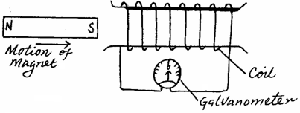

- Show on the diagram the direction of induced current in the coil. (1mk)

- State and explain clearly what is observed on the galvanometer when the S-pole of the magnet is moved into and then withdrawn from the coil. (4mks)

____________________________________________________________________________________________________________________________________________________________________________________________________________________________________________________________________

(b) A transformer has 800 turns in the primary and 40 turns in the secondary winding.
The alternating e.m.f connected to the primary is 240V and the current is 0.5A.
- Determine
I. The secondary e.m.f (2mks)

II. The power in the secondary if the transformer is 95% efficient. (2mks)

- Explain how energy losses in a transformer are reduced by having:
I. A soft-iron core. (2mks)

_________________________________________________________________________________________________________________________________________________________________________________________________________________________________

II. A laminated core. (1mk)
______________________________________________________________________________________________________________________________________________________________________________

16. (a) (i) Distinguish between thermionic emission and photoelectric emission. (2mks)

_____________________________________________________________________________________________________________________________________________________________________________________________________________________________________________________________________

(ii) State one factor which affects the rate of each of the above types of emission.
Thermionic emission. (1mk)

_______________________________________________________________________________________

Photoelectric emission. (1mk)

_______________________________________________________________________________________
(b) Sodium has a work function of 2.3eV. Given that: Planck’s constant h = 6.63 × 10
⁻³⁴JS, velocity of light in vacuum, C = 3.0 × 10⁸m/s, 1 electron-volt (1eV) = 1.6 × 10⁻¹⁹ C and mass of an electron, m_{e} = 9.1 × 10⁻³¹kg, calculate:
(i) Its threshold frequency. (2mks)

(ii) the maximum velocity of the photoelectrons produced when the sodium is illuminated by light of wavelength 5.0 × 10⁻⁷m. (4mks)

(iii) The stopping potential V, with the light of this wavelength. (2mks)

17. (a) State two advantages of using a Cathode Ray Oscilloscope (C.R.O) as a voltmeter over the ordinary voltmeter. (2mks)

_____________________________________________________________________________________________________________________________________________________________________________________________________________________________________________________________________

(b) An X-ray operates at 30000V and the current through it is 2mA. Given that the charge of an electron is 1.6 × 10⁻¹⁹C, h = 6.63 × 10⁻³⁴JS, speed of light, C = 3.0 × 10⁸m/s,
Calculate:-
(i) The maximum kinetic energy of the electrons when hitting the target.(2mks)

(ii) The number of electrons hitting the target per second. (2mks)

(iii) The minimum wavelength of the X-rays emitted. (2mks)

18. (a) A radioactive carbon-14 decays to nitrogen by beta particles as shown below.
Determine the values of χ and y. (2mks)

(b) The graph below shows the activity (disintegrations per minute) of a sample of
carbon-14 against the time in years.



(i) From the graph determine the half-life of carbon-14. (2mks)

(ii) A mass of 100g of carbon-14 decays and the mass taken after 15000 years.
Determine the mass that remains. (3mks)

- The figure below shows the cross-section of a diffusion cloud chamber used to detect radiation from radioactive sources.
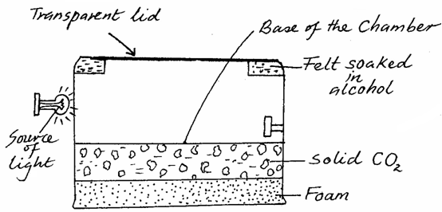

- State the function of the following:
- Alcohol. (1mk)

______________________________________________________________________________________________________________________________________________________________________________

II. Solid CO₂. (1mk)
______________________________________________________________________________________________________________________________________________________________________________

(ii) Explain briefly how the diffusion cloud chamber can be used to detect and identify alpha particles. (3mks)
_____________________________________________________________________________________________________________________________________________________________________________________________________________________________________________________________________

