NAME …………………………..……………….. DATE:…………………………

ADM NO ……….……….…………………...…..… CLASS ……………..…………..

233/1
CHEMISTRY
THEORY
PAPER 1
TIME: 2 HOURS.

LANET JOINT EVALUATION (LANJET 2023)

FORM 4
Kenya Certificate of Secondary Education

- Instruction to candidates

- Write your name and index number in the spaces provided above.
- Sign and write the date of examination in the spaces provided above.
- Answer all the questions in the spaces provided in the question paper.
- KNEC mathematical tables and silent non- programmable electronic calculators may be used.
- All working must be clearly shown where necessary.
- This paper consists of 13 printed pages.
- Candidates should check the question paper to ascertain that all the pages are printed as indicated and that no questions are missing.
- Candidates should answer the questions in English.

1 | 2 | 3 | 4 | 5 | 6 | 7 | 8 | 9 | 10 | 11 | 12 | 13 | 14 | 15 | 16 | 17
For Examiner’s Use Only

18 | 19 | 20 | 21 | 22 | 23 | 24 | 25 | 26 | 27 | 28

Grand
Total

- (a) Complete the Table 1 below by naming the structure of the oxides of the elements.
Element | Aluminium | Silicon | Sulphur | Chlorine
Structure of the oxide
(1 mark)
(b) One of the element forms an amphoteric oxide. Give the formula of the oxide. (1 mark)
…………………………………………………………………………………………………………………………………………………
…………………………………………………………………………………………………………………………………………………
…………………………………………………………………………………………………………………………………………………
(c) When excess sodium hydroxide is reacted with the oxide named above, a colourless complex ion is formed below.

[Al (OH)₄]^{X}
Explain how the value of X can be determined. (1 mark)
…………………………………………………………………………………………………………………………………………………
…………………………………………………………………………………………………………………………………………………
…………………………………………………………………………………………………………………………………………………
- The formulas in Figure 1 below represent active ingredients of two cleansing agents A and B.
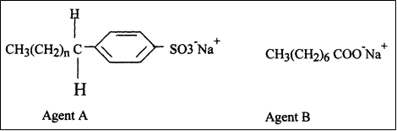
Which one of the cleansing agents would be suitable to be used in water containing magnesium hydrogen carbonate. Explain your answer. (2 marks)
…………………………………………………………………………………………………………………………………………………
…………………………………………………………………………………………………………………………………………………
…………………………………………………………………………………………………………………………………………………
…………………………………………………………………………………………………………………………………………………

- An ion of element H has the formula:
$${}_{15}^{31} H^{3-}$$

- Give one use of the element in relation to organic chemistry. (1 mark)
…………………………………………………………………………………………………………………………………………………
…………………………………………………………………………………………………………………………………………………
- Using cross (x) and dots (.), draw the ion formation structure. (2 marks)
…………………………………………………………………………………………………………………………………………………
…………………………………………………………………………………………………………………………………………………
…………………………………………………………………………………………………………………………………………………
…………………………………………………………………………………………………………………………………………………
- (a) Draw a well labelled set-up for the electrolysis of barium bromide. (2 marks)
…………………………………………………………………………………………………………………………………………………
…………………………………………………………………………………………………………………………………………………
…………………………………………………………………………………………………………………………………………………
…………………………………………………………………………………………………………………………………………………
…………………………………………………………………………………………………………………………………………………
(b) During an experiment of electrolysis of barium (ii) bromide, one of the electrode was not dipped in the electrolyte. Explain why the bulb did not light. (1 mark)
…………………………………………………………………………………………………………………………………………………
…………………………………………………………………………………………………………………………………………………
- Using chemical equations, show how bleaching action of sulphur (iv) oxide differ from the bleaching action of chlorine. (3 marks)
…………………………………………………………………………………………………………………………………………………
…………………………………………………………………………………………………………………………………………………
…………………………………………………………………………………………………………………………………………………
…………………………………………………………………………………………………………………………………………………
…………………………………………………………………………………………………………………………………………………

- Study the Table 2 below and answer the questions that follows.
Mineral acids | Relative formula mass | Boiling points
HCl | 36.5 | 35.0
HNO₃ | 83 | 83.0
H₂SO₄ | 98 | 333.0

- Which of the following mineral acid is less volatile. (1 mark)
…………………………………………………………………………………………………………………………………………………
- Using chemical equations, explain how concentrated sulphuric (VI) acid displaces the more volatile mineral acids. (2 marks)
…………………………………………………………………………………………………………………………………………………
…………………………………………………………………………………………………………………………………………………
…………………………………………………………………………………………………………………………………………………
- (a) Hydroxide ions are responsible alkalinity in a substance. An increase in the number of hydroxide ions influences two properties evident in a strong alkali.
State the two properties. (1 mark)
…………………………………………………………………………………………………………………………………………………
…………………………………………………………………………………………………………………………………………………
(b) In an experiment, soap solution was added to two samples of water. The results below in Table 3 show the volume of soap solution required to lather with 500 cm³ of each water sample before and after boiling.
samples | 1 | 2
Volume of soap used before water boiled | 26.0 | 14.0
Volume of soap after water boiled | 26.0 | 4.o

- Which water sample is likely to have permanent hardness? (1 mark)
…………………………………………………………………………………………………………………………………………………
…………………………………………………………………………………………………………………………………………………
- Explain the change in volume of soap solution used in sample 2.
(1 mark)
…………………………………………………………………………………………………………………………………………………
…………………………………………………………………………………………………………………………………………………
…………………………………………………………………………………………………………………………………………………
- 0.135 grams of a gaseous hydrocarbon X on complete combustion produces 0.41 grams of a gas found in beverages and 0. 209 grams of a liquid that form largest part of the earth’s crust. 0.29 grams of X occupy 120 cm³ at room temperature and pressure. Name hydrocarbon X and draw its isomer. (4 marks)
…………………………………………………………………………………………………………………………………………………
…………………………………………………………………………………………………………………………………………………
…………………………………………………………………………………………………………………………………………………
…………………………………………………………………………………………………………………………………………………
…………………………………………………………………………………………………………………………………………………
…………………………………………………………………………………………………………………………………………………
…………………………………………………………………………………………………………………………………………………
- (a) in an Experiment I, concentrated sulphuric (vi) acid was found to have no effect on litmus paper. In another Experiment II, dilute sulphuric (vi) acid was found to change blue litmus paper red. Explain the observations made. (1 mark)
…………………………………………………………………………………………………………………………………………………
…………………………………………………………………………………………………………………………………………………
…………………………………………………………………………………………………………………………………………………
…………………………………………………………………………………………………………………………………………………
(b)The diagram 1 below may be used to react dry hydrogen sulphide and dry sulphur (iv) oxide. Study it and answer the questions that follows.
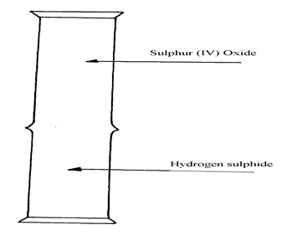
(i) After sometime no observable change occurred. What would be done in order to see the observations? (1 mark)
…………………………………………………………………………………………………………………………………………………
…………………………………………………………………………………………………………………………………………………
(ii) After the correction of the mistake done in b(i) above, state the possible observations made in the gas jars. (1 mark)
…………………………………………………………………………………………………………………………………………………
…………………………………………………………………………………………………………………………………………………
- Write the equation for the reaction. (1 mark)
…………………………………………………………………………………………………………………………………………………
…………………………………………………………………………………………………………………………………………………
- (a) Explain how an increase in temperature affects solubility of salts. (1 mark)
…………………………………………………………………………………………………………………………………………………
…………………………………………………………………………………………………………………………………………………
- The Figure 2 below shows energy levels for the reaction;
$\frac{1}{2}$ H₂ (g) + $\frac{1 }{2}$F₂ (g) $→$ HF (g)

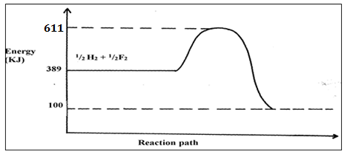

- Work out the activation energy, (Ea.) for the reaction. (1 mark)
…………………………………………………………………………………………………………………………………………………
…………………………………………………………………………………………………………………………………………………
- Calculate the heat of formation of HF. (1 mark)
…………………………………………………………………………………………………………………………………………………
…………………………………………………………………………………………………………………………………………………
- Is the reaction endothermic of exothermic? (1 mark)
…………………………………………………………………………………………………………………………………………………

- A typical electrolysis cell uses a current of 40, 000 amperes. Calculate the mass of aluminium (in Kg) produced in one hour.
(Al = 27.0, 1 Faraday = 96 500 coulombs) (3 marks)
…………………………………………………………………………………………………………………………………………………
…………………………………………………………………………………………………………………………………………………
…………………………………………………………………………………………………………………………………………………
…………………………………………………………………………………………………………………………………………………
…………………………………………………………………………………………………………………………………………………
- (a) Explain how hydrogen is used in the manufacture of margarine. (1$\frac{1}{2}$ marks)
…………………………………………………………………………………………………………………………………………………
…………………………………………………………………………………………………………………………………………………
…………………………………………………………………………………………………………………………………………………
(b) For water gas(mixture of carbon (ii) oxide and hydrogen) to form, a suitable condition must be present.
(i) State the condition. ($\frac{1}{2}$ mark)
…………………………………………………………………………………………………………………………………………………
…………………………………………………………………………………………………………………………………………………
(ii) Write the equation for the formation of water gas. (1 mark)
…………………………………………………………………………………………………………………………………………………
…………………………………………………………………………………………………………………………………………………
- Starting with sodium hydroxide, describe how you can obtain dry sodium hydrogen carbonate.
(3 marks)
…………………………………………………………………………………………………………………………………………………
…………………………………………………………………………………………………………………………………………………
…………………………………………………………………………………………………………………………………………………
…………………………………………………………………………………………………………………………………………………
…………………………………………………………………………………………………………………………………………………

- 1.0 grams of an alloy of aluminium and copper were reacted with aqueous hydrochloric acid. If 840 cm³ of hydrogen at standard temperature and pressure was produced. Calculate the percentage of copper in the alloy.
(Al = 27.0, Molar Gas Volume = 22.4 dm³) (3 marks)
…………………………………………………………………………………………………………………………………………………
…………………………………………………………………………………………………………………………………………………
…………………………………………………………………………………………………………………………………………………
…………………………………………………………………………………………………………………………………………………
…………………………………………………………………………………………………………………………………………………
…………………………………………………………………………………………………………………………………………………
- Carbon exists in many forms.
- Give the name of the impure form of carbon. (1 mark)
…………………………………………………………………………………………………………………………………………………
- Explain why the impure carbon identified above in (a), do not conduct electricity though it contains graphite with its structure. (1 marks)
…………………………………………………………………………………………………………………………………………………
…………………………………………………………………………………………………………………………………………………
- Charcoal is an example of an impure carbon. Give the property that makes it possible to be used in gas masks. (1 mark)
…………………………………………………………………………………………………………………………………………………
…………………………………………………………………………………………………………………………………………………
- Ethanol (C₂H₅OH) and dimethyl ether (C₂H₆O) has same relative molecular mass. However, dimethyl ether boils at – 24 while ethanol boils at 78.2. (2 marks)
…………………………………………………………………………………………………………………………………………………
…………………………………………………………………………………………………………………………………………………
…………………………………………………………………………………………………………………………………………………

- Study the information given in the table 4 below and answer the questions that follow.
Bond | C-H | Cl-Cl | C-Cl | H-Cl
Average bond enthalpy(kJmol⁻¹) | 414 | 244 | 326 | 431

- Calculate the enthalpy change for the reaction. (2 marks)
CH₄ (g) + Cl₂ (g) $→$ CH₃Cl(g) + HCl(g)
…………………………………………………………………………………………………………………………………………………
…………………………………………………………………………………………………………………………………………………
…………………………………………………………………………………………………………………………………………………
…………………………………………………………………………………………………………………………………………………
…………………………………………………………………………………………………………………………………………………
- Is the reaction exothermic or endothermic? Explain your answer. (1 mark)
…………………………………………………………………………………………………………………………………………………
…………………………………………………………………………………………………………………………………………………

- (a) State the Avogadro’s law. (1 mark)
…………………………………………………………………………………………………………………………………………………
…………………………………………………………………………………………………………………………………………………
(b) 100 cm of hydrogen was mixed with 300cm³ of chlorine and the mixture allowed to react. Determine the maximum volume of hydrogen chloride gas that would form.
(2 marks)
…………………………………………………………………………………………………………………………………………………
…………………………………………………………………………………………………………………………………………………
…………………………………………………………………………………………………………………………………………………

- (a) What is a nuclide? (1 mark)
…………………………………………………………………………………………………………………………………………………
…………………………………………………………………………………………………………………………………………………
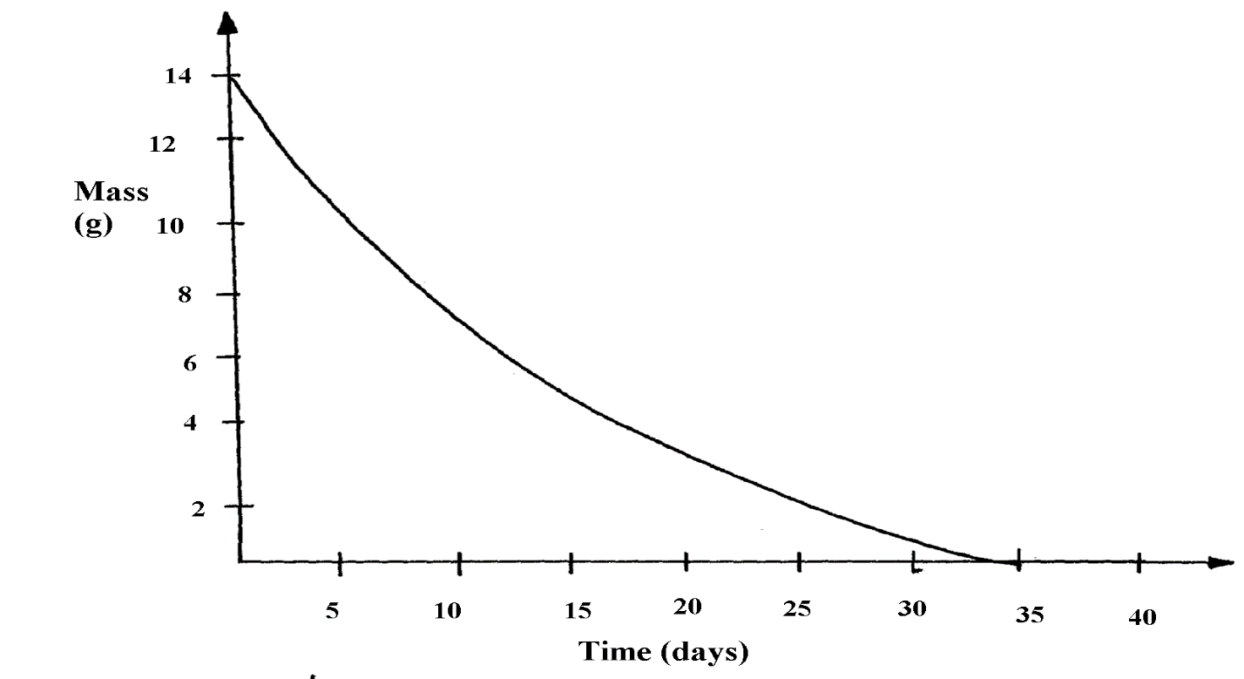
(b) The Figure 3 below shows the graph of a radioactive decay of a certain nuclide. Determine the half-life of the nuclide. (1 mark)
(c) What effect do excess exposures of radiation have on metals? (1 mark)
…………………………………………………………………………………………………………………………………………………
…………………………………………………………………………………………………………………………………………………
…………………………………………………………………………………………………………………………………………………
- A student mixed equal volume of Ethanol and butanoic acid. He added a few drops concentrated sulphuric (VI) acid and warmed the mixture.
- Name and write the formula of the main products. (2 marks)
Name………………………………………………………………………………………..

Formula……………………………………………………………………………………

- Which homologous series does the product named in (i) above belong?(1 mark)
…………………………………………………………………………………………………………………………………………………
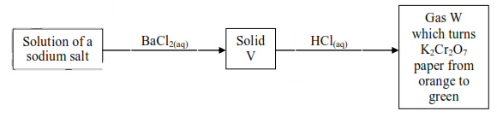
- Study Figure 4 below and answer the question that follow.

- Name
- Solid V…………………………………………………………………………………….. (1 mark)

- Gas W……………………………………………………………………………………….. (1 mark)

- Write an equation for reaction between solid V and dilute hydrochloric acid. (1 mark)
…………………………………………………………………………………………………………………………………………………
…………………………………………………………………………………………………………………………………………………
- (a) A burning magnesium ribbon continues to burn in a jar of nitrogen gas but a burning splint is extinguished. Explain. (1 mark)
…………………………………………………………………………………………………………………………………………………
…………………………………………………………………………………………………………………………………………………
(b) Using equations explain what happens when concentrated nitric (V) acid is reacted with wood charcoal. (2 marks)
…………………………………………………………………………………………………………………………………………………
…………………………………………………………………………………………………………………………………………………
…………………………………………………………………………………………………………………………………………………

24. The Figure 5 below represents a set of apparatus used to study properties of chlorine water.
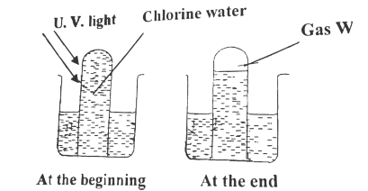
(a) Name two components of chlorine water. (1 mark)
…………………………………………………………………………………………………………………………………………………
…………………………………………………………………………………………………………………………………………………
(b) Write an equation for the reaction that produces gas W. (1 mark)
…………………………………………………………………………………………………………………………………………………
…………………………………………………………………………………………………………………………………………………
(c) The following test was carried out on chlorine water contained in a test tube. A piece of blue flower was dropped in the test-tube. Explain why the flower was bleached.
(2 marks)
…………………………………………………………………………………………………………………………………………………
…………………………………………………………………………………………………………………………………………………
…………………………………………………………………………………………………………………………………………………
25. State and explain what would be observed if concentrated sulphuric (VI) acid is added to:
(a) Sugar crystals. (1 mark)
…………………………………………………………………………………………………………………………………………………
…………………………………………………………………………………………………………………………………………………
…………………………………………………………………………………………………………………………………………………
(b) Cobalt (ii) chloride crystals. (1 mark)
…………………………………………………………………………………………………………………………………………………
…………………………………………………………………………………………………………………………………………………
…………………………………………………………………………………………………………………………………………………

26. 60 cm³ of ozone (O₃) diffused through a semi permeable membrane in 80 seconds. Calculate the time taken for 90 cm³ of nitrogen (VI) oxide (NO₂) to diffuse under the same conditions.
(O = 16.0, N = 14) (3 marks)
…………………………………………………………………………………………………………………………………………………
…………………………………………………………………………………………………………………………………………………
…………………………………………………………………………………………………………………………………………………
…………………………………………………………………………………………………………………………………………………
27. The table 5 below shows pH values of some solutions.
Solution | A | B | C | D
pH values | 13 | 7 | 1 | 6.5
- What solution would react vigorously with sodium metal? (1 mark)
…………………………………………………………………………………………………………………………………………………
- Industrial hydrochloric acid. (1 mark)
…………………………………………………………………………………………………………………………………………………
- Which solution forms complex ions with zinc (II) oxide? (1 mark)
…………………………………………………………………………………………………………………………………………………
28. 6g of Potassium nitrate solid was added to 120 cm³ of water in a plastic beaker. The mixture was stirred gently and the following results were obtained.
Initial temperature = 21.5 ºC
Final temperature = 17.0 ºC
- Calculate the enthalpy change for the reaction. ( Density = 1g/cm³, C = 4.2 kJ kg⁻¹K⁻¹)
(2marks)
…………………………………………………………………………………………………………………………………………………
…………………………………………………………………………………………………………………………………………………
…………………………………………………………………………………………………………………………………………………
…………………………………………………………………………………………………………………………………………………
- Calculate the molar enthalpy for the dissolution of potassium nitrate. (K = 39.0, N = 14.0, O = 16.0) (2 marks)
…………………………………………………………………………………………………………………………………………………
…………………………………………………………………………………………………………………………………………………
…………………………………………………………………………………………………………………………………………………

