NAME...............................................................................................INDEX NO...........................
CANDIDATE’S SIGNATURE.................................................. DATE....................................
441/1
HOMESCIENCE
PAPER I
THEORY
2 ½ Hours
MOKASA TWO JOINT EXAMINATIONS
Kenya Certificate of Secondary Education
INSTRUCTIONS TO CANDIDATES
a). Write your name and index number in the spaces provided above.
b). Sign and write the date of examination in the spaces provided above
c). This paper consists of three sections A, B and C
d). Answer all the questions in sections A and B and any two questions from section C
e). This paper consists of 20 printed pages. Candidates should check the question paper to ascertain that all the pages are printed as indicated and that no questions are missing.
f). Candidates should answer the questions in English.

For Examiner’s Use Only
Section | Question | Maximum score | Candidate’s Score
A | 1-40 | 40
B | 41 | 20
C | 42 | 20
 | 43 | 20
 | 44 | 20
 | Total Score | 100

SECTION A (40 marks). Answer all the questions in this section in the spaces provided.
- List two ways through which sodium is lost in the body (1mark)
………………………………………………………………………………………………………………………………………………………………………………………………………………………………………………………………………………………………
- Use an example to define the term food vehicle in relation to food fortification (1mark)
………………………………………………………………………………………………………………………………………………………………………………………………………………………………………………………………………………………………
- Suggest two reasons why beef curry with fried potatoes is not suitable for a person convalescing from typhoid (1mark)
………………………………………………………………………………………………………………………………………………………………………………………………………………………………………………………………………………………………
- Identify any two causes of malnutrition (1mark)
………………………………………………………………………………………………………………………………………………………………………………………………………………………………………………………………………………………………
- Name the two main types of beriberi in adults (1mark)
………………………………………………………………………………………………………………………………………………………………………………………………………………………………………………………………………………………………
- State two reasons why it is important to leave batter mixture to stand for at least half an hour before cooking (1mark)
………………………………………………………………………………………………………………………………………………………………………………………………………………………………………………………………………………………………
- List any two methods suitable for reheating left over ugali (1mark)
………………………………………………………………………………………………………………………………………………………………………………………………………………………………………………………………………………………………
- Identify any two topics in home science that deal with health education (1mark)
………………………………………………………………………………………………………………………………………………………………………………………………………………………………………………………………………………………………
- Outline two practices that are harmful to leather shoes (1mark)
………………………………………………………………………………………………………………………………………………………………………………………………………………………………………………………………………………………………
10.Identify two ways of replacing stale air with fresh air in a room (1mark)
………………………………………………………………………………………………………………………………………………………………………………………………………………………………………………………………………………………………
11. State two advantages of owning a home (1mark)
………………………………………………………………………………………………………………………………………………………………………………………………………………………………………………………………………………………………
12. Mention two factors that determine the size of a flower arrangement (1mark)
………………………………………………………………………………………………………………………………………………………………………………………………………………………………………………………………………………………………
13. Name two laundry equipment used to extract water in laundry(1mark)
………………………………………………………………………………………………………………………………………………………………………………………………
14. Typhoid is water borne, how about;(1 mark)
i) Malaria ……………………………………………………………………………...
- Tuberculosis ………………………………………………………………………
15. Give two importance of care labels on school pullovers (1mark)
………………………………………………………………………………………………………………………………………………………………………………………………
16. Point out two risks of working in a room that is inadequately lit (1mark)
………………………………………………………………………………………………………………………………………………………………………………………………………………………………………………………………………………………………
17. Note down two methods of soap manufacture (1mark).
………………………………………………………………………………………………………………………………………………………………………………………………
18. Write down two steps to follow when removing fresh fruit stains from white cottons and linens (1mark)
………………………………………………………………………………………………………………………………………………………………………………………………………………………………………………………………………………………………
19.Give the difference between filtration and sedimentation (1mark)
………………………………………………………………………………………………………………………………………………………………………………………………………………………………………………………………………………………………
20. Explain how an oven can be improvised (1mark)
………………………………………………………………………………………………………………………………………………………………………………………………
21. Outline two functions of foot rests /pouffes in a living room (1mark)
………………………………………………………………………………………………………………………………………………………………………………………………………………………………………………………………………………………………
22. Use two statements to describe a well-dressed lady (1mark)
………………………………………………………………………………………………………………………………………………………………………………………………………………………………………………………………………………………………
23. What is the meaning of wipe in figure 8 movement in cleaning of surfaces (1mark)
………………………………………………………………………………………………………………………………………………………………………………………………………………………………………………………………………………………………
24. Give the functions of safety pins in (1 mark)
- A sewing kit : ……………………………………………………………….

- A first aid kit: ………………………………………………………………
25. Write down two disadvantages of teethers to a baby (1mark)
………………………………………………………………………………………………………………………………………………………………………………………………………………
26. Mention two ways in which tetanus can be transmitted (1mark)
………………………………………………………………………………………………………………………………………………………………………………………………………………………………………………………………………………………………
27. Outline two physical needs of an expectant mother (1mark)
………………………………………………………………………………………………………………………………………………………………………………………………………………………………………………………………………………………………
28. Describe the following terms as used in child development (1mark)
- Physical play…………………………………………………………………

- Habit training ……………………………………………………………
29. Give two ways of sterilizing a baby’s feeding equipment (1mark)
………………………………………………………………………………………………………………………………………………………………………………………………………………
30.How does the increase of income affect a budget (1mark)
………………………………………………………………………………………………………………………………………………………………………………………………………………………………………………………………………………………………………………………
31.Consumers are prone to exploitations name two agencies that can protect the interest of consumers (1mark)
………………………………………………………………………………………………………………………………………………………………………………………………………………
32. List down any two fibres that have a high affinity to dye (1mark)
………………………………………………………………………………………………………………………………………………………………………………………………………………
33. Name the part of a sewing machine that discharges the function discharges the function (1 mark)
- Controlling the tightness of the thread …………………………………………………………………………
- Moving forward the fabric being sewn ………………………………………………………………………….
34. Give two pleats that are the reverse of one another (1mark)
………………………………………………………………………………………………………………………………………………………………………………………………………………
35. List two pattern symbols that need not to be transferred (1mark)
………………………………………………………………………………………………………………………………………………………………………………………………………………
36. List two sets of fasteners suitable for a faced slit opening (1mark)
………………………………………………………………………………………………………………………………………………………………………………………………………………
37. Describe how to take measurements labelled a and b (1mark)
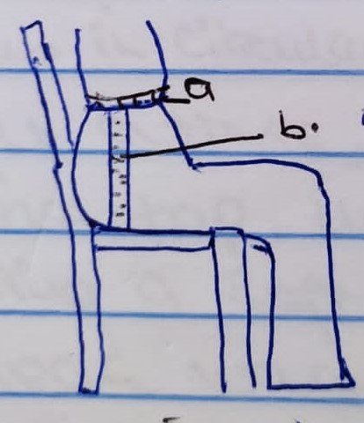
- ………………………………………………………………………………………………………………………………………………………………………………………………………………………………………………………………………………………………
- ………………………………………………………………………………………………………………………………………………………………………………………………………………………………………………………………………………………………

38. Chef Bruno refuses to use frying in preparing his dishes despite the fact that fried food is tasty. Identify two reasons to support his view. (1mark)
………………………………………………………………………………………………………………………………………………………………………………………………………………………………………………………………………………………………………………………
39. Point out two limitations of using open fires for lighting in the home(1mark)
....................................................................................................................................................................................................................................................................................................................................................................................................................................................................................
40. Give two examples of substitute products when purchasing goods(1mark)
....................................................................................................................................................................................................................................................................................................................................................................................................................................................................................

SECTION B – 20 MARKS. This section is compulsory
41.Games is back after the long covid-19 break. In preparation for the upcoming ball games;
- Launder your white polyester games uniform with grass stain (7marks)
- Thoroughly clean the trophy display table made of Formica and a neglected silver trophy to be given to the winning team (13marks)
……………………………………………………………………………………………………………………………………………………………………………………………………………………………………………………………………………………………………………………………………………………………………………………………………………………………………………………………………………………………………………………………………………………………………………………………………………………………………………………………………………………………………………………………………………………………………………………………………………………………………………………………………………………………………………………………………………………………………………………………………………………………………………………………………………………………………………………………………………………………………………………………………………………………………………………………………………………………………………………………………………………………………………………………………………………………………………………………………………………………………………………………………………………………………………………………………………………………………………………………………………………………………………………………………………………………………………………………………………………………………………….
……………………………………………………………………………………………………………………………………………………………………………………………………………………………………………………………………………………………………………………………………………………………………………………………………………………………………………………………………………………………………………………………………………………………………………………………………………………………………………………………………………………………………………………………………………………………………………………………………………………………………………………………………………………………………………………………………………………………………………………………………………………………………………………………………………………………………………………………………………………………………………………………………………………………………………………………………………………………………………………………………………………………………………………………………………………………………………………………………………………………………………………………………………………………………………………………………………………………………………………………………………………………………………………………………………………………………………………………………………………………………………………………………………………………………………………………………………………………………………………………………………………………………………………………………………………………………………………………………………………………………………………………………………………………………………………………………………………………………………………………………………………………………………………………………………………………………………………………………………………………………………………………………………………………………………………………………………………………………………………………………………………………………………………………………………………………………………………………………………………………………………………………………………………………………………………………………………………………………………………………………………………………………………………………………………………………………………………………………………………………………………………………………………………………………………………………………………………………………………………………………………………………………………………………………………………………………………………………………………………………………………………………………………………………………………………………………………………………………………………………………………………………………………………………………………………………………………………………………………………………………………………………………………………………………………………………………………………………………………………………………………………………………………………………………………………………………………………………………………………………………………………………………………………………………………………………………………………………………………………………………………………………………………………………………………………………………………………………………………………………………………………………………………………………………………………………………………………………………………………………………………………………………………………………………………………………………………………………………………………………………………………………………………………………………………………………………………………………………………………………………………………………………………………………………………………………………………………………………………………………………………………………………………………………………….
SECTION C (40MARKS).
Answer any two questions from this section. Each question carries the same marks
42
- Give four reasons why it is important to consider using foods in season while planning meals (4marks)
- A draft of an apron is given. Outline four steps you would follow in preparing the skirt part in readiness for attachment (4marks)
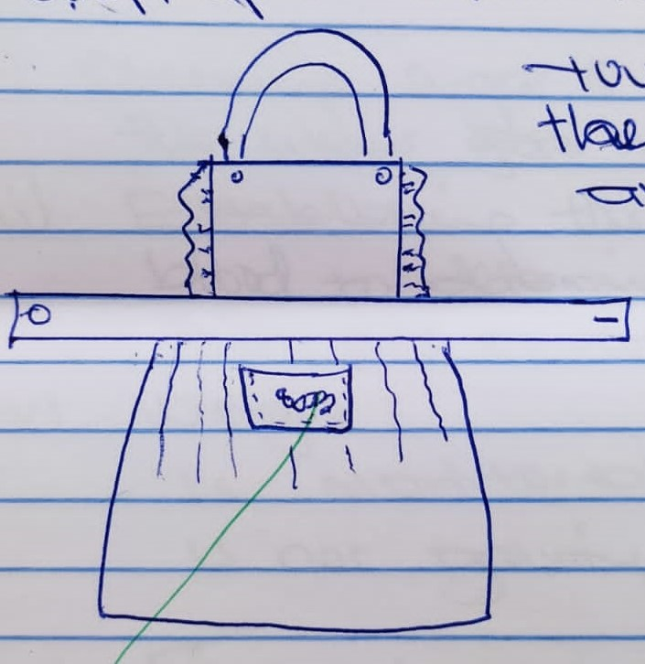
Chain stitch

- Describe how the skin discharges its functions of;(4marks)
- Regulating body temperatures
- Protecting the body against germs
- Synthesizing vitamin D
- As an excretory organ
- Mention four activities that take place in the antenatal clinic (4marks)
- Give four roles of advertisement to a consumer (4marks)
43
- Use relevant examples to explain the danger of re-heating food more than once (4marks)
- Describe the process of preparing a peter pan collar without an interfacing. OMIT the transfer of pattern marks .(4marks)
- As an interior decorator, explain to your client five factors to bear in mind when planning lighting in the home (4marks)
- Suggest five precautions a young mother should take in order to ensure her active toddler does not suffer from burns and scalds (4marks)
- E Describe two methods a consumer can purchase goods and services (4marks)
44
- Explain four reasons why convenience foods is so popular among the youths today(4marks)
- Give four points to consider when buying a blender (4marks)
- Give four reasons why clothes and household articles should never be stored dirty (4 marks)
- State five qualities of a well-made seam(4marks)
- Outline four problems related to weaning (4marks)
………………………………………………………………………………………………………………………………………………………………………………………………………………………………………………………………………………………………………………………………………………………………………………………………………………………………………………………………………………………………………………………………………………………………………………………………………………………………………………
………………………………………………………………………………………………………………………………………………………………………………………………………………………………………………………………………………………………………………………………………………………………………………………………………………………………………………………………………………………………………………………………………………………………………………………………………………………………………………
……………………………………………………………………………………………………………………………………………………………………………………………………………………………………………………………………………………………………………………………………………………………………………………………………………………………………………………………………………………………………………………………………………………………………………....................................................................................................
………………………………………………………………………………………………………………………………………………………………………………………………………………………………………………………………………………………………………………………………………………………………………………………………………………………………………………………………………………………………………………………………………
………………………………………………………………………………………………………………………………………………………………………………………………………………………………………………………………………………………………………………………………………………………………………………………………………………………………………………………………………………………………………………………………………………………………………………………………………………………………………………
………………………………………………………………………………………………………………………………………………………………………………………………………………………………………………………………………………………………………………………………………………………………………………………………………………………………………………………………………………………………………………………………………………………………………………………………………………………………………………
………………………………………………………………………………………………………………………………………………………………………………………………………………………………………………………………………………………………………………………………………………………………………………………………………………………………………………………………………………………………………………………………………………………………………………………………………………………………………………
………………………………………………………………………………………………………………………………………………………………………………………………………………………………………………………………………………………………………………………………………………………………………………………………………………………………………………………………………………………………………………………………………………………………………………………………………………………………………………
………………………………………………………………………………………………………………………………………………………………………………………………………………………………………………………………………………………………………………………………………………………………………………………………………………………………………………………………………………………………………………………………………………………………………………………………………………………………………………………………………………………………………………………………………………………………………………………………………………………………………………………………………………………………………………………………………………………………………………………………………………………………………………………………………………………………………………………………………………………………………………………………………………………………………………………………………………………………………………………………………………………………………………………………………………………………………………………………………………………………………………
………………………………………………………………………………………………………………………………………………………………………………………………………………………………………………………………………………………………………………………………………………………………………………………………………………………………………………………………………………………………………………………………………………………………………………………………………………………………………………………………………………………………………………………………………………………………………………………………………………………………………………………………………………………………………………………………………………………………………………………………………………………………………………………………………………………………………………………………………………………………………………………………………………………………………………………………………………………………………………………………………………………………………………………………………………………………………………………………………………………………………………………………………………………………………………………………………………………………………………………………………………………………………………………………………………………………………………………………………………………………………………………………………………………………………………………………………………………………………………………………………………………………………………………………………………………………………………………………………………………………………………………………………………………………………………………………………………………………………………………………………………………………………………………………………………………………………………………………………………………………………………………………………………………………………………………………………………………………………………………………………………………………………………………………………………………………………………………………………………………………………………………………………………………………………………………………………………………………………………………………………………………………………………………………………………………………………………………………………………………………………………………………………………………………………………………………………………………………………………………………………………………………………………………………………………………………………………………………………………………………………………………………………………………………………………………………………………………………………………………………………………………………………………………………………………………………………………………………………………………………………………………………………………………………………………………………………………………………………………………………………………………………………………………………………………………………………………
………………………………………………………………………………………………………………………………………………………………………………………………………………………………………………………………………………………………………………………………………………………………………………………………………………………………………………………………………………………………………………………………………………………………………………………………………………………………………………………………………………………………………………………………………………………………………………………………………………………………………………………………………………………………………………………………………………………………………………………………………………………………………………………………………………………………………………………………………………………………………………………………………………………………………………………………………………………………………………………………………………………………………………………………………

