MARANDA HIGH SCHOOL
Kenya Certificate of Secondary Education
MOCK EXAMINATIONS 2022

312/2 Geography Paper 2
September, 2022 Time: 2¾ Hours

Name: ………………………………………….…….…… Adm No: ………………
Class: ………………Candidate’s Signature: ………..…….. Date: 13th September, 2022.
Time: 2.00-4.45 PM Instructions to candidates
- Write your name, admission number and class in the spaces provided above.
- This paper has two sections A and B
- Answer all the questions in SECTION A.
- Answer question 6 and any other two questions from SECTION B.
- All answers must be written in English.
- This paper consists of 15 printed pages.
- Candidates should check the question paper to ascertain that all the pages are printed as indicated and that no questions are missing.

For Examiner’s Use Only

Questions | Candidate’s  Score | Maximum  Score
1 -5 |  | 25
6 |  | 25
 |  | 25
 |  | 25
Total Score |  | 100

- (a) Define economic geography (2 marks)
(b) State three reasons why it is important to study human geography (3 marks)
- (a) Name two towns where motor vehicle assembly plants are located in Kenya. (2 marks)
(b) State three ways in which proximity to Nairobi has favoured development of Thika Town. (3 marks)

- The diagram below represents the functional zones of an urban center.
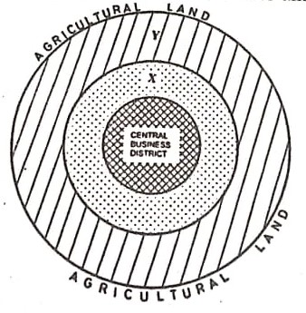
(a) Name the zones marked X and Y. (2 marks)
(b) Give three functions of the Central Business District. (3 marks)
- (a) Name two forest reserves found in the coastal region of Kenya. (2 marks)
(b) State three physical factors that favour the growth of natural forests in the coastal region of Kenya. ` (3 marks)
- (a) Differentiate between emigration and immigration. (2 marks)
(b) State three causes of urban to rural migration (3 marks)
SECTION B
Answer question 6 and any other two questions from this section.
- (a) The table below passenger traffic that used different modes of transport between Mombasa and Nairobi for the year 2017 to 2020.
MODE OF TRANSPORT | 2017 | 2018 | 2019 | 2020
SGR | 700,000 | 1,500,000 | 1,600,000 | 1,700,000
BUSES | 1,500,000 | 1,200,000 | 900,000 | 800,800
AIR | 578,700 | 686,800 | 787,500 | 486,500

- Using a scale of 1cm rep 200,000 people, draw a comparative bar graph to represent data in the table above. (8 marks)
- State two disadvantages of using a comparative bar graph to represent the above data. (2 marks)
- Give four reasons why there is limited use of river transport in Africa. (4 marks)
- Identify any three activities involved in the development of St. Lawrence Seaway project. (3 marks)
- State four benefits of the Standard Gauge Railway to the economy of Kenya. (4 marks)
- Explain how the following factors have negatively affected development of transport and communication in Africa
    - Rugged Terrain (2 marks)
    - Civil wars (2 marks)

- (a) (i) Define the term Fisheries. (2 marks)
(ii) Give four measures the Government has taken to conserve fresh water fisheries in Kenya. (4 marks)
- (i) Explain ways in which each of the following factors affect fishing in Kenya;
      - Technology (2 marks)
      - Fish eating culture (2 marks)
(ii) Describe how trawling method is used in catching Fish (4 marks)
- Study the Map below and use it to answer question 7 (c) (i) to (iii)
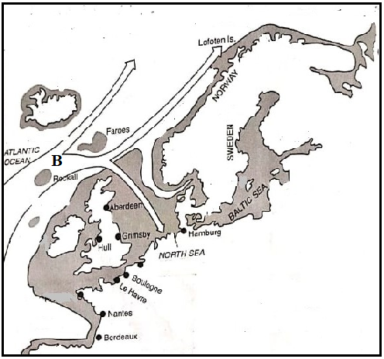
- Give two fish species caught in the above fishing ground (2 marks)
- Name the ocean current marked B (1 mark)
- Explain how the above ocean current influences fishing in the above fishing ground (2 marks)
- Explain the significance of fishing in Japan. (6 marks)

- (a) (i) Define the term balance of trade. (2 marks)
(ii) Name two major imports to Kenya from European Union (2 marks)
- State four factors that inhibit trade between Kenya and her neighbours. (4 marks)
- Explain how the following factors influence trade in Kenya.
    - Security (2 marks)
    - Transport (2 marks)
- (i) Name two member states of ECOWAS. (2 marks)
(ii) Give three roles played by SADC in the economies of her member states (3 marks)
(iii) Explain the measures the government of Kenya has taken to reduce her unfavourable balance of trade. (8 marks)

- (a) (i) Differentiate between domestic dairy farming and commercial dairy farming. (2 marks)
(ii) Name two breeds of dairy cattle reared in Kenya. (2 marks)
- (i) Give four characteristics of dairy cattle breeds reared in Kenya. (4 marks)
(ii) Name three counties where dairy farming is practiced in large scale in Kenya. (3 marks)
(iii) State three physical factors favouring dairy farming in Kenya (3 marks)
- Give reasons why Kenya’s dairy sector fails to meet its domestic demand. (5 marks)
- State three differences between dairy farming in Kenya and Denmark. (6 marks)

- a) Give three ways in which minerals occur. (3 marks)
- Explain three factors that influence the mining of trona in Lake Magadi (6 marks)
- Study the diagram below and use it to answer question c (i) and (ii)
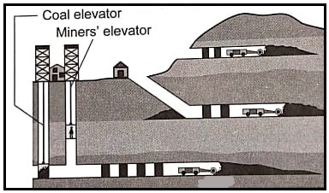
(i) Identify the mining method shown on the diagram above (1 mark)
(ii) Describe how the method is used to extract minerals (5 marks)
- Explain three effects of mining on the environment (6 marks)
(e) Maranda high school students carried out a field study on the processing of trona on Lake Magadi.
(i) Identify two methods they will use in recording data (2 marks)
(ii) Give two follow up activities they may have carried out (2 marks)

……………………………………………………………………………………………………………………………………………………………………………………………………………………………………………………………………………………………………………………………………………………………………………………………………………………………………………………………………………………………………………………………………………………………………………………………………………………………………………………………………………………………………………………………………………………………………………………………………………………………………………………………………………………………………………………………………………………………………………………………………………………………………………………………………………………………………………………………………………………………………………………………………………………………………………………………………………………………………………………………………………………………………………………………………………………………………………………………………………………………………………………………………………………………………………………………………………………………………………………………………………………………………………………………………………………………………………………………………………………………………………………………………………………………………………………………………………………………………………………………………………………………………………………………………………………………………………………………………………………………………………………………………………………………………………………………………………………………………………………………………………………………………………………………………………………………………………………………………………………………………………………………………………………………………………………………………………………………………………………………………………………………………………………………………………………………………………………………………………………………………………………………………………………………………………………………………………………………………………………………………………………………………………………………………………………………………………………………………………………………………………………………………………………………………………………………………………………………………………………………………………………………………………………………………………………………………………………………………………………………………………………………………………………………………………………………………………………………………………………………………………………………………………………………………………………………………………………………………………………………………………………………………………………………………………………………………………………………………………………………………………………………………………………………………………………………………………………………………………………………………………………………………………………………………………………………………………………………………………………………………………………………………………………………………………………………………………………………………………………………………………………………………………………………………………………………………………………………………………………………………………………………………………………………………………………………………………………………………………………………………………………………………………………………………………………………………………………………………………………………………………………………………………………………………………………………………………………………………………………………………………………………………………………………………………………………………………………………………………………………………………………………………………………………………………………………………………………………………………………………………………………………………………………………………………………………………………………………………………………………………………………………………………………………………………………………………………………………………………………………………………………………………………………………………………………………………………………………………………………………………………………………………………………………………………………………………………………………………………………………………………………………………………………………………………………………………………………………………………………………………………………………………………………………………………………………………………………………………………………………………………………………………………………………………………………………………………………………………………………………………………………………………………………………………………………………………………………………………………………………………………………………………………………………………………………………………………………………………………………………………………………………………………………………………………………………………………………………………………………………………………………………………………………………………………………………………………………………………………………………………………………………………………………………………………………………………………………………………………………………………………………………………………………………………………………………………………………………………………………………………………………………………………………………………………………………………………………………………………………………………………………………………………………………………………………………………………………………………………………………………………………………………………………………………………………………………………………………………………………………………………………………………………………………………………………………………………………………………………………………………………………………………………………………………………………………………………………………………………………………………………………………………………………………………………………………………………………………………………………………………………………………………………………………………………………………………………………………………………………………………………………………………………………………………………………………………………………………………………………………………………………………………………………………………………………………………………………………………………………………………………………………………………………………………………………………………………………………………………………………………………………………………………………………………………………………………………………………………………………………………………………………………………………………………………………………………………………………………………………………………………………………………………………………………………………………………………………………………………………………………………………………………………………………………………………………………………………………………………………………………………………………………………………………………………………………………………………………………………………………………………………………………………………………………………………………………………………………………………………………………………………………………………………………………………………………………………………………………………………………………………………………………………………………………………………………………………………………………………………………………………………………………………………………………………………………………………………………………………………………………………………………………………………………………………………………………………………………………………………………………………………………………………………………………………………………………………………………………………………………………………………………………………………………………………………………………………………………………………………………………………………………………………………………………………………………………………………………………………………………………………………………………………………………………………………………………………………………………………………………………………………………………………………………………………………………………………………………………………………………………………………………………………………………………………………………………………………………………………………………………………………………………………………………………………………………………………………………………………………………………………………………………………………………………………………………………………………………………………………………………………………………………………………………………………………………………………………………………………………………………………………………………………………………………………………………………………………………………………………………………………………………………………………………………………………………………………………………………………………………………………………………………………………………………………………………………………………………………………………………………………………………………………………………………………………………………………………………………………………………………………………………………………………………………………………………………………………………………………………………………………………………………………………………………………………………………………………………………………………………………………………………………………………………………………………………………………………………………………………………………………………………………………………………………………………………………………………………………………………………………………………………………………………………………………………………………………………………………………………………………………………………………………………………………………………………………………………………………………………………………………………………………………………………………………………………………………………………………………………………………………………………………………………………………………………………………………………………………………………………………………………………………………………………………………………………………………………………………………………………………………………………………………………………………………………………………………………………………………………………………………………………………………………………………………………………………………………………………………………………………………………………………………………………………………………………………………………………………………………………………………………………………………………………………………………………………………………………………………………………………………………………………………………………………………………………………………………………………………………………………………………………………………………………………………………………………………………………………………………………………………………………………………………………………………………………………………………………………………………………………………………………………………………………………………………………………………………………………………………………………………………………………………………………………………………………………………………………………………………………………………………………………………………………………………………………………………………………………………………………………………………………………………………………………………………………………………………………………………………………………………………………………………………………………………………………………………………………………………………………………………………………………………………………………………………………………………………………………………………………………………………………………………………………………………………………………………………………………………………………………………………………………………………………………………………………………………………………………………………………………………………………………………………………………………………………………………………………………………………………………………………………………………………………………………………………………………………………………………………………………………………………………………………………………………………………………………………………………………………………………………………………………………………………………………………………………………………………………………………………………………………………………………………………………………………………………………………………………………………………………………………………………………………………………………………………………………………………………………………………………………………………………………………………………………………………………………………………………………………………………………………………………………………………………………………………………………………………………………………………………………………………………………………………………………………………………………………………………………………………………………………………………………………………………………………………………………………………………………………………………………………………………………………………………………………………………………………………………………………………………………………………………………………………………………………………………………………………………………………………………………………………………………………………………………………………………………………………………………………………………………………………………………………………………………………………………………………………………………………………………………………………………………………………………………………………………………………………………………………………………………………………………………………………………………………………………………………………………………………………………………………………………………………………………………………………………………………………………………………………………………………………………………………………………………………………………………………………………………………………………………………………………………………………………………………………………………………………………………………………………………………………………………………………………………………………………………………………………………………………………………………………………………………………………………………………………………………………………………………………………………………………………………………………………………………………………………………………………………………………………………………………………………………………………………………………………………………………………………………………………………………………………………………………………………………………………………………………………………………………………………………………………………………………………………………………………………………………………………………………………………………………………………………………………………………………………………………………………………………………………………………………………………………………………………………………………………………………………………………………………………………………………………………………………………………………………………………………………………………………………………………………………………………………………………………………………………………………………………………………………………………………………………………………………………………………………………………………………………………………………………………………………………………………………………………………………………………………………………………………………………………………………………………………………………………………………………………………………………………………………………………………………………………………………………………………………………………………………………………………………………………………………………………………………………………………………………………………………………………………………………………………………………………………………………………………………………………………………………………………………………………………………………………………………………………………………………………………………………………………………………………………………………………………………………………………………………………………………………………………………………………………………………………………………………………………………………………………………………………………………………………………………………………………………………………………………………………………………………………………………………………………………………………………………………………………………………………………………………………………………………………………………………………………………………………………………………………………………………………………………………………………………………………………………………………………………………………………………………………………………………………………………………………………………………………………………………………………………………………………………………………………………………………………………………………………………………………………………………………………………………………………………………………………………………………………………………………………………………………………………………………………………………………………………………………………………………………………………………………………………………………………………………………………………………………………………………………………………………………………………………………………………………………………………………………………………………………………………………………………………………………………………………………………………………………………………………………………………………………………………………………………………………………………………………………………………………………………………………………………………………………………………………………………………………………………………………………………………………………………………………………………………………………………………………………………………………………………………………………………………………………………………………………………………………………………………………………………………………………………………………………………………
THIS IS THE LAST PRINTED PAGE

