** MARANDA HIGH SCHOOL**

**Kenya Certificate of Secondary Education**

**MOCK EXAMINATIONS 2022**

**312/1 Geography Paper 1**

**September, 2022 Time: 2¾ Hours**

**Name**: ………………………………………….…….…… **Adm** **No**: ……………….

**Class**: ………………**Candidate’s** **Signature**: ………..…….. **Date: 2nd September, 2022.**

**Time: 2.00-4.30 PM** ***Instructions to candidates***

1. *Write your name, admission number and class in the spaces provided above.*
2. *This paper has* ***two*** *sections:* ***A*** *and* ***B.***
3. *Answer* ***all*** *the questions in section* ***A.***
4. *Answer* ***question 6*** *(compulsory) and any other two questions from section* ***B.***
5. ***This paper consists of 14 printed pages.***
6. ***Candidates should check the question paper to ascertain that all the pages are printed as indicated and that no questions are missing.***

**For Examiner’s Use Only**

|  |  |  |  |
| --- | --- | --- | --- |
| **Section** | **Questions** | **Maximum Score** | **Candidate’s Score** |
| **A** | **1 - 5** | **25** |  |
| **B** | **6** | **25** |  |
|  | **25** |  |
|  | **25** |  |
|  | **Total Score** | **100** |  |

**SECTION A** (**25 Marks**)

Answer ***all*** the questions in this section in the spaces provided below each question

1. (a) Define the term Geomorphology. (2 marks)

………………………………………………………………………………………………………………………………………………………………………………………………………………………………………………………………………………………………………………………………………………

(b) Other than being a career subject, state ***three*** reasons why it is important for students in secondary school to study geography. (3 marks)

……………………………………………………………………………………………………………………………………………………………………………………………………………………………………………………………………………………………………………………………………………………………………………………………………………………………………………………………………………………………………………………………………………………………………………….

1. The diagram below shows an instrument used in measuring one of the weather elements. Study it and answer the questions that follow.

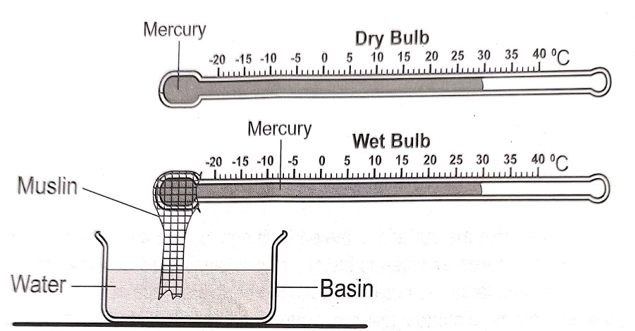

1. Identify; (i) the instrument shown above. (1 mark)

…………………………………………………………………………………………………………

(ii) the weather element measured using the instrument identified in (a) (i). (1 mark)

…………………………………………………………………………………………………………

1. State ***three*** importance of the weather element identified in (a) (ii) in the atmosphere. (3 marks) ………………………………………………………………………………………………………………………………………………………………………………………………………………………………………………………………………………………………………………………………………………………………………………………………………………………………
2. (a) Name the temperate grassland found in:
3. New Zealand: ……………………………………………………………………....... (1 mark)
4. Central Asia: ………………………………………………………………………… (1 mark)

(b) State ***three*** uses of vegetation. (3 marks)

………………………………………………………………………………………………………………………………………………………………………………………………………………………………………………………………………………………………………………………………………………………………………………………………………………………………………………………………

1. (a) Name ***two*** output processes in the hydrological cycle. (2 marks)

………………………………………………………………………………………………………………………………………………………………………………………………………………………………

(b) State ***three*** negative influences that rivers have on human environment. (3 marks)

……………………………………………………………………………………………………………………………………………………………………………………………………………………………… ………………………………………………………………………………………………………………………………………………………………………………………………………………………………

1. (a) Define the term soil. (2 marks)

………………………………………………………………………………………………………………………………………………………………………………………………………………………………………………………………………………………………………………………………………………

(b) State ***three*** causes of chemical degeneration of soils. (3 marks)

………………………………………………………………………………………………………………………………………………………………………………………………………………………………………………………………………………………………………………………………………………

**SECTION B (75 Marks)**

Answer ***question 6*** (compulsory) and any other ***two*** questions in this section in the spaces provided after question 10.

1. Study the map of Nyeri 1:50,000 (Sheet 120/4) provided and answer the questions that follow.
2. (i) Give the longitudinal extent of the area covered by the map. (2 marks)

(ii) Name ***two*** districts in the area covered by the map. (2 marks)

1. (i) Calculate the area of Nyeri forest. Give your answer in kilometres. (2 marks)

(ii) What is the magnetic variation of the area covered by the map. (1 mark)

1. Describe the drainage of the area covered by the map. (6 marks)
2. (i) Using a scale of 1 cm represents 50 metres, draw a cross-section along northing 64 between easting 68 and 74. (4 marks)

(ii) On the cross-section, mark and label the following;

* + Hill. (1 mark)
  + All weather road loose surface. (1 mark)
  + River. (1 mark)

1. Calculate the vertical exaggeration of the cross-section. (2 marks)
2. Citing evidence from the map, identify ***three*** social functions of the area covered by the map. (3 marks)
3. Below is a world map showing the distribution of fold mountains. Use it to answer question (a).



1. (i) Name the fold mountains marked ***A*** and ***B***. (2 marks)

(ii) Give the orogenies during which the fold mountains marked ***X*** and ***Y*** were formed. (2 marks)

1. With the aid of well labelled diagrams, describe the formation of anticlinorium and synclinorium complex of folds. (6 marks)
2. (i) Give ***three*** features resulting from folding other than fold mountains. (3 marks)

(ii) Describe how fold mountains were formed according to the proponents of contraction theory.

(3 marks)

1. Explain ***two*** positive significance of folding to human activities. (4 marks)
2. Your class intends to carry out a field study on folding;

(i) State ***three*** ways in which you would prepare for the field study. (3 marks)

(ii) Give ***two*** methods of data collection you would use during the field study (2 marks)

1. (a) (i) Differentiate between a mineral and a rock. (2 marks)

(ii) Describe the following characteristics of minerals:

* Tenacity (2 marks)
* Streak (2 marks)

(b) Describe the process of formation of the following rocks:

(i) Chemically formed sedimentary rocks. (5 marks)

(ii) Volcanic ejecta. (4 marks)

(c) State ***four*** characteristics of metamorphic rocks. (4 marks)

(d) Explain ***three*** significance of rocks to human activities in Kenya. (6 marks)

1. (a) (i) What is a piedmont glacier? (2 marks)

(ii) Give ***three*** ways through which ice moves. (3 marks)

1. (i) Apart from roche mountonnee, name ***three*** other features formed by glacial erosion in lowlands. (3 marks)

(ii) Using a well labelled diagram, describe the formation of a roche mountonnee. (6 marks)

(c) Your class is planning to carry out a field study on features formed by glacial erosion in highlands;

(i) State ***two*** objectives you would have for the study. (2 marks)

(ii) Give ***three*** qualities of a good questionnaire you would prepare for collecting data. (3 marks)

(d) Explain ***three*** positive significance of glaciation in lowland areas. (6 marks)

1. (a) (i) Define the term denudation. (2 marks)

(ii) Explain how the following factors influence weathering:

* Mineral composition of the rocks (2 marks)
* Colour of the rocks (2 marks)
* Structure of the rocks (2 marks)

(b) The diagram below shows a process of mechanical weathering:

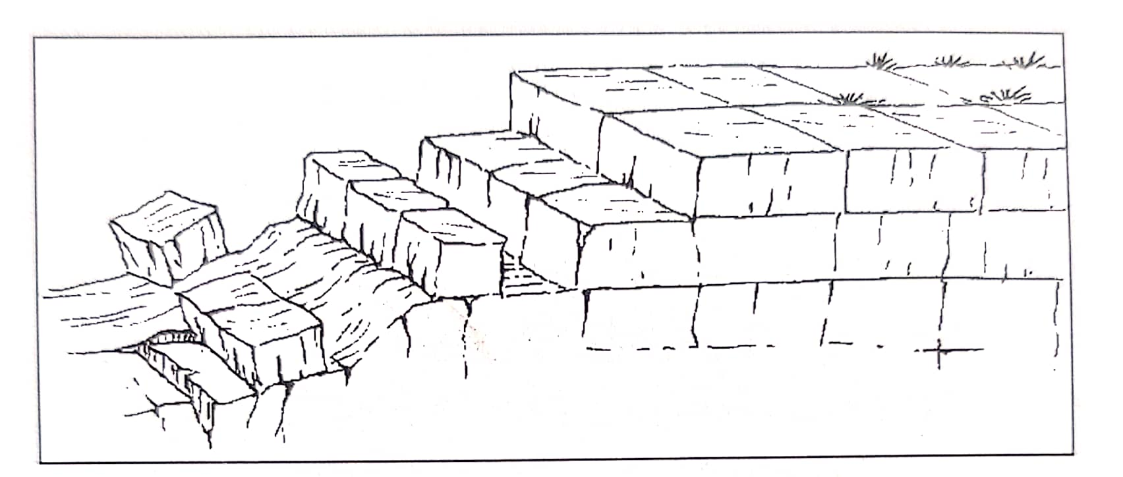

(i) Identify the process. (1 mark)

(ii) Describe how the process occurs. (5marks)

(c) State ***five*** evidences of soil creep. (5marks)

(d) Explain ***three*** significance of mass wasting on the physical and human environments. (6marks)

……………………………………………………………………………………………………………………………………………………………………………………………………………………………………………………………………………………………………………………………………………………………………………………………………………………………………………………………………………………………………………………………………………………………………………………………………………………………………………………………………………………………………………………………………………………………………………………………………………………………………………………………………………………………………………………………………………………………………………………………………………………………………………………………………………………………………………………………………………………………………………………………………………………………………………………………………………………………………………………………………………………………………………………………………………………………………………………………………………………………………………………………………………………………………………………………………………………………………………………………………………………………………………………………………………………………………………………………………………………………………………………………………………………………………………………………………………………………………………………………………………………………………………………………………………………………………………………………………………………………………………………………………………………………………………………………………………………………………………………………………………………………………………………………………………………………………………………………………………………………………………………………………………………………………………………………………………………………………………………………………………………………………………………………………………………………………………………………………………………………………………………………………………………………………………………………………………………………………………………………………………………………………………………………………………………………………………………………………………….……………………………………………………………………………………………………………………………………………………………………………………………………………………………………………………………………………………………………………………………………………………………………………………………………………………………………………………………………………………………………………………………………………………………………………………………………………………………………………………………………………………………………………………………………………………………………………………………………………………………………………………………………………………………………………………………………………………………………………………………………………………………………………………………………………………………………………………………………………………………………………………………………………………………………………………………………………………………………………………………………………………………………………………………………………………………………………………………………………………………………………………………………………………………………………………………………………………………………………………………………………………………………………………………………………………………………………………………………………………………………………………………………………………………………………………………………………………………………………………………………………………………………………………………………………………………………………………………………………………………………………………………………………………………………………………………………………………………………………………………………………………………………………………………………………………………………………………………………………………………………………………………………………………………………………………………………………………………………………………………………………………………………………………………………………………………………………………………………………………………………………………………………………………………………………………………………………………………………………………………………………………………………………………………………………………………………………………………………………………………………………………………….……………………………………………………………………………………………………………………………………………………………………………………………………………………………………………………………………………………………………………………………………………………………………………………………………………………………………………………………………………………………………………………………………………………………………………………………………………………………………………………………………………………………………………………………………………………………………………………………………………………………………………………………………………………………………………………………………………………………………………………………………………………………………………………………………………………………………………………………………………………………………………………………………………………………………………………………………………………………………………………………………………………………………………………………………………………………………………………………………………………………………………………………………………………………………………………………………………………………………………………………………………………………………………………………………………………………………………………………………………………………………………………………………………………………………………………………………………………………………………………………………………………………………………………………………………………………………………………………………………………………………………………………………………………………………………………………………………………………………………………………………………………………………………………………………………………………………………………………………………………………………………………………………………………………………………………………………………………………………………………………………………………………………………………………………………………………………………………………………………………………………………………………………………………………………………………………………………………………………………………………………………………………………………………………………………………………………………………………………………………………………………………………….………………………………………………………………………………………………………………………………………………………………………………………………………………………………………………………………………………………………………………………………………………………………………………………………………………………………………………………………………………………………………………………………………………………………………………………………………………………………………………………………………………………………………………………………………………………………………………………………………………………………………………………………………………………………………………………………………………………………………………………………………………………………………………………………………………………………………………………………………………………………………………………………………………………………………………………………………………………………………………………………………………………………………………………………………………………………………………………………………………………………………………………………………………………………………………………………………………………………………………………………………………………………………………………………………………………………………………………………………………………………………………………………………………………………………………………………………………………………………………………………………………………………………………………………………………………………………………………………………………………………………………………………………………………………………………………………………………………………………………………………………………………………………………………………………………………………………………………………………………………………………………………………………………………………………………………………………………………………………………………………………………………………………………………………………………………………………………………………………………………………………………………………………………………………………………………………………………………………………………………………………………………………………………………………………………………………………………………………………………………………………………………………………………………………………...…….…………………………………………………………………………………………………………………………………………………………………………………………………………………………………………………………………………………………………………………………………………………………………………………………………………………………………………………………………………………………………………………………………………………………………………………………………………………………………………………………………………………………………………………………………………………………………………………………………………………………………………………………………………………………………………..……………………………………………………………………………………………………………………………………………………………………………………………………………………………………………………………………………………………………………………………………………………………………………………………………………………………………………………………………………………………………………………………………………………………………………………………………………………………………………………………………………………………………………………………………………………………………………………………………………………………………………………………………………………………………………………………………………………………………………………………………………………………………………………………………………………………………………………………………………………………………………………………………………………………………………………………………………………………………………………………………………………………………………………………………………………………………………………………………………………………………………………………………………………………………………………………………………………………………………………………………………………………………………………………………………………………………………………………………………………………………………………………………………………………………………………………………………………………………………………………………………………………………………………………………………………………………………………………………………………………………………………………………………………………………………………………………………………………………………………………………………………………………………………………………………………………………………………………………………………………………………………………………………………………………………………………………………………………………………………………………………………………………………………………………………………………………………………………………………………………………………………………………………………………………………………………………………………………………………………………………………………………………………………………………………………………………………………………………………………………………………………………………………………………………………………………………………………………………………………………………………………………………………………………………………………………………………………………………………………………………………………………………………………………………………………………………………………………………………………………………………………………………………………………………………………………………………………………………………………………………………………………………………………………………………………………………………………………………………………………………………………………………………………………………………………………………………………………………………………………………………………………………………………………………………………………………………………………………………………………………………………………………………………………………………………………………………………………………………………..…………………………………………………………………………………………………………………………………………………………………………………………………………………………………………………………………………………………………………………………………………………………………………………………………………………………………………………………………………………………………………………………………………………………………………………………………………………………………………………………………………………………………………………………………………………………………………………………………………………………………………………………………………………………………………………………………………………………………………………………………………………………………………………………………………………………………………………………………………………………………………………………………………………………………………………………………………………………

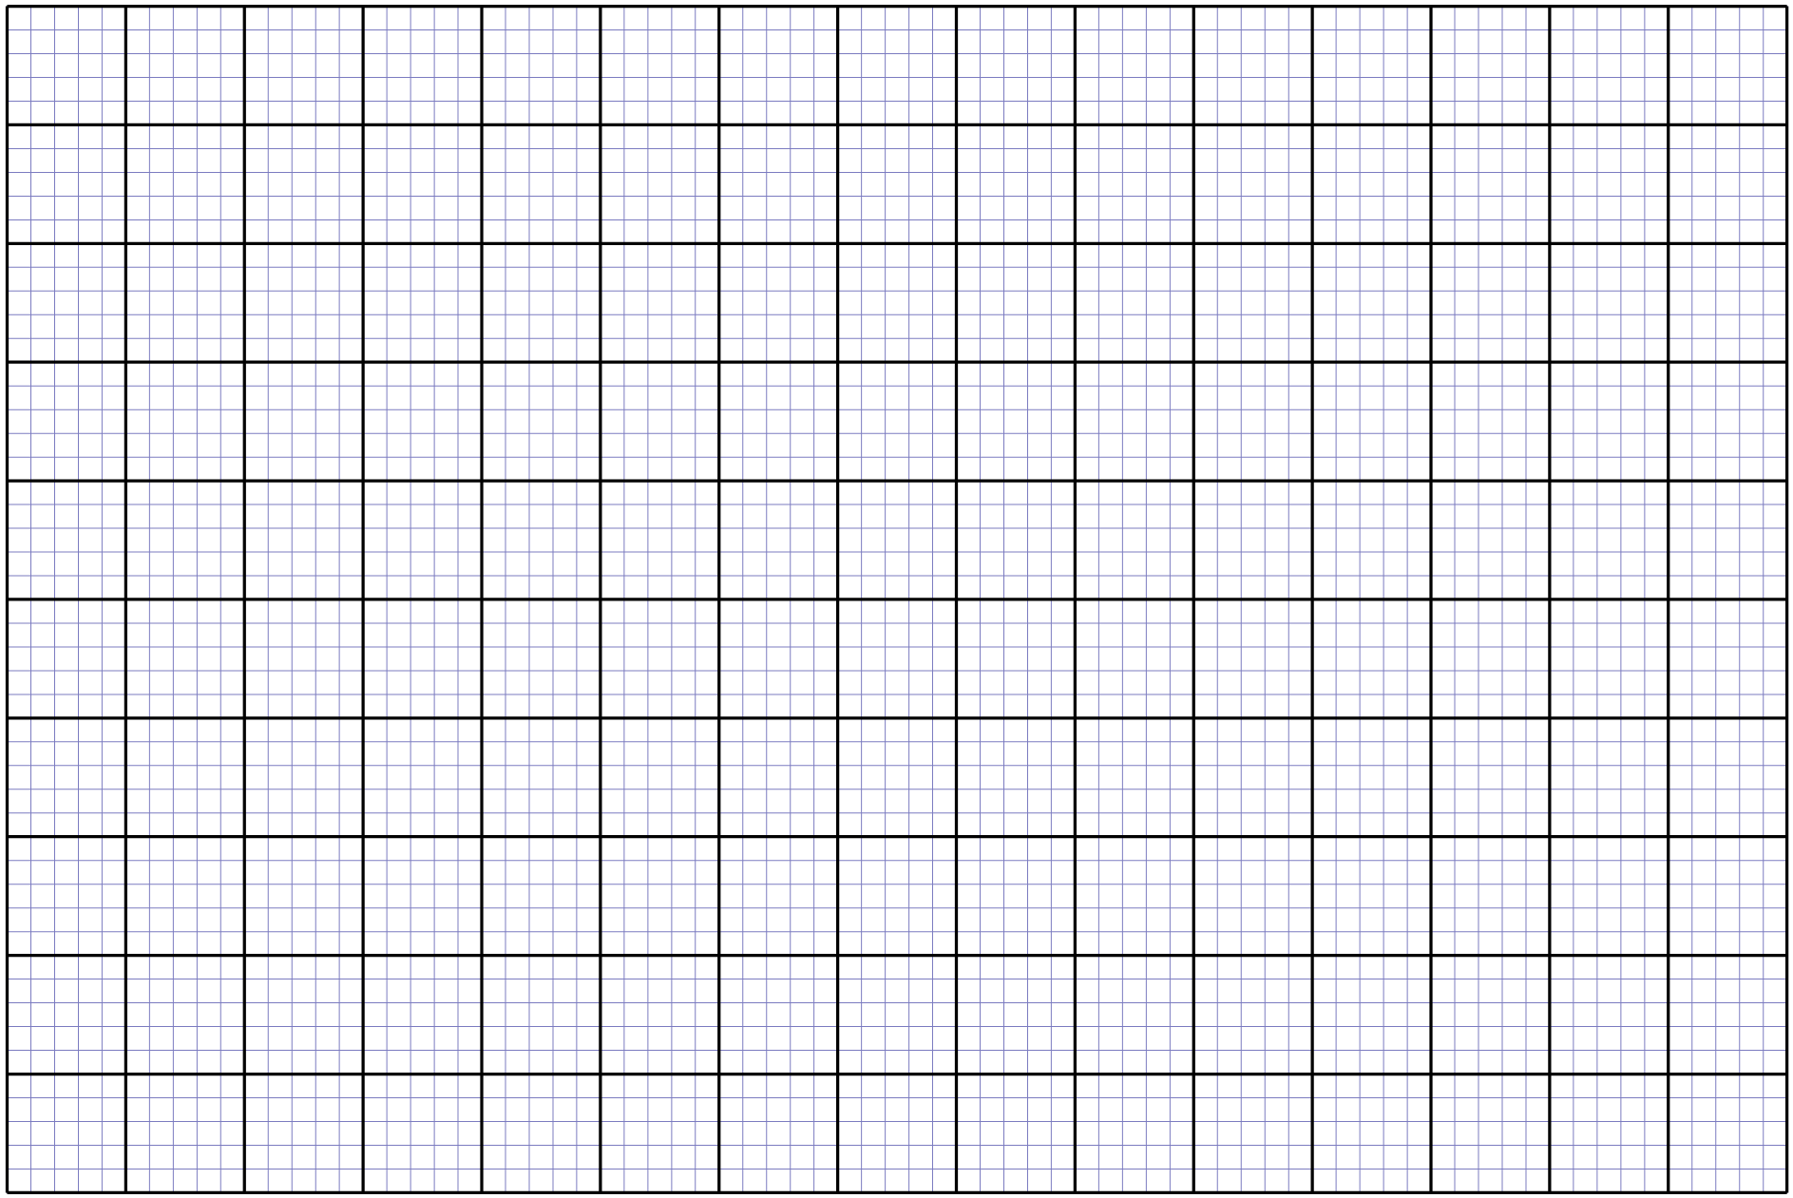

**-THIS IS THE LAST PRINTED PAGE-**