312/1
Geography
Paper 1.
August/ September 2022.
Time:2$\frac{3}{4}$ hours

MOKASA 2 JOINT EXAMINATION
Kenya Certificate of Secondary Education.
312/1
Paper 1.
Geography
INSTRUCTIONS TO THE CANDIDATES.
- This paper has two sections A and B.
- Answer ALL questions in section A. in section B answer question 6 and any other TWO questions.

SECTION A
Answer all questions in this section.
- (a) Name two types of environment. (2 marks)
(b) List three main branches under physical geography. (3 marks)
- Use the following weather instrument to answer the questions that follow.
(a) Name the above instrument. (1 mark)
(b) Describe how the instrument above works. (4 marks)
- (a) Give two types of sedimentary rocks. (2 marks)
(b) State three characteristics of sedimentary rocks. (3 marks)

- The diagram below represents zones of natural vegetation on a mountain in Africa. Use it to answer questions A and B.
Snow and bed rock
5000
Y
Height in meters
4000
X
3000

W
2000
1000
Savanna
0

(a) Name the vegetation zones marked W, X and Y. (3 marks)
(b) Give two uses of Savannah vegetation. (2 marks)
- (a) What is soil erosion? (2 marks)
(b) Name three types of soil erosion. (3 marks)
SECTION B
Answer question 6 and any other TWO questions in this section.
- Study the map of Nyeri 1:50,000 (sheet 120/4) provided and answer the following questions.

(a) (i) Give the six figure grid reference of the forest Guard Post at grid square 5059. (2 marks)

(ii) What is the magnetic variation of the map? (2 marks)
(b) (iii) What is the general direction of the flow of river Chanya? (1 mark)
(c) (i) Using a vertical scale of 1cm to represents 50m; draw a cross section along Northing 64 from Easting 68 to Easting 78. On it mark and label the following.

- All weather road
- A hill.
- River. (7 marks)
(ii) Calculate the vertical exaggeration of the cross section. (2 marks)
(iii) Determine the intervisibility of the cross section. (1 mark)
(d) Citing evidence from the map, identify three social services offered in the area covered by the map. (6 marks)
(e) Explain two ways relief has influenced the distribution of settlement in the area covered by the map. (4 marks)
7. (a) (i) Define the term volcanicity. (2 marks)
(ii) Name two active volcanoes in Kenya. (2 marks)
(b) (i) Differentiate between solfatara and moffete. (2 marks)
(ii) Identify two areas in Kenya where geysers are found. (2 marks)
(c) (i) A part from batholiths, name three features resulting from intrusive vulcanicity. (3 marks)
(ii) With the aid of a diagram describe how a batholith is formed. (6 marks)

(d) Explain four negative effects of vulcanicity. (8 marks)
8. (a) (i) What is weathering? (2 marks)
(ii) Give three factors influencing the rate of weathering (3 marks)
(b) Name three processes of slow mass wasting. (3 marks)
(c) (i) A part from block disintegration, list four other physical weathering processes. (4 marks)

(ii) Describe how block disintegration occurs. (5 marks)
(d) Explain four significance of weathering to human activities. (8 marks)
9. (a) (i) Define the term ocean (2 marks)
(ii) Name three types of coasts (3 marks)
(b) (i) List three features that result from wave erosion (3 marks)
(ii) Describe the longshore drift. (3 marks)

(c) The diagram below shows coastal features resulting from wave deposition
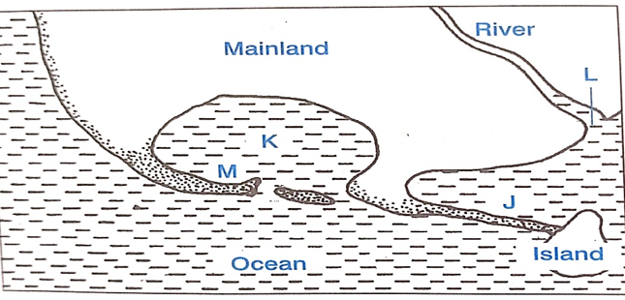
(i) Name the features marked J, K and M. (3 marks)
(ii) Describe how the feature marked M is formed (5 marks)
(iii) State three conditions that favor for the growth of coral polyps. (3 marks)
(c) State three significances of coastal features to human activities. (3 marks)
10. (a) (i) Differentiate between an ice sheet and an ice berg. (2 marks)
(ii) Name three types of glacial moraines. (3 marks)
(b) The diagram below shows features resulting from glaciation in a low land area.
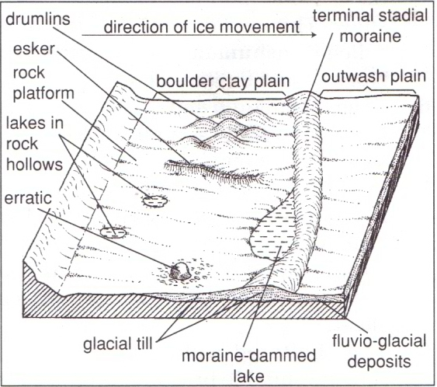
Esker
N
M
L
Y
(i) Name the features marked X, Y and Z. (3 marks)
(ii) Describe how a terminal moraine is formed. (4 marks)
(c) Your class carried out a field study on glacial erosional features in a glacial lowland area.

(i) Give two methods of collecting data you could use. (2 marks)
(ii) State three importance of dividing into groups. (3 marks)
(d) Explain four economic significance of glaciation in lowland areas. (8 marks)

