MARKING SCHEME FORM 4 CEKENAS TERM 2 PAPER 1

Section A: (20 marks)
Answer all the questions in the spaces provided.
- a) Study the illustration given and answer the questions that follow.
- Mention the appropriate technique that was used to produce it. (1mk)
- Pottery
- Mention any one tool and material used. (2mks)
- Material- Clay, water, grog, slip.
- Tool- loop tool, kidney scrappers, cutting wire, brush, sponge
b) Explain the smearing technique of drawing forms. (1mk)
- Using wet media such as ink or paint, dye etc; to produce a drawn composition.
c) State and explain any material that is used in clay correction during the preparation process. (2mks)
- Grog- used to help in hardening the clay thus making it less plastic to enhance it’s workability. It is added in the kneading stage in the preparation process.
d) How can ornaments be used to preserve a nation’s heritage? (1mk)
- Open ended as long as it sound logical.
e) Give any two factors to consider in packaging design. (2mks)
- The type of item to be packed.
- Advertisement
- Durability
- Size and shape of the product

f) State any four tools used in weaving. (2mks)
- Shuttle
- Shed stick
- Loom
- beater
g) Study the diagram below and answer the questions that follow.
i. State the most outstanding element used in the picture. (1mk)
- Lines

ii. Explain one use of the above-mentioned element. (1mk)
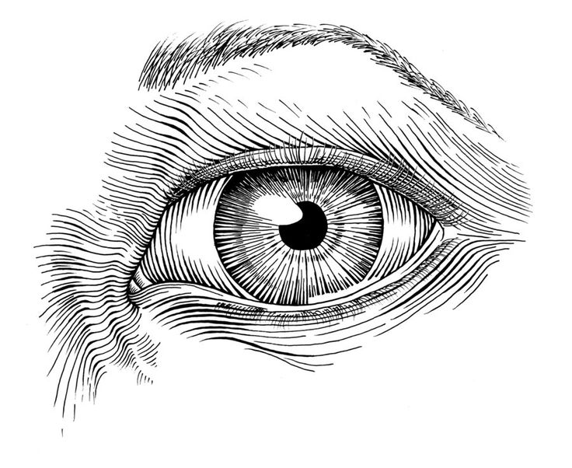
- Enclose shapes
- Define form
- Create depth
- Create mood, express feelings

h) Distinguish between a monochromatic colour scheme and an analogous colour scheme. (2mks)
- Monochromatic- different shades of the same/one colour (colours with same varied hues)
- Analogous- colour placed next/ besides each othe in the colour wheel, and appear to belong in the same family,
- Illustrate and state the importance of a view finder in Art. (2mks)
- Used to limit the area under study in landscape drawings and paintings.
j) Explain the 3 techniques of making marks on a surface. (3mks)
- Smearing a mark using wet media
- Etching/ cutting /scraping the surface
- Pressing dry media such as charcoal, chalk or pencil
Section B: 25mks
- a) Identify the stage and approach of drawing the illustration given is. (1mk)
Stage
- drawing as a study
Approach
- drawing from observation
b) Highlight any two advantages of using the above mentioned approach and 2 disadvantages. (4mks)
- Advantages- good capturing of details
- Improves keenness, curiosity

- Disadvantages- limits creativity
- Monotony

- a) Differentiate between tritik and discharge technique of decorating fabric in terms of the process. (2mks)
- Tritik- use of a needle and thread to make detailed stiches if the design to be produced on the fabric,
- Discharge- using a substance o dis-colour he fabric thus altering the initial colour giving it an effect of design.
b) Explain the importance of using shellac on a silk screen as opposed to varnish. (1mk)
- It is washable thus the screen can be used to print different design unlike varnish which is not washable thus more permanent making the screen only usable for one given design only.
c) Define serigraphy as a printing process and the mention the two techniques used under the process. (2mks)
- Serigraphy the printing process that is done thru a surface,
- Stencil printing
- Silk screen printing
- a) Identify the types of illustrations shown. (3mks)
- silhouette
- typographic
- line art
b) Explain the importance of illustrations in a graphic artwork. (2mks)
- To help in aiding the message with an actual image thus making it easy for the audience to understand what is being communicated.
- Make the work more appealing.
- a) Explain the mosaic technique under the following:
- support (1mk)
- The supporting surface onto which the work is carried out on.
- pasting (1mk)
- The technique of attaching the tesserae being used.
- materials (1mk)
- The actual material being used to produce the artwork referred to as the tesserae.
b) Outline the importance of interstices in a Mosaic artwork. (2mks)
- Helps to give the work a shimmering effect and also create the web-like effect that enhances the appearance of the work, this making it look unique.
- a) Differentiate between visual symbols and corporate symbols. (1mk)
- Visual symbol- is an image or sign that is used to stand for something.
- Corporate symbol- designs derived from visual symbols and are used mostly for office stationaries.
b) Identify and list four components of a badge. (4mks)
- Shield
- Emblem
- Motto
- Name of institution or organization.
Section C
- a. (1mk)
- Duplication/ transfer of images from one surface to another.
b. (5mks)
- Planography/ lithography; printing from a flat surface
- Serigraphy; printing through a surface e.g silk screen printing
-Relief; printing from a raised surface.
- Intaglio/ gravure; printing from a sunken surface e.g etching, engraving
- computer assisted printing
- photographic printing
c. (2mks)
i. -To spread the ink evenly on a flat surface.
- Transfer the ink onto the printing block.
i. (3mks)
Illustration 1mk
Labeling 2 mks
- Handle
- Roller
d. (4mks)
-ve and +ve

- a. (2mks)
Tritik; a fabric is stitched and dyed to produce intricate designs.
b. (3mks)
- Remove excess dye
- Remove starch
- Remove dirt
c. (3mks)
- Vat
-Dylon
-Procion
-Reactives
d. (7mks)
- collect materials
- measure, mark and cut the fabric into required size
- wash and dry the fabric
-tie the fabric as required
- prepare the dye bath (starting with the lightest colour)
- immerse the fabric in the bath as desired and allow it to get the required shade (stir if necessary)
- remove the fabric and oxidise it
- wash the fabric to remove excess dye
- repeat the process for the second colour
- untie, dry the fabric, iron and present it.

- a. (1mk)
i. Keramos
ii. ‘potter’s clay’
b. (4mks)
-Residual; found near the original rock source, they are the purest types
-Sedimentary; have been carried away from the original source by water, erosion etc. They are impure since they contain a lot of other substances.
c. (10mks)
Digging (wet) – getting the clay from the source
Crash (dry) – turn the dry clay to small fragments.
Slake- soak the clay in water for about 2 days
Mix- stir to mix into a porridge like consistency
Seive- to remove any impurities, after grog is added if necessary or any other ingridients needed to make a working clay body eg. Kaolin
Wedge/ knead- the clay is kneaded to expel all the air in it to render it into a smooth consistency. All air must be removed to prevent the form from cracking during firing.
Store- kneaded clay can be stored in plastic buckets, polythen bags or polythene.

