231/3
BIOLOGY
PAPER 3
PRACTICAL
END OF TERM 2 2022

MARKING SCHEME

1.You are provided with solution W ,Solid Q, Iodine solution ,Benedict’s solution, Hydrochloric acid and Water bath.
a)Using reagents provided carry out tests to determine the food substance present
Record the procedure ,observation and conclusion in the table below. 6mks
Food substance | Procedure | Observation | Conclusion
Reducing sugar(s);  Reject: Specific sugars e.g. Glucose/ Simple sugars/ Monosaccharide(s) | - To 1ml/ 2ml or drops of the solution W (in a test tube) add 1ml/ 2ml\drops of Benedict’s solution; [food substance and Benedict’s solution used must be the Equal proportion] Heat to boil/ Accept Place in a hot water bath  √Reject: Benedict ^/ benedict’s/ Benedict’s only  Note: √Procedure must be correct, all the way√ Quantities used- ratio of 1:1 | Blue colour persist | Reducing sugars Absent

Food test | Procedure | Observation | Conclusion
Starch | To the( drops /2ml/1ml )of solution W in a testtube ,Add drops iodine solution  Reject ,iodine only | Blue black colour  Reject any other colour,  Accept black | Starch present
6mks

b)Label three testtubes as A, B and C.Place 3ml of Solution W into each testtube.Divide solid Q into three equal portions.
To the testtube A , add one portion of solid Q and shake thoroughly
To the testtube B ,add the second portion of Solid Q shake thoroughly and boil for five minutes.
To the testtube C ,add the third portion of solid Q,followed by about 8 drops of 2M hydrochloric acid.
Place the three set ups into a water bath maintained at 37 ºc for 40 minutes.
Add equal amounts of benedict’s solution to each of three testtubes and boil.Record your observation.
Set up A Orange colour 1mk
B Blue colour/ Green 1mk
C Blue colour/ Green 1mk
Account for your observations above 3mks
Solid Q was an enzyme Hydrolysed/breakdown Starch into sugars/Glucose in A
In testtube B Boiling denatured the enzyme hence starch was not hydrolysed.
In testtube C Starch was not hydrolysed ,Acidic pH denatured the enzyme
c)Name any other factor that affect reactions above .(1mk)
Substrate concentration; Inhibition ; Coenzyme and co-Factor
d)Give a reason why temperature of the water bath was maintained at 37ºc(2mks)
To provide Optimum/suitable temperature for enzyme reaction.
2. a)You are provided with Flower specimen K. Use it to answer the questions that follow
i)Name the type of gynoecium in the flower.(1mk) Syncarpous

ii) With a reason state the agent of pollination .
Agent of pollination……Insect Accept correct example of an insect eg Bee1mk
Reason 1mk
Brightly coloured petals
b)The photographs labelled Q, R and S are sections of some plant parts.
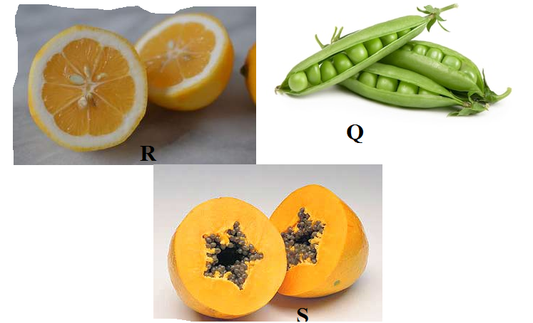
(i)Name the type of placentation in the specimens shown in photographs Q, R and S With reasons (6mks )
Q Marginal placentation - Placenta running longitudinally with seeds in a single line
R Axile/ central placentation –Placenta centrally placed/ presence of loculi/chambers
S Parietal placentation.-Ovary wall divided by placenta which is on ridges with many seeds attached
(ii)Giving a reason in each case, name the mode of dispersal of the specimen in photograph Q and S (4marks)
Q Mode Self-dispersal
Reason The pods contains lines of weakness/sutures.
S Mode Animal
Reason Succulent /fleshy /brightly coloured. Any 1mk
iii)What type of fruit is R .Give a reason.(2mks)
Berry
Reason: -Has a centrally placed placenta
-Has many seeds
-Presence of loculi(with juicy sacs)
3. The diagram below represent a section of human skeleton and muscles.
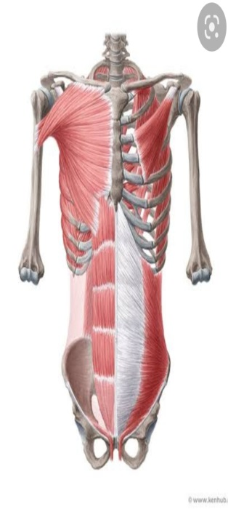a)i)Name the parts labelled :
P
R
S
Q
W
A
W Ilium 1mk
S Rib 1mk
R Humerus 1mk
Q External intercoastal muscles 1mk
ii) What is the significance of part A
-Allow passage of nerves and blood vessels (1mk)
Make pelvic girdle less denser/lighter to reduce the weight load supported by hind limb
(iii)Describe the role of Q during inhalation .(2mks)
It Contract moving Ribcage upward and outward,This increase volume of thoracic cavity reducing pressure in the thoracic cavity.
(iv)Name the type of muscle on the diagram above. 1mk)
Skeletal Muscle;
v)What type of joint is at P. (1mk)
Ball and socket
b)Name the bone that articulate with R at:
i)Proximal end . Scapula (1mk)
ii)Distal end . Ulna (1mk)

