NAME ____________________________________ INDEX NO. _______________
SCHOOL ____________________________________ SIGNATURE _______________ DATE _______________

232/1
PHYSICS
PAPER 1
TIME: 2 HOURS
LANJET JOINT EXAMINATION
kenya certificate of secondary education
INSTRUCTIONS TO CANDIDATES
- Write your name, school and index number in the spaces provided above.
- Write the date of examination and sign in the spaces provided above.
- This paper consists of two sections, Section A and B.
- Answer ALL the questions in section A and B in the spaces provided.
- ALL answers and working MUST be clearly shown.
- Mathematical tables and electronic calculators may be used.
- Take acceleration due to gravity, g = 10m/s²

FOR EXAMINER’S USE ONLY:
Section | Question | Maximum score | Candidate’s score
A | 1−12 | 25
B | 13 | 12
 | 14 | 11
 | 15 | 10
 | 16 | 12
 | 17 | 10
 | Total | 80

This paper consists of 10 printed pages
Candidates should check to ensure that all pages are printed as indicated and no questions are missing

- Figure 1 below shows a micrometer screw gauge being used to measure the diameter of a metal rod. The thimble scale has 50 divisions.
Metal rod
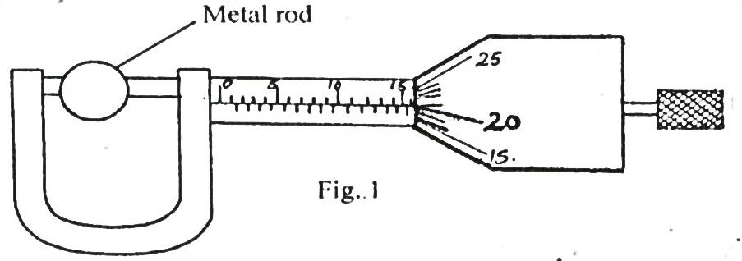
Fig. 1
Find the diameter of the metal rod. (1 mark)
…………………………………………………………………………………………………………………………………………………………………………………………………………….................

- Explain briefly how the temperature in a green house is kept higher than outside. (2 marks)
……………………………………………………………………………………………………………………………………………………………………………………………………………………………………………………………………………………………………………………………………..
The diagram shown in figure 2 below is an arrangement of three pulley wheels used to help in lifting loads. Use it to answer questions 3 and 4.
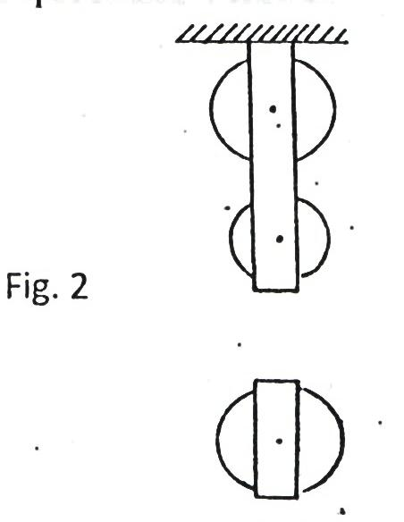 Fig. 2
- Complete the diagram to show how the rope goes round the wheels, position of the load and the effort. (2 marks)
4. Write down the velocity ratio (VR) of the system. (1 mark)
………………………………………………………………………………………………………………..
- State how temperature affects the speed of sound in air. (1 mark)
………………………………………………………………………………………………………………………………………………………………………………………………………………………..

__
- State two facts which show that heat from the sun does not reach the earth surface by convection. (2 marks)
……………………………………………………………………………………………………………………………………………………………………………………………………………………………………………………………………………………………………………………………………
- The diagram in figure 3 below shows water with negligible viscosity flowing steadily in a tube of different cross-section area. If at a point A, the cross section area is 120cm² and the velocity of water is 0.40ms⁻¹, calculate the velocity at B where cross section area is 4.0cm²? (3 marks)
B
A
Fig. 3
…………………………………………………………………………………………………………………………………………………………………………………………………………………………………………………………………………………………………………………………………………………………………………………………………………………………………………………………………………………………………………………………………………………………………………………………………………………………………………………………………………………………………………………………………………………………………………………………………..
8. A motor uses an electrical energy at a rate of 200W and raises a mass of 25kg through a vertical distance of 20m in 0.5 minutes. Determine the efficiency of the motor. (3 marks)
…………………………………………………………………………………………………………………………………………………………………………………………………………………………………………………………………………………………………………………………………………………………………………………………………………………………………………………………………………………………………………………………………………………………………………………………………………………………………………………………………………………………………………………………………………………………………………………………………
9. Name three types of forces that act between bodies not in contact. (3marks
…………………………………………………………………………………………………………………………………………………………………………………………………………………………………………………………………………………………………………………………………………….
10. How long will it take 240V, 3000W electric immersion heater to raise the temperature of 150 litres of water in a well-lagged calorimeter made of copper of mass 20kg from 15⁰ to 70⁰C? (3 marks)
………………………………………………………………………………………………………………………………………………………………………………………………………………………………………………………………………………………………………………………………………………………………………………………………………………………………………………………………………………………………………………………………………………………………………………………………………………………………………………………………………………………………………………………………………………………………………………………………….

11. The diagram shown in the Figure 4 below shows a system in equilibrium with the rule horizontal.
AB is a uniform rule of length 1.0m and weight 1.8N. Calculate the weight of the block X. (3 marks)

40cm

30cm

Fig. 4
180 g
X
Q
B
A
……………………………………………………………………………………………………………………………………………………………………………………………………………………………………………………………………………………………………………………………………………………………………………………………………………………………………………………………………………………………………………………………………………………………………………………………………………………………………………………………………………………………………………………………………………………………………………………………………………………………………………………………………………………………………
12. State the reason why a trailer carrying heavy loads has many wheels. (1 mark)
………………………………………………………………………………………………………………………………………………………………………………………………………………………………………………………………………………………………………………………………………..

SECTION B (55 MARKS)
Answer ALL the questions
13.(a) The figure5 below shows the displacement – time graph of the motion of particle.
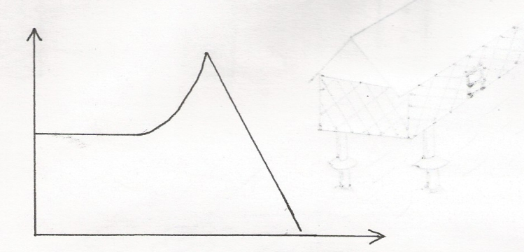
B
C

A
Displacement (M)
D

Time (s)

- State the nature of the motion of the particle between
- A and B (1mk)
………………………………………………………………………………………………..
………………………………………………………………………………………………..
- B and C (1mk)
………………………………………………………………………………………………..
………………………………………………………………………………………………..
- C and D (1mk)
………………………………………………………………………………………………..
………………………………………………………………………………………………..
- A ball is thrown horizontally from top of a vertical tower and strikes the ground at a point 50 m from the bottom of the tower. Given that the height of the tower is 45m, determine the
- Time taken by the ball to hit the ground. (2m)
……………………………………………………………………………………………………………………………………………………………………………………………………………………………………………………………………………………………………………………………………………………………………………………………………………………………………………………………………………………………………………………………………………………………………….
- Initial horizontal velocity of the ball (2mks)
………………………………………………………………………………………………………………………………………………………………………………………………………………………………………………………………………………………………………………………………………………………………………………………………………………………………………………………………………………………………………………………………………………………………………..
- Vertical velocity of the ball just before striking the ground. (2mks)
( take acceleration due to gravity g as 10m/s)

………………………………………………………………………………………………………………………………………………………………………………………………………………………………………………………………………………………………………………………………………………………………………………………………………………………………………………………………….

14. a) State the pressure law; (1 mark)
………………………………………………………………………………………………………………………………………………………………………………………………………………………………………………………………………………………………………………………………………………………………………………………………………………………………………………..
- Explain how a gas exerts pressure. (2 marks)
………………………………………………………………………………………………………………………………………………………………………………………………………………………………………………………………………………………………………………………………………
- The figure below shows a set up used to verify pressure law.
- State the measurement that may be taken in the experiment. (2 marks)
……………………………………………………………………………………………………………………………………………………………………………………………………………………………………………………………………………………………………………………….....................
- Explain how the measurement in (i) above may be used to verify pressure law. (2 marks)
……………………………………………………………………………………………………………………………………………………………………………………………………………………………………………………………………………………………………………………………………………………………………………………………………………………………………………………………………………………………………………………………………………………………………………………………………………………………………………………………………………………………………………………………………………………………………………………………
- A car tyre is at pressure of 5.0x10⁵ Pa at a temperature of 37$℃$. While it is running the temperature rises to 75$℃$. What is the new tyre pressure? (Assume the tyre does not expand) (3 marks)
……………………………………………………………………………………………………………………………………………………………………………………………………………………………………………………………………………………………………………………………………………………………………………………………………………………………………………………………………………………………………………………………………………………………………………………………………………………………………………………………………………………………………………………………………………………………………………………………………………………………………………………………………………………………………
15. i) Distinguish between inelastic and elastic collisions. (2 marks)
…………………………………………………………………………………………………………………………………………………………………………………………………………………………………………………………………………………………………………………………………………………………………………………………………………………………………………
b) The diagram in Figure 6 below shows a sphere moving in a viscous liquid in a tall measuring cylinder.
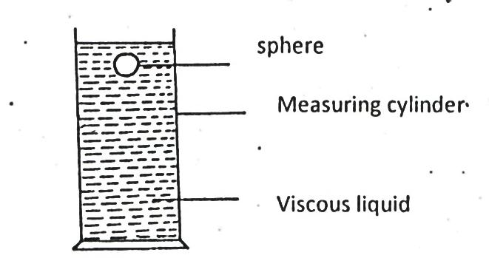
Measuring cylinder
Viscous liquid
Sphere
i) Show on the diagram the forces acting on the sphere. (3 marks)
ii) Sketch a graph showing the variation of velocity with time in figure 7 below. Show on the graph the terminal velocity, V_{T}. (2 marks)

- A mass of 1kg is attached to a cord of length 50cm. It is whirled in a circle in a vertical plane at 10 revolutions per second as shown in the figure 8 below.
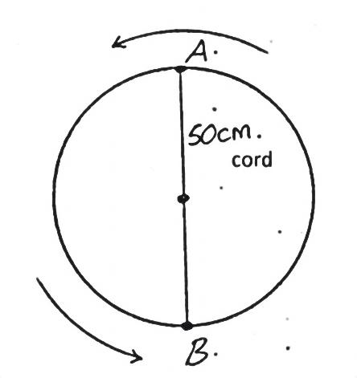
B

A

50cm
cord
- Find the tensions in the cord when the mass is at:
- Highest point of the circle A. (2 marks)
…………………………………………………………………………………………………………..
……………………………………………………………………………………………………………….
………………………………………………………………………………………………………………….
………………………………………………………………………………………………………………..
………………………………………………………………………………………………………………..
…………………………………………………………………………………………………………………
- Lowest point of the circle B. (2 marks)
…………………………………………………………………………………………………………………
…………………………………………………………………………………………………………………………………………………………………………………………………………………………
…………………………………………………………………………………………………………………..
b).The diagram below shows a spring tied to an object, m, and rotated in a circular path of
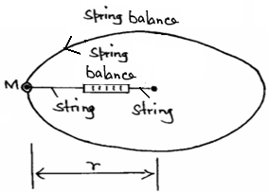
radius, r.

(i).What provides the force that keeps the object moving in a circular path. (1 mark)

……………………………………………………………………………………………

(ii). The speed of the object is constant but the body is accelerating. Explain.
(1 mark)
……………………………………………………………………………………………………….

5
(iii). If the object is whirled faster, what would happen to spring balance reading?
(1 mark)

………………………………………………………………………………..

(iv). Give a reason for your answers in b(iii) above. (1 mark)

……………………………………………………………………………………..

v). As the object is whirled round the string snaps and cuts off. Describe the subsequent path of the object. (1 mark)

…………………………………………………………………………………..

………………………………………………………………………………………………..

…………………………………………………………………………………………………..

17. (a) State the law of floatation. (1 mark)

………………………………………………………………………………………………………………………………………………………………………………………………
(b) Figure 9 shows a piece of cork held with a light thread attached to the bottom of a beaker. The beaker is filled with water.
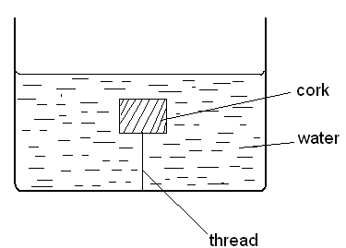

Figure 9
- Indicate and label on the diagram the forces acting on the cork. (1 mark)

- Write an expression showing the relationship between the forces above. (1 mark)
………………………………………………………………………………………………………………………………………………………………………………………………A solid displaces 8.5cm³ of liquid when floating in a certain liquid and 11.5cm³ when fully submerged in the same liquid. The density of the solid is 0.8g/cm³. Determine:-
i)The upthrust on the solid when floating. (2 marks)
………………………………………………………………………………………………………………………………………………………………………………………………………………………………………………………………………………………………
ii) The density of the liquid. (2 marks)
………………………………………………………………………………………………………………………………………………………………………………………………………………………………………………………………………………
- The upthrust on the solid when fully submerged. (2 marks)
………………………………………………………………………………………………………………………………………………………………………………………………………………………………………………………………………………

18.) The following results were obtained in a experiment to verify Hooke’s law when a spring was
extended by hanging various loads on it.
Load (N) | 0.00 | 1.00 | 2.00 | 3.00 | 4.00 | 5.00 | 6.00
Length of spring in cm | 10.00 | 11.50 | 13.00 | 14.50 | 16.00 | 18.00 | 24.00
Extension | 0.00
(I) Complete the table for the extension e above. (1mk)

(II) Plot a graph of load (y-axis) against extension (5mks)

(III) From the graph determine the spring constant. (2mks)
………………………………………………………………………………………………….
…………………………………………………………………………………………………………………
…………………………………………………………………………………………………………………..

(IV) Calculate the energy stored when the spring is stretched to 16 cm. (2mks)
……………………………………………………………………………………………………………………………………………………………………………………………………………………………………………………………………………………………………………………………………………………………………………………………………………………………………………………………………………………………………………………………………………………………………………………..

