Name ……………………………………………Adm No…………… Class…………… School…………………………………Sign………………… Date………………………
233/2
CHEMISTRY
PAPER 2
(THEORY)
TIME: 2HOURS.

LANJET JOINT EVALUATION TEST, 2021
Kenya Certificate of Secondary Education.

INSTRUCTIONS TO CANDIDATES.
- Write your name and index number in the spaces provided above.
- Answer ALL the questions in the spaces provided.
- Mathematical tables and silent electronic calculators may be used.
- All working MUST be clearly shown where necessary.
- Ensure that all pages are printed as indicated.
- This paper has 15 printed pages.

FOR EXAMINER’S USE ONLY.

Questions | Maximum score | Candidates score
1 | 13
2 | 11
3 | 13
4 | 13
5 | 12
6 | 10
7 | 8
Total score | 80

1. Sulphuric (VI) acid can be prepared using hydrogen sulphide as shown in flow chart below.
Study it and answer the questions that follow.
DRY HYDROGEN SULPHIDE
SOLID C
BURNERS
OLEUM
AIR
CHAMBER D
ABSORPTION TOWER
GAS A
SULPHUR (VI) OXIDE
LIQUID B

- Identify:
- Gas A: (1 mark)
……………………………………………………………………………………………
- Liquid B: (1 mark)
……………………………………………………………………………………………
- (i) What function does solid C play in the chamber D? ( 1mark)
……………………………………………………………………………………………
……………………………………………………………………………………………
(ii) Write an equation for the reaction in chamber D. (1 mark)
……………………………………………………………………………………………
……………………………………………………………………………………………
- Explain the observations made if hydrogen sulphide gas is bubbled through copper (II) nitrate solution? (2 marks)
……………………………………………………………………………………………
……………………………………………………………………………………………
……………………………………………………………………………………………
……………………………………………………………………………………………
(d)Write an ionic equation for the confirmatory test for hydrogen sulphide gas.1 mark)

……………………………………………………………………………………………
……………………………………………………………………………………………
……………………………………………………………………………………………

(e)Write a chemical equation to show the formation of concentrated Sulphuric (VI) acid from the oleum. (1 mark)
……………………………………………………………………………………………
……………………………………………………………………………………………
……………………………………………………………………………………………

(f)Explain why in contact process SO₃ gas is not directly dissolved in water to make concentrated sulphuric (VI) acid. (2 marks)
……………………………………………………………………………………………
……………………………………………………………………………………………
……………………………………………………………………………………………
(g)Name the main pollutant from the process above and how it is controlled. (2 marks)
……………………………………………………………………………………………
- State two factors that increases the yield of sulphur (VI) oxide using the equation below. (1 marks)
2SO_{2(g)} + O_{2(g)} 2SO_{3(g)} -ve
……………………………………………………………………………………………
……………………………………………………………………………………………
2.a) During an experiment a student added soap solution to separate samples of water until
lather was formed. Below is a table showing the volumes of soap solution that was
required to form lather with 100cm³ of each sample of water before and after boiling
the samples.
 | Volume (cm³) of soap required by water sample
 | X | Y | Z
Before boiling | 4.5 | 19.5 | 22.5
After boiling | 4.5 | 19.5 | 4.5

- (a)State the most likely source of water sample X. (¹/₂ mark)
……………………………………………………………………………………………
(b) Identify a salt most likely to be present in water sample Y. (¹/₂ mark)
……………………………………………………………………………………………

- Write an equation for the reaction that may have occurred in water sample Z when it was being boiled. (1 mark)
……………………………………………………………………………………………

b) Study the flowchart below and answer the questions that follow.
- Name the types of reaction that occurs in steps I and II
Step I : …………………………………….. (¹/₂ mark)
Step II : …………………………………… (¹/₂ mark)

- What conditions are necessary for the reaction you have named in (i) above? (1¹/₂ mark)
……………………………………………………………………………………………
……………………………………………………………………………………………

- Write a chemical equation for the reaction that takes place in step IV (1 mark)
……………………………………………………………………………………………
……………………………………………………………………………………………
……………………………………………………………………………………………
- Why is substance R used in some soaps? (¹/₂ mark)
……………………………………………………………………………………………

c) The flow diagram below shows some of the steps followed during the industrial manufacture of a detergent.
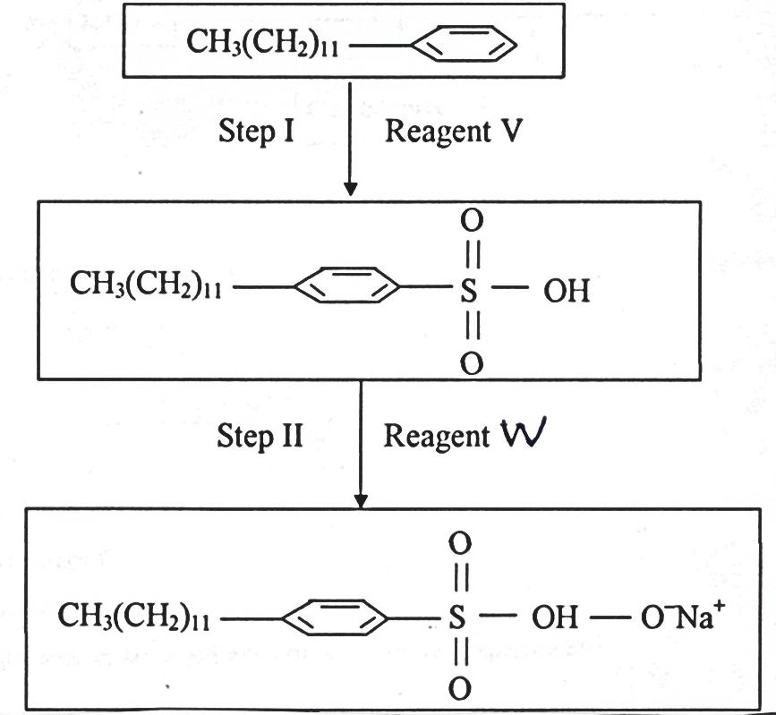
i) What is a detergent? (1 mark)
……………………………………………………………………………………………
……………………………………………………………………………………………
……………………………………………………………………………………………

ii) Identify reagents V and W (2 marks)
- Reagent V ……………………………………………………………..
- Reagent W ……………………………………………………………

iii) Write an equation for the reaction that may occur when the detergent is added to water containing magnesium ions. (1 mark)
……………………………………………………………………………………………
……………………………………………………………………………………………

iv) State one advantage of using the above detergent. (1 mark)
……………………………………………………………………………………………
……………………………………………………………………………………………

3. Metals K and N were connected to form a cell as shown in the diagram below. Their reduction potentials are as shown below:
K⁺_{(aq)} / K_{(s)} ≡ - 0.17V
N⁺_{(aq)} / N_{(s)} = + 1.1 6V
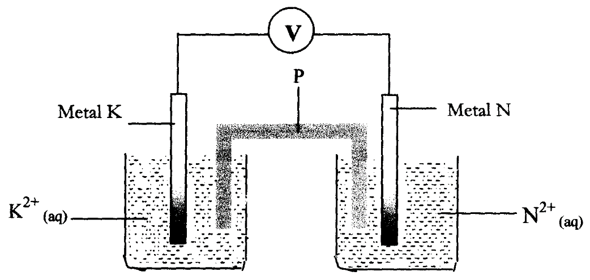

I. Write the equation for the half-cell reaction that occurs at
Metal K electrode (1mark)
………..........................................................................................................
Metal N electrode (1mark)
......................................................................................................................
II) Identify P and state two roles in the above setup
(i). Identity of P (1 mark)
……………………………………………………………………………………………

- Two Roles of P in the setup. ( 1 mark)

…………………………………………………………………………….
III. On the diagram, show the flow of :-
I. Electrons (¹/₂ mark)
……………………………………………………………………………………………
……………………………………………………………………………………………
II. Current. (¹/₂ mark)
……………………………………………………………………………………………
……………………………………………………………………………………………
IV Calculate cell potential (E) for the cell represented in the setup above (1 mark)
……………………………………………………………………………………………
……………………………………………………………………………………………
(b) The table gives the standard redox potentials for a number of half reactions. Use it to answer the questions that follow:-
(E^{θ}/Volts)
Zn²⁺ _{(aq)} + 2e⁻ Zn_{(s)} -0.76
Fe²⁺ _{(aq)} + 2e⁻ Fe_{(s)} -0.44
I²⁺ _{(l)} + 2e⁻ 2I⁻ _{(aq)} +0.54
Fe³⁺ _{(aq)} + e⁻ Fe²⁺_{(aq)} +0.77
Ag⁺ + e⁻ Ag_{(s)} +0.88
- Relative to which half-cell reaction are the above electrode potentials expressed?
(¹/₂ mark)
……………………………………………………………………………………………
……………………………………………………………………………………………

(ii) Calculate the e.m.f of the cell made up by combining the I_{2(l)} /2I⁻_{(aq)} electrode and

Zn²⁺_{(aq)}/Zn_{(s)} electrode (1marks)
……………………………………………………………………………………………
……………………………………………………………………………………………
(ii) Which of the substances listed in the above table is :- ( 1marks)

- The strongest oxidising agent
……………………………………………………………………………………………
……………………………………………………………………………………………
- The strongest reducing agent
……………………………………………………………………………………………
……………………………………………………………………………………………
(iv) Which substances could be used to convert iodide ions to iodine? Write balanced equations for any possible conversions (1mark)

…………………………………………………………………………………………….
(v) Draw a cell diagram formed between zinc and lead. (2marks)

c) A steady current of 2.5A was passed for 15 minutes through a cell containing divalent ions
M²⁺. During this process 0.74g of metal M was deposited (IF = 96500C)
Calculate the quantity of electricity passed in this cell (1mark)
……………………………………………………………………………………………
……………………………………………………………………………………………
ii) Determine the relative atomic mass of M (2marks)
……………………………………………………………………………………………
……………………………………………………………………………………………
……………………………………………………………………………………………

4. In an experiment, a student measured the amount of gas produced with time when excess 1.0 M hydrochloric acid was reacted with 0.42 g of a carbonate, XCO₃ and obtained the following results. (Note: The reaction was carried out at room temperature)
Time (minutes) | Volume of carbon (IV) oxide, cm³
0.0 | 0
0.5 | 20
1.0 | 32
2.0 | 52
5.0 | 86
7.5 | 103
10.0 | 112
12.0 | 118
14.0 | 120
16.0 | 120
18.0 | 120
a) On the graph paper provided, draw a graph of volume of carbon (IV) oxide against time.{3 mks}

b) From the graph,
i) Determine the time at which half the original mass of marble chips will have reacted.
(1 mark)
……………………………………………………………………………………………
- Determine the reaction rate between the 5th and 6th minutes. (2 marks)
……………………………………………………………………………………………
……………………………………………………………………………………………
c) i)Write the equation for the reaction that takes place. (1 mark)
……………………………………………………………………………………………
……………………………………………………………………………………………
……………………………………………………………………………………………
……………………………………………………………………………………………

ii) Calculate the total number of moles of carbon (IV) oxide produced in this reaction.
(Molar gas volume at r.t.p = 24 dm³) (2 marks)
……………………………………………………………………………………………
……………………………………………………………………………………………
……………………………………………………………………………………………
……………………………………………………………………………………………
iii) Determine the relative molecular mass of XCO₃. (2 marks)
……………………………………………………………………………………………
……………………………………………………………………………………………
……………………………………………………………………………………………
……………………………………………………………………………………………
iv) Determine the relative atomic mass of X. (1 mark)
……………………………………………………………………………………………
……………………………………………………………………………………………
……………………………………………………………………………………………

d) On the same graph paper, draw a sketch of the curve that would be obtained if 0.5 M hydrochloric acid was used. Label the curve A. (1 mark)
……………………………………………………………………………………………
……………………………………………………………………………………………

5. Sodium metal tarnishes when exposed to air to form a white powder on its surface. A small piece of sodium metal was dropped into 30 g of propanol and 2400cm³ of hydrogen gas produced at room temperature and pressure .The unreacted propanol was evaporated and white solid remained .( molar Gas Volume at room temperature and pressure =24dm³ Na=23 , C=12 , O= 16)
a) (i)Give the name of the white powder formed on the original piece of sodium metal. (1mark)
……………………………………………………………………………………………
……………………………………………………………………………………………
(ii)Explain how the white solid was formed. (2marks)
……………………………………………………………………………………………
……………………………………………………………………………………………
……………………………………………………………………………………………
b) (i)White down the chemical equation for the reaction between propanol and sodium metal. (1mark)
……………………………………………………………………………………………
……………………………………………………………………………………………
(ii)Determine the mass of sodium that reacted with propanol. (2marks)
……………………………………………………………………………………………
……………………………………………………………………………………………
……………………………………………………………………………………………
(iii) What mass of propanol was evaporated? (2 marks)
……………………………………………………………………………………………
……………………………………………………………………………………………
……………………………………………………………………………………………
(iv) The propanol was evaporated at 97⁰c and the white solid remained unaffected at this temperature .what is the difference in structure of propanol and white solid. (1 mark)
……………………………………………………………………………………………
……………………………………………………………………………………………
……………………………………………………………………………………………

c) (i)Name the inorganic liquid which liberates hydrogen gas with sodium metal. (1 mark)
……………………………………………………………………………………………
……………………………………………………………………………………………
……………………………………………………………………………………………
(ii)State two differences you would observe if similar pieces of sodium metal were dropped
separately into beakers containing equal amount of propanol and liquid named in (i)
above respectively. (2marks)
……………………………………………………………………………………………
……………………………………………………………………………………………
……………………………………………………………………………………………
……………………………………………………………………………………………
6. The figure below is a section of periodic table. Study and answer the questions that follow. The letters do not represent the actual symbol of elements.
A
 |  |  |  |  | D |  | I | E
F | G |  | H
J

(i) Select the elements which belongs to the same chemical family. (¹/₂ mark)
……………………………………………………………………………………………
(ii)Identify the strongest reducing element. (¹/₂ mark)
……………………………………………………………………………………………

b) (i) The chloride of H vaporizes easily while the oxide of H has a high melting point. Explain
the observation in terms of structure and bonding. (2marks)
……………………………………………………………………………………………
……………………………………………………………………………………………
……………………………………………………………………………………………
……………………………………………………………………………………………
(ii)Blue and red litmus papers were dropped into solution of chloride of H, state and explain the observations made. (1mark)
……………………………………………………………………………………………
……………………………………………………………………………………………
……………………………………………………………………………………………
c) K⁻ has ionic configuration of 2:8:8
(i) Give the chemical family name to which element K belong. (1mark)
……………………………………………………………………………………………
……………………………………………………………………………………………
(ii) Place element K on the above periodic table. ( 1mark)
……………………………………………………………………………………………
……………………………………………………………………………………………

d) The first and second ionization energies of element G at random are 665kjmol⁻ and 560 kjmol⁻
(i) Define the term the ionization energy. (1mark)
……………………………………………………………………………………………
……………………………………………………………………………………………
(ii) Write equations for the first and second ionization energies for element G indicating their energies. (1 mark)
……………………………………………………………………………………………
……………………………………………………………………………………………
(iii) Explain your answer in (ii) above. (1mark)
……………………………………………………………………………………………
……………………………………………………………………………………………
e) Explain the difference in the atomic radii of D and I. (1mark)
……………………………………………………………………………………………
……………………………………………………………………………………………

7. The diagram below illustrates the Hall’s cell for the extraction of Aluminium. Study it and answer the questions that follow.
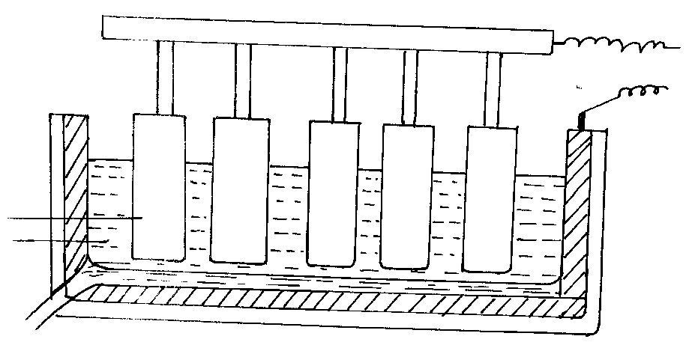
G
Molten Aluminium
Electrolyte
- (i) Name the electrode labeled G (1 mark)

……………………………………………………………………………………………

(b) Electrolysis is carried at 800 – 900⁰C and newly formed Aluminium is tapped off as a
liquid. What does this indicate about the melting point of Aluminium? (1 mark)
……………………………………………………………………………………………
(c) (i) Give the ionic equations for the reaction that takes place at the cathode. (1 mark)
……………………………………………………………………………………………
……………………………………………………………………………………………
(ii) The anode has to be replaced frequently. Explain. (1 mark)
……………………………………………………………………………………………
……………………………………………………………………………………………
d) Cryolite is used in the extraction of aluminium from bauxite. State its function. (1mark)
……………………………………………………………………………………………
……………………………………………………………………………………………
d) A piece of unpolished aluminium foil is not attacked by water steam and dilute hydrochloric acid. Explain. (1mark)
……………………………………………………………………………………………
……………………………………………………………………………………………

e) (i) The basic raw material for extraction of aluminium is bauxite. Name two major impurities in bauxite. (1 mark)
……………………………………………………………………………………………
……………………………………………………………………………………………
(ii) State one property of duralium that make it more suitable than pure aluminium in aeroplane construction. (1 mark)

