**LANET JOINT EVALUATION TEST**

**231/ 1 - BIOLOGY - Paper 1**

**Dec. 2021 – 2 hours**

**Name ...................................................................................................... Index Number.................................**

**Candidate’s Signature.............................................................................. Date................................................**

**Instructions to Candidates:**

*(a) Write your name and Index Number in the spaces provided above.*

*(b) Sign and write the date of examination in the spaces provided above.*

*(c) Answer* ***all*** *questions in the spaces provided in this booklet.*

*(d)* ***This paper consists of 11 printed pages.***

*(e)* ***Candidates should check the question paper to ascertain that all the pages are printed as indicated and that no questions are missing.***

*(f)* ***Candidates should answer the questions in English.***

**For Examiner’s Use Only**

|  |  |  |  |  |  |  |  |  |  |  |  |  |  |  |  |
| --- | --- | --- | --- | --- | --- | --- | --- | --- | --- | --- | --- | --- | --- | --- | --- |
| **1** | **2** | **3** | **4** | **5** | **6** | **7** | **8** | **9** | **10** | **11** | **12** | **13** | **14** | **15** | **16** |
|  |  |  |  |  |  |  |  |  |  |  |  |  |  |  |  |

|  |  |  |  |  |  |  |  |  |  |  |  |  |  |
| --- | --- | --- | --- | --- | --- | --- | --- | --- | --- | --- | --- | --- | --- |
| **17** | **18** | **19** | **20** | **21** | **22** | **23** | **24** | **25** | **26** | **27** | **28** | **Grand Total**  **Turn over** |  |
|  |  |  |  |  |  |  |  |  |  |  |  |

**1.** a) Grazers and browsers co-exist without problems with each other. Explain. (2marks)

………………………………………………………………………………………………..……………………………………………………………………………………………………………..……………………………………………………………………………………………………………..……………………………………………………………………………………………………………...……....….

b) With reference to the leaves only give **two** adaptations of submerged hydrophytes. ( 2marks)

………………………………………………………………………………………………..……………………………………………………………………………………………………………..……………………………………………………………………………………………………………..……………………………………………………………………………………………………..………...………….

**2.** a) i) Name the part of the eye where image is formed. (1mark)

……………………………………………………………………………………………………………………………………………………………………………………………………………………………………………………………………………………………………………………………………………………………...…………………………………………………………………………………….

ii) State **two** characteristics of the image formed on part named in (a) above. (2marks)

……………………………………………………………………………………………………………………………………………………………………………………………………………………………………………………………………………………………………………………………………………………………………………………...…………………………………………………………….

b) State the functional difference between semi circular canals and the vestibule apparatus of the ear. ( 2marks)

……………………………………………………………………………………………………………………………………………………………………………………………………………………………………………………………………………………………………………………………………………………………………………………...…………………………………………………………….

**Turn over**

**3**. A layer of glycerine was applied on upper surface of a freshwater floating plant that had been kept in the dark for 24 hours. The plant was left undisturbed in bright light. After three hours test for starch carried out on the leaves produced a brown colour of iodine solution. Account for the observation. (3 marks)

……………………………………………………………………………………………………………………………………………………………………………………………………………………………………………………………………………………………………………………………………………………………………………………...…………………………………………………………….

…………………………………………………………………………………………………………………………………………………………………………………………………………………………

**4**. A form four student was walking around the school compound and saw leaves from Nandi flame tree on the ground.

(a) Name the hormone responsible for this phenomenon. (1 mark)

…………………………………………………………………………………………………………………………………………………………………………………………………………………………

(b) State the significance of the above phenomenon to the tree. (2 marks)

………………………………………………………………………………………………………………………………………………………………………………………………………………………………………………………………………………………………………………………………………………………………………………………………………………………………………………….

**5.** The following are diagrams of two pollen grains.

**K**

**L**

1. State **one** observable difference between K and L. (1 mark)

………………………………………………………………………………………..…………………………………………………………………………………………………………………………………

**Turn over**

1. State the agent of pollination for each of them. (2 marks)

K …………………………………………………………………………………………………

L ………………………………………………………………………………………………….

**6**. During oxidation of certain food substances, the respiratory quotient was found to be 0.718.

1. Name the type of food substance being oxidized. (1mark)

…………………………………………………………………………………………………………..………………………………………………………………………………………………………………

1. State **two** advantages of using the food substances named. (2marks)

………………………………………………………………………………………………………………………………………………………………………………………………………………………………………………………………………………………………………………………………………………………………………………………………………………………………………………….

1. The diagram below represents a cell at one stage of the cell division.

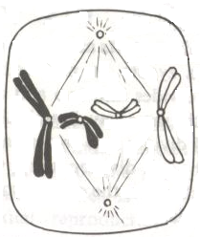

1. Identify the stage. (1 mark)

………………………………………………………………………………………………………..…………………………………………………………………………………………………………………

i) Is the cell of a plant or an animal? (1 mark)

…………………………………………………………………………………………………………..………………………………………………………………………………………………………………

ii) Give **a** reason for your answer in (b)(ii) above. (1 mark)

…………………………………………………………………………………………………………..………………………………………………………………………………………………………………

**Turn over**

1. The quantity of urine passed per day was measured in four mammals; A, B, C and D of the same species in their natural habitats. The results were as shown below.



1. In what form is nitrogenous waste likely to be in organism D? Explain. (3 marks)

……………………………………………………………………………………………………………………………………………………………………………………………………………………………………………………………………………………………………………………………………………………………………………………...…………………………………………………………….

1. Explain why it is advisable to breathe through the nose rather than the mouth in man. (2 marks)

………………………………………………………………………………………………………………………………………………………………………………………………………………………………………………………………………………………………………………………………………………………………………………………………………………………………………………….

1. Name the valve which opens during:
2. Systole ………………………………………………………………...................(1 mark)
3. Diastole…………………………...............……………………………………… (1 mark)
4. State the branch of Biology that would be used in solving the problem of disputed parentage. (1mark)

…………………………………………………………………………………………………………………………………………………………………………………………………………………………

**Turn over**

1. Explain why carbohydrates are stored in their polysaccharide forms in both plants and animals. (3 marks)

………………………………………………………………………………………………………………………………………………………………………………………………………………………………………………………………………………………………………………………………………

1. Name the organelles that are abundant in:

(a) Goblet cells ..........................................................................................................(1 mark)

(b) Liver cells..............................................................................................................(1 mark)

**14**. Give a reason why it is difficult to calculate Respiratory Quotient (RQ) in plants. (2 marks)

………………………………………………………………………………………………………………………………………………………………………………………………………………………………………………………………………………………………………………………………………

**15**. A biological washing detergent contains enzymes which remove stains like mucus and oils from clothes which are soaked in water with the detergent.

(a) Name the two groups of enzymes that are present in the detergent. (2 marks)

…………………………………………………………………………………………………………………………………………………………………………………………………………………………………………………………………………………………………………………………………….

……………………………………………………………………………………………………………

1. Why would the stains be removed faster with the detergent in water at 35°C rather than at 15°C? (2 marks)

………………………………………………………………………………………………………………………………………………………………………………………………………………………………………………………………………………………………………………………………………

……………………………………………………………………………………………………………

**Turn over**

**16**. Explain why it is important to go for Voluntary Counselling and Testing (VCT) on HIV/AIDS. (2 marks)

………………………………………………………………………………………………………………………………………………………………………………………………………………………………………………………………………………………………………………………………………

…………………………………………………………………………………………………………………………………………………………………………………………………………………………

1. The diagram below shows the eggs of a certain amphibian.

**Jelly**

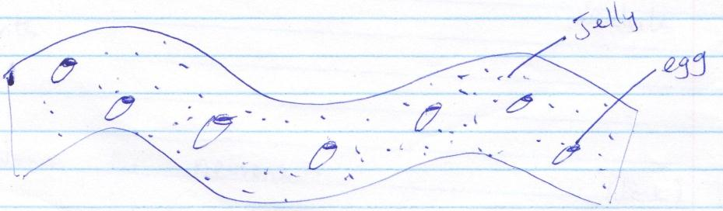

**Egg**

a) State **three** functions of the jelly. (3 marks)

………………………………………………………………………………………………………………………………………………………………………………………………………………………………………………………………………………………………………………………………………………………………………………………………………………………………………………….

b) What is the biological importance of the organism laying many eggs? (1 mark)

…………………………………………………………………………………………………………………………………………………………………………………………………………………………

…………………………………………………………………………………………………………………………………………………………………………………………………………………………

**18**. The diagram below show various types of gene mutations.

**Mutation I**;

|  |  |  |  |  |  |  |
| --- | --- | --- | --- | --- | --- | --- |
| K | L | M | N | O | P | Q |

|  |  |  |  |  |
| --- | --- | --- | --- | --- |
| K | L | M | P | Q |

**Turn over**

**Mutation II;**

|  |  |  |  |  |  |  |
| --- | --- | --- | --- | --- | --- | --- |
| S | T | U | V | W | X | Y |

|  |  |  |  |  |  |  |
| --- | --- | --- | --- | --- | --- | --- |
| S | T | U | N | W | X | Y |

i) Identify the type of mutations shown above (2 marks)

………………………………………………………………………………………………………..…………………………………………………………………………………………………….………….………………………………………………………………………………………………………………

ii) Name **one** disorder that results from gene mutation II. (1 mark)

………………………………………………………………………………………………………..…………………………………………………………………………………………………………………

**19**. State **three** advantages of metamorphosis to the life of an insect (3marks)

………………………………………………………………………………………………………..…………………………………………………………………………………………………………………

………………………………………………………………………………………………………..…………………………………………………………………………………………………………………

…………………………………………………………………………………………………………………………………………………………………………………………………………………………

**20**. (a) State **two** limitations of fossil records as an evidence for organic evolution theory. (2marks)

………………………………………………………………………………………………………..…………………………………………………………………………………………………………………

………………………………………………………………………………………………………..……………………………………………………………………………………………………………………………………………………………………………………………………………………………………………………………………………………………………………………………………………

(b) State an idea that led to the formulation of Lamarck’s theory of evolution. (1mark)

………………………………………………………………………………………………………..……………………………………………………………………………………………………………………………………………………………………………………………………………………………………………………………………………………………………………………………………………

**Turn over**

**21**. Explain what happens to red blood cells placed in distilled water for 20 minutes. (3 marks)

………………………………………………………………………………………………………..…………………………………………………………………………………………………………………

………………………………………………………………………………………………………..……………………………………………………………………………………………………………………………………………………………………………………………………………………………………………………………………………………………………………………………………………

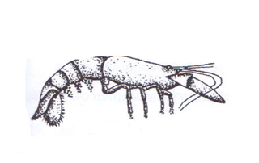

**22**. Below is a photograph of an organism

1. Identify the class to which this organism belongs to. (1 mark)

………………………………………………………………………………………………………..…………………………………………………………………………………………………………………

ii) Give reasons for your answer in (i) above. (2 marks)

……………………………………………………………………………………………………………………………………………………………………………………………………………………………………………………………………………………………………………………………………………………………………………………………………………………………………………………

**Turn over**

**23**. What are the functions of the odontoid process found on the axis bone of the vertebra (2marks)

………………………………………………………………………………………………………..…………………………………………………………………………………………………………………

………………………………………………………………………………………………………..…………………………………………………………………………………………………………………

**24**. Give **three** main reasons why plants do not require an elaborate excretory system like animals (3marks)

………………………………………………………………………………………………………..…………………………………………………………………………………………………………………

………………………………………………………………………………………………………..…………………………………………………………………………………………………………………

…………………………………………………………………………………………………………………………………………………………………………………………………………………………

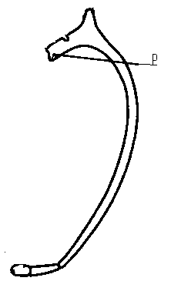**25**. Study the diagram of an animal below and answer the questions that follow.

1. Name the part labeled P (1mark)

P ………………………………………………………………………………………………

1. How is the above structure adapted to its function? (2marks)

………………………………………………………………………………………………………..…………………………………………………………………………………………………………………

………………………………………………………………………………………………………..……………………………………………………………………………………………………………...…...………………………………………………………………………………………………………..……

**Turn over**

**26**. State how herbaceous plants obtain their support (3marks)

………………………………………………………………………………………………………..…………………………………………………………………………………………………………………

………………………………………………………………………………………………………..………………………………………………………………………………………………………………...

…………………………………………………………………………………………………………………………………………………………………………………………………………………………

**27**. a) Name **two** structures for gaseous exchange in aquatic plants. (2 marks)

………………………………………………………………………………………………………..…………………………………………………………………………………………………………………

………………………………………………………………………………………………………..………………………………………………………………………………………………………………...

b) Explain why guards cells have thicker inner walls and thinner outer walls. (1 mark)

………………………………………………………………………………………………………..…………………………………………………………………………………………………………………

………………………………………………………………………………………………………..………………………………………………………………………………………………………………...

**28**. Explain the significance of etiolation in plants growing in the dark (2 marks)

………………………………………………………………………………………………………..…………………………………………………………………………………………………………………

………………………………………………………………………………………………………..………………………………………………………………………………………………………………...

**Turn over**

**THIS IS THE LAST PAGE**

**THIS IS THE LAST PRINTED PAGE**