MECS GEO PAPER 2 MARKING SCHEME
SECTION A.
Answer all the questions in this section
- (a) Name two breeds of dairy cattle reared in Kenya(2mks)
Guernsey Jersey Friesian zebu
Ayrshire/Holstein Alderney Sahiwal Swiss Brown
(b) State three factors which favour dairy farming in Denmark (2mks)
- There is specialisation advanced technology/well-developed co-operative movement provided capital.
- Availability of market for dairy product
- Cool climate/moderate temperature (12-15)ºC moderate, high rainfall (500-1500)
- Well-developed transport/communication network/infrastructure
- Plenty of food/pasture
- Mechanised system of farming.
- (a) State three physical factors which influence the location of settlements (3mks)
-Reliability/availability of landscape - favourable relief/suitability
-suitability of climate/adequate rainfall -fertile soils type of soils
Absence of pest and diseases/healthy environment
(b) Use the sketch map below to answer questions (i) and (ii) (3mks)
Name the main settlement pattern in
- the northern part of the area represented by the map (lmk)
- Clustered nucleated

- the southern part of the area represented by the map
- linear

3(a) State three reasons why marine fisheries in Kenya are underdeveloped. (3mks)
- The continental shelf is narrow.
- Poor transport connections to the fisheries
- The coastline is fairly straight/has few identifications
- The water is too warm for fish breeding shallow continental lack of upwelling of water
- There is low local demand for fish
- The fishermen lack modern equipment preservation facilities storage
- Inadequate skills/ research technology
- Competition from developed countries
(b) State three ways through which fish farming contributes to the economy of Kenya (3mks)
- Provide an alternative source of protein/saves foreign exchange
- Encourage development of infrastructure
- It is a source of income for the farmer/earns foreign exchange
- It creates employment opportunities
- It promotes industrial development

4(a) Name two conditions that are necessary for the formation of petroleum (2mks)
- Presence of sedimentary rocks
- Presence of non-porus rocks
- Presence of non-porus rocks/caprock
- Presence of porous rocks
- Presence of organic remains fossils
- Presence of pressure of pressure
(b) List three ways in which open-cast mining effects the environment (3mks)
- it leaves behind ugly open craters/derelicts landscape
- it causes air/water pollution/noise pollution
- it leads to soil erosion
- dumping of heaps of rock waste litters, the surface/land pollution
- Water collects in the open craters forming breeding ground for mosquitos/pests
- Destruction of biodiversity (plans & animals)
5. State four factors that have influence the development of industries in Eldoret town (4mks)
- Availability of agricultural raw materials/any other raw materials
- Availability of power
- Availability of large lands
- Availability of labour
- Availability of ready market
- Government policy

SECTION B
Answer question 6 and any other two questions in this section
6. The table below shows the various modes of transport used by tourists visiting Kenya between the years 2006 and 2009. Use it to answer the following questions.
Mode of transport
 | 2006 | 2007 | 2008 | 2009
Road | 100,000 | 50,000 | 150,000 | 200,000
Air | 600,000 | 650,000 | 700,000 | 800,000
Water | 200,000 | 150,000 | 100,000 | 50,0000
- i) Calculate the percentage increase in the number of tourists between year 2008 and 2009 (3mks)
1,050,000 -950,000= 10,000
100,000 x 100
950,000
= 10.526%/ 10.53/10.5%
ii) Draw a compound bar graph to represent the data (8mks)
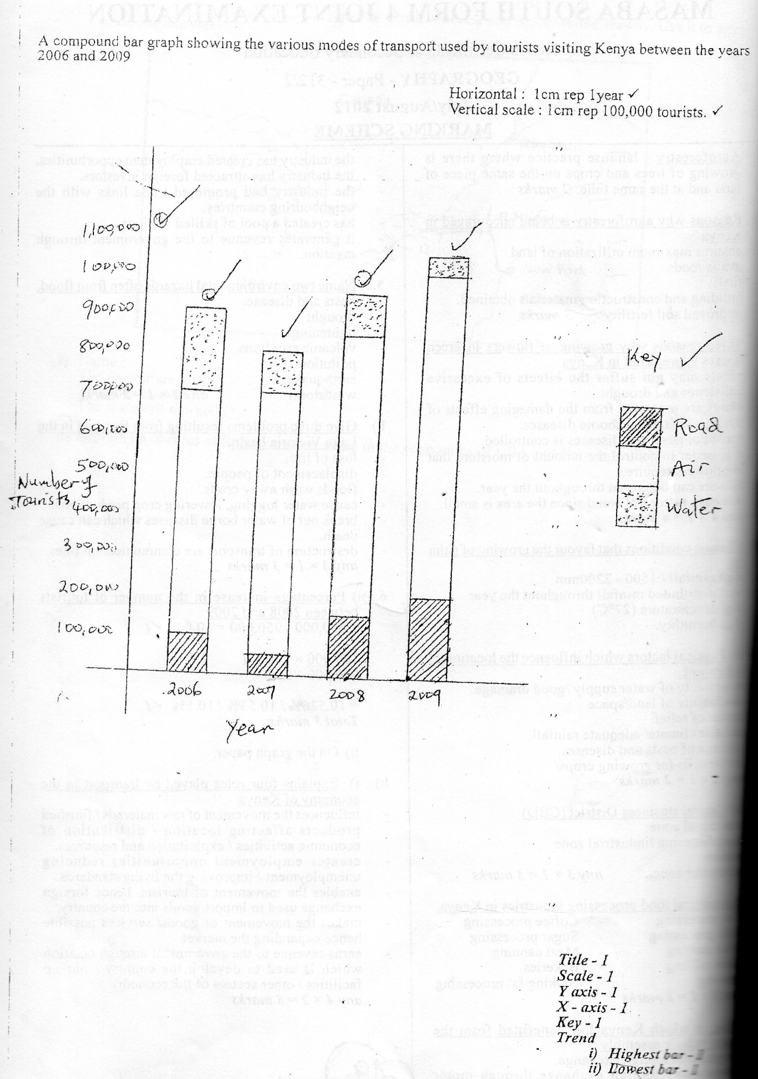
- (i) Explain any four roles played by transport in the economy of Kenya (8mks)
- Influences the movement of raw materials/finished products affecting location/distribution of economic activates/exploitation and resources.
- Creates employment opportunities reducing unemployment /improving the living standards.
- Enables the movement of tourists, hence foreign exchange used to import goods into the country
- Makes the movement of good/services possible hence expanding the market.
- Earns revenue to the government through taxation which is used to develop the country/put up facilities/other sectors of the economy. (any 4x2=8mks)

- State two problems that face the construction of trans-continental highway in Africa (2mks)
- Some countries have internal conflicts
- Scarcity of capital to invest in road construction
- Some highways are designed to pass through thick forests, that are difficult to clear or expensive
- Political differences cannot allow them to construct a road ( any 1x1= 1mk)

- Students from your class visited Kisumu airport for a field study
- Identify two methods they used to record their data(2mks)
- Note taking
- Video recording
- Filling in questionnaires
- Taking photographs
- Tallying
- Sketching (any 2x1=2)
- Give two follow up activities they engaged in (2mks)
- Compile notes.
- Discuss findings.
- Draw better diagrams/maps.
- Display photographs.
- Making models. (any 2x1=2mks)
7. (i) What is industrialisation (2mks)
It is the processes by which a non-industrialised country become industrialised by establishing manufacturing industries 2x1=2mks)

(ii) Name a town in Kenya where each one of the following industries are located
- Oil refining - Mombasa (lmk)
- Paper manufacturing – Webuye (lmk)
- Motor vehicle assembly – Thika, Nairobi , Mombasa, Kisumu (lmk)

- Explain four factors which influenced location of iron and steel industry in the Ruhr region of Germany (8mks)
- Availability of coal in the Ruhr valley provide power required for smelting iron ore
- Availability of iron ore in the Ruhr valley provided raw materials needed in the industry.
- The rich merchants and companies in the region provide capital required for the establishment of the industry.
- The local population had acquired the skills in iron working which was required in the iron and steel industry.
- Availability of cheap transport for raw materials and finished products provided by river Rhine
- Availability of ready market from western Europe and the population with high purchasing power in the region. (any 4x2=8mks)

C(i) Give five reasons why development of Juakali industry is encouraged in Kenya (5mks)
- To produce cheap goods for local use
- To utilise the locally available raw materials which could be otherwise waste.
- It requires little capital hence appropriate for a country like Kenya where capital is a challenge.
- It requires simple skill hence appropriate for a country like Kenya where skilled labour is a challenge.
- To create employment/self-employment opportunities in the sector. Any 5 x1 =5mks
- Apart from Jua Kali industry give three other categories of manufacturing industries in Kenya (3mks)
- Agricultural food processing
- Agricultural non-food processing
- Non –Agricultural manufacturing industries
d) State four negative effect of industrialisation to a country (4mks)
- Smoke, noise and other waste from industries pollute the environment
- Manufacture of computers, conveyor belts replace human labour resulting to replacement
- Extraction of mineral raw material has resulted to Land degradation
- Industries have taken up land which could be used for farming and settlement (4x1=4mks)

8(a) Name four sources of electric power apart from water (4mks)
- Coal
- Oil
- Nuclear energy
- Biogas
- Wind
- Solar energy
(b) (i) State four factors that favoured location of hydro-electric power plants along river Tana (4mks)
- Large constant volume of water in river Tana to provide water for H.E.P production
- Steep slope along the river which provide hydraulic force to turn the turbines
- Presences of gorges/narrow valley along the river favourable for creation of water reservoirs.
- Sparse population in the lower Tana ensured adequate space for water reservoirs.

- Explain four ways in which Kenya has benefited from development of seven folks hydro- electric power scheme (8mks)
- Government earn some income/revenue from the sales of electricity which is used in development of other sectors eg transport.
- The scheme generate electricity which is used for industrial purposes thus promoting industrialisation.
- The dams have helped to control flooding in the lower river Tana enabling people to make use of the valley eg. Farming
- Employment opportunities are affected in the power station thus improving the people living standard
- The project provide site for tourist attraction who bring in foreign exchange used in development of other sectors eg. Agriculture.
- The reservoirs have become habitat for fish
- The dams have acted as bridge across the Tana valley thus improving transport and communication.
- The water reservoirs have modified the local climate which has become cooler and wetter for farming.
C(i) Give three disadvantages of coal as a source of power (3mks)
- Burning of coal produce smoke and ash which pollute the environments
- Coal has low caloric valve
- It is bulky to transport. (3x1= 3mks)
ii) Explain three problems Kenya face as a result of overdependence on petroleum (3mks)
- high prices of petroleum drain the country’s economic reserves used for its importation
- industrial production increases due to high price of oil thus causing inflation
- Agricultural production cost increase due to high cost of fertilizers and other farm chemicals whose production become high when prices of petroleum increase.
- Transportation cost becomes high due to high prices of oil any 3x2=6m

9(a) What is meant by overpopulation (2mks)
- It is a situation whereby the number of people living in a country or a region exceed the available resources.

(b) How does Kenya population differ from Sweden’s (4mks)
- The population of Kenya consist mainly of youth while population in Sweden consist of ageing population
- Population of Kenya is mainly rural based while of Sweden is urban based.
- Kenya has high fertility rate while Sweden has low fertility rate
- Kenya has low life expectance while Sweden has high life expectancy. Any 4x1=4

c) Explain four factors that influence population distribution in Kenya

- Rainfall amount and distribution- Areas with high and well distributed rainfall are densely populated as they are favourable for farming.
- Areas with low and un-reliable rainfall are sparsely populated as they are less favourable for farming.
- Relief: steep areas have thin soil which discourage farming. They are sparsely populated.
- Gentle slopping areas have deep well drained soil favourable for farming. N They are densely populated.
- Availability of transport and communication facilities. Dense population is in areas that are accessible with roads. Inaccessible areas are sparsely populated
- Drainage: high areas are densely populated as they are well drained: Lowland areas are sparsely populated as they are prone to floods
- Pest and diseases: Areas infested by diseases cause pests eg tsetse fly are sparsely populated. Areas relatively free from past and diseases are densely populated.
- Soil fertility: Areas with fertile soil are conducive for farming. They are densely populated. Areas with infertile soil are less conducive for farming. They are sparsely populated. ) Any 4x2=8mks)

d(i) Apart from rural rural migration, list three other types of migrations in Kenya (3mks)
- Rural- urban migration
- Urban- rural migration
- Urban –urban migration

(ii) Explain four causes of rural-rural migration
- Search for water and pasture for pastoralist communities for their livestock.
- Search for employment in farms eg. In plantations.
- Relocation of people by the government to another rural area to pave way for establishment of a government project eg construction of a dam.
- Natural catastrophes eg a government project eg construction of a dam.
(Any 4x2=8mks)

10(a)(i) State four physical factors favouring beef farming in Agentina (4mks)
- High rainfall which favour growth of pasture in the Pampas of Argentina
- Alluvial soil provides fertile soil for growth of pasture in the pampas.
- Gently sloping terrain which is conclusive for grazing.
- The cool climate favour survival of high quality beef breed.
(any 4x1=4)
(ii) Give four characteristic features of beef farming in Argentina (4mks)
- High quality beef breed are reared eg short horn, Aberdeen Angus, Sahiwal etc
- Beef cattle are reared in ranches
- Cattle are mainly fed on sown pasture eg Alfafa
- Beef farms are scientifically managed eg. Use of Artificial Insemination for breeding; pest and disease control.
- Cows are managed by farm workers called cow boys on horses.
- Production is mainly geared for export market
- Each farm has a manager and a slaughter house.
(Any 4 x1=4mks)
(b) Your class intend to carry out a field study on a beef farm in Narok:
(i) Give three ways in which they prepare for the study
- Reading about beef farming from secondary sources
- Seeking permission from relevant authority
- Carrying out a pre-vist
- Drawing a working schedule.
(any 3 x1=3mks)
(ii) Name three types of beef breeds they identified (3mks)
- Sahiwal
- Aberdeen Angus
- Short horn (Any 3x1=3mks)
(iii) Give three benefits derived from studying beef farming in a field study (3mks)
- It breaks the monotony of listening to the teacher in the classroom
- It enhances understanding of the content lean in class
- It makes geography real and practically seeing what is learnt in the class.
- What is seen can hardly be forgotten.
c. Explain four problems facing beef farming in Kenya (8mks).
- Low rainfall discourages growth of pasture of cattle
- Poor soil in the beef farming areas hence poor growth of pasture for cattle feeds.
- Poor roads in the areas delay transportation of beef cattle to the market.
- Attack of cattle by pest eg. tsetse fly and diseases such as Nagana which weaken and sometimes kills the cows. (Any 4x 2= 8mks)

