312/2
GEOGRAPHY
Paper 2
JUNE/JULY, 2021
Time: 2¾ hours

MOKASA I JOINT EXAMINATION
Kenya Certificate of Secondary Education
312/2
Paper 2
GEOGRAPHY
MARKING SCHEME

SECTION A
Answer ALL the questions in this section.

1. a) Give the relationship between Geography and Economics. (2 marks)
- Geography uses the information from economics to study exploitation of natural resources, the methods of production, trade, tourism, and factors influencing such economic activities.
- Economics uses geography to show where economic activities are carried out, factors of production and consumption of goods and services.

b) State reasons for studying Geography in secondary schools. (3 marks)
- Provides knowledge/understanding the environment
- Helps students to manage time well.
- Prepares students for career opportunities
- Promotes the development of practical skills and critical thinking.
- Creates awareness on social values
- Promotes awareness on the proper use of natural resources.

2. a) Identify three characteristics of bar graphs (3 marks)
- It has a title
- It has a scale
- The x-axis is the independent variable
- The Y-axis is the
- dependent variable
- The bars have uniform width

b) State advantages of using bar graphs (2 marks)
- Easy to draw/read
- Gives a good visual impression
- Can be used for a wider variety of data
- Easy to interpret.

3. a) The diagram below represents the occurrence of petroleum in the earths crust. Name the parts marked X, Y and Z (3 marks)
- X - impermeable rock
- Y - Oil
- Z - Gas

b) Give the by-products obtained when refining crude oil (3 marks)
- Wax
- Bitumen/tar/asphalt
- Sulphur
- Lubricants/grease
- Resin/petro-chemicals

4. a) Define re-afforestation (2 marks)
- The planting of trees in an area/region where trees have been cut down.

b) Identify the importance of agro-forestry (3 marks)
- For maximum land use
- Trees act as wind breakers
- For land conservation from soil erosion
- To sustain field wood supply
- To provide raw materials for various industries
- Vegetative matter decay/decompose for humus
- For beauty of the landscape
- For provision of food
- For animal fodder

5. a) State three characteristics of beef cattle ranching (3 marks)
- Practiced on extensive, gentle sloping level.
- Land carrying capacity is checked/observed
- Single/one breed of beef cattle is kept
- Ranches are scientifically managed/using modern methods
- Ranches are paddocked to control animal movement
- Animals are provided with watering points
- High quality breeds are kept
- High nutritious pasture are planted
- Ranches have organized marketing systems
- Ranching is capital intensive

SECTION B:
Answer question 6 and any other TWO questions from this section.

6. Study the photograph below and use it to answer question (a)

(a) (i) Identify the type of photograph shown above. (1 mark)
Ground general view
(ii) Using evidence from the photograph, give two indicators to show that the area is experiencing semi-arid conditions. ( 3 marks)
- There are patches of bareground in the foreground/middle ground
- There are few short/stunted trees /plants
- There is an oasis/playa in the middle ground
- The grass is short and dry/brown on the photograph.
(iii) Describe the features shown on the photograph. (3 marks)
- On the foreground there is a bare ground, a herdsman herding and the goats browsing/grazing.
- There is a playa/oasis in the middle ground.
- There are scattered clouds in the background.
- There are hills in the middle ground.
(iv) Draw a rectangle measuring 15 cm by 10 cm to represent the area covered by the photograph. (1 mark)
- On the rectangle, sketch and label four main features shown on the photograph. (4 marks)
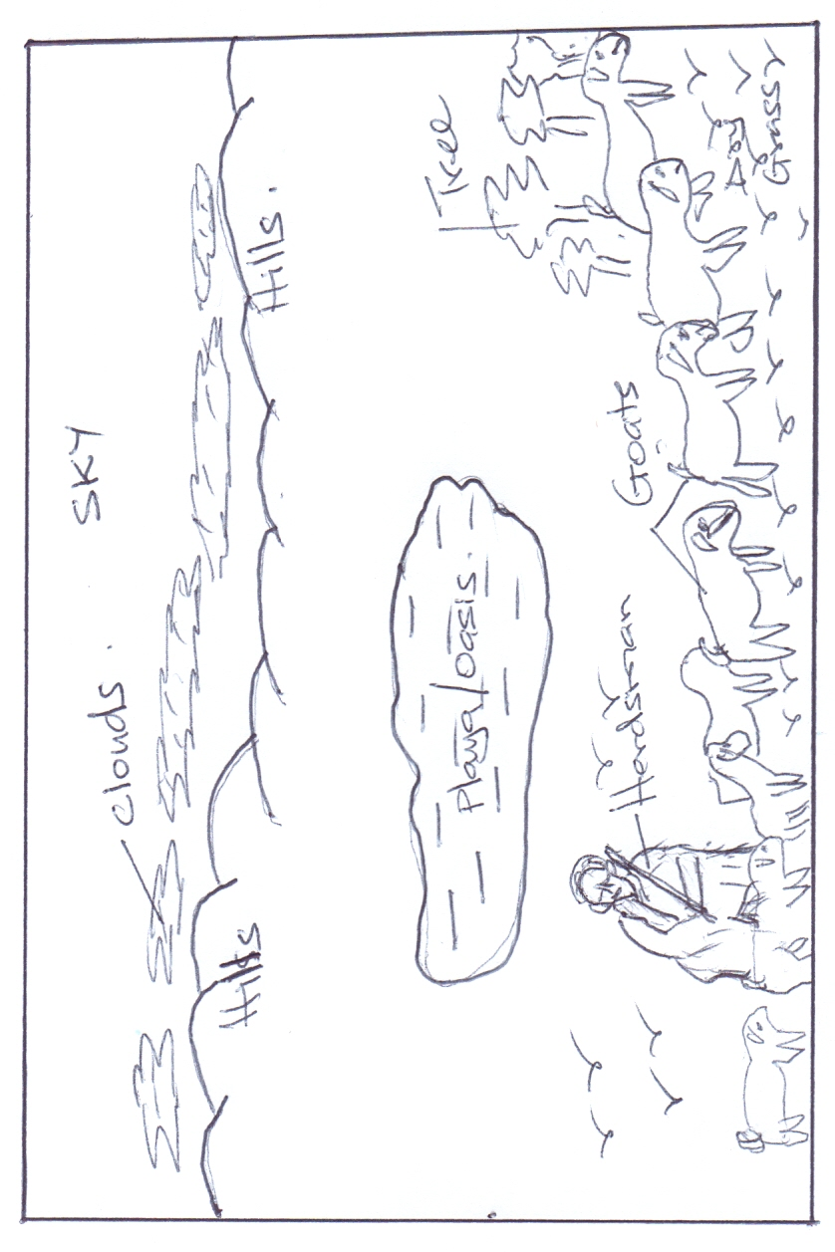

(b) (i) Name two pastoral communities in East Africa. (2 marks)

- Maasai
- Rendile
- Samburu
- Somali
- Borana
- Turkana
- Pokot

(ii) Outline three physical factors that favour pastoral farming in Kenya.
(3 marks)
- The grazing areas are free from tsetse fly due to dry and hot conditions.
- Large tracts of land due to sparse population in the Northern and North Eastern regions.
- Availability of natural pasture in the Wooded Savannah lands.
- The gentle sloping landscape enable easy movement of livestock from one place to another.
(c.) State three problems facing pastoralists in Kenya. (3 marks)
      - Prolonged drought which leads to shortage of water and pasture.
      - Low quality/less nutritious natural pasture.
      - Overstocking which leads to overgrazing hence poor pasture.
      - Pests e.g. ticks
      - Diseases e.g. Rinder pest/East coast fever/foot and mouth.
      - Low quality local breeds/Zebu/Boran which yields little milk/provide low quality meat.
      - Inadequate extension services.
      - Frequent livestock raids/cattle rustling.
      - Competition for range pastures with wildlife.
      - Poor transport connection hinders accessibility to potential markets.
      - Fire outbreaks destroy huge tracts of the grassland hindering their regeneration.
(d.) Explain three ways in which the government of Kenya assists nomadic pastoralists to improve the quality of their livestock. (6 marks)
- Establish demonstration ranches to sensitize pastoralists on better methods of animal husbandry.
- Cattle dips have been constructed to control pests.
- The government is encouraging group ranching to enable the pastoralist to view livestock keeping as a commercial undertaking.
- Boreholes have been sunk to provide water for livestock.
- Encouraging crossbreeding of indigenous breed with hybrid breeds to improve quality of livestock.
- Improvement of transport system in the areas for faster transportation of their livestock.
- Revival of Kenya Meat Commission to guarantee market for livestock.
- Establishment of anti-stock theft police to curb cattle raids.
- Research centres have been established for pest and disease control.
- Veterinary services have been provided to treat their animals.
- Extension services are being offered to educate/advice farmers.

7.) a.) i.) Define mining (2 marks)
- It is the process of extracting valuable minerals both solid, gas or liquid from the earth’s crust.
ii.) Explain how the following factors influence mining
      - Quality of the mineral ore (2 marks)
- Mining can be done if the mineral deposits have high mineral content because they are economical to work on but deposits with low mineral content are rarely worked on except if the mineral in them is rare e.g. uranium.
      - Capital (2 marks)
- Inadequacy of capital causes developing countries not to exploit minerals and leave it to international companies because a lot of money is needed for exploration, infrastructure, salaries, energy etc.
b.) Describe how the deep shaft method of mining is carried out (6 marks)
- Vertical shafts are sunk into the earth’s crust to reach the layer with the mineral.
- Horizontal tunnels/galleries are dug from the vertical shaft to reach the vein of the mineral bearing rock.
- The mineral bearing rock is blasted loose by explosives.
- The mineral is transported along the shaft by light railway or conveyor belt.
- It is then brought to the surface by a type of a crane or a lift called cage which also transports miners and their equipment to and fro the working level.
- The galleries are supported by timber pit props or steel concrete beams which are erected to support the roof to prevent it from collapsing. It should also be well ventilated and kept free from water.

c.) i.) Give two uses of soda ash (2 marks)
  - It is used in the manufacture of glasses and bottles.
  - It is used in the manufacture of soaps and detergents.
  - It is used in softening water in paper making.
  - It is used in textile industry.
  - It is used in oil refining.

ii.) State the contributions of soda ash mining to the economy of Kenya (5 marks)
- Soda ash mining has led to urbanization e.g. growth of Magadi town ship.
- It has led to development of social amenities such as hospitals and schools
- It has led to development of infrastructure e.g. railway line from Konza to L. Magadi.
- Soda ash mining has provided employment opportunities e.g. the Magadi Soda Company employs many people.
- Export of soda ash earns Kenya a substantial amount of foreign exchange

d.) Explain three problems facing mining (6 marks)
- Inadequate capital –This makes mining is left to multinational companies who pocket all the money to recover mining cost.
- Inaccessibility of some areas. This is due to poor transport and infrastructure which makes prospecting and mining difficult.
- Insufficient skilled personnel This causes dependence on expatriates who are expensive to pay, thus reducing the profits accruing from mining.
- Control by foreign companies e.g. Tullow Oil thus making most of the mineral revenue to end up to them as salaries and dividends.
- Occurrence of minerals in very small deposits. They are not economically viable e.g. Nyiru in Turkwel has very small deposits of beryl, asbestos and copper which makes mining to be very expensive.
- Land use conflicts. This affects mining e.g. in Kwale, the mining of Titanium has been hindered by a conflict between Tiomin and the local people due to inadequate compensation

8. a)i) Name three exotic softwood tree species planted in Kenya (3 marks)
- Cypress
- Pines
- Graveila
- Fir

ii) State four factors favoring the development of softwood forests in Kenya
(4 marks)
- Cool climate experienced in the Kenya highland
- Heavy rainfall
- Rugged and steep landscape experienced in some parts of the Kenya highlands discourage settlement/agriculture leaving the forests to flourish.
- High demand for timber and wood products in the country
- Volcanic soils
- Government’s efforts to create forests through implementation of afforestation and re-afforestation programmes.

b) Explain four measures that the government of Kenya is taking to conserve forests in the country (8 marks)
- The government is registering/recognizing the efforts of NGOs like the green belt movement which have mounted campaigns on planting of trees
- It’s also gazetting forested areas to reduce encroachment of the public
- Creating public awareness through mass media/baraza’s on the importance of conserving forest resources.
- Enacting laws to prohibit the cutting of trees without a license protecting indigenous tree species.
- Employing forest guards to protect forests from fires/other illegal human activities.
- Encouraging people to practice agro-forestry so as to avoid cutting tress from the forests.
- Enactment of laws e.g. that are meant to effectively manage the forests e.g. The Forest Bill 2000
- Carrying out research through KEFRI and ICRAF in order to come up with ways of controlling diseases/develop species suitable for different ecological regions.

c)i) Give reasons why forests are more wide spread in Canada than Kenya.
(4 marks)
- The cool to cold climate, which prevails across Canada, favours the growth of coniferous but discourage settlement and agriculture leaving large area under forest.
- Population in Canada is very low (3 persons per squae km) hence a lot of land is available for the establishment of forests unlike Kenya.
- In Kenya a lot of land has been converted to agriculture and settlement reducing areas under forest unlike in Canada.
- Unregulated human activities such as charcoal production is rampant in Kenya unlike in Canada which destroyed a large area under forest.
- Large tract of land is rugged and with thin soils discouraging agriculture leaving forest to thrive.

ii) Compare forestry in Canada and Kenya under the following sub-headings;
- Tree species (2 marks)
- In Kenya there are both exotic and indigenous softwoods while in Canada main trees are indigenous.
- Harvesting (2 marks)
- In Kenya harvesting is done throughout the year while in Canada it is done in winter and early spring.
- In Kenya harvesting is done selectively while in Canada clear cutting of trees is done.
- Transportation (2 marks)
- In Kenya transportation of logs is done by road while in Canada logs are transported using meltwater/rivers, mobile steel bars/skidded along ice covered ground.
- In Kenya, transportation is expensive while in Canada it is cheap.

9. a) Name three counties in Western highlands where tea is grown.
(3 marks)
- Narok - Bomet - Kericho
- Nyamira - Kisii - Nandi
- Bungoma - Kakamega - West Pokot

b) State four physical conditions that favour tea growing in the Kenya highlands. (4 marks)
- High rainfall annually/1000mm-2000mm annually.
- Well distributed rainfall throughout the year.
- Cool to warm conditions/moderate temperature/15° to 20°C
- Frost free conditions annually
- Deep, well drained soils/red volcanic soils
- Gentle/ sloping land
- Slightly acidic soils/volcanic
- High altitude/1500m-2400m above sea level.

c) i) Describe the stages involved in the processing of tea from harvesting to marketing. (7 marks)
- First harvesting is done 18-24 months after planting
- Picking of tea leaves is done weekly
- Top most two leaves and a bud are picked and put in airy baskets.
- Green tea leaves are then transported in airy baskets to collecting centres
- Green leaves are sorted out and then weighed.
- Leaves are transported to processing factory by lorries fitted with airy bags.
- At the factory, the leaves are then weighed again.
- Leaves are then spread out on long wire trays
- Leaves are then dried/withered by passing warm air beneath the trays.
- Dried leaves are chopped/crushed using sets of rollers
- Leaves are fermented in large containers to reduce tonic acid.
- Leaves are roasted with high temperature
- Leaves dry up and turn black and then cooled for 24 hrs.
- Leaves are sifted, tested and graded for various classification
- Graded leaves are weighed and packed in tea chests or in small packages.

ii) State the ways in which the Kenya Tea Development Agency (KTDA) assist small scale farms in Kenya (5 marks)
- Establishing tea nurseries where the tea farmers can buy tea seedlings for planting.
- Organize for farmers education for tea farmers
- Provide extension services for tea farmers
- Purchase farm inputs in bulk and sell to tea farmers at low prices
- Provision of credit facilities to tea farmers to buy farm inputs
- Improve feeder roads to transport tea leaves to the processing factory
- Conduct research on diseases/pests affecting tea
- Marketing tea leaves and paying farmers
- Collecting tea leaves from farms and deliver to the factory on behalf of the farmers.

d) Explain three problems experienced by small scale tea farmers in Kenya.
(6 marks)
- Adverse weather conditions such as drought, hailstones and frost leading to destruction of tea leaves lowering the productivity/leaf quality
- Pests such as termites, beetles, red spiders which destroy tea plants reducing yields/reducing quality.
- Diseases such as root rot, brown dust which kill tea bushes lowering tea yields
- Poor feeder roads in the growing areas delaying collections/delivery of green tea leaves to the factory leading to losses.
- High cost of farm inputs which is unaffordable leading to lowering yields/lowering farmers’ profit margins.
- Poor marketing strategies leading to low earnings.
- Delayed payments lowering farmers’ morale.
- Fluctuating tea prices in the world markets making farmers discouraged in tea growing/making it difficult for farmers to plan ahead.

10.) a.) i.) Differentiate between land reclamation and land rehabilitation (2 marks)
- Land reclamation is the process of converting wasteland into farm land for growing of crops and keeping of animals while land rehabilitation is the process of restoring land to its former productive state.
b.) Identify three methods of land reclamation in Kenya (3 marks)
- Irrigation
- Drainage of Swamps
- Control of Pests
c.) i.) State four physical factors that influenced the location of Mwea Tabere irrigation scheme (4 marks)
- Availability of extensive land which made created room for future expansion.
- Black cotton soils with high water retention capacities suitable for rice growing.
- Freely draining clay loamy soils suitable for growing of other cash and food crops.
- Gently sloping land which allows use of tractors and allows water to flow by gravity reducing the cost of pumping it to the fields.
- Availability of plenty of water from permanent rivers Thiba and Nyamindi draining the area.
- Experiences warm weather during the second part of the year suitable for rice growing.
ii.) Explain four problems facing Mwea Tabere irrigation scheme (8 marks)
- Stagnant water has become a breeding ground for mosquitoes and snails which transmit malaria and Bilharzia respectively
- Shortage of water due to excessive droughts and diversion of water into ‘Jua Kali’ rice farms.
- Pests and diseases e.g. case warm and leaf miner which attack crops lowering the yields and Quelea birds which feed on rice leading to a major loss of the crop.
- Inadequate capital on the part of farmers since the co-operatives collapse making them unable to acquire inputs forcing them to lease out all or part of their farms.
- Shortage of labour during the planting and harvesting season which forces the farmers to hire labour from outside at a high cost.

d.) i.) Outline the stages that were involved in reclamation of land from the sea in Netherlands (5 marks)
- Dykes were constructed to protect the land from getting flooded during high tide.
- Ring canals were constructed to carry water from the area to be reclaimed into the sea.
- Pumps were installed to pump out water from the area enclosed by dykes.
- Reeds were sowed to use up excess water.
- Drainage pipes were laid in ditches to drain water from the water table.
- The soil was treated with chemicals to lower salinity.
- Drained land was flushed with fresh water to remove salt from the soil.

ii.) State three benefits of irrigation farming in Kenya (3 marks)
- Resettlement of landless people e.g. in Mwea.
- It has made barren land reproductive.
- Enables farmers to earn an income when they sell farm produce.
- Provision of employment opportunities which has alleviated poverty and improved the standard of living.
- Creation of settlement for landless.
- Earning of foreign exchange by the country after exportation chillies, flowers, peas, fruits, etc.
- Promoted industrial development through providing raw materials e.g. rice mills, pineapple processing, sugarcane factories, etc.
- Has assisted in the control of environmental hazards such as droughts and floods.
- Has enhanced food security in the country by encouraging growing of food crops such as maize, beans, rice, etc

