Name………………………………………………… Adm no. ……………Class…….

School ………………………………………………...

231/3
BIOLOGY
PAPER 3 (PRACTICAL)
Sept 2021
Time: 1 ¾ HOURS

KASSU JET EXAMINATION -2021

231/3
BIOLOGY PAPER 3 (PRACTICAL)
Time: 1 ¾ HOURS
Sept 2021

INSTRUCTIONS TO CANDIDATES
- Answer ALL the questions.
- You are required to spend the first 15 minutes of 1 ¾ hours allowed for this paper reading the whole paper carefully before commencing your work.
- Answers must be written in the spaces provided in the question paper.
- Additional pages must not be inserted.

FOR EXAMINERS USE ONLY
Question | Maximum score | Candidate’s score
1 | 12
2 | 14
3 | 14
Total Score | 40  Marks

This paper consists of 5 printed pages.Candidates should check the question paper to ensure that all pages are printed as indicatedand no questions are missing
- You are provided with the photomicrograph of an onion outer epidermis as seen under light microscope
a) On the photograph, name parts labelled A, C, and D (3mark) A ……………………………………………………………
C ……………………………………………………………
D ……………………………………………………………
- Explain how the part labelled B is adapted to its function (2marks)
………………………………………………………………………………………………………………………………………………………………………………………………
- Calculate the actual size of the cell marked K, give your answer in micrometres
(2marks)

- The differences between the cells in the photograph and those obtained from an animal epithelial cells (3marks)
Onion epidermal cells | Animal epithelial cells

- State the process that make the structures in the cell above appear more distinct
(1mark)
………………………………………………………………………………………..
- In microscopic procedure in 1 (d) above name what was used to achieve the process
(1mark)
……………………………………………………………………………………………

- The photographs below represent specimen labeled A, B, C and D

SPECIMEN A | SPECIMEN B
 | 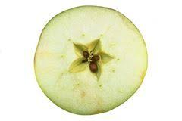
SPECIMEN C | SPECIMEN D
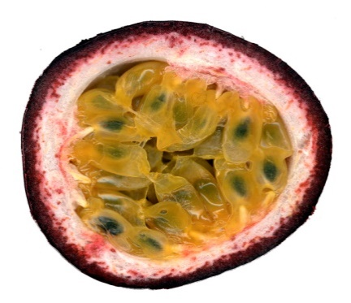

- Name the type of placentation shown in specimen A and B (2 marks)
A…………………………………………………………………………...……
B…………………………………………………………..………………….…
- Identify the type of sections from which specimen C and D was obtained?
(2 marks)
C……………………………………………………………………………...…
D…………………………………………………………..………………….…
- Classify the above specimen labeled D (1mark)
………………………………………………………………………………
- You are provided with specimen labeled D1, D2, D3 and D4. Examine them
Draw and label specimen labeled D2 (3marks)

- Giving a reason and state the agent of dispersal of the specimen (6marks)
Specimen | Agent of dispersal | Reason
D1
D3
D4
- You are provided with the following. Solution P, Q and Z.
- (i) Put 2 cm³ of solution P into two test tubes labeled A and B. Add iodine solution drops into test tube A. Observe and record. (1 mark)

…………………………………………………………………………………………..
(ii)To test tube B, add an equal amount of Benedict’s solution. Heat to boil. Record your observation. (1 mark)

…………………………………………………………………………………………..
(iii) From the results in (a) (i) and (ii), identify solution P. (1 mark)

…………………………………………………………………………………………..
(iv). Put 2cm³ of solution Z into a clean test tube labelled C. Add equal volume of Benedict’s solution. Heat to boil. (1 mark)

……………………………………………………………………………………..……
(v) Open the visking tubing provided, Pour solution P into the visking tubing and add 1cm³ of the solution R. Tie the visking tubing and ensure there is no leakage. Pour solution Z into a clean beaker till it is half full. Immerse visking tube in the solution Z in the beaker. Allow it to stand for 30 minutes. After 30 minutes, take 2cm³ of solution Z from the beaker into a clean test tube labelled D. Add equal amount of Benedict’s solution. Heat to boil. Record your observation. (1 mark)

…………………………………………………………………………………………..

(vi)Account for the observation made in (v) above. (3 marks)

…………………………………………………………………………………………………………………………………………………………………………………………………………………………………………………………………………………………………………………………………………………………………………..
- i) Pour 2 cm³ of solution Q into a clean test tube. Observe and record the color of solution Q. (1 mark)

…………………………………………………………………………………………
ii) Add 1 cm³ of sodium hydroxide into test tube containing solution Q. Record your observation. (1 mark)
……………………………………………………………..……………………………
iii) Explain the results observed in (b)(ii) above. (2 marks)

………………………………………………………………………………………………………………………………………………………………………………………………………………………………………………………………….…………….
iv). what is the identity of solution R? (1 mark)
……………………………………………………………..……………………………v) State one factor that can affect the process demonstrated in 3a (v) above (1 mark)
……………………………………………………………..……………………………

