231/1
phy PAPER 1
FORM 4
TIME: 2HRS

Marking Scheme

Main scale + vernier Scale + error
2.5 + 0.04 + 0.05 = 2.59
mass of the liquid = 12 – 6 = 6 g
volume of the liquid = 9 cm³
density of the liquid = 6/9 = 0.6667 g/cm³
Gas pressure = atm pressure + hpg

= $0.76 ×13600 ×10+0.1 ×1000 ×10$

$$=103360+1000=104360N/M$$

Mass of the object = $\frac{49}{9.8}=5 kg$

Acc due to gravity =$\frac{40.5}{5}=\frac{8.1N}{kg}$
 | mater is made up of many tiny particle. Small particles of salt fit in between molecules of water when dissolving
The thermometer in C
The rate of conductivity of heat increases with cross-sectional area.

 | Boiling water would burst the clinical thermometer
$$0.2 ×10=w ×40$$

$$w= \frac{0.2 ×10}{40}=0.5N$$

Total weight = $\frac{2000}{1000}+0.5$

$$2+0.5=2.5N$$

$$tension=2.5 N$$
 | the molecules of the air above the car moves at high velocity therefore lowering the pressure above the vehicle
to make and break contact of the circuit. The strip bends and straiten when the metal contract or expand at different temperatures.

ii) When the switch is closed, current flows through the heater and warm air in the room, thus heating the strip, the strip bends away from the contact . This disconnect the heater, when the strip cools down, it reconnect and the process repeat itself.
 | Section B
- (a)  (b) (i)  (ii) I)  (II)  (C) (i)  (ii) | The velocity is the ration of effort distance to that of load distance.  V.R = $\frac{1}{\sin{30}}= \frac{1}{0.5}$  = 2  $$effeciency=\frac{M.A}{V.R} ×100$$  $$75= \frac{M.A}{2} ×100$$  $$M.A= \frac{75 X 2}{100}$$  $$=1.5$$  $$M.A= \frac{L}{E}$$  $$1.5=\frac{L}{E}$$  $$1.5= \frac{800}{E}$$  $$E=\frac{800}{1.5}=533.33n$$  This due to inertia, the object tends to continue in uniform motion in a straight line  $$S=\frac{1}{2}{gt}^{2} S=0.2+3.2=3.4m$$  $$3.4=\frac{1}{2} ×{10t}^{2}$$  $$t^{2}=0.68, t=0.8246 seconds$$
- (a)  (b) | Hooke’s law states that force applied to an elastic material is directly proportional to the extension provided elastic limit is not exceeded.  F = ke  0.2N = K $×0.1$  $$K= \frac{0.2}{0.1}=\frac{2N}{M}$$  $$F=2×0.15$$  $$F=0.30 N$$  $$=0.03kg or 30g$$
- (a)  (b)  (c)  (ii)  (iii)  (d) | When a body is partially or totally immersed in a fluid, it experiences an up thrust equal to weight of the fluid displaced  Balloons/ships (explain any one)  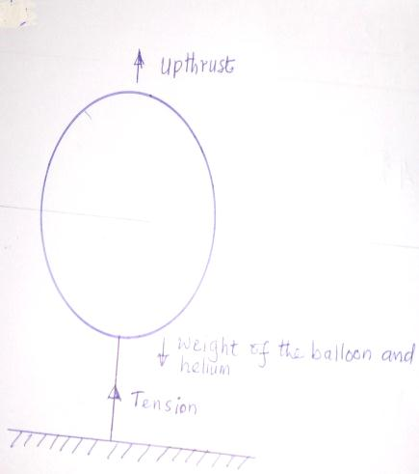  T = upthrust – weight  Volume of air displaced = 2000m³  Upthrust = 2000 X 1300 X 10  26 X 10⁶ N  Weight of balloon + helium  (2000 X 0.18 X 10) + (500 X 10) = 8600  7 = 26 X 106 – 8600  = 25991,400N  F = Ma = resultant force  25991400 = (500 + 360)a  A = 30,222.56ms²  To displace large volumes of the liquid hence provide sufficient upthrust.
- (a) (i)  (ii)  iii)  (c) | Tension in the spring supporting the object  There is change in the direction of instantaneous velocity at various points along the circular path  The object moves tangentially to the circular path at that point where it cuts.  Reading of spring balance = centripetal force  $$\frac{{MV}^{2}}{V}$$  $$81= \frac{0.5 X V^{2}}{0.5} V^{2}=81$$  $$V=9M^{-S}$$
- (a)  (b)(i)  (d)  (c) | The pressure of a fixed mass on an ideal gas is directly proportional to the absolute temperature provided the volume remains constant.  $$\frac{I}{V}=55$$  $$v= \frac{1}{55}$$  $$V=0.01812{cm}^{3}$$  Increase in temperature causes molecules to move faster causing more number of collisions with the wall of the cylinder, for pressure to remain constant volume must increase

17 a) the quantity of heat required to raise the temperature of a unit mass of a substance by 1 degree Celsius or by 1 kelvin.
b ) i) Q = MLv
0.1 x 2 2600 000 = 226 000 J
ii)Q = MLv + MC x change in temperature = 22600 + 0.1 x 4200 x 50 = 247 000J
iii) 247 000 = m x 4200 x 23
m = 2.557 kg

