NAME: ………………………………………………….. INDEX.NO: ……..…………………..

SCHOOL: ………………………………………………..CANDIDATES SIGN: ………..….…

DATE: …………………………………

232/1
PHYSICS
PAPER 1
DECEMBER 2020

MERU CENTRAL SUB-COUNTY CLUSTER EXAMINATION
KENYA CERTIFICATE OF SECONDARY EDUCATION (KCSE)

TIME: 2 HOURS.

Instructions to candidates
1. Write your name, index number and school in the spaces provided above.
2. Sign and write the date of examination in the spaces provided above.
3. This paper consist of TWO sections; A and B.
4. Answer ALL the questions in section A and B in the spaces provided.
5. ALL working MUST be clearly shown.

FOR EXAMINERS USE ONLY
MAXIMUM SCORE | 80 MARKS
CANDIDATE’S SCORE

SECTION A – 25 MARKS (ANSWER ALL THE QUESTIONS)

- The verneir calipers in the figure below has a zero error of -0.05cm.

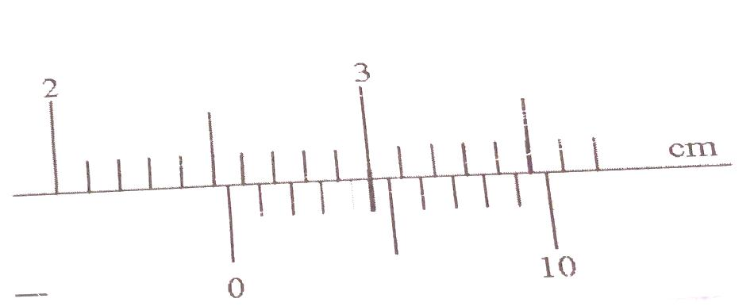

State the actual reading of the measuring instrument (2 marks)

2.Fig.1(a) and (b) shows a set – up to determine the density of a liquid.
Determining the density of the liquid. (3mks)
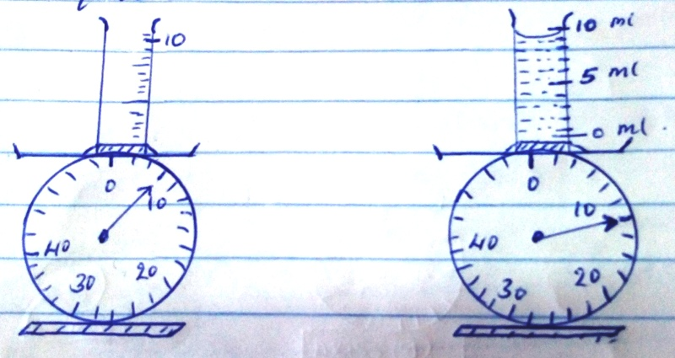

3. The figure below shows an open-ended monometer with water connected to a gas supply
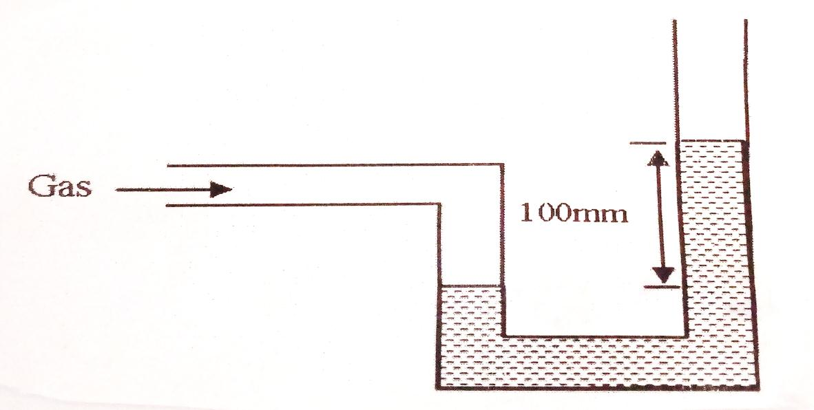

If a mercury barometer reads 760mm, calculate the pressure of gas (give your answer in N/m³).
(Density water = 1g/cm3, density of mercury = 13.6 g/cm³ (3 marks)

4.An object weighs 49N on earth where gravitational acceleration is 9.8N/Kg and 40.5N on another planet. Determine the gravitational acceleration on the planet (2 marks)

5.A measuring cylinder contains 20cm³ of water. 10cm³ of salt is added and stirred. Explain why the new volume is not 30cm³ (2 marks)

6.The figure below shows samples of same liquid B and C being heated through a well-lagged copper rod of non-uniform thickness. A thermometer is placed on each sample for some time.

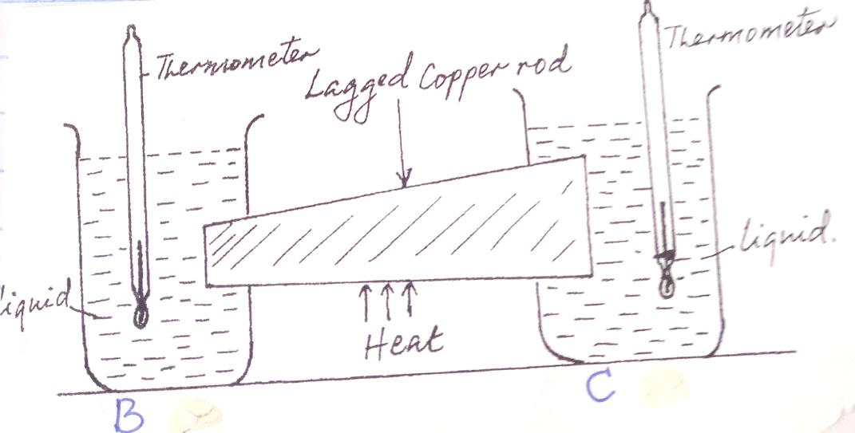
If the rod is heated at the middle, state and explain which of thermometers records a higher temperature (2 marks)

7. Give one reason why boiling water cannot be used to sterilize a clinical thermometer (1mark)

8. The figure 6 below shows a uniform 50cm rod. It is balanced horizontally by a load of 4N on one end. Calculate the weight of the rod 2mks)

9. Explain why a car feels lighter as it travel at a higher velocity. (2mks)

10. Pure water at 0⁰c is heated up to 10⁰c. Sketch the graph of volume against temperature on the axes given below 2mks)

11. The figure 8 below shows a circuit diagram for a device for controlling the temperature in a room.

i) Explain the purpose of the metallic strip 2mks)
ii) Describe how the circuit controls the temperature when the switch S is closed 2mks)

SECTION B – 55 MARKS (ANSWER ALL THE QUESTIONS)
- (a) Define the term velocity ratio of a machine (1 mark)

(b) A man pushes a load of mass 80kg up an inclined plane through a vertical height of 5m as shown below. The inclined plane makes and angle of 300 to the horizontal (take g to be 10m/s²)
(i) Determine the velocity ratio of the velocity ratio of the inclined plane. (2 marks)

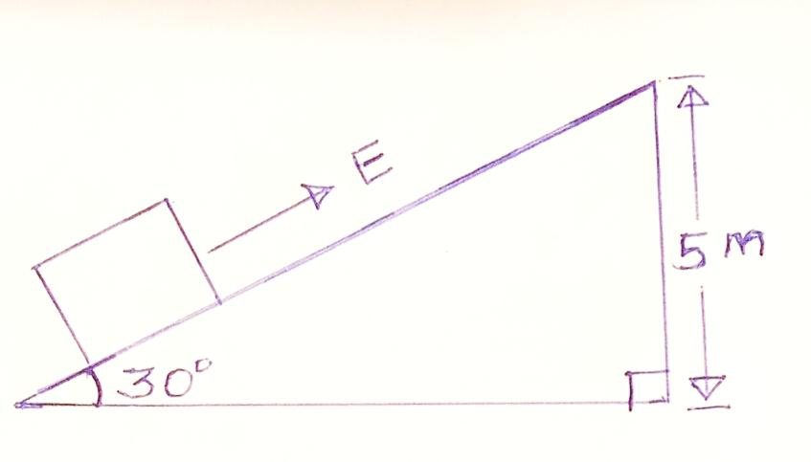

(ii) If the efficiency of the plane is 75% determine:
- The mechanical advantage (2 marks)

- The effort E, needed to pull the load up the plane. (2 marks)

(c) A trolley of height 0.2m moving on a horizontal bench of height 3.2m strikes a barrier at the edge of the bench. The object on top of the trolley flies off on impact and lands on the ground 2.5m from the edge of the bench as shown below. Use this information to answer the questions that follow:
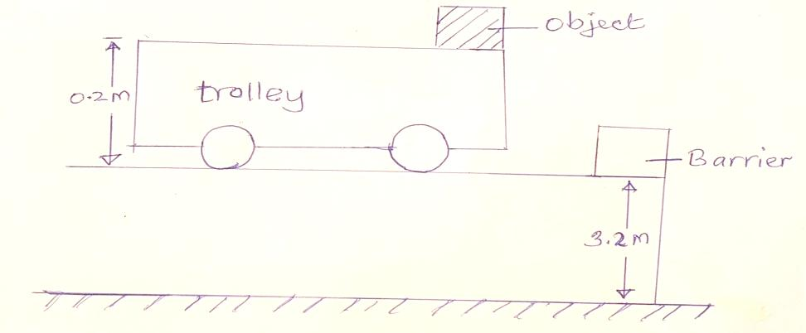

- Give a reason why the object on the trolley flies off on impact (2 marks)

- Determine the time taken by the object to land on the ground (2 marks)

- (a) state Hooke’s Law (1 Mark)

(b) (i) A vertical spring of un streched length of 30cm is clamped at its upper end. When sand is placed in a pan attached to the lower end of the spring its length becomes 45cm. When 20g mass is placed on top of the sand the length increases to 55cm. Determine the mass of the sand
(3 marks)

(ii) If the spring in (i) above is compressed from its original length to a length of 24cm, calculate the work done in compressing the spring. (3 marks)

(c) The graph below shows the relationship between (F) against extension (e) of a spring.
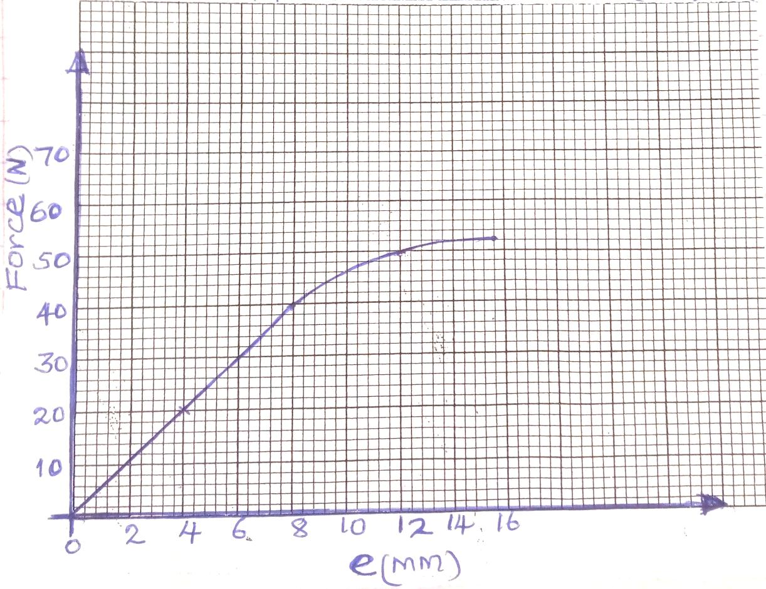
Determine the spring constant of the spring (3 marks)

- (a) state Archimedes Principle (1 mark)

(b) Explain one application of Archimedes Principle in real life situation (2 marks)

(c) The mass of the fabric of a large balloon is 500g. The balloon is inflated with 2000m³ of helium gas. The balloon is attached to a cable tied on the ground as shown. (Density of helium and air are 0.18g/cm³ and 1.3g/cm³ respectively.
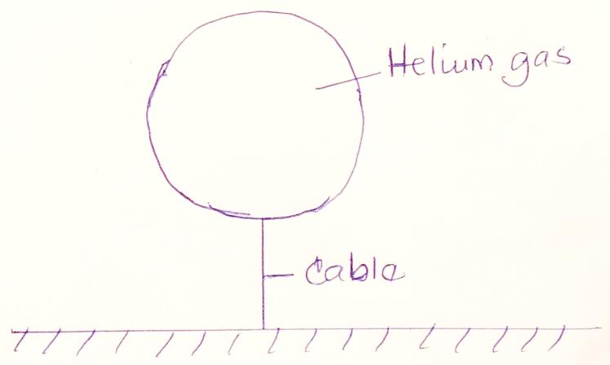

- State 3 forces acting on the set up. (3 marks)

- Determine the tension in the cable (3 marks)

- Calculate the acceleration of the balloon if the cable is cut. (2 marks)

(d) The diagram below shows a hydrometer.
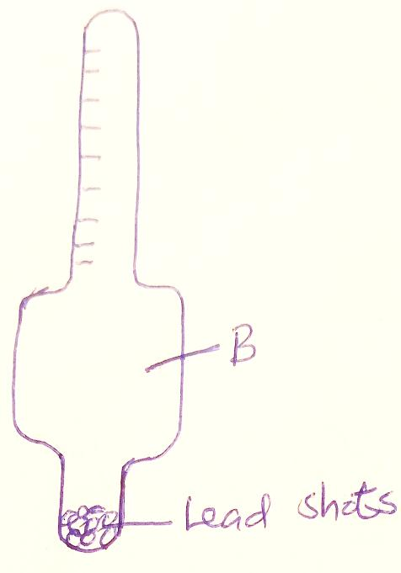
Why is the part marked B wider? (1 mark)

- The diagram below shows a spring balance tied to an object of mass M and rotated in a circular path of radius r.
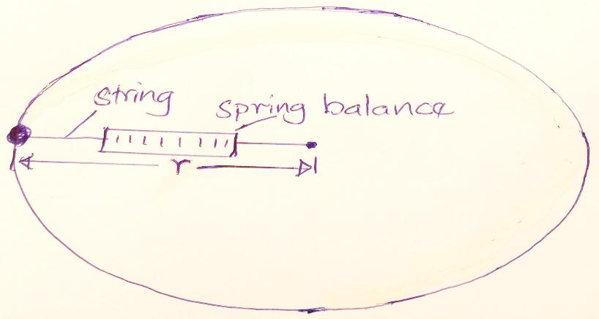

- (i) State the force that keeps the object moving in a circular path. (1mark)

(ii) The speed of the object is constant but the body is acceleration on the circular path. Explain (1 mark)

- (i) If the object is whirled faster, what would happen to the spring balance reading? (1 mark)

(ii) Give a reason for your answer in b (i) above (1mark)

(iii) As the object is whirled round, the sting snaps and cuts off. Describe the subsequent path of the object (1 mark)

- If the mass m of the object s 500g and radius r is 50cm. determine the velocity of the body if the spring balances reads 81N (3 marks)

- (a) State the pressure law for an ideal gas. (1 mark)

(b) The pressure P of a fixed mass of gas at constant temperature of T = 200k is varied continuously and the values of corresponding volume recorded. A graph of P against $\frac{1}{v}$ is shown on the graph below.

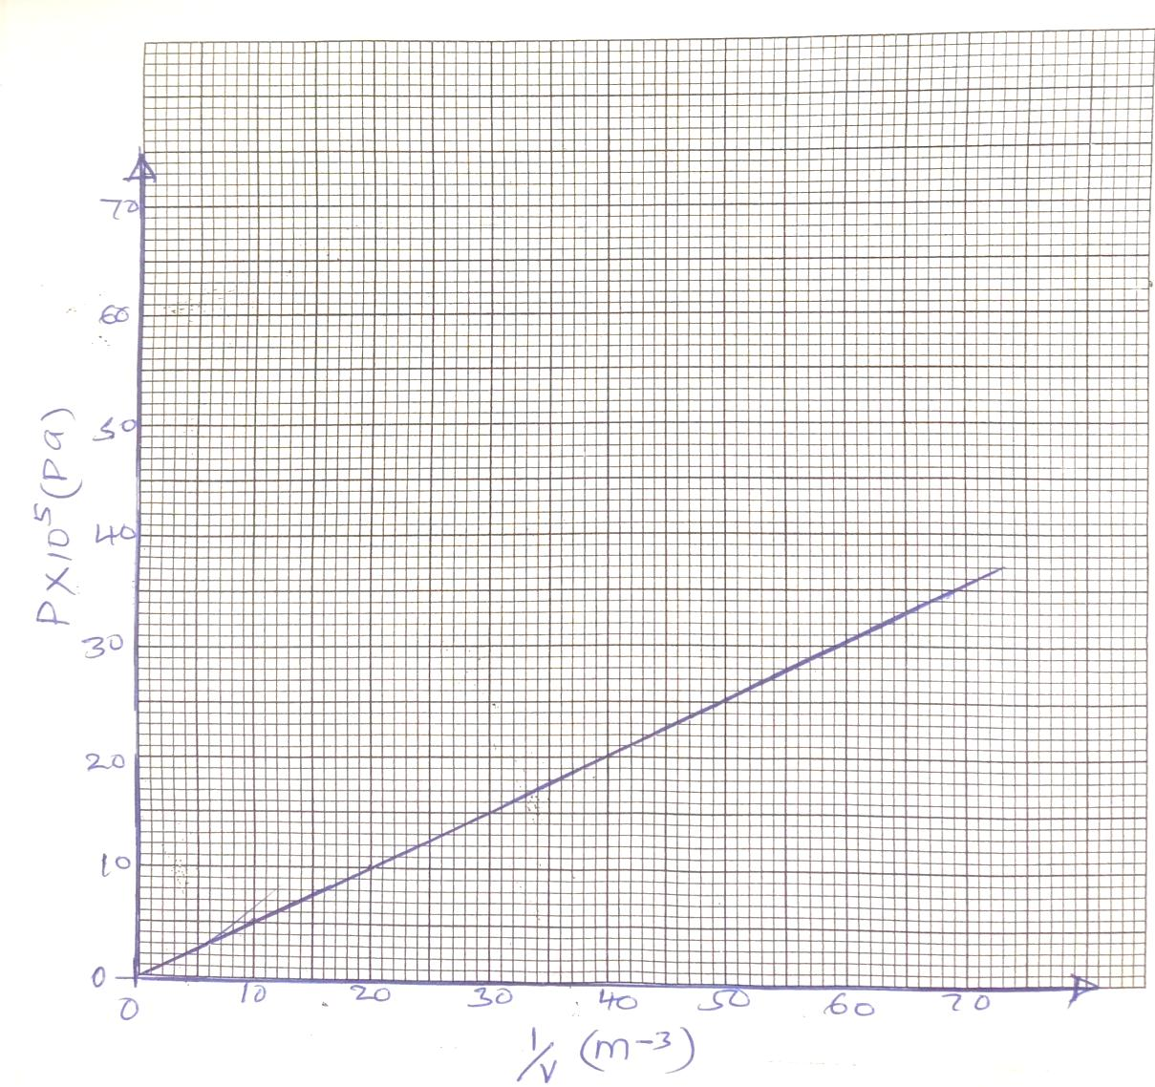

Use the graph to:
- Determine the volume of the gas when pressure reads 2.8 x 10⁵ pa (2marks)

(d) The petrol air mixture in the cylinder of a car engine is ignited when the piston is in the position shown below.

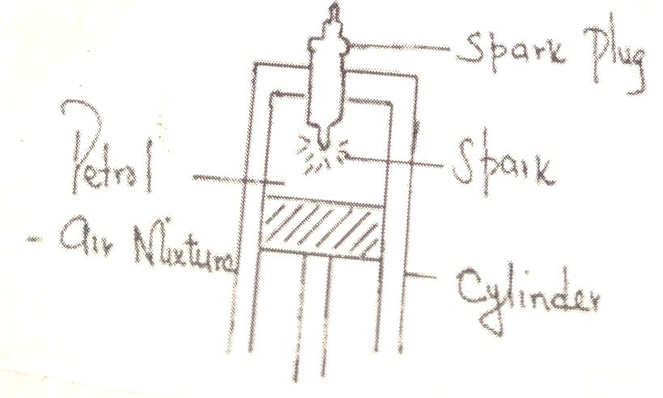
Use kinetic theory of matter to explain why the piston moves down. (3 marks)

17.(a) Define the term specific heat capacity. (1mk)

(b) 100g of steam of 100⁰C was passed into cold water at 27ºC. The temperature of the mixture became 500C. Taking specific heat capacity of water as 4200jkg⁻¹k⁻¹ and specific latent heat of vaporization of water as 2260kjkg⁻¹ and that heat losses were negligible. Determine
(i) quantity of heat lost by steam. (2mks)

- quantity of heat gained by water. (3mks)

- Mass of the cold water. (3mks)

