KENYA HIGH EXAMINTIONS 2021
312/1
GEOGRAPHY
PAPER 1
MARKING SCHEME

SECTION A
Answer ALL questions in this section.
Question1.
(a) Weather is the condition of the atmosphere of a given place over a given period of time/ shot period of time. (3 marks)
(b) Five factors considered when siting a weather station.
- Secure place; should be sited in a secure place to avoid vandalism and theft.
- The site should be away from obstruction (e.g. buildings, vegetation).
- The site should be relatively flat and free from flooding.
- The site should be in an open space where there’s free flow of air.
- The site should have a wide view of surrounding landscape and sky.
Question2.
(a) Ways that make it possible for geographers to study the earth’s interior.
- By studying seismic shock waves
- Through study of volcanic lava flows
- Through study of rocks on the moon and meteorites
- Through very deep mining drilling. (1 x 2 = 2mks) any 2 points
(b) Changes that may occur in a rock after it has undergone metamorphism
- New minerals are formed
- Rocks change in hardness
- The rock change in physical appearance
- Rock particles become compacted
- Minerals recrystalise further. (1 x 3 = 3mks)
Question3.
(a) Differentiate between folding and faulting.
- Folding is the bending of crustal rocks due to earth movements while
Faulting is the breaking / fracturing of crustal rocks due to tectonic forces.
(b) 4 orogenesis periods in fold mountains formation.
- Charnianorogeny: e.g. African block, Laurentian shield, Russian platform & Deccan Plateau.
- Caledonian Orogeny: e.g. Akwapim hills, Scottish Highlands
- Hercynian Orogeny: e.g. Cape ranges, Appalachian Mtns, Ural
- Alpine Orogeny: e.g. Atlas, Alps, Himalayas, Rockies & Andes Mountains. (1 x 4= 4mks)
Question4.
(a) Differentiate between a spring and a well.
- A spring is a place on the surface of the earth where underground water flows out onto the surface while
- A well is a relatively deep hole in the ground which is dug by people for the purpose of getting water.
(1 x 2 = 2mks)
(b) Ways by which springs develop.
- When a permeable rock lies on top of an impermeable rock.
- When the hilly country rocks are well jointed.
- When a dyke acts as a dam
- When limestone rocks (escarpments) overlie impermeable rocks.
- When gently sloping layers of permeable rock alternate with layers of impermeable rock.
Any 3 (1 x 3 = 3mks)
Question5.
(a) Two ways in which mulching improves soil.
- Enhancing infiltration / reduce run off.
- Protect soil against splash erosion
- Enable soil to regain fertility / add humus to soil
- Enable moisture retention / reduces excess evaporation. Any 2 pints ( 1 x 2 = 2mks)

SECTION B

Question 6
(a) (i) 21km² 2marks
(ii) 6.2 km 2marks 4fig (1mk)
(iii) 517 388 2marks 6fig (1mk)
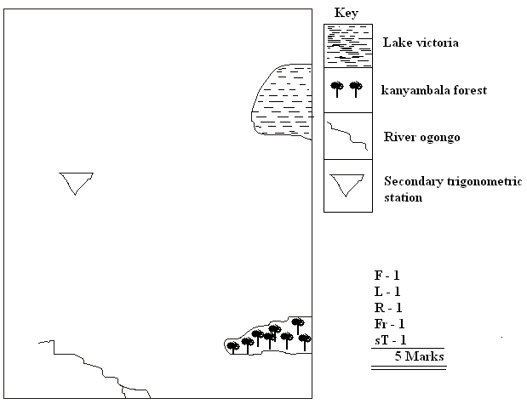
(iv)

(b) Using evidence from the map, state three functions of Homabay town
Function Evidence
- Industrial centre Ginnery
- Health centre Hospital
- Educational centre Schools/ nursing training, farmers training centre
- Transport centre Roads / Pier
- Communication centre Post office
- Trading centre Market Any 3 ( 3x1=3mks)
NB: The point should be qualified (evidence) to earn a mark
(c) (i) 3 types of vegetation
- Forests
- Papyrus swamp
- Scrub (3 marks)
(ii) Settlement patterns
- Linear
- Nucleated
- Dispersal (3 marks)
(d) Describe the relief of the area covered by the map.
- The area between Easting 51 and 54 is hilly as indicated by the presence of Ruri Hills
- The West of the area covered by the map is flat as indicated by widely spaced contour.
- There are rivers valleys around Ruri Hills
- Around Olambwe East the region is very steep as indicated by dense contours.
- The land is plainsland around Olambwe Valley national reserve.( 1 x 5 = 5mks)
Question 7
- Definition of vulcanicity
- It’s the processes through which solids, liquids, gaseous and molten materials are forced out of the earth’s interior or are intruded into the earth’s crust. (1x2 = 2 marks)
- Four characteristics of a composite volcano.
- Has vertical vent / pipe/ fissure
- Composed of alternating layers of ash / lava
- Its conical in shape / steep sided
- Has side vents
- Its made up of acidic lava / viscous lava
- Has conelets / parasitic cones
- At the summit, it may have caldera / crater / plug. (4 x 1 = 4mks)
- How a lava plateau is formed.
- Formed when magma reaches the earth’s surface through fissures / vents
- Lava is ultra basic / low intensity
- Lava flows over a long distance spreading over a large area before cooling.
- Lava cools slowly forming an extensive lava platform bounded by steep slopes.(4 x 1 = 4mks)
- Four negative effects of vulcanicity.
- Volcanic eruptions can result in loss of lives
- Volcanic eruptions can destroy property
- Weathered volcanic rocks / materials e.g. ashes and granite can result in infertile soils.
- Volcanic features like mountains create barriers to transport and communication
- The rugged nature of volcanic landscape discourages economic activities e.g. agriculture and settlement.
- Volcanic eruptions produce poisonous gases e.g. sulphur Co₂ which pollute the environment / threaten human life.
- Volcanic mountains create a rain shadow effect which discourage farming activities
- Recent lava flows have immature soils which are not suitable for farming.
- Volcanic eruptions and related hazards cause panic and affect people psychologically / inhibit development.
- Dust particles from volcanic eruptions absorb and scatter solar energy, lowering global temperatures; resulting to health problems to man.
- Volcanic eruptions may cover / burry minerals making mining difficulty and expensive.
(4x2 = 8 marks)
- (i) Four sources of information that you would use in the preparation for the study
- Written materials / magazines/ newspapers / text books
- Maps
- Photographs / films
- Resource persons
- Electronic media e.g. T.V / radio (4 x 1 = 4mks)
(ii) Three factors that would make it difficult for you to collect accurate data during the field study.
- Fear of eruptions
- Inaccessibility of some areas due to piled up lava
- Inadequate information because people have been evacuated
- There may be restrictions to access the area. (3 x 1 = 3mks)

Question 8
- Three agents of weathering
- Heat / temperature
- Water / rainfall / moisture
- Plants
- Animals
- Man
- Wind (3 x 1 = 3mks)
- Frost action as a process of weathering.
- Occurs where temperatures are within the freezing point
- When temperatures rise, snow melt and water enters the crack in the rock
- When temperatures drop, the water freezes, expands and widens the cracks
- Continued process of freezing and thawing lead to break up of rocks.(4 x 1 = 4mks)
- Explain how an exfoliation done is formed.
- High temperatures during the day causes rocks to expand
- At night temperatures are low hence rocks contract
- Repeated expansion and contraction cause stress on the rocks hence cracks develop.
- Eventually, the outer layer peels off leading to rounded mass of rock known as exfoliation dome.
- Further wind action may smoothen the surfaces.
(5 x 1 = 5mks)
- 3 factors that influence the rate of mass wasting.
- Steep slopes increase the rate of mass wasting
- The heavier the material, the faster the movement of the material
- The higher the rainfall the faster the movement of the material
- Bare surface increase the rate of the movement of the material
- Earth movements trigger movement of materials
- Human activities e.g. mining / farming / construction accelerate the rate of materials movement.
(3 x 2 = 6mks)
- Four slow types of mass wasting.
- Soil creep
- Talus creep
- Solifluction
- Scree creep
- Rock creep (4 x 1 = 4mks)
- Three positive effects of mass wasting.
- Create scenery that attract tourists for foreign exchange
- It facilitates deposition of rich soils for agriculture in the low lands
- Landslides create barriers across river courses / valley leading to formation of lakes.
- It causes slope retreat encouraging human activities (3 x 1 = 3mks)
Question 9
- (i) Three factors that influence transportation of materials in the sea.
- Ocean currents
- Tidal currents
- Strength of waves
- Nature of materials
- Depth of water
- Slope of the coast / shore
- alignment of the coast Any 3 x 1 = 3 mks

(ii) A simple well labeled diagram of a sea wave. 3marks
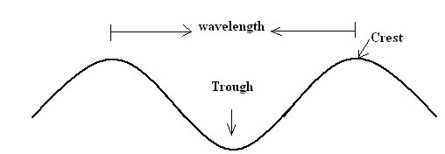

(iii)Three ways in which islands are formed.
- Volcanic eruption
- Accumulation of coral into coral reefs
- Submergence of an upland coast
- Deposition across the bays / river mouths / lagoons
- Erosion of head lands(any 3 x 1 = 3mks)
- (i) Hydraulic action
- Action caused by the force of moving water in form of waves
- Involves direct wave force where the pounding force of the wave causes shattering of rocks on the cliff /causes compression of air in the cracks.
- As the wave retreats, the air expands explosively.
- Gradually the rock disintegrates. Any 3 x 1 = 3mks
(ii) Solution
- Is the process where sea water dissolves soluble minerals in the rock which are in contact with it on the sea side and bed.2 x 1 = 2mks
- Formation of a spit.
- It forms on a shallow shore at a point where there is a change in the angle of the coastline
- Sand and shingles are deposited from the headland seaward by long shore drift / oblique waves.
- Continued deposition leads into accumulation of materials seawards.
- With time, an elongated ridge of sand and shingles with one end attached to the mainland and the other projecting into the sea called a spit is formed. Any 5 x 1 = 5mks
- 3 economic importances of coastal landforms.
- Coastal rocks e.g. coral limestone are used in building and construction
- Limestone rock is used as a raw material in cement industries
- Coastal features like coral reef attract tourist who bring in foreign exchange
- Fiord and rias provide suitable sites for construction of the harbours / breeding of fish
- Marine life is used in education and research
- Mud flats and mangroves swamps are drained and used for rice cultivation / mangrove forests are exploited to provide poles for construction
- Extensive coastal plains provide suitable sites for human settlements and agriculture. Any 3 x 2 = 6mks
Question 10
- Four physical factors that contribute to development of deserts.
- Continentality / distance from large water bodies
- A place being located in an area with descending winds / anticyclones
- Rain shadow effect
- Prolonged droughts
- Cold ocean currents
- Prolonged / persisted high temperatures
- Climate change / global warming
- Persistent offshore / dry winds / cold winds Any 4 x 1 = 4 mks

- Four characteristics of desert landscape.
- Most of the ground is bare / scanty vegetation
- Total absence / partial surface water
- Wind is dorminant leading to desert sand storms
- Land surface is covered by fine sand / stones / rock outcrops
- Galleys / badlands are common
- Thin soils
- Little organic matter.Any 4 x 1 = 4mks
- Three factors that influence wind transport in the desert.
- Speed and the force / strength of the wind
- Nature of the load / either light / heavy
- Intervening obstacles e.g. dead animals , twig or rock
- Water mass / rain / moisture. Any well explained 3 x 2 = 6mks
- How a deflation hollow is formed.
- A pre-existing depression /localized fault is exposed to wind erosion.
- Wind eddies remove the unconsolidated materials by with deflation
- Weathering aids in breaking down the exposed rock
- Wind abrasion excavates the depression by eroding the rock along weak lines
- The depression is deepened and widened as a deflation continues to remove the loose materials leading to formation of a large depression known as deflation hollow. Any 4 x 1 = 4mks
- (i)Four preparations for your study.
- Seeking permission
- Conduct a reconnaissance
- Formulate / adjust hypothesis and objectives
- Choose methods of data collection
- Assemble necessary tools / materials
- Prepare a working schedule
- Divide the students into groups
- Discuss the topic in class
- Literature reviewAny 4 x 1 = 4mks
(ii) List three water depositional features you identified.
- Salina / playa
- Alluvial fans / cones
- Bajadas3 x 1 = 3mks

