NAME …………………………………….. DATE ……………………….…………………..……

ADMN NO. …………….……….……..…..… CANDIDATE’S SIGNATURE ………..…..………..

443/2
AGRICULTURE
PAPER 2 (THEORY)
TIME: 2 HOURS

KENYA HIGH EXAMINTIONS 2021
Kenya Certificate of Secondary Education

443/2
AGRICULTURE
PAPER 2 (THEORY)
TIME: 2 HOURS

INSTRUCTIONS TO CANDIDATES
- Write your name and index number in the spaces provided above.
- This paper has THREE sections: A , B and C
- Answer ALL the questions in section A and B and any TWO questions in section C
- ALL answers MUST be written in the spaces provided.
- Do not remove any pages from this booklet.

FOR EXAMINER’S USE ONLY

 | Questions | Maximum score | Candidate’s score
A | 01-17 | 30 marks
B | 18-22 | 20 marks
C | 23-25 | 40 marks
 |  | Total score

This paper consists of 8 printed pages.
Candidates should check to ensure that all pages are printed as indicated and no questions are missing
SECTION A (30 MARKS)
Answer ALL questions in this section.
- State four problems associated with nomadic pastoralism method of farming. (2 marks)
………………………………………………………………………………………………………………………………………………………………………………………………………………………………
- State one use of the following tools in the farm. (2 marks)
- Spoke shave
………………………………………………………………………………………………………………
- Pipe wrench
………………………………………………………………………………………………………………
- Stock and die
………………………………………………………………………………………………………………
- Wire strainer
………………………………………………………………………………………………………………
- Name one exotic dairy cattle breed in Kenya which produces milk with:
- Highest butter fat content. (1 mark)
………………………………………………………………………………………………………………
- Lowest butter fat content. (1 mark)
………………………………………………………………………………………………………………
- Name two dual purpose breeds of dairy cattle reared in Kenya. (1 mark)
………………………………………………………………………………………………………………………………………………………………………………………………………………………………
- Name two sources of energy concentrates. (1 mark)
………………………………………………………………………………………………………………………………………………………………………………………………………………………………
- Using Pearson’s square method, compute a 100kg ration with 20% DCP from sunflower seed cake which contains 10% DCP and simsim seed containing 60% DCP. (4 marks)

- Name three livestock diseases transmitted by ectoparasites. (1½marks)
………………………………………………………………………………………………………………………………………………………………………………………………………………………………
………………………………………………………………………………………………………………
- Name an intermediate host for the following internal parasites. (2 marks)
- Tapeworms
………………………………………………………………………………………………………………
- Liver flukes
………………………………………………………………………………………………………………
- Give any two reasons for docking in sheep rearing. (1 mark)
………………………………………………………………………………………………………………………………………………………………………………………………………………………………
- State two functions of the queen in a beehive. (1 mark)
………………………………………………………………………………………………………………………………………………………………………………………………………………………………
- State three maintenance practices carried out on a piggery unit. (1½ marks)
………………………………………………………………………………………………………………………………………………………………………………………………………………………………
………………………………………………………………………………………………………………
- State four disadvantages of an electrical fence. (2 marks)
………………………………………………………………………………………………………………………………………………………………………………………………………………………………
………………………………………………………………………………………………………………………………………………………………………………………………………………………………
- State four advantages of using a spray race for controlling parasites. (2 marks)
………………………………………………………………………………………………………………………………………………………………………………………………………………………………
………………………………………………………………………………………………………………………………………………………………………………………………………………………………
- Give four disadvantages of artificial insemination in livestock production. (2 marks)
………………………………………………………………………………………………………………………………………………………………………………………………………………………………
………………………………………………………………………………………………………………………………………………………………………………………………………………………………

- Give any four structural requirements that a calf pen should possess. (2 marks)
………………………………………………………………………………………………………………………………………………………………………………………………………………………………
………………………………………………………………………………………………………………………………………………………………………………………………………………………………
- List two signs of infertility in cows. (1 mark)
………………………………………………………………………………………………………………………………………………………………………………………………………………………………
- Give two methods of introducing vaccines to livestock. (2 marks)
………………………………………………………………………………………………………………………………………………………………………………………………………………………………

SECTION B (20 marks)
Answer ALL questions in this section.
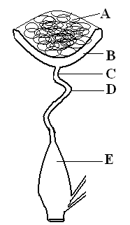
- Study the diagram below and answer the questions that follow.

- Name the parts labelled A, B, C, D and E in the diagram. (2½ marks)
A………………………………………………………………………………………………………...
B………………………………………………………………………………………………………...
C………………………………………………………………………………………………………...
D………………………………………………………………………………………………………...
E…………………………………………………………………………………………………………
- State the function of each part. (2½ marks)
A………………………………………………………………………………………………………... ………………………………………………………………………………………………………….. B………………………………………………………………………………………………………... ………………………………………………………………………………………………………….. C………………………………………………………………………………………………………... ………………………………………………………………………………………………………….. D………………………………………………………………………………………………………... ………………………………………………………………………………………………………….. E………………………………………………………………………………………………………… …………………………………………………………………………………………………………..
- Give two reasons why a jersey breed cattle is adapted to arid and semi arid areas. (2marks)
………………………………………………………………………………………………………………………………………………………………………………………………………………………………
- The diagram below represents an aerial view of a farm structure. Study it carefully and answer the questions that follow.

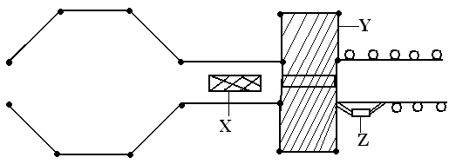

- Identify the structure. (1 mark)
………………………………………………………………………………………………………………
- Name the parts labeled X, Y and Z. (3 marks)
X………………………………………………………………………………………………………...Y………………………………………………………………………………………………………...Z…………………………………………………………………………………………………………
- List two roles of the part labeled Y. (2 marks)
……………………………………………………………………………………………………………………………………………………………………………………………………………………………
- Give two reasons for carrying out hoof trimming. (1 mark)
………………………………………………………………………………………………………………………………………………………………………………………………………………………………

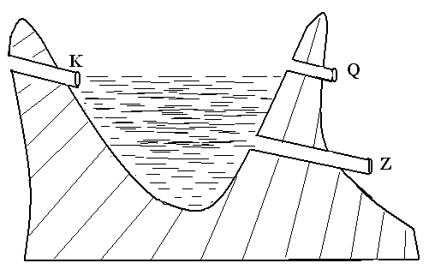
- The illustration below is a farm structure.

- Identify the structure. (1 mark)
…………………………………………………………………………………………………………
- Name the parts labeled K, Q and Z. (3 marks)
K………………………………………………………………………………………………………...Q……………………………………………………………………………………………………..….Z…………………………………………………………………………………………………………
- Give four maintenance practices carried out on the above structure. (2 marks)
………………………………………………………………………………………………………………………………………………………………………………………………………………………………………………………………………………………………………………………………………………………………………………………………………………………………………………………………

SECTION C (40 MARKS)
Answer ANY TWO questions in this section
- a) Give five functions of vitamins in livestock production. (5 marks)
- Describe the importance of colostrum to young animals within the first week of birth. (10 marks)
- Outline five advantages of embryo transplant technology in cattle management. (5 marks)

- a) Mention four methods of water harvesting. (4 marks)
- Describe the different types of micro catchments used in water conservation. (10 marks)
- Explain the importance of micro catchments. (6 marks)

- a) Outline ten factors to consider when selecting gilt for breeding stock. (10 marks)
b) Explain the economic importance of parasites to livestock animals. (10 marks)
………………………………………………………………………………………………………………………………………………………………………………………………………………………………………………………………………………………………………………………………………………………………………………………………………………………………………………………………
………………………………………………………………………………………………………………………………………………………………………………………………………………………………………………………………………………………………………………………………………………………………………………………………………………………………………………………………
………………………………………………………………………………………………………………………………………………………………………………………………………………………………………………………………………………………………………………………………………………………………………………………………………………………………………………………………
………………………………………………………………………………………………………………………………………………………………………………………………………………………………………………………………………………………………………………………………………………………………………………………………………………………………………………………………
………………………………………………………………………………………………………………………………………………………………………………………………………………………………………………………………………………………………………………………………………………………………………………………………………………………………………………………………
………………………………………………………………………………………………………………………………………………………………………………………………………………………………………………………………………………………………………………………………………………………………………………………………………………………………………………………………
………………………………………………………………………………………………………………………………………………………………………………………………………………………………………………………………………………………………………………………………………………………………………………………………………………………………………………………………
………………………………………………………………………………………………………………………………………………………………………………………………………………………………………………………………………………………………………………………………………………………………………………………………………………………………………………………………
………………………………………………………………………………………………………………………………………………………………………………………………………………………………………………………………………………………………………………………………………………………………………………………………………………………………………………………………
………………………………………………………………………………………………………………………………………………………………………………………………………………………………………………………………………………………………………………………………………………………………………………………………………………………………………………………………
………………………………………………………………………………………………………………………………………………………………………………………………………………………………………………………………………………………………………………………………………………………………………………………………………………………………………………………………
………………………………………………………………………………………………………………………………………………………………………………………………………………………………………………………………………………………………………………………………………………………………………………………………………………………………………………………………
………………………………………………………………………………………………………………………………………………………………………………………………………………………………………………………………………………………………………………………………………………………………………………………………………………………………………………………………
………………………………………………………………………………………………………………………………………………………………………………………………………………………………………………………………………………………………………………………………………………………………………………………………………………………………………………………………
………………………………………………………………………………………………………………………………………………………………………………………………………………………………………………………………………………………………………………………………………………………………………………………………………………………………………………………………
………………………………………………………………………………………………………………………………………………………………………………………………………………………………………………………………………………………………………………………………………………………………………………………………………………………………………………………………
………………………………………………………………………………………………………………………………………………………………………………………………………………………………………………………………………………………………………………………………………………………………………………………………………………………………………………………………
………………………………………………………………………………………………………………………………………………………………………………………………………………………………………………………………………………………………………………………………………………………………………………………………………………………………………………………………
………………………………………………………………………………………………………………………………………………………………………………………………………………………………………………………………………………………………………………………………………………………………………………………………………………………………………………………………

