NAME: ………………………………………………..…CLASS:….…ADM NO:…………
SIGNATURE:…………………………………INDEX NO:…………………………………
DATE:…………………………..

232/2
PHYSICS
PAPER 2
December 2020
TIME: 2 HOURS

KASSU JET EXAMINATION - 2020
Kenya Certificate of Secondary Education
Physics Paper 2

Instructions to candidates

- Write your name, admission number, class, signature and date in the spaces provided at the top of the page.
- This paper consists of two sections A and B.
- Answer all the questions in the two sections in the spaces provided after each question
- All working must be clearly shown.
- Electronic calculators, mathematical tables may be used.
- All numerical answers should be expressed in the decimal notations.
- This paper consists of 14 printed pages. Candidates should check to ascertain that all pages are printed as indicated and that no questions are missing.

SECTION | QUESTION | MAX MARKS | CANDIDATE’S SCORE
A | 1 – 11 | 25
B | 12 | 10
 | 13 | 10
 | 14 | 8
 | 15 | 16
 | 16 | 11
TOTAL |  | 80

SECTION A: (25 MARKS)
1. Explain why repulsion method is the best test for polarity of a magnet as opposed to attraction. (1 mark)

2. Define the following;
(i) the direction of an electric field. (1 mark)

(ii) the capacitance of a capacitor. (1 mark)

3. The diagram below shows a set of parallel rays of light incident on a thin lens and emerging out from the lens. The lens is placed inside a blackbox with narrow opening on both sides.

F
0

2cm
10cm

(a) State the type of the lens in the box and explain your answer. (2 marks)

4. In an experiment to magnetize two substances P and Q using electric currents, two curves were obtained as shown below.
Strength of magnet
P

Q

Magnetising curret

(i) Explain the difference between substances P and Q with reference to domain theory. (1 mark)

(ii) State and explain which of the two substances in (i) above would be suitable for use as a core of an electromagnet. (1 mark)

5. The letters in the figure below represents different types of radiations in the electromagnetic spectrum.
A | B | C | Visible light | E | F | G
P Q
Decreasing wavelength
(i) Which colours of spectrum appears at P and Q?
P - …………………………………………… (1 mark)
Q - …………………………………………… (1 mark)
(ii) How is radiation marked C detected? (1 mark)

6. The diagram below shows a circuit that was connected by a form one student. Comment with a reason on the brightness of the bulbs. (2 marks)

V

7. A car battery requires topping up with distilled water occasionally. Explain why this is necessary and why distilled water is used. (2 marks)

8. The figure below shows the wiring in a modern mains appliance.
Appliance
X

Y

Casing
Z

Identify the wires X, Y and Z. (2 marks)
X - …………………………………………………………………………………………………………
Y - …………………………………………………………………………………………………………
Z - …………………………………………………………………………………………………………
9. Three resistors of resistance 2.0Ω, 4.0Ω and 6.0Ω are connected together in a circuit. Draw a circuit diagram to show the arrangement to the resistors which gives;
(i) An effective resistance of 3.0Ω (2 marks)

(ii) A minimum resistance. (1 mark)

10. When rod X was rubbed with material Y, it was observed that the material acquired a negative charge.
(i) State the charge on the rod X. (1 mark)

(ii) Explain how the rod X acquired the charge. (1 mark)

(iii) Explain briefly how you would test the nature of the charge on rod X using an electroscope. (2 marks)

11. Distinguish between intrinsic semi-conductor and extrinsic semiconductor. (2 marks)

SECTION B: (55 MARKS)
12. The following figure shows a circuit where a battery of an e.m.f. 12v, switches A and B, two capacitors C₁ = 9.0μF and C₂ = 3.0μF and a voltmeter connected as shown below.
12V

V
A

C₁

B
C₂

(i) Determine the charge on C₁ when the switch A is closed and B open. (2 marks)

(ii) What is the voltmeter reading when switch A is closed and switch B open? (Assume capacitor C₁ is fully charged). (1 mark)

Switch A is now opened and switch B closed. Determine:
(iii) The effective capacitance of C₁ and C₂. (2 marks)

(iv) The voltmeter reacing V. (3 marks)

(v) The energy stored by C₁ (2 marks)

13. (a) In an experiment to study one of the properties of waves, a double slit was placed close to the source of monochromatic light as shown below.

S₁

Monochromatic source
Screen
S₂

(i) What property of waves is being investigated? (1 mark)

(ii) State the function of the double slit. (1 mark)

(iii) State and explain the observation made on the screen. (2 marks)

(iv) State what is observed on the screen when;
(I) the slit separation S₁ S₂ is decreased. (1 mark)

(II) White source of light is used in place of monochromatic source. (1 mark)

(III) S₁ and S₂ are made larger. (1 mark)

(b) The diagram below shows plane wave fronts in a ripple tank incident on a boundary between a deep to shallow region.

Deep
Deep
Shallow

On the same diagram, sketch the wave pattern in and beyond the shallow region. (2 marks)
(c) The equation below represents a nuclear decay. (1 mark)
A
$\begin{matrix}232 \\ 90\end{matrix}W$ $\begin{matrix}228 \\ 88\end{matrix}X$
Identify the radiation A.
A - ………………………………………………………………………………………………….
14. (a) The diagram below shows an object O placed infront of a concave mirror as shown.

C
F
O
P

(i) Complete the diagram to show the image formed. (2 marks)

(ii) State two characteristics of the image formed. (1 mark)

(b) (i) State two factors that determine the speed by which electrons are emitted from metal surface by light falling on it. (2 marks)

(ii) In an experiment using a photocell, light of varying frequency but constant intensity was shone onto the surface of a metal. The maximum kinetic energy, (Ke)_{max} emitted for each frequency, was determined. The graph below shows how Ke_{max} varies with frequency f.
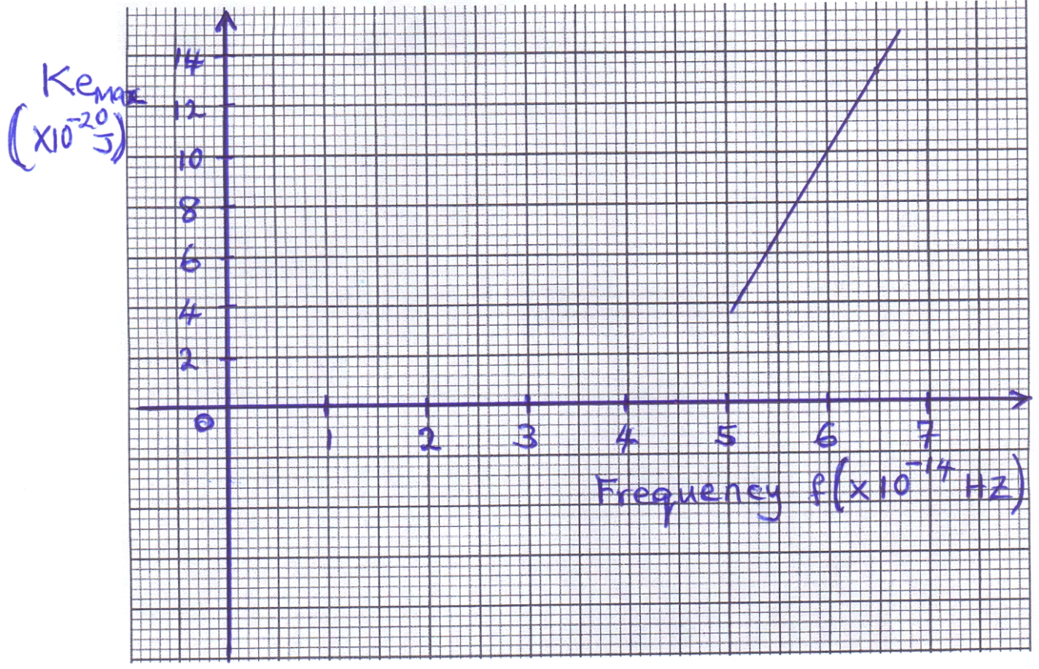

From Einstein’s equation, hf = Ɵ + Ke_{max}, where Ɵ is the work function. Determine.
(i) the threshold frequency, f₀ from the graph (1 mark)

(ii) the planks constant, h (2 marks)

15. (a) An electric cooker has an oven rated 3KW, a grill rated 2KW and two rings each rated at 500W. The cooker operates from 240V mains. What is the cost of operating all the parts for 30 minutes if electricity cost Ksh.6.50 per unit? (3 marks)

(b) Fig. below shows identical copper coils A and B placed close to each other. Coil A is connected to a d.c. power supply while coil B is connected to a galvanometer.

B
A
G

(i) State and explain what is observed on the galvanometer when the switch is closed. (2 marks)

(ii) State what is observed on the galvanometer when the switch is opened. (1 mark)

(iii) State what would be observed if the number of turns of coil B is doubled. (1 mark)

(c) A transformer with 2000 turns in the primary circuit and 150 turns in the secondary circuit has a primary circuit connected to a 800V ac source. It is found that when a heater is connected to the secondary circuit, it produces heat at the rate of 1000w. Assuming 90% efficiency, determine the;
(i) Voltage in the secondary circuit. (2 marks)

(ii) the current in the primary circuit. (2 marks)

(iii) Current in the secondary circuit (1 mark)

(d) A cell drives a current of 5A through a 1.6Ω resistor. When connected to a 2.8Ω resistor, the current that flows is 3.2A. Determine the e.m.f. (E) and internal resistance (r) of the cell. (4 marks)

16. (a) State how each of the following can be increased in an x-ray tube.
(i) Intensity of x-rays. (1 mark)

(ii) penetrating power of x-rays. (1 mark)

(b) An x-ray tube has an electron beam current of 10mA and is accelerated through a p.d of 60KV. The efficiency is 0.5%. Calculate;
(i) the input power (2 marks)

(ii) the quantity of heat produced per second. (1 mark)

(iii) the number of electrons hitting the target per second. (2 marks)

(c) The fig. below shows an a.c. signal on the C.R.O screen.
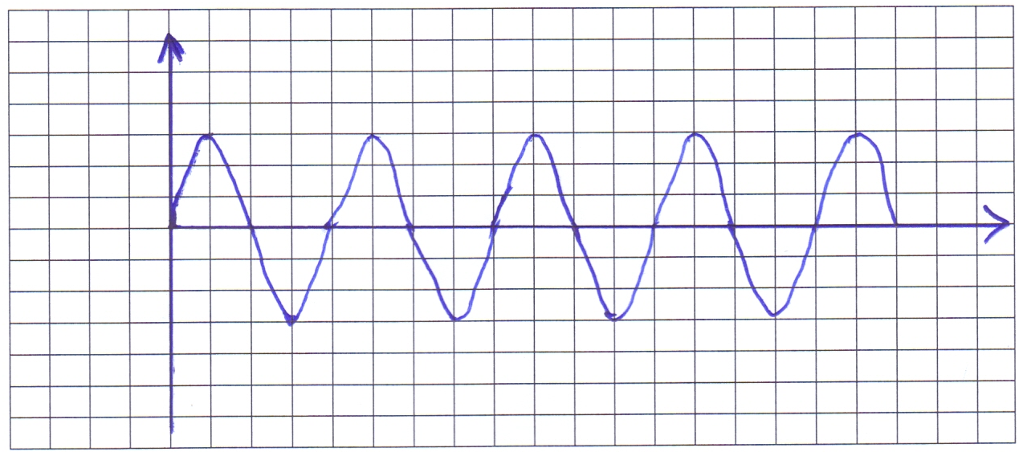

Determine:
(i) The frequency of the signal given that the time base is set at 10ms/div. (2 marks)

(ii) The peak voltage of the signal given that the y-gain is set at 50v/div (2 marks)

